Supplementary information

ROI | DVH-parameter |  |  |  | Weight
cARF
PTV | D98% | > | 38.05 | Gy | 5
 | D2% | < | 42.85 | Gy | 5
Heart | MHD | < | 3.00 | Gy | 1
Lungs | MLD | < | 6.00 | Gy | 1
External | D_{max} | < | 42.85 | Gy | 1
U-net
PTV | D98% | > | 38.05 | Gy | 5
 | D_{max} | < | 42.50 | Gy | 5
External | D_{max} | < | 43.00 | Gy | 1
Table A. 1. Mimick settings for cARF and U-net model.

AI planning
For generating the AI plans, two separate AI planning models were used in this study. The first model, an in-house developed model, is an adapted version of the U-net architecture, based on the architecture used by Nguyen et al. [1]. The architecture is visualized in Figure A.1. The input of the model contains four channels, representing four contours; PTV, heart, lungs and the external contour. These contours are represented by binary masks, except for the PTV mask, where the voxels inside the contour were assigned a weight value, equal to the prescribed dose.
The second model was based on a contextual atlas regression forest (cARF), and is extensively described by McIntosh and Purdie [1, 2]. The method consists of two phases; (1) the atlas-to-image mapping phase, and (2) the atlas-selection phase. In the first phase, the relationship between image features and the dose distribution are modeled by training atlas regression forests (ARFs). In the second phase a model is trained to select the most relevant ARF for a new patient, using density estimation over the observed image features. To find the most probable dose distributions, a conditional random field model is used.

[1] Nguyen D, Long T, Jia X, Lu W, Gu X, Iqbal Z, Jian S. A feasibility study for predicting optimal radiation therapy dose distributions of prostate cancer patients from patient anatomy using deep learning. Scientific reports 2019;9:1–10. https://doi.org/10.1038/s41598-018-37741-x
[2] McIntosh C and Purdie TG, Contextual atlas regression forests: multiple-atlas-based automated dose prediction in radiation therapy. IEEE transactions on medical imaging 2015;35:1000–12. https://doi.org/10.1109/tmi.2015.2505188
[3] McIntosh C and Purdie TG. Voxel-based dose prediction with multi-patient atlas selection for automated radiotherapy treatment planning. Physics in Medicine & Biology 2016;2:415. https://doi.org/10.1088/1361-6560/62/2/415

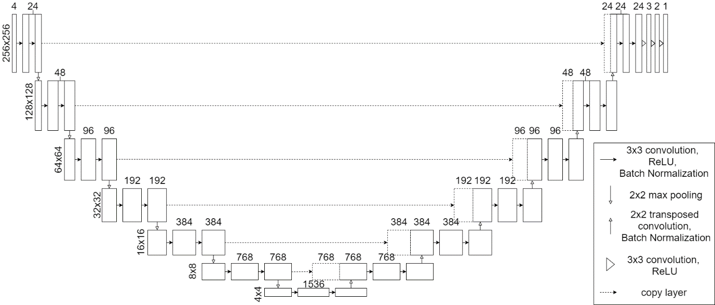
Figure A. 1. U-Net architecture used for the in-house developed model. Numbers on the side represent 2D feature size, numbers above layers represent number of features of that layer.

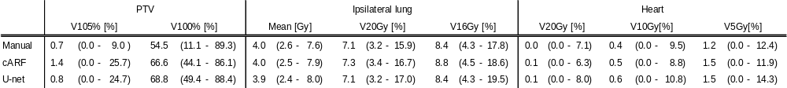
Table A. 2. Additional DVH-parameters for the different types of plans. All values are reported as median (range).

 | Clinical goals met
 |  | [%]
 | Manual | cARF | U-net
PTV average dose > 99% | 95 | 100 | 100
PTV average dose < 101% | 90 | 70 | 50
Table A. 3 Clinical goals added after model development based on recent Dutch consensus guidelines.
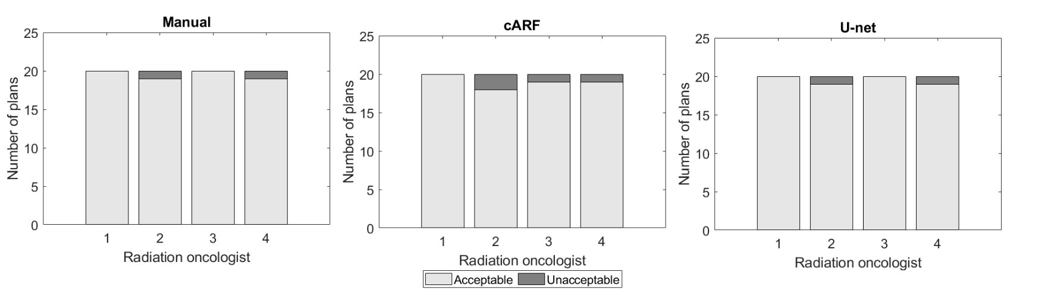
Figure A. 2. Judgement of the clinical acceptability of the plans by the Radiation Oncologists on an individual basis.

