Fig S1:

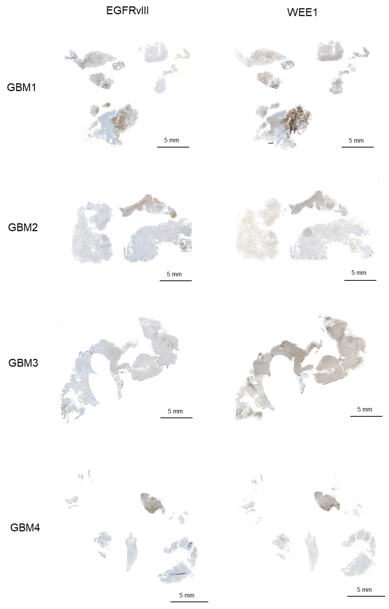

Fig. S1: Heterogenous EGFRvIII and WEE1 expression in human GBM samples. Immunohistochemical detection of EGFRvIII in four GBM samples patient samples used for the analysis of WEE1 expression in EGFRvIII- and EGFRvIII+ areas. Scale bars represent 5 mm.

Fig S2:
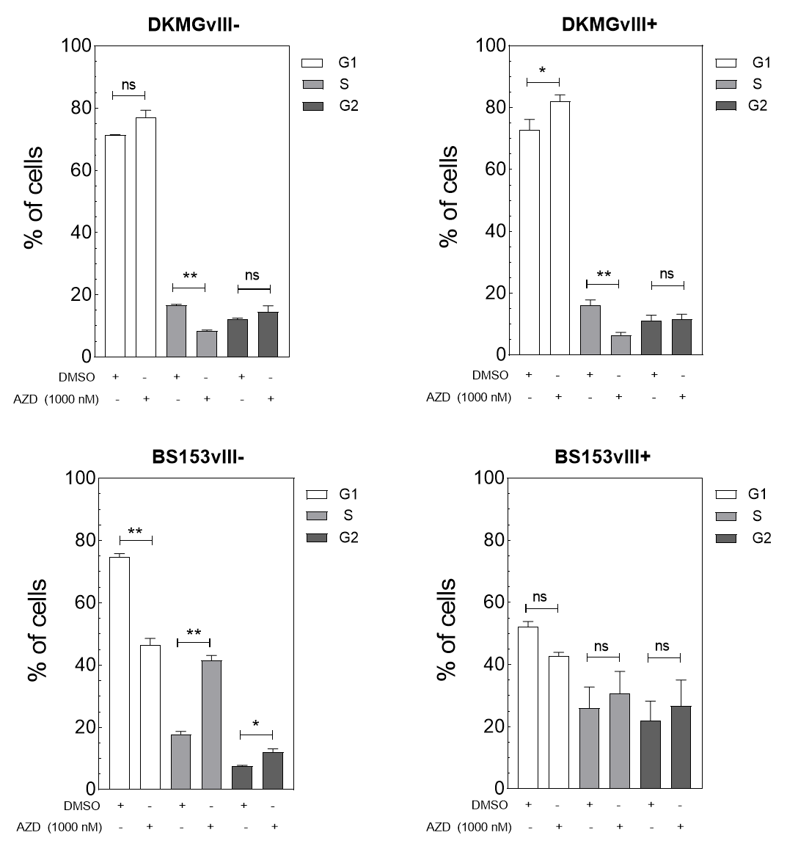

Fig. S2. Effect of Wee1 inhibtion on cell cycle distribution. Quantification of cells in G1-, S- and G2-phase after DMSO and adavosertib treatment for 24 h. (n=3; mean with S.E.M; P-values are obtained by using two-tailed Student´s t-test, *p <0.05, **p<0.001; ns: not significant).

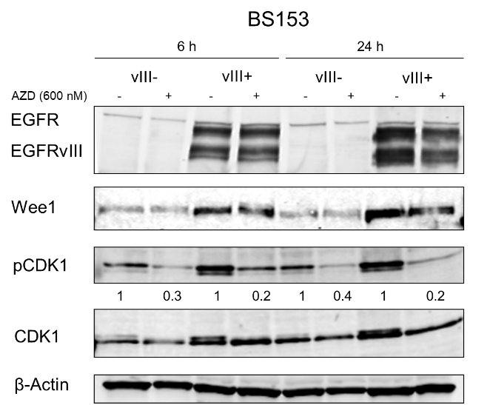
Fig S3:

Fig. S3. Phosphorylation of CDK1 after Wee1 inhibtion. BS153vIII-/+ cells were treated with 600 nM adavosertib and harvested after different timepoints as indicated. Expression respectively phosphorylation of CDK1 was assessed by Western blot analysis. β-Actin served as loading control. For quantification of relative CDK phosphorylation after irradiation phosphorylation values were normalized to values of CDK1 expression and to the respective untreated control.

Fig S4:
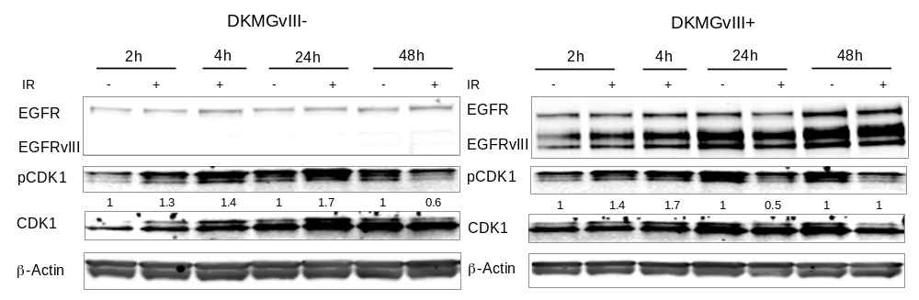

Fig. S4. Phosphorylation of CDK1 after irradiation. DKMGvIII-/+ cells were treated with 6 Gy irradiation and harvested after different timepoints as indicated. Expression respectively phosphorylation of CDK1 was assessed by Western blot analysis. β-Actin served as loading control. For quantification of relative CDK phosphorylation after irradiation phosphorylation values were normalized to values of CDK1 expression and to the respective untreated control.

