Fig.S1. Bias risk assessment chart

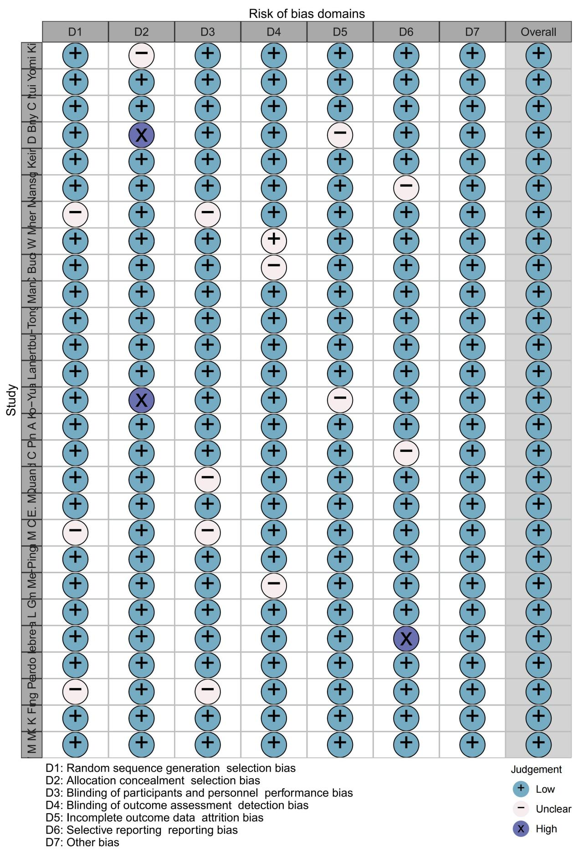

Fig.S2. Subgroup Analysis of the Association of RT With Hearing Loss by Cochlear irradiation dose

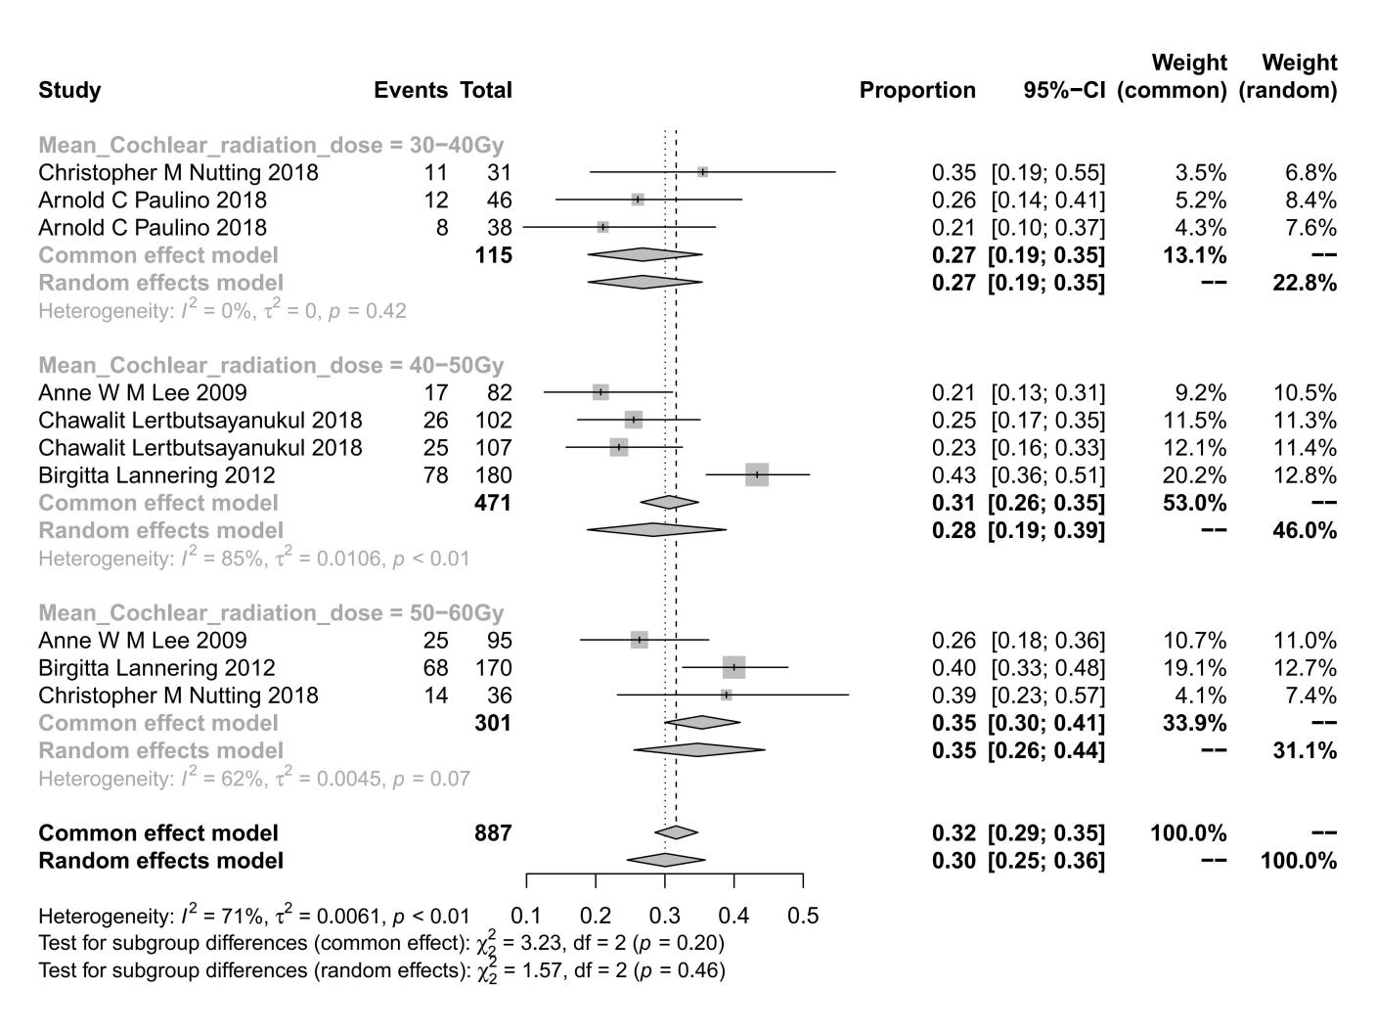

Fig.S3.Funnel chart of total hearing loss

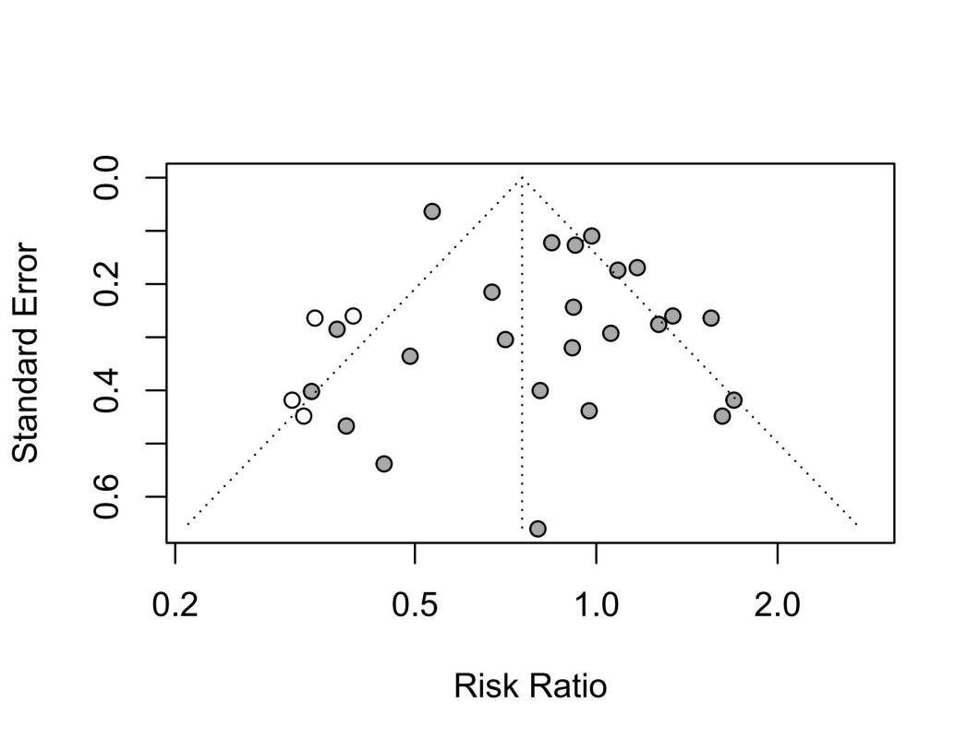

Fig.S4.Sensitivity analysis of hearing loss

