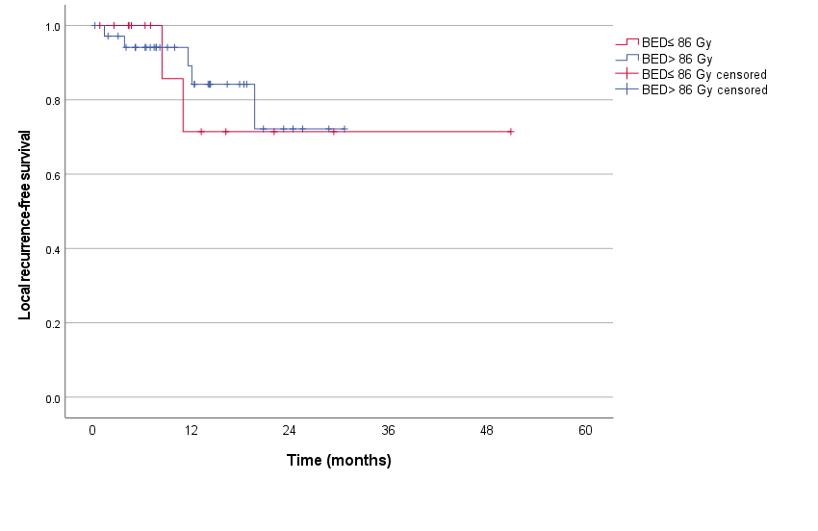
Supplementary Figure 3. Subgroup analysis of local recurrence-free survival in HCC patients treated with BED over and under the median dose 86 Gy (calculated for α/β= 7 Gy). A. GTV equivalent diameter≤ 5 cm B. GTV equivalent diameter> 5 cm.
A.

Number at risk
BED≤ 86 Gy | 14 | 5 | 2 | 1 | 1 | 0
BED> 86 Gy | 36 | 17 | 4 | 0 | 0 | 0
Log-rank P=0.833

