Supplement
Supplementary material and methods
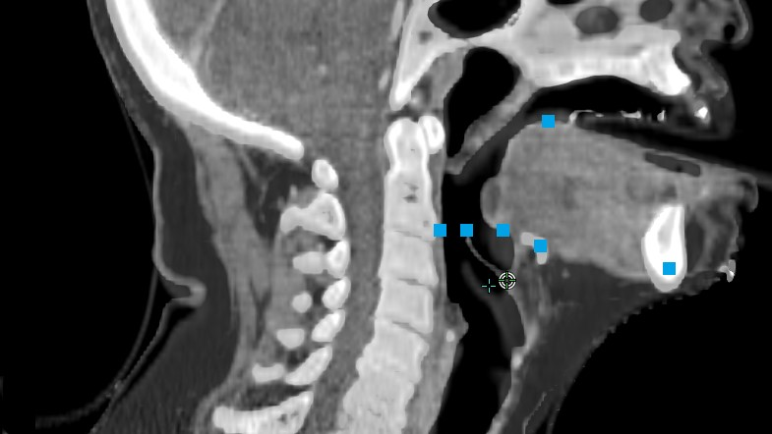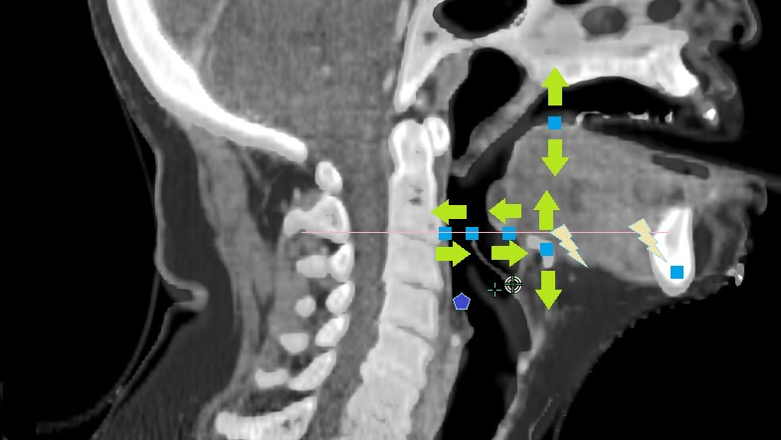
Supplementary Figure 1 | Inter- and intrafractional deformations evaluated by measuring specific points at predefined 8 landmarks (highlighted with red coloured stars) on the sagittal plane in the midline of the planning-CT, CBCT1 and CBCT2: (a) anterior/ posterior deviation of posterior pharyngeal wall at the tip of the epiglottis ; (b) maximum anterior/ posterior deviation of posterior pharyngeal wall ; (c) maximum deviation of mandible ;  (d) maximum craniocaudal deviation of os hyoideum ; (e) overall maximum deviation of os hyoideum ; (f) maximum anterior/ posterior deviation of tongue base ;(g) maximum craniocaudal deviation of tongue back ; and (h) anterior/ posterior deviation of tongue base at the tip of the epiglottis

Supplementary results
When comparing other important CTV dose metrics of the adaptive applied fractions, it becomes obvious that D_{99%_CTV} and D_{min_CTV} differ significantly between adaptive and scheduled plans (p = 0.012; p = 0.020).

