Supplementary Materials
Table S1: Differences of clinicopathological characteristics between the training and test sets.
 | Training set  (n=235) | Test set  (n=99) | All  (n=334) | Pvalue
Gender
female | 234 (99.6%) | 97 (98.0%) | 331 (99.1%)
male | 1 (0.4%) | 2 (2.0%) | 3 (0.9%) | 0.438
Age
≥56 | 136 (57.9%) | 55 (55.6%) | 191 (57.2%)
＜56 | 99 (42.1%) | 44 (44.4%) | 143 (42.8%) | 0.787
Tumour location
UOQ | 120 (51.1%) | 54 (54.5%) | 174 (52.1%)
non-UOQ | 115 (48.9%) | 45 (45.5%) | 160 (47.9%) | 0.644
BSGI features
Tumour TNR(CC)
≥2.5 | 124 (52.8%) | 49 (49.5%) | 173 (51.8%)
＜2.5 | 111 (47.2%) | 50 (50.5%) | 161 (48.2%) | 0.67
Tumour TNR(MLO)
≥2.5 | 119 (50.6%) | 43 (43.4%) | 162 (48.5%)
＜2.5 | 116 (49.4%) | 56 (56.6%) | 172 (51.5%) | 0.279
Axillary mass satus
negative | 182 (77.4%) | 71 (71.7%) | 253 (75.7%)
positive | 53 (22.6%) | 28 (28.3%) | 81 (24.3%) | 0.329
Ultrasonic features
Tumour echogenicity
low | 229 (97.4%) | 96 (97.0%) | 325 (97.3%)
other | 6 (2.6%) | 3 (3.0%) | 9 (2.7%) | 1
Transverse diameter of tumour (mm)
≥22 | 110 (46.8%) | 45 (45.5%) | 155 (46.4%)
＜22 | 125 (53.2%) | 54 (54.5%) | 179 (53.6%) | 0.915
Longitudinal diameter of tumour (mm)
≥13 | 135 (57.4%) | 58 (58.6%) | 155 (46.4%)
＜13 | 100 (42.6%) | 41 (41.4%) | 179 (53.6%) | 0.847
Tumour margin
irregular | 234 (99.6%) | 96 (97.0%) | 330 (98.8%)
regular | 1 (0.4%) | 3 (3.0%) | 4 (1.2%) | 0.148
Tumour CDFI
no signal (0) | 34 (14.5%) | 13 (13.1%) | 47 (14.1%)
spot (I) | 21 (8.9%) | 6 (6.1%) | 27 (8.1%)
linear (II) | 105 (44.7%) | 48 (48.5%) | 153 (45.8%)
abundant (III) | 75 (31.9%) | 32 (32.3%) | 107 (32.0%) | 0.795
Tumour RI
0 | 129 (54.9%) | 54 (54.5%) | 183 (54.8%)
>0 | 106 (45.1%) | 45(45.5%) | 151 (45.2%) | 0.953
Lymphatic echogenicity
cystic | 84 (35.7%) | 32 (32.3%) | 116 (34.7%)
hypoechoic | 79 (33.6%) | 30 (30.3%) | 109 (32.6%)
hyperechoic | 68 (28.9%) | 37 (37.4%) | 105 (31.4%)
other | 4 (1.7%) | 0 (0.0%) | 4 (1.2%) | 0.292
Transverse diameter of lymph nodes (mm)
no | 84 (35.7%) | 32 (32.3%) | 116 (34.7%)
＜9.5 | 33 (14.0%) | 18 (18.2%) | 51 (15.3%)
≥9.5 | 118 (50.3%) | 49 (49.5%) | 167 (50.0%) | 0.599
Longitudinal diameter of lymph nodes (mm)
no | 84 (35.7%) | 32 (32.3%) | 116 (34.7%)
＜5.1 | 51 (21.7%) | 25 (25.3%) | 76 (22.8%)
≥5.1 | 100 (42.6%) | 42 (42.4%) | 142 (42.5%) | 0.733
Absence of lymph node hilum
no or not described | 231 (98.3%) | 96 (97.0%) | 327 (97.9%)
yes | 4 (1.7%) | 3 (3.0%) | 7 (2.1%) | 0.722
Lymphatic CDFI
no signal (0) | 177 (75.3%) | 72 (72.7%) | 249 (74.6%)
spot (I) | 12 (5.1%) | 5 (5.1%) | 17 (5.1%)
linear (II) | 31 (13.2%) | 13 (13.1%) | 44 (13.2%)
abundant (III) | 15 (6.4%) | 9 (9.1%) | 24 (7.2%) | 0.856
Lymphatic RI
0 | 225 (95.7%) | 92 (92.9%) | 317 (94.9%)
>0 | 10 (4.3%) | 7(7.1%) | 17 (5.1%) | 0.285
Pathological features
Infiltration depth
in situ | 7 (3.0%) | 6 (6.1%) | 13 (3.9%)
infiltrative | 223 (94.9%) | 88 (88.9%) | 311 (93.1%)
other | 5 (2.1%) | 5 (5.1%) | 10 (3.0%) | 0.138
Histologic type
ductal | 220 (93.6%) | 90 (90.9%) | 310 (92.8%)
lobular | 7 (3.0%) | 3 (3.0%) | 10 (3.0%)
other | 8 (3.4%) | 6 (6.1%) | 14 (4.2%) | 0.541
SBR grade
no | 30 (12.8%) | 17 (17.2%) | 47 (14.1%)
I | 8 (3.4%) | 5 (5.1%) | 13 (3.9%)
II | 97 (41.3%) | 37 (37.4%) | 134 (40.1%)
III | 100 (42.6%) | 40 (40.4%) | 140 (41.9%) | 0.618
Estrogen receptor status
negative | 57 (24.3%) | 32 (32.3%) | 89 (26.6%)
positive | 178 (75.7%) | 67 (67.7%) | 245 (73.4%) | 0.165
Progesterone receptor status
negative | 80 (34.0%) | 44 (44.4%) | 124 (37.1%)
positive | 155 (66.0%) | 55 (55.6%) | 210 (62.9%) | 0.094
Proliferation index (Ki-67)
＜14% | 52 (22.1%) | 16 (16.2%) | 68 (20.4%)
≥14% | 183 (77.9%) | 83 (83.8%) | 266 (79.6%) | 0.277
Her-2 overexpression
negative | 172 (73.2%) | 73 (73.7%) | 245 (73.4%)
positive | 63 (26.8%) | 26 (26.3%) | 89 (26.6%) | 1
Molecular subtype
Luminal A | 43 (18.3%) | 9 (9.1%) | 52 (15.6%)
Luminal B | 135 (57.4%) | 58 (58.6%) | 193 (57.8%)
Her2 positive | 27 (11.5%) | 18 (18.2%) | 45 (13.5%)
Triple negative | 30 (12.8%) | 14 (14.1%) | 44 (13.2%) | 0.101
lymphovascular invasion
no | 206 (87.7%) | 79 (79.8%) | 285 (85.3%)
yes | 29 (12.3%) | 20 (20.2%) | 49 (14.7%) | 0.092
Multifocality
no | 229 (97.4%) | 97 (98.0%) | 326 (97.6%)
yes | 6 (2.6%) | 2 (2.0%) | 8 (2.4%) | 1
T stage
Tis | 7 (3.0%) | 6 (6.1%) | 13 (3.9%)
T1 | 122 (51.9%) | 51 (51.5%) | 173 (51.8%)
T2 | 98 (41.7%) | 38 (38.4%) | 136 (40.7%)
T3 | 8 (3.4%) | 4 (4%) | 12 (3.6%) | 0.579
N stage
N0 | 143 (60.9%) | 60 (60.6%) | 203 (60.8%)
N1 | 48 (20.9%) | 21 (21.2%) | 70 (21.0%)
N2 | 28 (11.9%) | 10 (10.1%) | 38 (11.4%)
N3 | 15 (6.3%) | 8 (8.1%) | 23 (6.8%) | 0.919
Axillary lymph node metastasis
yes | 92 (39.1%) | 39 (39.4%) | 131 (39.2%)
no | 143 (60.9%) | 60 (60.6%) | 203 (60.8%) | 1
UOQ: Upper-outer quadrant; BSGI: breast specific gamma image; TNR: tumour-to-normal lesion ratio; CC: craniocaudal; MLO: mediolateral oblique; CDFI: color Doppler flow imaging; SBR grade: Scarff-Bloom-Richardson grade.
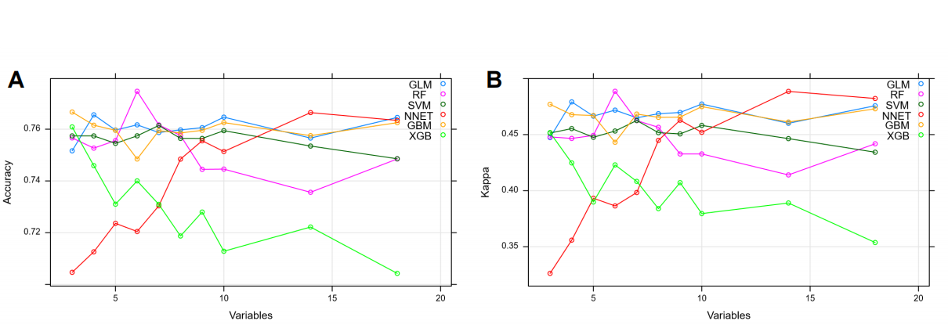
Figure S1: Variables selection with REF method. (A) The line graph shows the relationship between the number of candidate variables and the accuracy in each algorithm. (B) The line graph shows the relationship between the number of candidate variables and the Kappa values in each algorithm. GLM: generalized linear model; RF: random forest; SVM: support vector machine; NNET: neural network; GBM: gradient boosting machine; XGB: extreme boosting machine.
Table S2: The best hyperparameters of different machine learning models in evalution of variables importance
ML model
GLM | alpha: 0 | lambda:0.5
RF | ntree: 500 | mtry:1
SVM | sigma: 0.5 | cost: 0.001
NNET | size: 1 | decay: 0.1
GBM | nums of trees:1000 | interaction depth: 3 | shrinkage: 0.01 | nums of minobsinnode: 5
XGB | nrounds: 1000 | max depth: 20 | eta: 0.5 | gamma: 1 | colsample by tree: 1 | min child weight: 1 | subsample:0.8
ML: machine learning; GLM: generalized linear model; RF: random forest; SVM: support vector machine; NNET: neural network; GBM: gradient boosting machine; XGB: extreme boosting machine.

