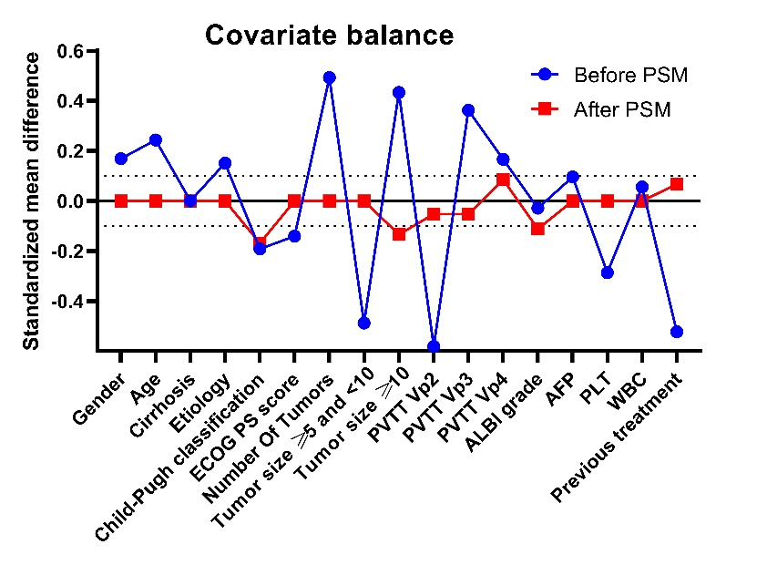
Supplementary Fig. 1. Standardized mean differences in covariates between patients in the stereotactic body radiotherapy and lenvatinib groups before and after propensity score matching analysis. ECOG, Eastern Cooperative Oncology Group; PS, performance status; PVTT, Portal Vein Tumor Thrombosis; ALBI, grade albumin-bilirubin grade; AFP, alpha-fetoprotein; PLT, platelet; WBC, white blood cell; PSM, propensity score matching.

