Supplementary Materials

Supplementary material A

Inclusion and exclusion criteria for training and testing set
Inclusion criteria: (1) Patients was confirmed NSCLC by pathology; (2) age ≥18 years and KPS ≥70; (3) Diagnosed inoperative locally advanced NSCLC (Clinical stage II-III, American Joint Committee on Cancer, 8th edition, 2017) before radiotherapy (RT), and underwent definitive RT; (4) follow-up time over 2 years. Exclusion criteria: (1) history of lung surgery for any reason before RT; (2) history of chest RT; (3) poor quality of planning CT; (4) Unacceptable dose deviation.

Overall survival (OS) of the RTOG0617 data and Lung1 data from Maastro
As the OS of the RTOG0617 data and Lung1 data defined as the time from the start of RT to death, we approximate modified OS by subtracting 42days from OS of the RTOG0617 data and Lung1 data to approach the starting point of OS in the training set.

Supplementary Figure 1. Flow of patient inclusion of RTOG0617 (1a) and Lung1 in Maastro (1b) for testing.

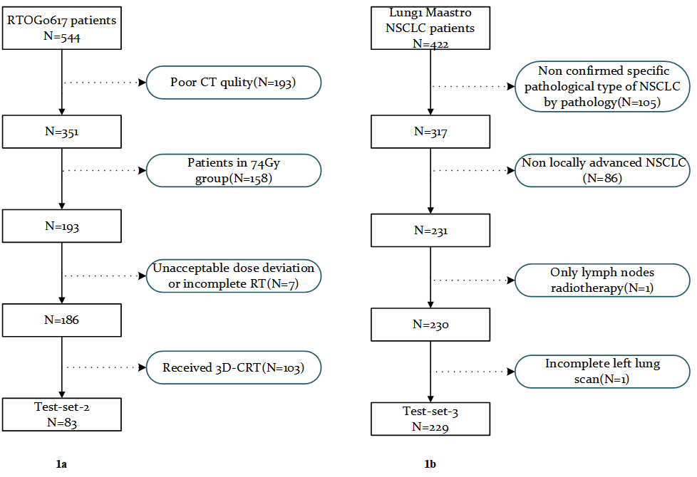
Supplementary Table 1a. Patient characteristics of Tianjin data.
 | All patients  N=349 | Training  set  N=292 | Test-set-1  N=57 | P value
Gender |  |  |  | 0.604
Male | 279(79.9％) | 232(79.5％) | 47(82.5％)
Female | 70(20.1％) | 60(20.5％) | 10(17.5％)
Age |  |  |  | <0.001*
≤60 | 176(50.4％) | 135(46.2％) | 41(71.9％)
＞60 | 173(49.6％) | 157(53.8％) | 16(28.1％)
Histology subtype |  |  |  | 0.015*
SCC | 200(57.3％) | 159(54.5％) | 41(71.9％)
Non-SCC | 149(42.7％) | 133(45.5％) | 16(28.1％)
Location |  |  |  | 0.019*
Central | 235(67.3％) | 189(64.7％) | 46(80.7％)
Peripheral | 114(32.7％) | 103(35.3％) | 11(19.3％)
Clinical Stage |  |  |  | 0.463
IIIA | 114(32.7％) | 95(32.5％) | 19(33.3％)
IIIB | 165(47.3％) | 135(46.2％) | 30(52.6％)
IIIC | 70(20.1％) | 62(21.2％) | 8(14.0％)
T stage |  |  |  | 0.823
T1 | 48(13.7％) | 40(13.7％) | 8(14.0％)
T2 | 84(24.1％) | 71(24.3％) | 13(22.8％)
T3 | 76(21.8％) | 61(20.9％) | 15(26.3％)
T4 | 141(40.4％) | 120(41.1％) | 21(36.8％)
N stage |  |  |  | 0.001*
N0 | 27(7.7％) | 26(8.9％) | 1(1.8％)
N1 | 27(7.7％) | 20(6.9％) | 7(12.3％)
N2 | 157(45.0％) | 121(41.6％) | 36(63.2％)
N3 | 137(39.3％) | 124(42.6％) | 13(22.8％)
KPS |  |  |  | 0.071
≤80 | 148(42.4％) | 130(44.5％) | 18(31.6％)
＞80 | 201(57.6％) | 162(55.5％) | 39(68.4％)
Loss Weight |  |  |  | 0.478
No | 287(82.2％) | 242(82.9％) | 45(78.9％)
Yes | 62(17.8％) | 50(17.1％) | 12(21.1％)
Radiotherapy doze |  |  |  | 0.004*
< 60 | 105(30.1％) | 97(33.2％) | 8(14.0％)
≥60 | 244(69.9％) | 195(66.8％) | 49(86.0％)
Induc chemo |  |  |  | 0.076
No | 43(12.3％) | 40(13.7％) | 3(5.3％)
Yes | 306(87.7％) | 252(86.3％) | 54(94.7％)
CCRT |  |  |  | 0.285
No | 236(67.6％) | 194(66.4％) | 42(73.7％)
Yes | 113(32.4％) | 98(33.6％) | 15(26.3％)
Conso chemo |  |  |  | 0.357
No | 220(63.0％) | 181(62.0％) | 39(68.4％)
Yes | 129(37.0％) | 111(38.0％) | 18(31.6％)
Survival |  |  |  | 0.059
Alive | 156(44.7％) | 137(46.9％) | 19(33.3％)
Dead | 193(55.3％) | 155(53.1％) | 38(66.7％)
Abbreviations: KPS = Karnofsky performance score; Induc chemo = induction chemotherapy; CCRT = concurrent chemoradiotherapy; Conso chemo = consolidation chemotherapy.
*The differences in characteristics were evaluated by Pearson X² test or exact Fisher test for categorical variables.

Supplementary Table 1b. Patient characteristics of test-set-2.
 | All patients
 | N=83 | %
Race
Asian | 5 | 6.0
Black or African American | 8 | 9.6
White | 70 | 84.3
Ethnicity  Hispanic or Latino  Not Hispanic or Latino  Unknown | 1  77  5 | 1.2  92.8  6.0
Zubrod  0  1 | 51  32 | 61.4  38.6
Histology
SCC | 30 | 36.1
Adenocarcinoma | 34 | 41.0
Large cell undifferentiated | 1 | 1.2
Non-small cell lung cancer NOS | 18 | 21.7
Survival
Alive | 43 | 51.8
Dead | 40 | 48.2
Abbreviations: SCC = squamous cell carcinoma; NOS = Not Otherwise Specified.

Supplementary material B

Details of segmentation of tumor and lung
Tumors and lungs were all segmented in pulmonary windows (window width 1400HU, window level -500HU). Malignant lymph nodes weren’t included in tumor ROIs. Both lungs (right and left lungs) were contoured. All inflated, fibrotic and emphysematic lungs were be contoured, small vessels extending beyond the hilar regions were included; however, tumor, collapsed lungs, hilars and trachea/main bronchus weren’t included in this structure.

Supplementary material C

Radiomics features extraction parameter settings file
imageType:
Original:
binWidth: 25
LoG:
binWidth: 10
sigma: [1.0, 2.0, 3.0]
Wavelet:
binWidth: 5
featureClass:

shape:
- VoxelVolume
- Elongation
- Flatness
- LeastAxisLength
- MajorAxisLength
- Maximum2DDiameterColumn
- Maximum2DDiameterRow
- Maximum2DDiameterSlice
- Maximum3DDiameter
- MeshVolume
- MinorAxisLength
- Sphericity
- SurfaceArea
- SurfaceVolumeRatio
firstorder: # Remove Total Energy, correlated to Energy (due to resampling enabled)
- 10Percentile
- 90Percentile
- Energy
- Entropy
- InterquartileRange
- Kurtosis
- Maximum
- Mean
- MeanAbsoluteDeviation
- Median
- Minimum
- Range
- RobustMeanAbsoluteDeviation
- RootMeanSquared
- Skewness
- Uniformity
- Variance
glcm: # Disable SumAverage by specifying all other GLCM features available
- 'Autocorrelation'
- 'JointAverage'
- 'ClusterProminence'
- 'ClusterShade'
- 'ClusterTendency'
- 'Contrast'
- 'Correlation'
- 'DifferenceAverage'
- 'DifferenceEntropy'
- 'DifferenceVariance'
- 'JointEnergy'
- 'JointEntropy'
- 'Imc1'
- 'Imc2'
- 'Idm'
- 'Idmn'
- 'Id'
- 'Idn'
- 'InverseVariance'
- 'MaximumProbability'
- 'SumEntropy'
- 'SumSquares'
glrlm:
glszm:
gldm:
ngtdm:

setting:
interpolator: 'sitkBSpline'
resampledPixelSpacing: [2, 2, 2]
padDistance: 10 # Extra padding for large sigma valued LoG filtered images

resegmentRange: [-3, 3]
resegmentMode: sigma
voxelArrayShift: 1000
label: 1

Supplementary material D
The Feature selection methods and results
Step1: Selection based on radiomic features frequencies.
The radiomic features were screened using the least absolute shrinkage and selection operator (LASSO) embedded within the COX proportional hazards model (COX) with 5-fold cross-internal validation. This process was conducted on 1000 unique bootstrap samples derived from the entire training set. For each of the 1000 bootstraps, every radiomic feature was ranked based on its frequency of selection by the LASSO-COX model.

The top twenty features that were screened are displayed in Supplementary Table 2. These features are sorted according to the number of frequencies selected and are visually represented in Supplementary Figure 2.

To determine the optimal cut-off point, we considered the ratio of selected features to the number of training samples, maintaining a 1:10 ratio—one feature selected for every 10 samples. This ensured an appropriate feature-to-sample balance, reducing the risk of overfitting while retaining model interpretability. Consequently, we selected a cut-off point between the 10th and 20th most frequently selected features, as illustrated in Supplementary Figure 2. This range provided sufficient diversity and ensured an ample feature set for the second selection step.

Step 2: Selection based on radiomic feature combination (signature) frequencies.
The radiomic features selected over the cut-off point were imported into the “feature pool” for further selection based on COX and stepwise backward Akaike information criterion (AIC) for the same 1000 bootstrap samples as in step 1.

The most frequently selected radiomic feature combination (signature), ranked as the top1 in the second step of feature selection, is detailed in Supplementary Table 3. The signature of tumor includes 11 features, which were selected 9 times, while the signature of lung includes 8 features, selected 45 times.

Supplementary Table 2a. The top twenty tumor radiomics features that were selected.
Number | Radiomics Feature | Frequency
1 | wavelet.HHH_glcm_Correlation | 790
2 | wavelet.HHL_glszm_LargeAreaLowGrayLevelEmphasis | 589
3 | wavelet.HHL_firstorder_Maximum | 557
4 | wavelet.LHL_firstorder_RootMeanSquared | 547
5 | wavelet.LLH_glcm_Correlation | 430
6 | wavelet.LLH_glcm_ClusterShade | 380
7 | wavelet.LHL_glcm_Correlation | 377
8 | original_firstorder_Skewness | 366
9 | wavelet.HLL_firstorder_Skewness | 364
10 | wavelet.HLH_glcm_Correlation | 357
11 | wavelet.LHH_firstorder_Skewness | 343
12 | wavelet.HLL_firstorder_Kurtosis | 341
13 | wavelet.LHL_glcm_ClusterShade | 341
14 | wavelet.LLL_glcm_ClusterShade | 335
15 | original_gldm_LargeDependenceHighGrayLevelEmphasis | 318
16 | wavelet.HLH_firstorder_RootMeanSquared | 304
17 | wavelet.LHL_firstorder_Kurtosis | 301
18 | wavelet.HLH_firstorder_Mean | 293
19 | wavelet.HLH_glcm_JointAverage | 282
20 | original_glszm_SmallAreaEmphasis | 270

Supplementary Table 2b. The top twenty lung radiomics features that were selected.
Number | Radiomics Feature | Frequency
1 | wavelet.HLL_firstorder_Maximum | 963
2 | original_shape_Sphericity | 778
3 | original_shape_Maximum3DDiameter | 749
4 | wavelet.HLH_firstorder_Mean | 725
5 | wavelet.LHL_firstorder_Skewness | 654
6 | wavelet.HLH_glcm_Imc2 | 616
7 | wavelet.HLL_glszm_ZoneEntropy | 578
8 | original_shape_Maximum2DDiameterSlice | 503
9 | wavelet.LHH_glszm_LargeAreaHighGrayLevelEmphasis | 491
10 | original_glszm_LargeAreaHighGrayLevelEmphasis | 459
11 | wavelet.HHL_firstorder_Skewness | 424
12 | wavelet.LLH_firstorder_Mean | 423
13 | wavelet.LHL_firstorder_Maximum | 400
14 | wavelet.LLH_glszm_ZoneEntropy | 400
15 | wavelet.LLH_gldm_SmallDependenceLowGrayLevelEmphasis | 390
16 | original_firstorder_Energy | 372
17 | wavelet.HHH_firstorder_Skewness | 372
18 | wavelet.HLH_glcm_Correlation | 370
19 | original_shape_LeastAxisLength | 364
20 | original_gldm_SmallDependenceLowGrayLevelEmphasis | 346

Supplementary Figure 2. (a) The tumor radiomics features are sorted according to the number of frequencies selected. (b) The lung radiomics features are sorted according to the number of frequencies selected.
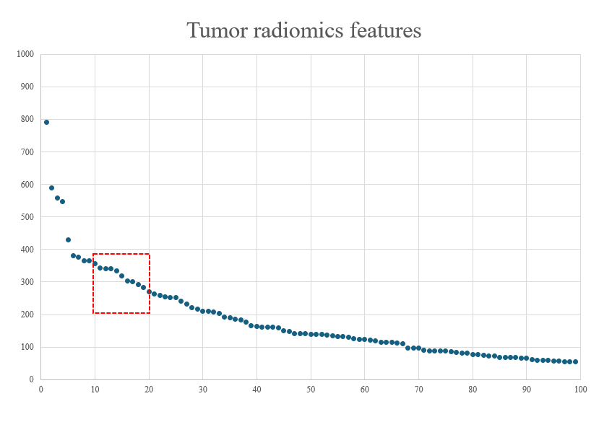
Supplementary Figure 2a
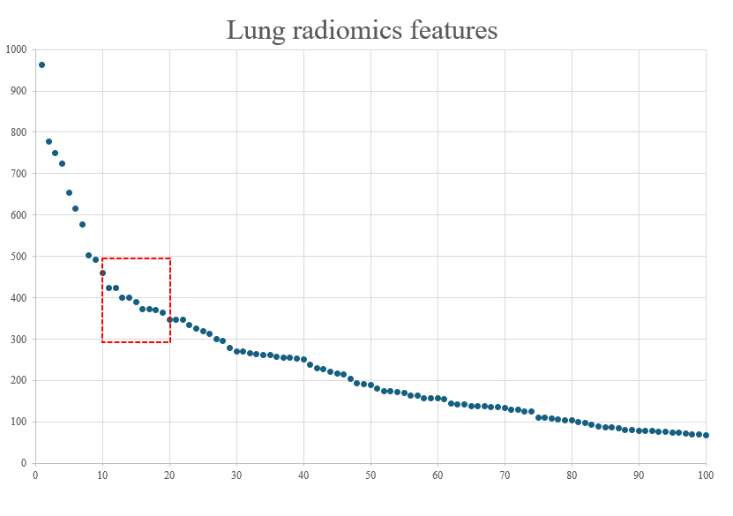
Supplementary Figure 2b

Supplementary Table 3. The top one frequently selected radiomics signature.

Radiomics signature | Radiomics features
Tumor | original_firstorder_Skewness
Tumor | original_gldm_LargeDependenceHighGrayLevelEmphasis
Tumor | wavelet.HHH_glcm_Correlation
Tumor | wavelet.HHL_firstorder_Maximum
Tumor | wavelet.HHL_glszm_LargeAreaLowGrayLevelEmphasis
Tumor | wavelet.HLH_firstorder_RootMeanSquared
Tumor | wavelet.LHL_firstorder_Kurtosis
Tumor | wavelet.LHL_firstorder_RootMeanSquared
Tumor | wavelet.LLH_glcm_ClusterShade
Tumor | wavelet.LHL_glcm_Correlation
Tumor | wavelet.LLL_glcm_ClusterShade
Lung | original_glszm_LargeAreaHighGrayLevelEmphasis
Lung | original_shape_Maximum2DDiameterSlice
Lung | original_shape_Maximum3DDiameter
Lung | wavelet.HLH_firstorder_Mean
Lung | wavelet.HLL_firstorder_Maximum
Lung | wavelet.HLL_glszm_ZoneEntropy
Lung | wavelet.LHH_glszm_LargeAreaHighGrayLevelEmphasis
Lung | wavelet.LLH_firstorder_Mean

The formulae for the construction of T-RPS, L-RPS, TL-RPS.
T-RPS = (-0.344822)×original_firstorder_Skewness
+(-9.840087E-06)×original_gldm_LargeDependenceHighGrayLevelEmphasis
+(-30.985651)×wavelet.HHH_glcm_Correlation
+0.001839×wavelet.HHL_firstorder_Maximum
+(-5.479932)×wavelet.HHL_glszm_LargeAreaLowGrayLevelEmphasis
+(-0.297379)×wavelet.HLH_firstorder_RootMeanSquared +0.037581×wavelet.LHL_firstorder_Kurtosis
+(-0.027175)×wavelet.LHL_firstorder_RootMeanSquared +0.000012×wavelet.LLH_glcm_ClusterShade
+3.549162×wavelet.LLH_glcm_Correlation
+(-2.578180E-08)×wavelet.LLL_glcm_ClusterShade
L-RPS = (3.779243E-08)×original_glszm_LargeAreaHighGrayLevelEmphasis
+(-0.029704)×original_shape_Maximum2DDiameterSlice
+0.037520×original_shape_Maximum3DDiameter
+2.678601×wavelet-HLH_firstorder_Mean
+(-0.002369)×wavelet-HLL_firstorder_Maximum
+ (-7.171278)×wavelet-HLL_glszm_ZoneEntropy
+(-2.029555E-09)×wavelet-LHH_glszm_LargeAreaHighGrayLevelEmphasis
+ 0.274985×wavelet-LLH_firstorder_Mean
TL-RPS = 0.801897×T-RPS+0.811871×L-RPS.

Supplementary material E
Supplementary Figure 3. The calibration curve of 2 years OS in training set.

Supplementary material F
Supplementary Table 4a1. Distribution of clinical factors in different risk groups, based on T-RM in whole cohort, training set and test sets (optimal cutoff point of training set).
 | Whole cohort |  |  | Training set |  |  | Test sets
Clinical  factors | High-risk  N=271 | Low-risk  N=161 | P-value | High-risk  N=204 | Low-risk  N=88 | P-value | High-risk  N=67 | Low-risk  N=73 | P-value
Tumor  location |  |  | 0.036* |  |  | 0.084 |  |  | 0.102
Central | 189(69.7％) | 96(59.6％) |  | 138(67.6％) | 50(56.8％) |  | 51(76.1％) | 46(63.0％)
Peripheral | 82(30.3％) | 65(40.4％) |  | 66(32.4％) | 38(43.2％) |  | 16(23.9％) | 27(37.0％)
T Stage |  |  | <0.001* |  |  | 0.032 |  |  | <0.001*
1 | 25(9.2％) | 41(25.5％) |  | 20(9.8％) | 20(22.7％) |  | 5(7.5％) | 21(28.8％)
2 | 66(24.4％) | 43(26.7％) |  | 51(25.0％) | 20(22.7％) |  | 15(22.4％) | 23(31.5％)
3 | 66(24.4％) | 32(19.9％) |  | 47(23.0％) | 14(15.9％) |  | 19(28.4％) | 18(24.7％)
4 | 114(42.1％) | 45(28.0％) |  | 86(42.2％) | 34(38.6％) |  | 28(41.8％) | 11(15.1％)

Abbreviations: T-RM: COX regression model based on tumor signature.
*The differences in characteristics were evaluated by Pearson X² test or exact Fisher test for categorical variables.
Supplementary Table 4a2. Distribution of clinical factors in different risk groups, based on T-RM in whole cohort, training set and test sets (cutpoint= median score of training set).
 | Whole cohort |  |  | Training set |  |  | Test sets
Clinical  factors | High-risk  N=251 | Low-risk  N=181 | P-value | High-risk  N=146 | Low-risk  N=146 | P-value | High-risk  N=105 | Low-risk  N=35 | P-value
Tumor  location |  |  | 0.471 |  |  | 0.086 |  |  | 0.057
Central | 170(67.7％) | 116(64.1％) |  | 102(69.9％) | 87(59.6％) |  | 68(64.8％) | 29(82.9％)
Peripheral | 81(32.3％) | 65(35.9％) |  | 44(30.1％) | 59(40.4％) |  | 37(25.2％) | 6(17.1％)
T Stage |  |  | 0.446 |  |  | 0.102 |  |  | 0.832
1 | 35(13.9％) | 31(17.1％) |  | 14(9.6％) | 26(17.8％) |  | 21(20.0％) | 5(14.3％)
2 | 60(23.9％) | 49(27.1％) |  | 33(22.6％) | 38(26.0％) |  | 27(25.7％) | 11(31.4％)
3 | 63(25.1％) | 35(19.3％) |  | 36(24.7％) | 25(17.1％) |  | 27(25.7％) | 10(28.6％)
4 | 93(37.1％) | 66(36.5％) |  | 63(43.2％) | 57(39.0％) |  | 30(28.6％) | 9(25.7％)
Abbreviations: T-RM: COX regression model based on tumor signature.
*The differences in characteristics were evaluated by Pearson X² test or exact Fisher test for categorical variables.

Supplementary Table 4b1. Distribution of clinical factors in different risk groups, based on L-RM in whole cohort, training set and test sets (optimal cutoff point of training set).
 | Whole cohort |  |  | Training set |  |  | Test sets
Clinical  factors | High-risk  N=173 | Low-risk  N=259 | P-value | High-risk  N=111 | Low-risk  N=181 | P-value | High-risk  N=62 | Low-risk  N=78 | P-value
N Stage |  |  | 0.024* |  |  | 0.015* |  |  | 0.906
0 | 8(4.6％) | 19(7.3％) |  | 8(7.2％) | 18(9.9％) |  | 0(0.0％) | 1(1.3％)
1 | 7(4.0％) | 26(10.0％) |  | 2(1.8％) | 18(9.9％) |  | 5(8.1％) | 8(10.3％)
2 | 98(56.6％) | 116(44.8％) |  | 55(49.5％) | 67(37.0％) |  | 43(69.4％) | 49(62.8％)
3 | 60(34.7％) | 98(37.8％) |  | 46(41.4％) | 78(43.1％) |  | 14(22.6％) | 20(25.6％)
Smoking |  |  | <0.001* |  |  | 0.003* |  |  | 0.023*
No | 15(8.7％) | 59(22.8％) |  | 14(12.6％) | 49(27.1％) |  | 1(1.6％) | 10(12.8％)
Yes | 158(91.3％) | 200(77.2％) |  | 97(87.4％) | 132(72.9％) |  | 61(98.4％) | 68(87.2％)
Abbreviations: L-RM: COX regression model based on lung signature.
*The differences in characteristics were evaluated by Pearson X² test or exact Fisher test for categorical variables.

Supplementary Table 4b2. Distribution of clinical factors in different risk groups, based on L-RM in whole cohort, training set and test sets (cutpoint= median score of training set).
 | Whole cohort |  |  | Training set |  |  | Test sets
Clinical  factors | High-risk  N=213 | Low-risk  N=219 | P-value | High-risk  N=146 | Low-risk  N=146 | P-value | High-risk  N=67 | Low-risk  N=73 | P-value
N Stage |  |  | 0.159 |  |  | 0.151 |  |  | 0.371
0 | 11(5.2％) | 16(7.3％) |  | 10(6.8％) | 16(11.0％) |  | 1(1.5％) | 0(0.0％)
1 | 11(5.2％) | 22(10.0％) |  | 7(4.8％) | 13(8.9％) |  | 4(6.0％) | 9(12.3％)
2 | 113(53.1％) | 101(46.1％) |  | 69(47.3％) | 53(36.3％) |  | 44(65.7％) | 48(65.8％)
3 | 78(36.6％) | 80(36.5％) |  | 60(41.1％) | 64(43.8％) |  | 18(26.9％) | 16(21.9％)
Smoking |  |  | <0.001* |  |  | 0.010* |  |  | 0.010*
No | 23(10.8％) | 51(23.3％) |  | 22(15.1％) | 41(28.1％) |  | 1(1.5％) | 10(13.7％)
Yes | 190(89.2％) | 168(76.7％) |  | 124(84.9％) | 105(71.9％) |  | 66(98.5％) | 63(86.3％)
Abbreviations: L-RM: COX regression model based on lung signature.
*The differences in characteristics were evaluated by Pearson X² test or exact Fisher test for categorical variables.

Supplementary material G

Supplementary Figure4. Kaplan-Meier survival curves based on the TL-RM according to the optimal cutoff point of training set in test-set-2.Abbreviations: TL-RM: COX proportional hazards model based on tumor signature and lung signature.

