Supplement 1
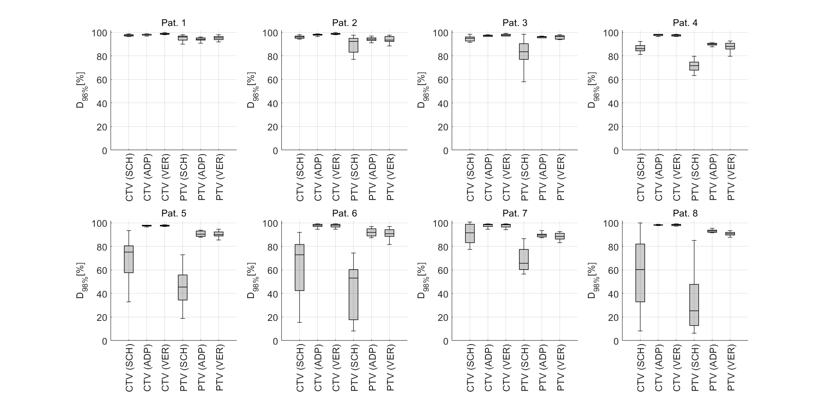
Figure 1 Dose coverage (D_{98%}) for scheduled (SCH), adapted (ADP), and veriﬁcation (VER) dose, for CTV (left) and PTV (right), for all individual patients.

Supplement 2
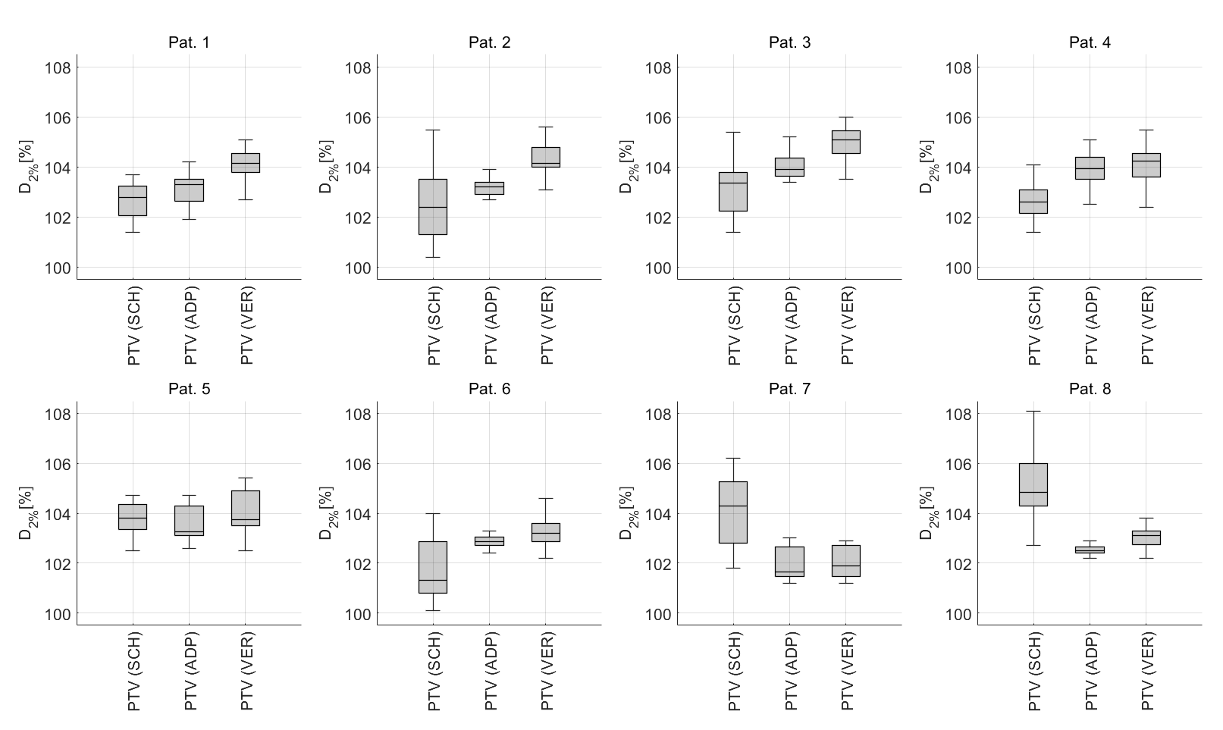
Figure 2 Dose near-max (D_{2%}) for SCH, ADP and VER dose, for PTV, for all individual patients.

Supplement 3
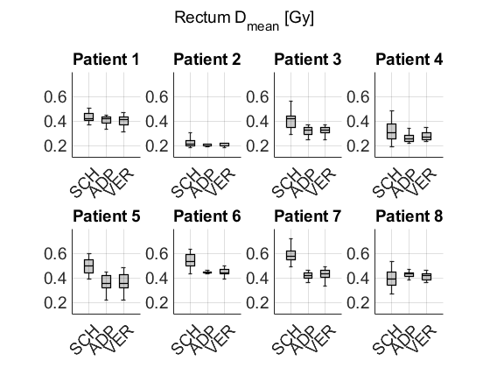
Figure 3 D_{mean} to rectum for SCH, ADP and VER dose, for all individual patients.

Supplement 4
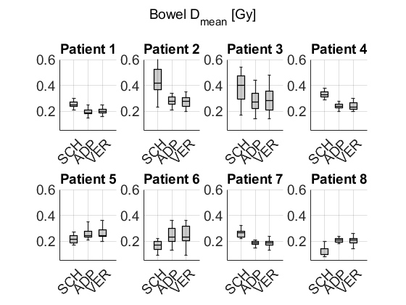
Figure 4 Dmean to bowel for SCH, ADP and VER dose, for all individual patients.

Supplement 5
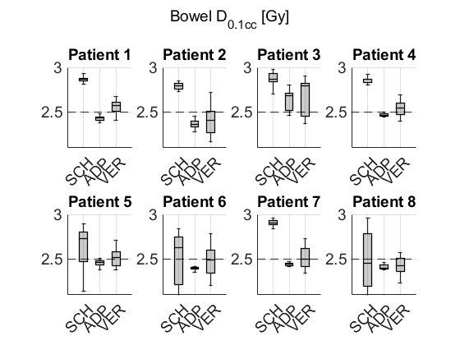
Figure 5 D_{0.1cc} to bowel for SCH, ADP and VER dose, for all individual patients.

