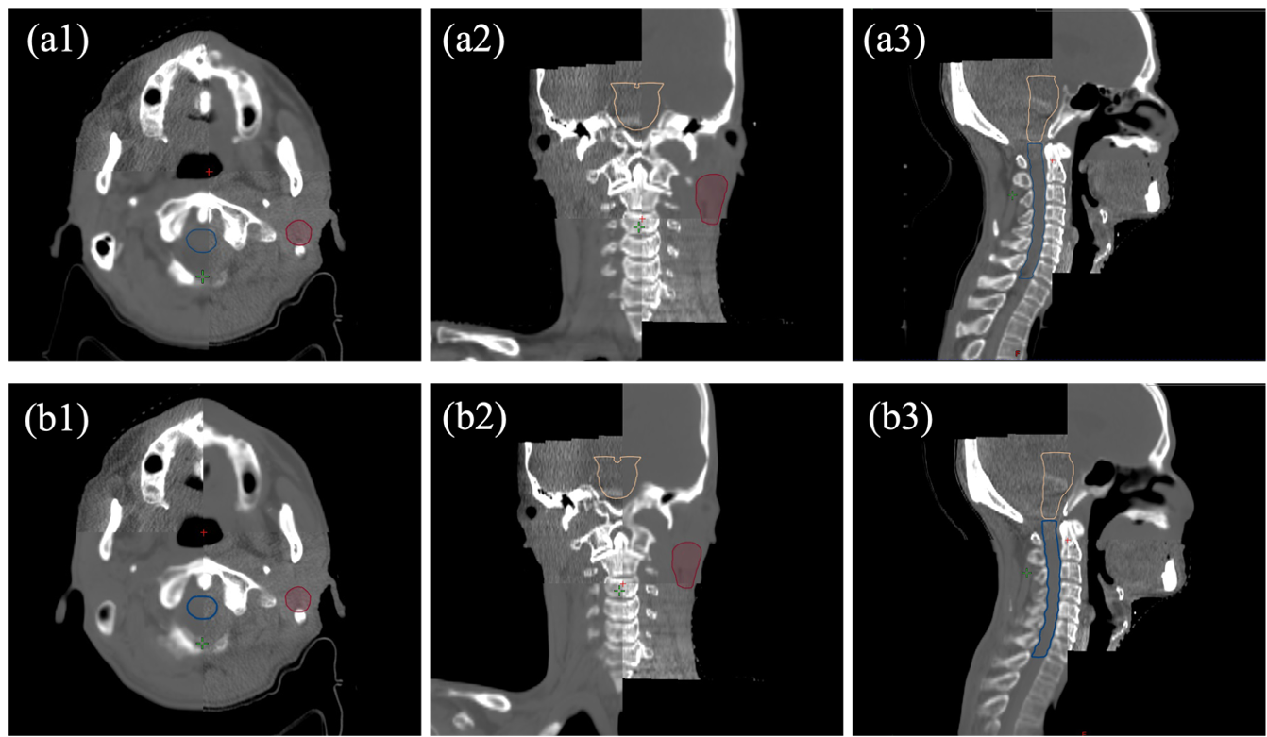
Fig S1. Rigid registration of CT-CBCT and sCT-CBCT images for a representative H&N case. Panels (a1–a3) show the CT-CBCT registration in the axial, coronal, and sagittal planes, respectively. Panels (b1–b3) display the corresponding sCT-CBCT registration. The delineated structures displays PTV, brainstem, and spinal cord.

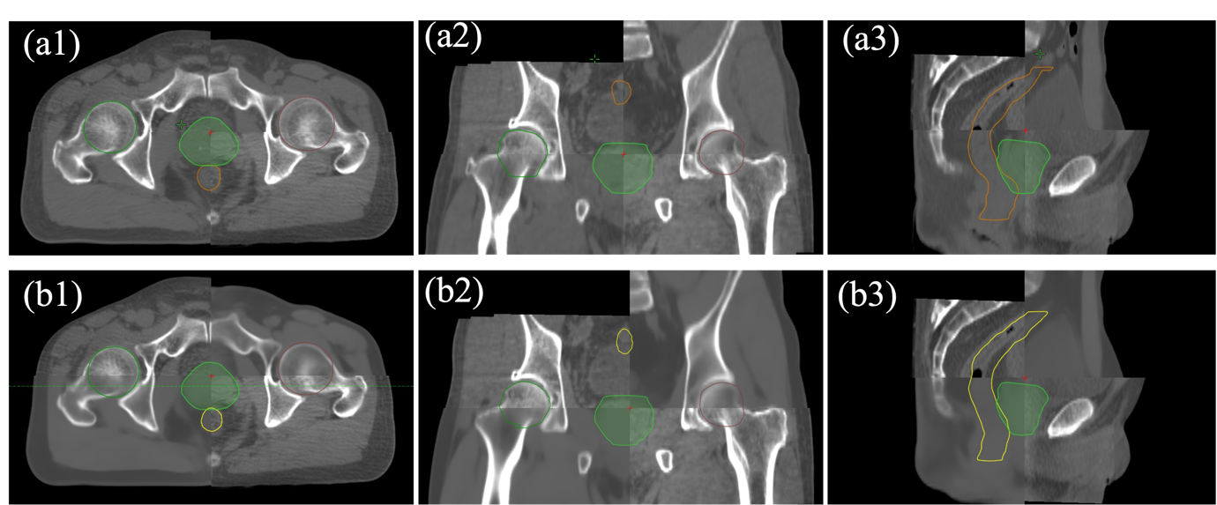
Fig S2. Rigid registration of CT-CBCT and sCT-CBCT images for a representative H&N case. Panels (a1–a3) show the CT-CBCT registration in the axial, coronal, and sagittal planes, respectively. Panels (b1–b3) display the corresponding sCT-CBCT registration. The delineated structures are displayed: PTV, femoral heads, and rectum.

Table S1 Overview of clinical evaluation criteria with results obtained in this study.
sCT Evaluation | Parameters (Guideline or Reference) | Criteria* | Results
sCT Evaluation | Parameters (Guideline or Reference) | Criteria* | H&N | Pelvis
Geometric Accuracy | DSC  (TG-132 [25]) | $≥$ 0.8-0.9 | Boby 0.99 $±$ 0.00  Soft Tissue 0.96 $±$ 0.01  Bone 0.87 $±$ 0.03  Air 0.82 $±$ 0.04 | Body 1.00 $±$ 0.00  Soft Tissue 0.98 $±$ 0.01  Bone 0.88 $±$ 0.02
Image  Intensity | ME | - | Body: -8.94 $±$ 9.50  Soft tissue: 7.75 $±$ 7.34  Bone: -121.08 $±$ 34.45  Air: 118.65 $±$ 41.65 | Body: -8.74 $±$ 6.26  Soft tissue: -1.25 $±$ 4.57  Bone: -71.31 $±$ 26.46
Image  Intensity | MAE  [32] | H&N:  Body 65-131 HU  Pelvis:  Body 27-65 HU | Body 67.30 $±$ 6.94  Soft Tissue 29.91 $±$ 3.30  Bone 203.57 $±$ 26.79  Air 211.20 $±$ 34.51 | Body 33.64 $±$ 3.91  Soft Tissue 24.17 $±$ 3.51  Bone 112.92 $±$ 15.24
Dose Difference | DVH Difference  [1, 35] | $≤$ 2% | $≤$ 0.76 $±$ 0.55% | $≤$ 0.35 $±$ 0.27%
Dose Difference | Gamma Pass Rate  (TG-218 [28]) | 3%/2 mm $≥$ 95%  2%/2 mm $≥$ 90% | 3%/2 mm: 96.34 $±$ 1.31%  2%/2 mm: 95.06 $±$ 1.40% | 3%/2 mm: 99.11 $±$ 0.76%  2%/2 mm: 98.72 $±$ 1.03%
Treatment  Plan QA | Global Gamma Pass Rate  3%/2 mm (TG-218 [28])  2%/2 mm [42] | 3%/2 mm $≥$ 95%  2%/2 mm $≥$ 90% | 3%/2 mm: 98.83 $±$ 3.13%  2%/2 mm: 97.36 $±$ 5.11% | 3%/2 mm: 99.31 $±$ 0.77%  2%/2 mm: 94.71 $±$ 7.63%
Treatment  Plan QA | sCT-CT Gamma Pass Rate Difference | - | 3%/ 2 mm: 0.01 $±$ 0.04%  2%/2 mm: 0.05 $±$ 0.06% | 3%/2 mm: 0.05 $±$ 0.08%  2%/2 mm: 0.12 $±$ 0.16%
Patient  Set-up Verification | CT-CBCT and sCT-CBCT differences | - | $≤$ 0.13 mm in translations  $≤$ 0.06$°$ in rotations | $≤$ 0.17 mm in translations  $≤$ 0.13$°$ in rotations
*As there are no standardized guidelines for sCT evaluation, criteria were adopted based on existing clinical recommendations and relevant publications.

Table S2 Overview of key geometric and dosimetric metrics from prior studies.
First author,  year [Ref] | Region | No. of  patients | sCT Generated Software | Geometric Accuracy | Image Intensity Accuracy |  | Dosimetric Accuracy |  | Treatment Plan QA Evaluation | Patient Verification
 |  |  |  | DSC | ME (HU) | MAE (HU) | %DVH Difference | Gamma Pass Rate (%) | sCT Plan-  CT Plan difference | CBCT-sCT vs CBCT-CT
This study | H&N  Pelvis | 10 H&N  9 Prostate  9 Rectum  5 Cervix | MRI Planner v.2.3 | H&N  Body: 0.99 $±$ 0.00  Soft tissue: 00.96 $±$ 0.01  Bone: 0.87 $±$ 0.03  Air: 0.82 $±$ 0.04  Pelvis  Body: 1.00 $±$ 0.00  Soft tissue: 0.98 $±$0.01  Bone: 0.88 $±$ 0.02 | H&N:  Body: -8.94 $±$ 9.50  Soft tissue: 7.75 $±$ 7.34  Bone: -121.08 $±$ 34.45  Air: 118.65 $±$ 41.65  Pelvis  Body: -8.74 $±$ 6.26  Soft tissue: -1.25 $±$ 4.57  Bone: -71.31 $±$ 26.46 | H&N  Body: 67.30 $±$ 6.94  Soft tissue: 29.91 $±$ 3.30  Bone: 203.57 $±$ 26.79  Air: 211.20 $±$ 34.51  Pelvis  Body: 33.64 $±$ 3.91  Soft tissue: 24.17 $±$ 3.51  Bone: 112.92 $±$ 15.24 | $≤$0.76% for H&N  $≤$0.35% for pelvis | H&N  3%/2 mm: 96.34 $±$ 1.31  2%/2 mm: 95.06 $±$ 1.40  1%/1 mm: 92.09 $±$ 2.02  Pelvis  3%/2 mm: 99.11 $±$ 0.76  2%/2 mm: 98.72 $±$ 1.02  1%/1 mm: 97.58 $±$ 1.73 | H&N  3%/2 mm: 0.01 $±$ 0.04%  2%/2 mm: 0.05 $±$ 0.06%  Pelvis  3%/2 mm: 0.05 $±$ 0.08%  2%/2 mm: 0.12 $±$ 0.16% | H&N  Translation:  $≤$ 0.13 mm  Rotation:  $≤$ 0.06$°$  Pelvis  Translation:  $≤$ 0.17 mm  Rotation:  $≤$ 0.13$°$
Palmér et al., 2017 [9] | H&N | 44 | MRI Planner  v.2.3 | Body: 0.98 $±$ 0.05  Soft tissue: 0.95 $±$ 0.05  Bone: 0.80 $±$ 0.07  Air: 0.81 $±$ 0.10 | Body: -5 $±$ 10  Soft tissue: -1 $±$ 7  Bone: -62 $±$ 28  Air: 107 $±$ 75 | Body: 67 $±$ 14  Soft tissue: 38 $±$ 6  Bone: 195 $±$ 27  Air: 198 $±$ 68 | < 0.3% | 2%/ 1 mm: 99.4% | - | -
Lerner et al., 2021 [20] | Brain | 20 | MRI Planner  v.2.3 | - | Body: -5.6 $±$ 4.6  Soft tissue: -1.3 $±$ 2.0  Bone: -46.3 $±$ 19.4 | Body: 62.2 $±$ 4.1  Soft tissue: 9.5 $±$ 0.7  Bone: 176.5 $±$ 18.8 | < 0.2% | 3%/ 3 mm: 100 $±$ 0.00  2%/ 2 mm: 99.8 $±$ 0.2  1%/ 1 mm: 99.1 $±$ 0.6 | - | Translation:  -0.3 to 0.5 mm  Rotation: -0.2 to 0.2$°$
Cronholm et al., 2020 [19] | Prostate | 34 | MRI Planner  v.2.3 | - | - | Body: 39.6 $±$ 6.7  Soft tissue: 24.2 $±$ 3.0  Bone: 176.5 $±$ 18.8 | Mean in Target:  -0.02% | 2%/2 mm: 99.94% | - | Translation: 0.02 $±$ 0.07 mm  Rotation: 0.05 $±$ 0.29$°$
Singhrao et al., 2023 [3] | H&N | 14 | MRI Planner  v.2.2 | - | - | - | Target:  $≤$ 2.3%  OARs: $≤$ 0.7% | 3%/ 3 mm: 95.5 $±$ 2%  2%/2 mm: 92.7 $±$ 2.1% | - | -
Han et al., 2017 [10] | Prostate | 18 | In House  DCNN: U-Net | - | Body: -3.1 $±$ 17.3 | Body: 84.8 $±$ 17.3 | - | - | - | -
Wang et al., 2019 [13] | H&N | 33 | In House  DCNN: U-Net | - | Body: -6 $±$ 13  Soft tissue: -48 $±$ 10  Bone: 247 $±$ 44 | Body: 131 $±$ 24  Soft tissue: 97 $±$ 13  Bone: 357 $±$ 44 | - | - | - | -
Maspero et al., 2018 [17] | Pelvis | 59 Prostate  18 Rectum  14 cervix | In House  cGAN | - | Body  Prostate: 1 $±$ 6  Rectum: 2 $±$ 9  Cervix: 4 $±$ 10 | Body  Prostate: 65 $±$ 10  Rectum: 56 $±$ 5  Cervix: 59 $±$ 6 | Target: $≤$ 0.3% | 3%/ 3 mm: 97%  2%/ 2 mm: 91% | - | -
Wang et al., 2022 [30] | Brain | 24 | In House  CUT vs cycleCUT | - | - | CUT  Body: 78.05 $±$ 8.26  cycleCUT  Body: 69 $±$ 5.68 | - | 3%/ 3 mm &  2%/ 2 mm: $≥$ 97% | - | -
Fridström et al., 2024 [31] | Prostate | 10 | MRI Planner  v.2.3 | - | - | Body: 71  Femoral Heads: 126 | VMAT  CTV: -0.8 $±$ 0.8  OARs: -0.4 $±$ 0.2  IMPT  CTV: 0.1 $±$ 0.1  OARs: -0.3 $±$ 0.4 | Global 3%/ 3mm  VMAT: 99.8  IMPT: 97.8%  Global 2%/2 mm  VMAT: 99.4%  IMPT: 95.8%  Local 3%/3mm:  VMAT:98.9%  IMPT: 97.2%  Local 2%/2 mm:  VMAT: 97.7%  IMPT: 94.9% | - | -
Dinkla et al., 2019 [14] | H&N | 34 | In House  DCNN: U-Net | Body: 0.98 $±$ 0.01  Bone: 0.70 $±$ 0.07  Air: 0.79 $±$ 0.08 | Body: 9 $±$ 11  Soft tissue: -2 $±$ 5  Bone: 106 $±$ 51  Air: -57 $±$ 41 | Body: 75 $±$ 9  Soft tissue: 35 $±$ 3  Bone: 214 $±$ 26  Air: 103 $±$ 24 | < 1% | - | - | -
Siversson et al., 2015 [21] | Prostate | 10 | MRI Planner v.1.1 | - | - | Body: 36.5 $±$ 4.1  Soft tissue: 34.0 $±$ 4.1  Bone: 98.1 $±$ 10.3 | 0.0 $±$ 0.2 | 2%/1 mm: 100% for SPACE and 99.7% for FSE | - | -
Persson et al., 2017 [34] | Prostate | 170 | MRI Planner | - | - | - | < 0.3% | 2%/2 mm: 99.7% | - | -
Ma et al., 2021 [35] | H&N | 20 | In House  U-net vs. GAN | - | U-net  Body: -9.3 $±$ 16.9  GAN  Body: -8.7 $±$ 17.3 | U-net  Body: 102.6 $±$ 11.4  GAN  Body: 104.2 $±$ 12.5 | Target:  $≤$ 0.4%  OARs: $≤$ 0.1% | 3%/ 2mm: 99.1% | - | -
O’Corner et al., 2022 [36] | Pelvis | 40  (20 Male & 20 Female) | In House  Bulk Density vs. Tissue Class Density vs. Hybrid Atlas vs. cGAN | - | Bulk Density  Body: 8 $±$ 13.7  Soft tissue: 7.8 $±$ 14.7  Bone: 5.7 $±$ 39.3  Tissue Class Density  Body: -9.8 $±$ 7.3  Soft tissue: -8.6 $±$ 7.5  Bone: -25.8 $±$ 39.7  Hybrid Atlas  Body: -2 $±$ 9  Soft tissue: 4.1 $±$ 8.5  Bone: -78.0 $±$ 35.3  cGAN  Body: -2.5 $±$ 5.8  Soft tissue: -0.7 $±$ 6.3  Bone: -46.0 $±$ 19.6 | Bulk Density  Body: 89.1 $±$ 7.7  Soft tissue: 76.1 $±$ 6.7  Bone: 244.1 $±$ 10  Tissue Class Density  Body: 58.8 $±$ 10.4  Soft tissue: 44.6 $±$ 8.5  Bone: 228.2 $±$ 11.2  Hybrid Atlas  Body: 57.4 $±$ 8.0  Soft tissue: 47.3 $± 7.8$  Bone: 186.9 $±$ 17.9  cGAN  Body: 34.7 $±$ 5.1  Soft tissue: 25.2 $±$ 3.4  Bone: 109.4 $±$ 12.3 | < 1.0% for all sCT methods | All sCT methods  3%/3 mm $≥$ 99.8%  All sCT methods  2%/2 mm $≥$ 99.6%  1%/1 mm  Bulk density: 93.6%  Tissue Clase Density: 95.3%  Hybrid Atlas: 94.8%  cGAN: 97.3% | - | -
Gonzalez-Moya et al., 2021 [41] | Brain &  Prostate | 16 Brain  31 Prostate | SIEMENS | - | - | - | < 0.5% | 1%/1 mm  Brain: 73.2%  Prostate: 84.7% | - | Translation: 3.5 mm  Rotation: 0.2$°$
Farjam et al., 2019 [42] | Prostate | 23 | In House vs MRCAT | - | - | In House  Body: 47 $±$ 5  Bone: 116 $±$ 12  Fat: 36 $±$ 6  Muscle: 47 $±$ 5  MRCAT  Body: 65 $±$ 5  Bone: 172 $±$ 9  Fat: 43 $±$ 7  Muscle: 42 $±$ 4 |  | In House  3%/2 mm: 97.9%  2%/2 mm: 97.1%  1%/1 mm: 92.7%  MRCAT  3%/2 mm: 97.9%  2%/2 mm: 97.1%  1%/1 mm: 90.6 | - | -
Maspero et al., 2018 [45] | Rectum | 20 | MRCAT | Body: 8 $±$ 6 | Body: 52 $±$ 3 | - | Mean: −0.3% | 2%/2 mm: 95.2% |  | Translation: <1 mm  Rotation: <0.5°
Hsu et al., 2022 [44] | Prostate | 57 | cGAN | - | Body: -6.8 $±$ 3.6  Soft tissue: -1.2 $±$ 2.4  Bone: -128.0 $±$ 35.2  Air: 388.4 $±$ 131.3 | Body: 30.1 $±$ 4.2  Soft tissue: 19.6 $±$ 2.3  Bone: 158.5 $±$ 26.0  Air: 396.5 $±$ 126.1 | < 1% for PTV an OARs | 2%/2 mm: 99.9%  1%/1 mm: 99.0% | - | -
Note. CUT: Contrastive Unpaired Translation Network
cycleCUT: CUT + cGAN

