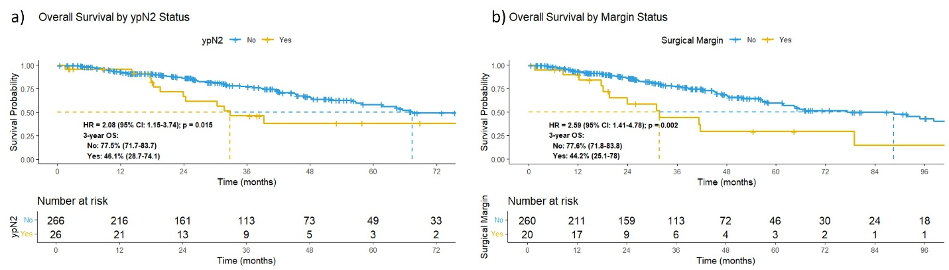
Figure S1. Kaplan-Meier analysis of Overall Survival (OS) stratified by key pathological factors in poor responders: a) OS by ypN2 status (No vs. Yes). b) OS by surgical margin status (Negative vs. Positive). Hazard ratios (HR) with 95% confidence intervals and log-rank p-values are shown for each comparison. Three-year rates in each subgroup are provided below the plots. The number of patients at risk at each time point is indicated below each panel.

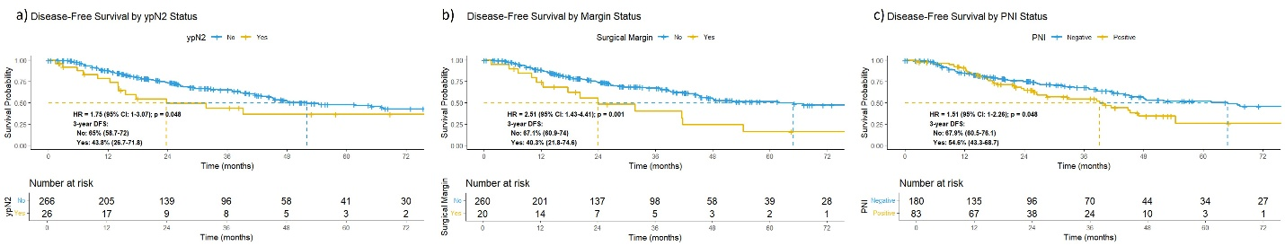
Figure S2. Kaplan-Meier analysis of Disease-Free Survival (DFS) stratified by key pathological factors in poor responders: a) DFS by ypN2 status (No vs. Yes). b) DFS by surgical margin status (Negative vs. Positive). c) DFS by perineural invasion (PNI) status (Negative vs. Positive). Hazard ratios (HR) with 95% confidence intervals and log-rank p-values are shown for each comparison. Three-year rates in each subgroup are provided below the plots. The number of patients at risk at each time point is indicated below each panel.

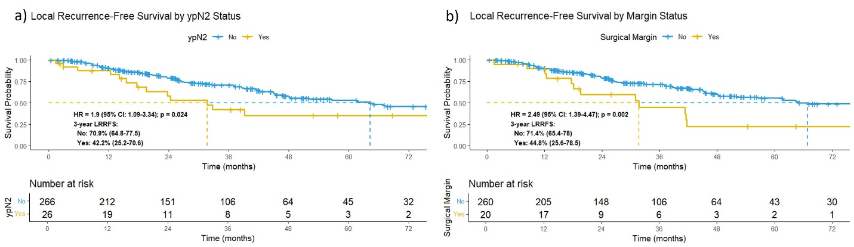
Figure S3. Kaplan-Meier analysis of Local Recurrence-Free Survival (LRRFS) stratified by key pathological factors in poor responders: a) LRRFS by ypN2 status (No vs. Yes). b) LRRFS by surgical margin status (Negative vs. Positive). Hazard ratios (HR) with 95% confidence intervals and log-rank p-values are shown for each comparison. Three-year rates in each subgroup are provided below the plots. The number of patients at risk at each time point is indicated below each panel.

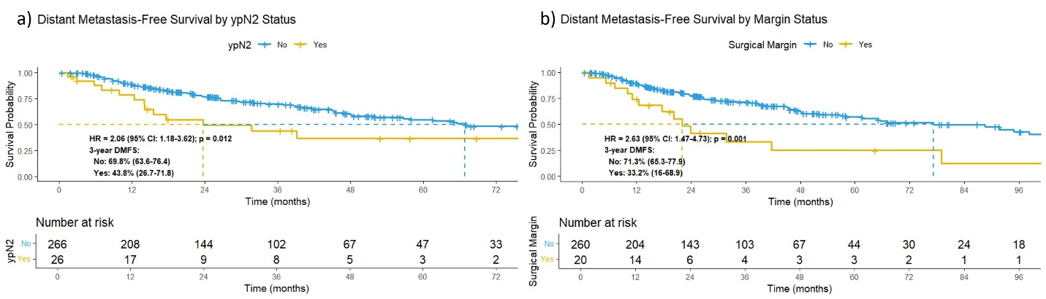
Figure S4. Kaplan-Meier analysis of Distant Metastasis-Free Survival (DMFS) stratified by key pathological factors in poor responders: a) DMFS by ypN2 status (No vs. Yes). b) DMFS by surgical margin status (Negative vs. Positive). Hazard ratios (HR) with 95% confidence intervals and log-rank p-values are shown for each comparison. Three-year rates in each subgroup are provided below the plots. The number of patients at risk at each time point is indicated below each panel.

