Suppl. Figure 1:
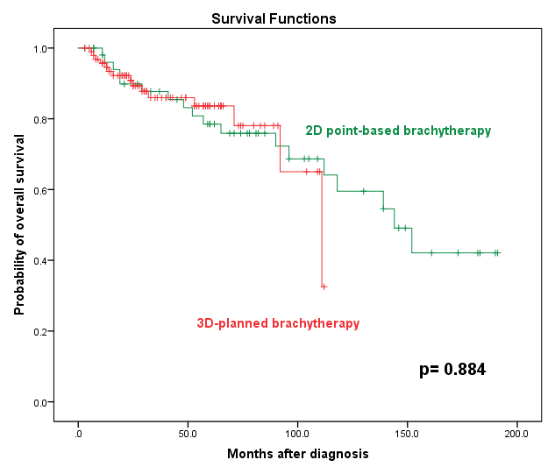
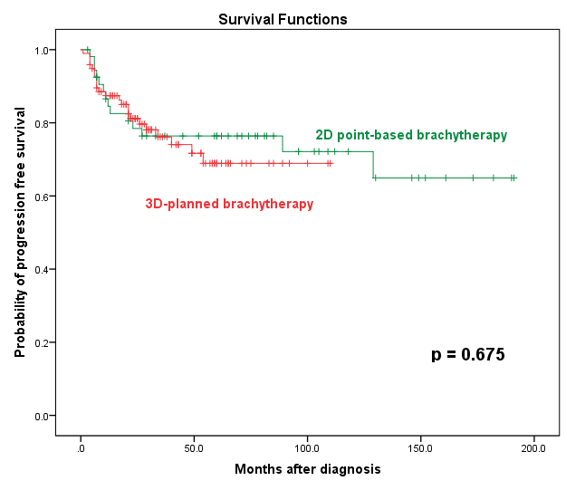
(A) (B)

Supplementary Figure 1: Kaplan–Meier survival curves comparing clinical outcomes according to brachytherapy planning technique in patients with locally advanced cervical cancer (n = 145). (A) Progression-free survival (PFS) and (B) Overall survival (OS) for patients treated with 2D point-based brachytherapy planning versus 3D image-guided brachytherapy planning.

Suppl. Table 1: Survival Analysis
 | locPFS |  |  |  | PFS |  |  |  | OS
 | No. Patients |  | P value |  | No. Patients |  | P value |  | No. Patients |  | P value
Variable | (relapsed) |  | P value |  | (relapsed) |  | P value |  | (died/total) |  | P value
IMRT/VMAT+4BT | 2/65 |  | 0.884 |  | 12/67 |  | 0.285 |  | 5/67 |  | 0.133
3DCRT+5BT | 5/74 |  | 0.884 |  | 23/74 |  | 0.285 |  | 25/74 |  | 0.133
Note: The significance level (P) was determined by log-rank test.

Suppl. Table 2: Univariable and multivariable Cox regression analysis adjusting for FIGO stage and treatment group for locPFS, PFS, and OS)
 | locPFS |  |  | PFS |  |  | OS
 | HR of recurrence (95% CI) | P value |  | HR of death (95% CI) | P value |  | HR of death (95% CI) | P value
Variable |  |  |  |  |  |  | HR of death (95% CI) | P value
Univariable
Treatment group (IMRT/VMAT+4BT vs. 3DCRT+5BT) | 0.88 (0.15-5.25) | 0.884 |  | 0.68 (0.34 - 1.38) | 0.290 |  | 0.47 (0.17 – 1.29) | 0.142
FIGO stage 2018 I ref.
FIGO stage 2018 II vs. I | 0.12 (0.01 - 1.41) | 0.092 |  | 0.46 (0.06 - 3.80) | 0.468 |  | 4864.2 (<0.001–>10^101) | 0.941
FIGO stage 2018 III vs. I | 0.16 (0.02 - 1.43) | 0.101 |  | 1.03 (0.14 - 7.64) | 0.974 |  | 10290.0 (<0.001–>10^101) | 0.936
FIGO stage 2018 IV vs. I | 0 (0-0) | 0.986 |  | 0.47 (0.04 - 5.23) | 0.542 |  | 20841.6 (<0.001–>10^101) | 0.931
Multivariable
FIGO stage 2018 I ref.
FIGO stage 2018 II vs. I | 0.12 (0.01 - 1.44) | 0.093 |  | 0.45 (0.05 - 3.79) | 0.463 |  | 4597.0 (<0.001–>10^101) | 0.942
FIGO stage 2018 III vs. I | 0.12 (0.01 - 1.21) | 0.072 |  | 0.91 (0.12 - 6.82) | 0.926 |  | 8404.7 (<0.001–>10^101) | 0.938
FIGO stage 2018 IV vs. I | 0 (0 - 0) | 0.989 |  | 0.57 (0.05 - 6.31) | 0.646 |  | 30182.3 (<0.001–>10^101) | 0.930
Treatment group (3DCRT+5BT vs. IMRT/VMAT+4BT) | 0.798 ( 0.13 - 5.01) | 0.810 |  | 0.75 (0.35 - 1.59) | 0.453 |  | 0.34 (0.11 - 1.11) | 0.073
Hazard ratios (HR) with 95% confidence intervals (CI) and p-values were calculated using Cox proportional hazards regression. The multivariable model included FIGO stage (reference (ref. FIGO stage I) and treatment group (ref. IMRT/VMAT+4BT).

Supplementary Table 3. Univariable Cox regression analyses of potential prognostic factors for locPFS, PFS, and OS.
 |  |  | locPFS |  |  |  | PFS |  |  |  | OS
 |  | No. Patients | HR of recurrence (95% CI) | P value |  | No. Patients | HR of death (95% CI) | P value |  | No. Patients | HR of death (95% CI) | P value
Variable | Numbers (Total 145) | (relapsed) | HR of recurrence (95% CI) | P value |  | (relapsed) | HR of death (95% CI) | P value |  | (dead) | HR of death (95% CI) | P value
Univariable
Treatment group (IMRT/VMAT+4BT vs. 3DCRT+5BT) | 68 vs 77 | 2 vs 5 | 0.88 (0.15-5.25) | 0.884 |  | 12 vs 23 | 0.68 (0.34 - 1.38) | 0.285 |  | 5 vs 25 | 0.47 (0.17 – 1.29) | 0.133
FIGO stage 2018 |  |  | 0.83 (0.20–3.52) | 0.802 |  |  | 1.93 (0.84–4.44) | 0.113 |  |  | 2.46 (0.94–6.41) | 0.058
I +II vs. III +IV | 41 vs. 104 | 3 vs 5 | 0.83 (0.20–3.52) | 0.802 |  | 7 vs 28 | 1.93 (0.84–4.44) | 0.113 |  | 5 vs 26 | 2.46 (0.94–6.41) | 0.058
Max. Diameter Tumor |  |  | 1.00 (0.19–5.15) | 0.979 |  |  | 1.13 (0.45–2.83) | 0.794 |  |  | 1.96 (0.65–5.91) | 0.233
<4 cm vs > 4cm | 33 vs. 93 | 2 vs 5 | 1.00 (0.19–5.15) | 0.979 |  | 6 vs 20 | 1.13 (0.45–2.83) | 0.794 |  | 4 vs 19 | 1.96 (0.65–5.91) | 0.233
Brachytherapy method |  |  | 0.75 (0.18–3.14) | 0.458 |  |  | 1.16 (0.58–2.31) | 0.675 |  |  | 1.06 (0.49–2.30) | 0.884
2D vs 3D | 53 vs 96 | 5 vs 3 | 0.75 (0.18–3.14) | 0.458 |  | 14 vs 23 | 1.16 (0.58–2.31) | 0.675 |  | 18 vs 15 | 1.06 (0.49–2.30) | 0.884
Number Brachytherapy |  |  | 0.79 (0.16–3.91) | 0.769 |  | 13 vs 24 | 1.44 (0.72–2.86) | 0.298 |  | 6 vs 26 | 1.93 (0.75–4.97) | 0.164
4 vs 5 | 68 vs 76 | 3 vs 5 | 0.79 (0.16–3.91) | 0.769 |  | 13 vs 24 | 1.44 (0.72–2.86) | 0.298 |  | 6 vs 26 | 1.93 (0.75–4.97) | 0.164
Treatment Interruption |  | 6 vs 2 | 2.35 (0.45–12.41) | 0.298 |  | 29 vs 8 | 1.50 (0.68–3.31) | 0.307 |  | 26 vs 7 | 1.72 (0.73–4.08) | 0.209
no vs yes | 118 vs 27 | 6 vs 2 | 2.35 (0.45–12.41) | 0.298 |  | 29 vs 8 | 1.50 (0.68–3.31) | 0.307 |  | 26 vs 7 | 1.72 (0.73–4.08) | 0.209
Hazard ratios (HR) with 95% confidence intervals (CI) and p-values were calculated using univariable Cox proportional hazards regression.

