Supplementary Data
Supplementary Figure 1: Outcome for SBRT of bone metastasis from lung cancer
Progression-free survival (PFS) depending on concomitant/ sequential systemic therapy (Sys or no Sys) and number of treated bone metastases (BoM) with A) 2-3 treated BoM and B) singular treated BoM.
Overall survival (OS) depending on concomitant/ sequential systemic therapy and number of treated BoM with C) 2-3 treated BoM and D) singular treated BoM.
B
A
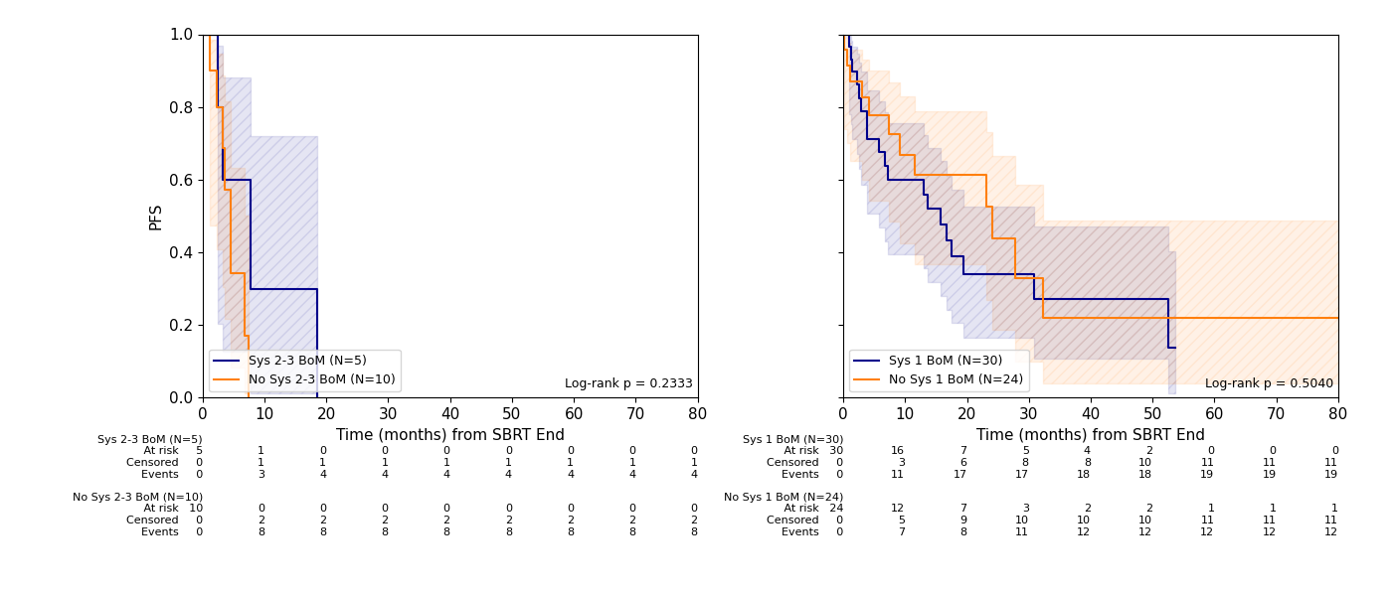
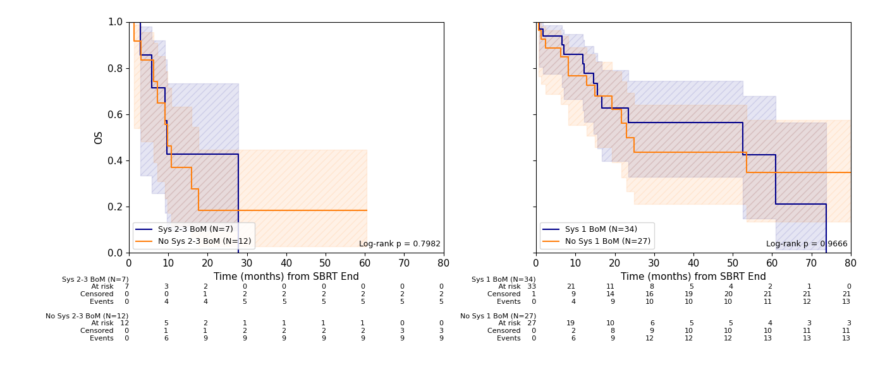
C
D

