Supplementary Figure S1. schematic view of a 384-micropillar plate and ASFA® spotter V6.

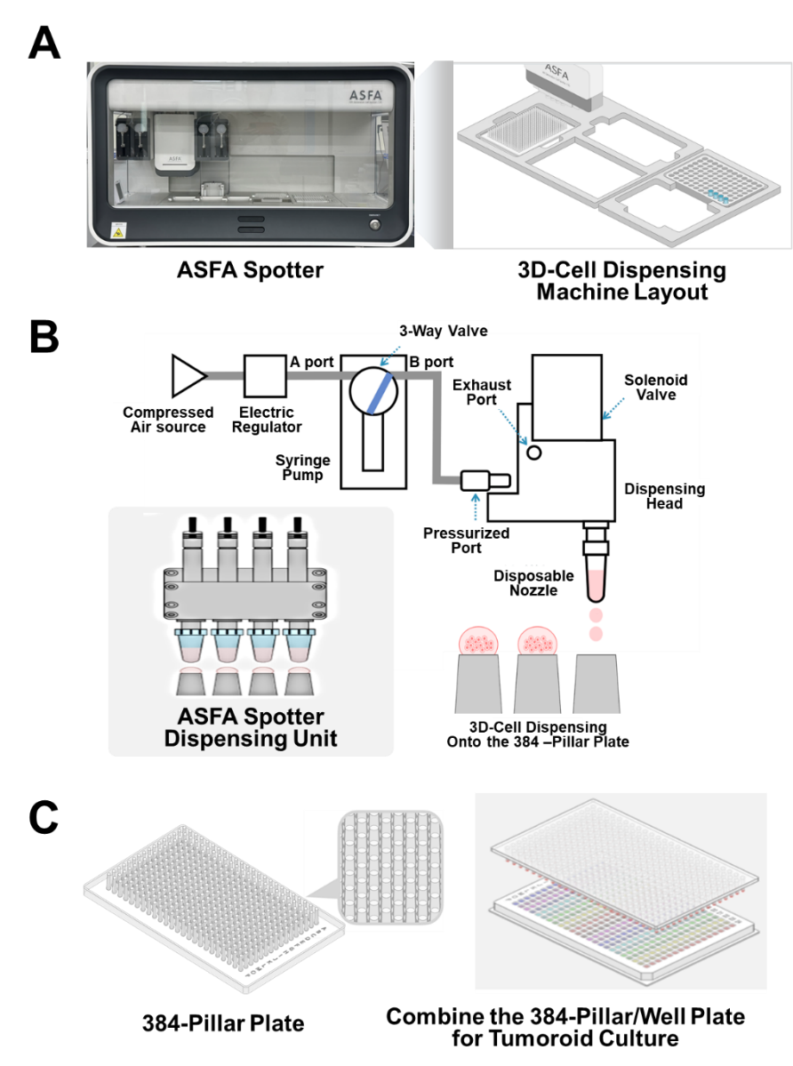
(A) Photograph of the proposed cell dispenser (ASFA® Spotter V6) composed of a disposable nozzle and sample dispensing unit. The layout of the 3D cell dispensing machine system. (B) Schematic diagram of the ASFA® Spotter module components and a summary image of the sample dispensing process. (C) Illustration of the 384-pillar/well plate, where oral cavity cancer PDOs are 3D cultured on the plate surface and used for radiosensitivity test.

Supplementary Figure S2. Overview of the patient selection process.

Supplementary Table S1. Detailed information about the medium supplements
No | Component | Final concentration | Manufacturer
1 | Advanced DMEM/F-12 | 1 X | Gibco
2 | Penicillin-streptomycin | 100 µg/mL for each | Gibco
3 | GlutaMAX | 1 X | Gibco
4 | HEPES | 10 mM | Gibco
5 | R-spondin 3 CM | 4% | U-Protein express BV
6 | Noggin CM | 4% | U-Protein express BV
7 | Y-27632 | 10 µM | AdooQ
8 | EGF | 50 ng/mL | Peprotech
9 | B27 | 1X | Gibco
10 | N-acetyl-L-Cysteine | 1.25 mM | Sigma aldrich
11 | Nicotinamide | 10 mM | Sigma aldrich
12 | FGF10 | 10 ng/mL | Peprotech
13 | FGF2 | 5 ng/mL | Peprotech
14 | PGE2 | 1 µM | Tocris
15 | CHIR99021 | 0.3 µM | Sigma aldrich
16 | Forskolin | 1 µM | Sigma aldrich
17 | Caspofungin | 0.5 µg/mL | Sigma aldrich

Supplementary Table S2. Cancer stage scoring table for the MPI algorithm
Cancer Stage | Stage Grouping | TNM Score
Stage I | T1, N0, M0 | 1
Stage II | T2, N0, M0 | 2
Stage III | T3, N0, M0  T1, N1, M0  T2, N1, M0  T3, N1, M0 | 3
Stage IV | T4a, N0, M0  T4a, N1, M0  T1, N2, M0  T2, N2, M0  T3, N2, M0  T4a, N2, M0  T4b, Any N, M0  Any T, N3, M0 | 4

Supplementary Table S3. Regression coefficients with uncertainty estimates
Variable | β coefficient | SE | 95% CI for β | p-value
Intercept | -0.635 | 0.597 | -1.805 to 0.534 | 0.287
AUC | 0.766 | 0.683 | -0.573 to 2.106 | 0.262
Growth rate | 0.841 | 0.710 | -0.550 to 2.233 | 0.236
TNM score | 0.674 | 0.736 | -0.768 to 2.116 | 0.360

Supplementary Table S4. Internal validation of the MPI model using bootstrap validation
Bootstrap validation metric | Result
Bootstrap resampling iterations | 5,000
Apparent AUROC | 0.800
Optimism-corrected AUROC | 0.646
Bootstrap 95% CI for AUROC | 0.467–0.808
Apparent Harrell’s C-index | 0.813
Optimism-corrected Harrell’s C-index | 0.684
Bootstrap 95% CI for C-index | 0.480–0.800

