Supplementary materials:

Table S1. Numeric results of the correlation and error-grid analyses. A p-value smaller than 0.05 is considered as statistically significantly correlated.
Body position | Correlation coefficient (R) | p-value | No/low risk  [%] | Medium risk  [%] | High risk  [%]
Pooled data  (n = 377) | 0.9 | 0.001 | 99.1 | 0.9 | 0.0
Supine  (n = 95) | 0.8 | 0.001 | 100.0 | 0.0 | 0.0
reverse Trendelenburg position
reverse Trendelenburg_{total}  (n = 84) | 0.9 | 0.001 | 100.0 | 0.0 | 0.0
reverse Trendelenburg^{15°}  (n = 31) | 0.9 | 0.001 | 100.0 | 0.0 | 0.0
reverse Trendelenburg^{30°}  (n = 31) | 0.9 | 0.001 | 100.0 | 0.0 | 0.0
reverse Trendelenburg^{45°}  (n = 28) | 0.9 | 0.001 | 100.0 | 0.0 | 0.0
HOB position
HoB_{total}  (n = 192) | 0.9 | 0.001 | 97.3 | 2.7 | 0.0
HoB^{15°}  (n = 64) | 0.8 | 0.001 | 97.4 | 2.6 | 0.0
HoB^{30°}  (n = 64) | 0.9 | 0.001 | 94.6 | 5.4 | 0.0
HoB 45°  (n = 64) | 0.9 | 0.001 | 100.0 | 0.0 | 0.0

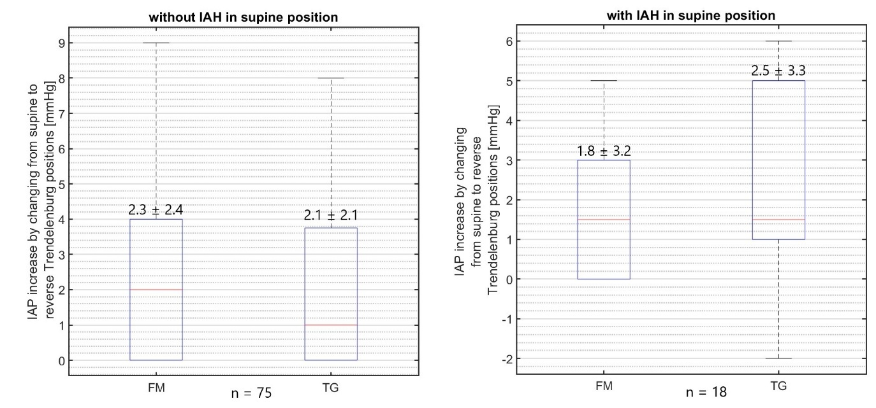
Figure S1. IAP changes when body positions change from supine to reverse Trendelenburg for patients with and without IAH.
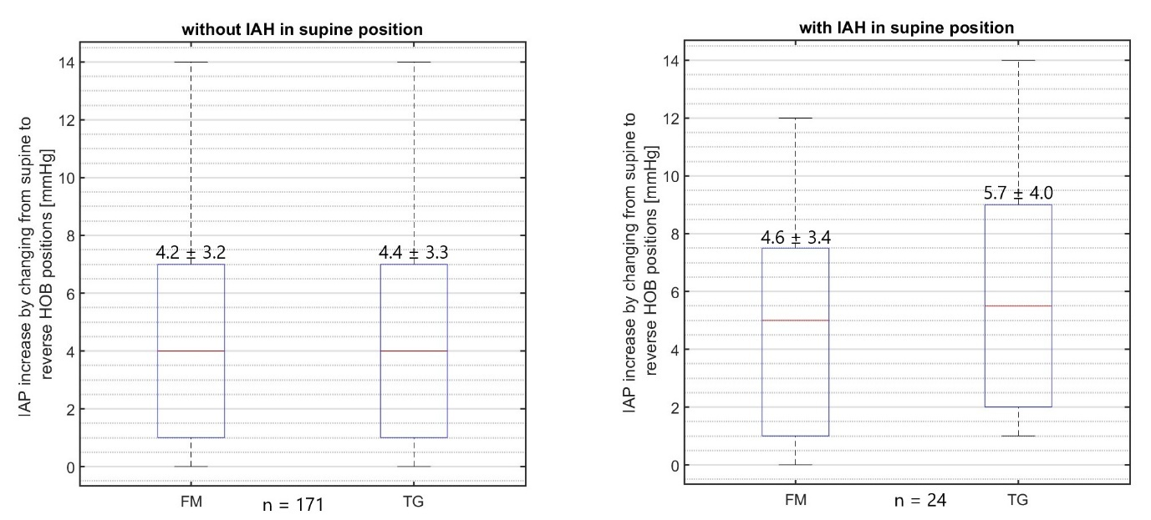
Figure S2. IAP changes when body positions change from supine to HOB for patients with and without IAH.

