Small versus large bore chest tube in traumatic hemothorax, hemopneumothorax, and pneumothorax: a meta-analysis of randomized controlled trials with trial sequential analysis

SUPPLEMENTARY MATERIALS
INDEX
- Search queries | 2
- PRISMA flow diagram | 4
- Certainty of evidence: GRADE assessment | 5

- Search queries
HEMOTHORAX/HEMOPNEUMOTHORAX
Pubmed: 55
((hemothorax) OR (trauma* hemothorax) OR (trauma* hemopneumothorax)) AND ((percutaneous catheter) OR (pigtail catheter) OR (small bore chest tube) OR (14 Ch drain*) OR (CVC) OR (central venous catheter)) AND ((large bore chest tube) OR (open chest tube) OR (standard chest tube) OR (28 Ch drain*) OR (32 Ch drain*) OR (tube thoracostomy))

EMBASE: 154
((hemothorax) OR (trauma* hemothorax) OR (trauma* hemopneumothorax)) AND ((percutaneous catheter) OR (pigtail catheter) OR (small bore chest tube) OR (14 Ch drain*) OR (CVC) OR (central venous catheter)) AND ((large bore chest tube) OR (open chest tube) OR (standard chest tube) OR (28 Ch drain*) OR (32 Ch drain*) OR (tube thoracostomy))

SCOPUS: 281
(“hemothorax” OR “trauma* hemothorax” OR “trauma* hemopneumothorax”) AND (“percutaneous catheter” OR “pigtail catheter” OR “small bore chest tube” OR “14 Ch drain*” OR “CVC” OR “central venous catheter”) AND (“large bore chest tube” OR “open chest tube” OR “standard chest tube” OR “28 Ch drain*” OR “32 Ch drain*” OR “tube thoracostomy”)

PNEUMOTHORAX
Pubmed: 132
((pneumothorax) OR (trauma* pneumothorax) OR (PNX)) AND ((percutaneous catheter) OR (pigtail catheter) OR (small bore chest tube) OR (14 Ch drain*) OR (CVC) OR (central venous catheter)) AND ((large bore chest tube) OR (open chest tube) OR (standard chest tube) OR (28 Ch drain*) OR (32 Ch drain*) OR (tube thoracostomy))

EMBASE: 436
((pneumothorax) OR (trauma* pneumothorax) OR (PNX)) AND ((percutaneous catheter) OR (pigtail catheter) OR (small bore chest tube) OR (14 Ch drain*) OR (CVC) OR (central venous catheter)) AND ((large bore chest tube) OR (open chest tube) OR (standard chest tube) OR (28 Ch drain*) OR (32 Ch drain*) OR (tube thoracostomy))

SCOPUS: 586
(“pneumothorax” OR “trauma* pneumothorax” OR “PNX”) AND (“percutaneous catheter” OR “pigtail catheter” OR “small bore chest tube” OR “14 Ch drain*” OR “CVC” OR “central venous catheter”) AND (“large bore chest tube” OR “open chest tube” OR “standard chest tube” OR “28 Ch drain*” OR “32 Ch drain*” OR “tube thoracostomy”)

- PRISMA flow diagram
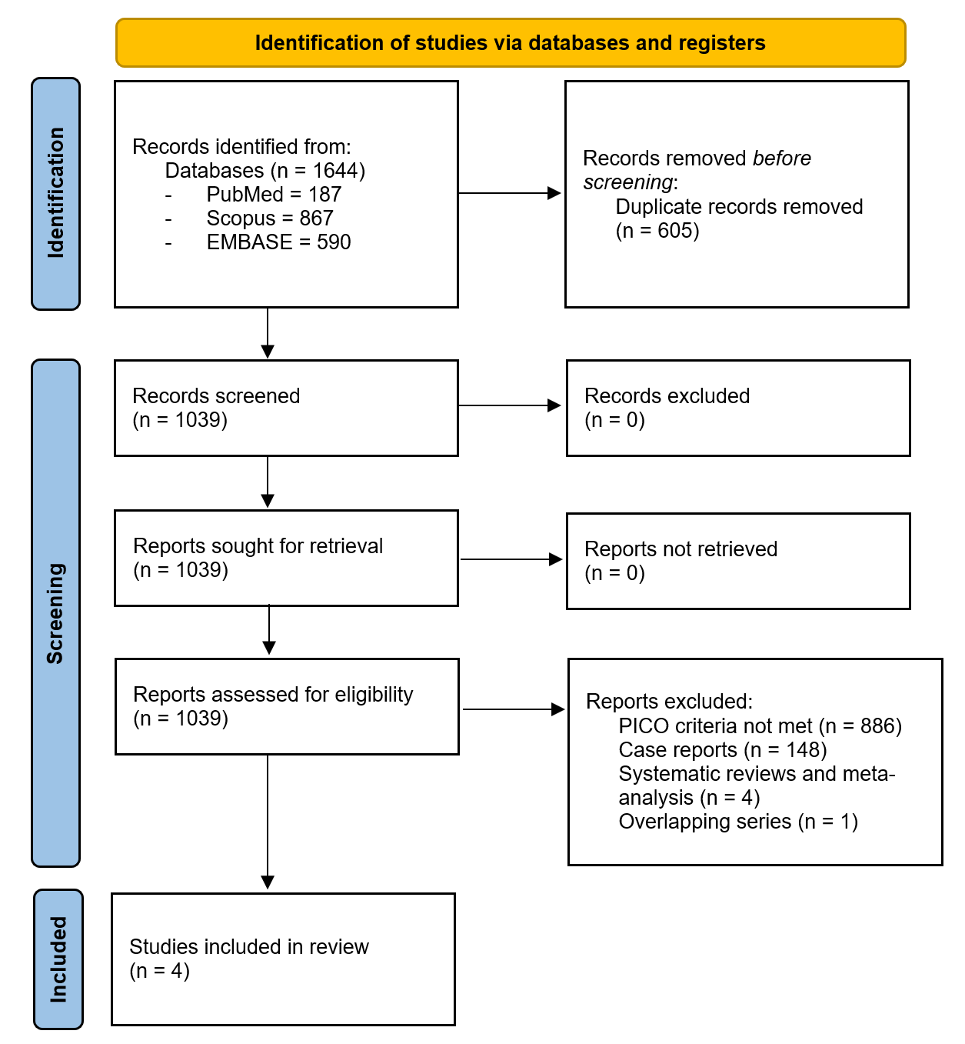

- Certainty of evidence: GRADE assessment
