Supplement 5. Subgroup analysis
a. Subgroup Analysis of SSI: Randomized vs Nonrandomized Studies
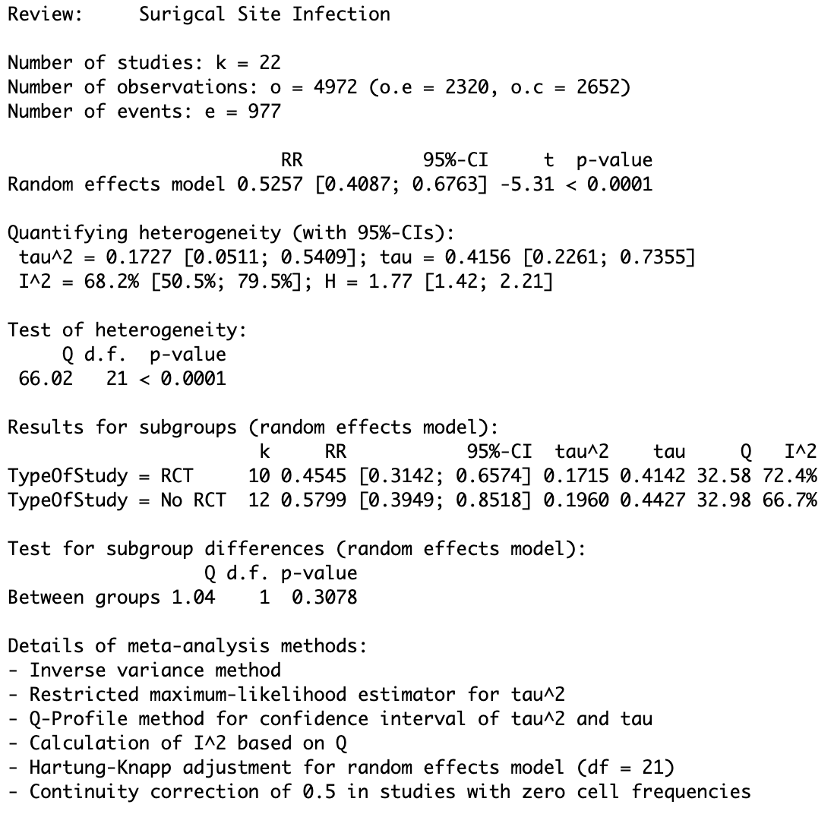

b. Subgroup Analysis of SSI: Skin Closure Technique
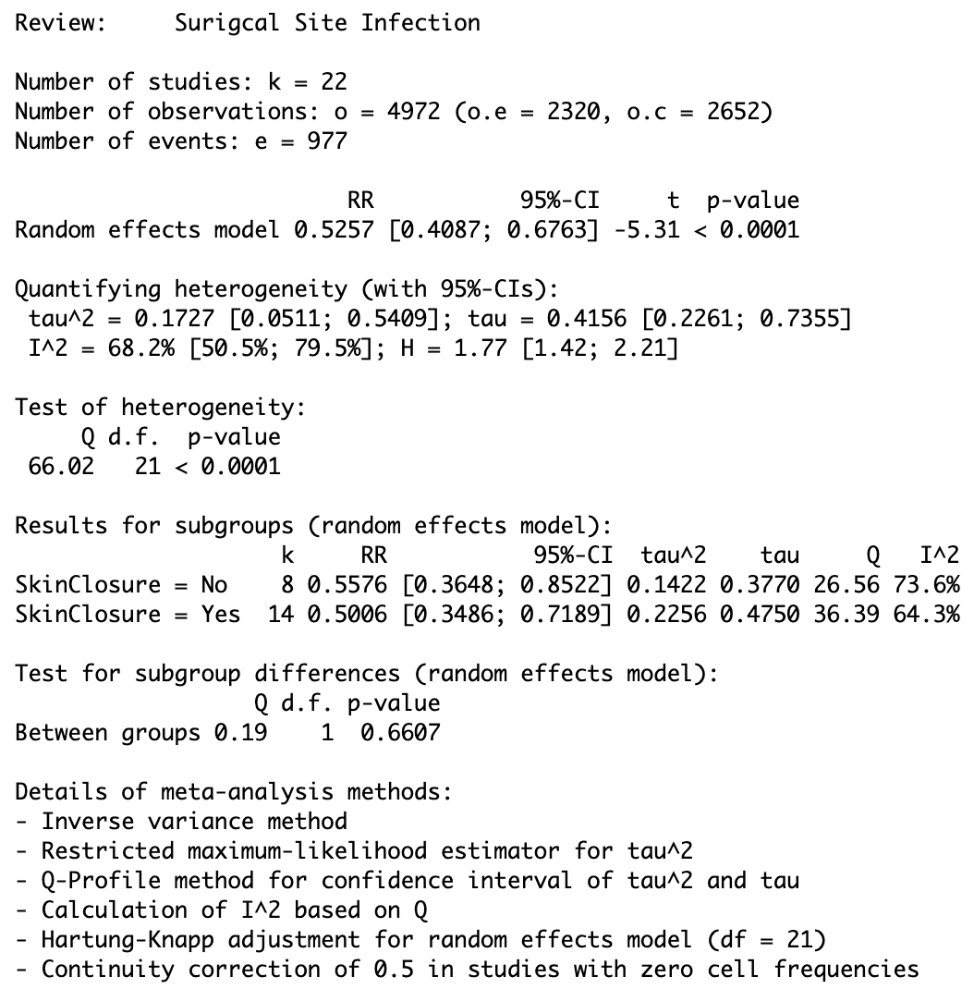

C. Subgroup Analysis of SSI: surgical indication
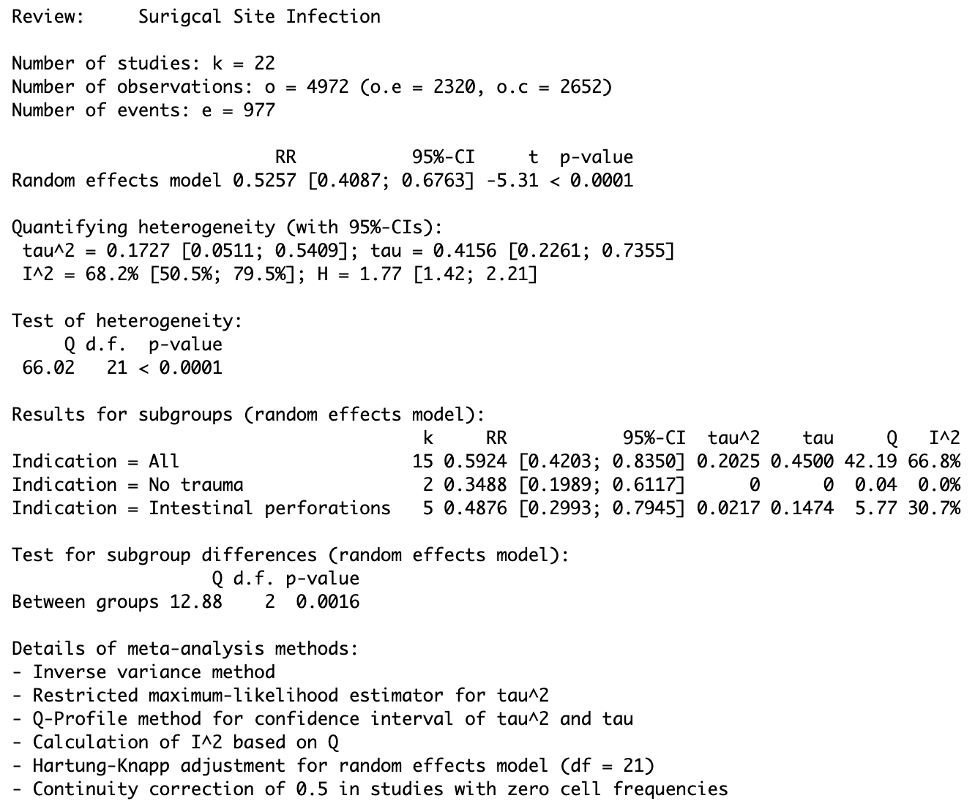
D. Subgroup Analysis of SSI: ≥50% CDC class III–IV wounds
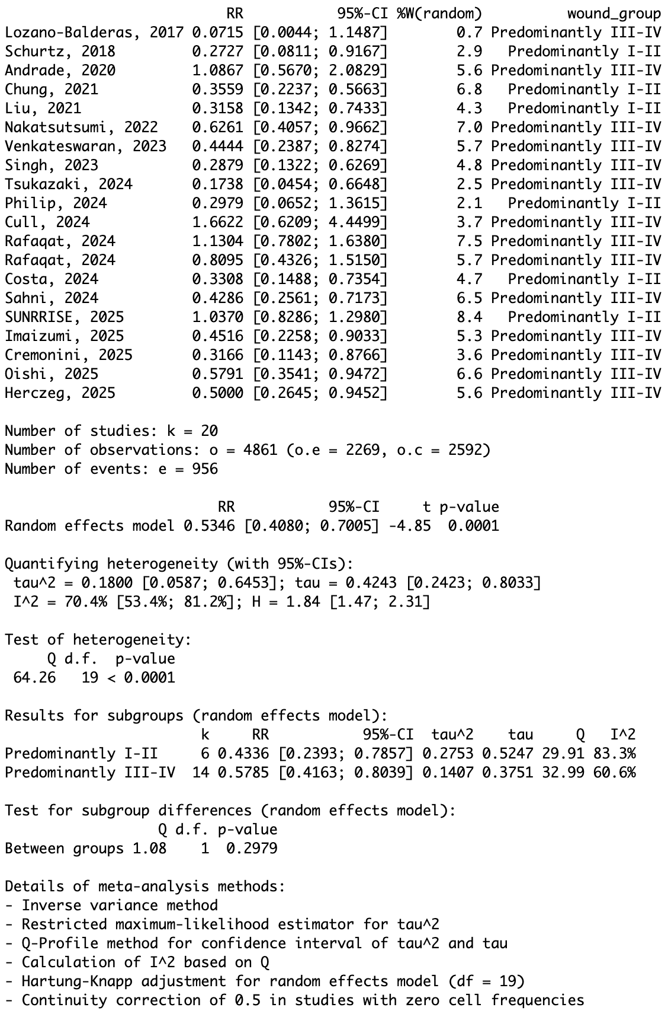
E. Subgroup Analysis of SSI: ≥80% CDC class III–IV wounds
