Figure S1. Summary of study search and selection
RCT = Randomized controlled trail

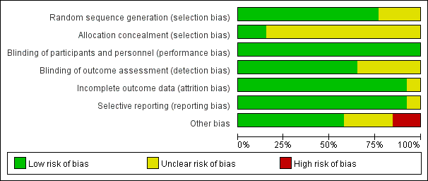
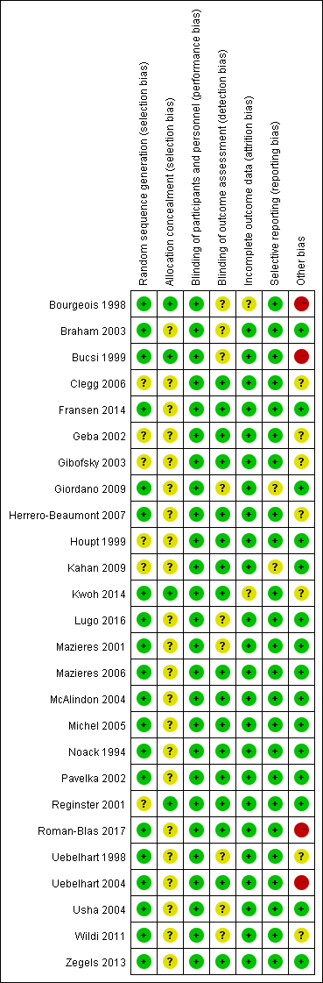
Figure S2 Plots of bias risk
Glucosamine vs. placebo (pain)

Chondroitin vs. placebo (pain)

Figure S3 Funnel plot of effect size

Table S1 The results of sensitivity analysis.
Comparison | Sensitive analysis
Comparison | Pain | Function | Stiffness
Glucosamine vs Placebo | -0.02(-0.10, 0.05) | -0.06(-0.14, 0.02) | -0.05(-0.14, 0.05)
Chondrotin vs Placebo | -0.09(-0.16, -0.01) | -0.14(-0.25, -0.03) | 0.10(-0.03, 0.23)
Glucosamine + Chondrotin vs Placebo | -0.10(-0.22, 0.03) | -0.12(-0.24, 0.01) | -0.07(-0.21, 0.07)
Data was pooled as standard mean difference (SMD) and its related 95% CI (credibility interval)

