Efficacy and safety of treating chronic nonspecific low back pain with radial extracorporeal shock wave therapy (rESWT), rESWT combined with celecoxib and eperisone (C+E) or C+E alone: a prospective, randomized trial

X. Guo, L. Li, Z. Yan, Y. Li, Z. Peng, Y. Yang, Y. Zhang, C. Schmitz, Z. Feng

Additional File 3 Outcome of the present study of the subgroup of subjects with Pain Self-Efficacy Questionnaire (PSEQ) score < 50 at baseline (radial extracorporeal shock wave therapy (rESWT): n=16; rESWT combined with celecoxib and eperisone (C+E) (n=21); C+E alone: n=20) (these subjects could have reached the minimal clinically important difference of the PSEQ score when treating chronic nonspecific low back pain). The figure shows Tukey boxplots of (A) PSEQ score, (B) Numerical Rating Scale (NRS) score, (C) Oswestry Low Back Pain Disability Questionnaire (OLBPDQ) score and (D) Patient Health Questionnaire 9 (PHQ-9) score of subjects suffering from chronic low back pain who were treated with respectively rESWT (dark gray bars), rESWT+C+E (light gray bars) or C+E alone (open bars) at baseline (X=0) and different follow-up times. The table summarizes key results of the statistical analysis of these data using two-way repeated measures ANOVA (P values < 0.05 are given boldface). Bonferroni's multiple comparison test showed no statistically significant differences between groups.

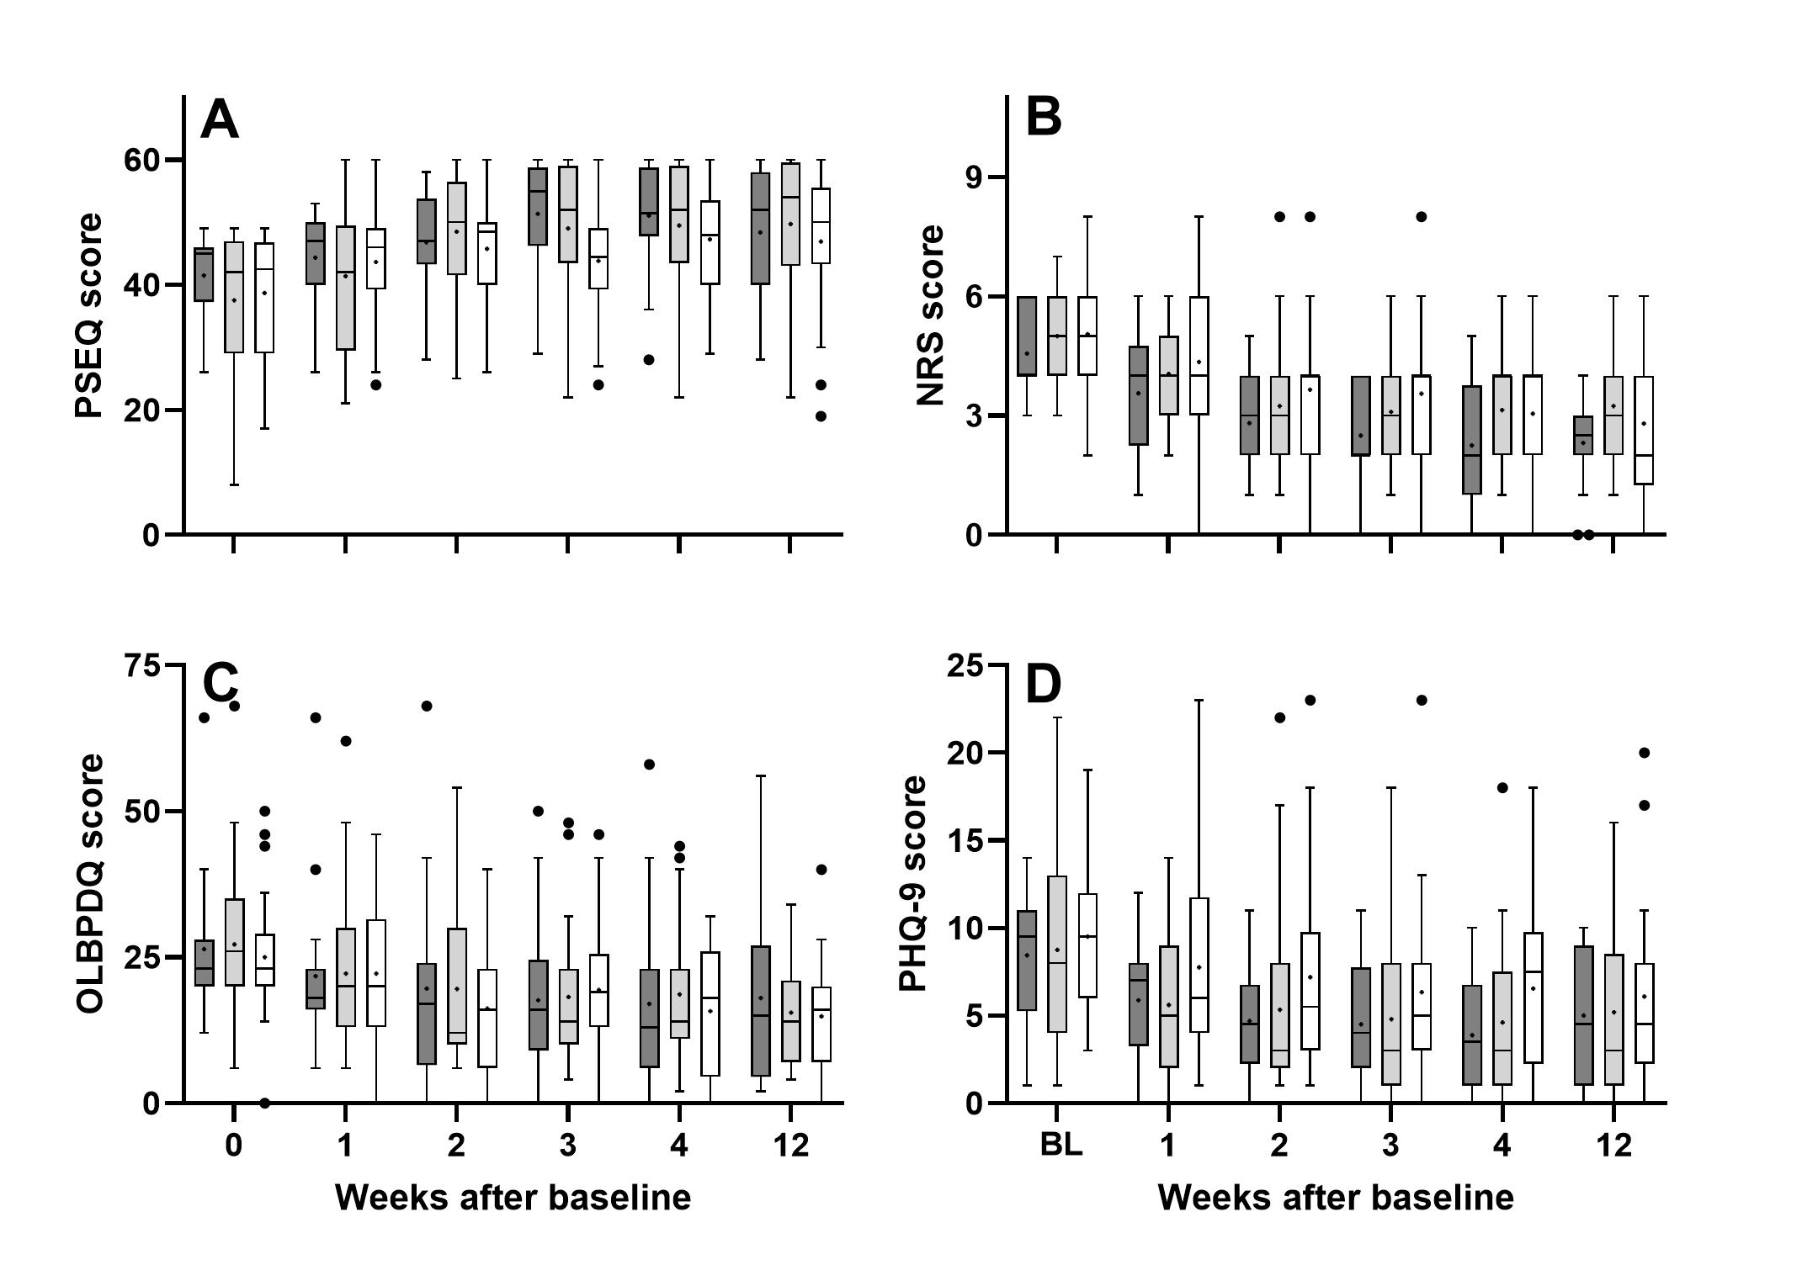

ANOVA: source of variation | PSEQ score | NRS score | OLBPDQ score | PHQ-9 score
Time | <0.001 | <0.001 | <0.001 | <0.001
Treatment | 0.550 | 0.200 | 0.926 | 0.339
Time × Treatment | 0.195 | 0.666 | 0.677 | 0.933
Subject | <0.001 | <0.001 | <0.001 | <0.001

