Additional file 2: Figure S1. Risk of bias assessment for the included studies. (A). Risk of bias summary for the nonrandomized studies. (B). Risk of bias summary for the randomized studies. (C). The average risk of bias contribution for each comparison within the network.

Supplementary Figure 1A

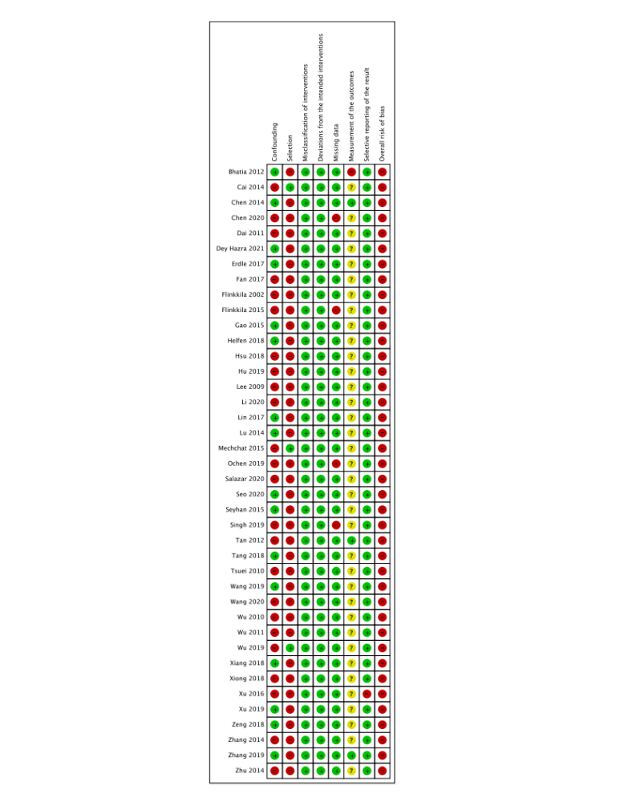

Supplementary Figure 1B

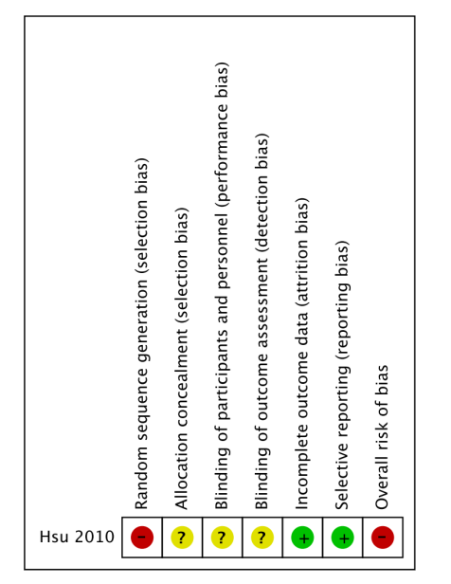

Supplementary Figure 1C

