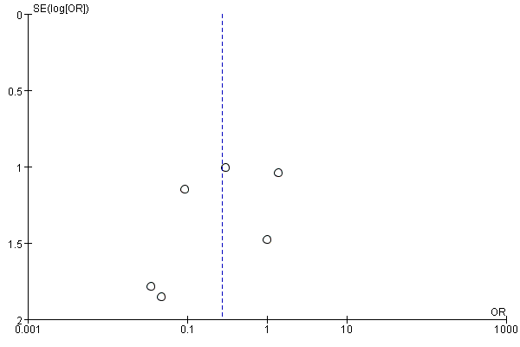
Fig. Publication bias funnel plot for mortality rate.

