Supplementary Material

Incidence of periprosthetic joint infection after primary total hip arthroplasty is underestimated
A synthesis of meta-analysis and bibliometric analysis

Supplementary Figures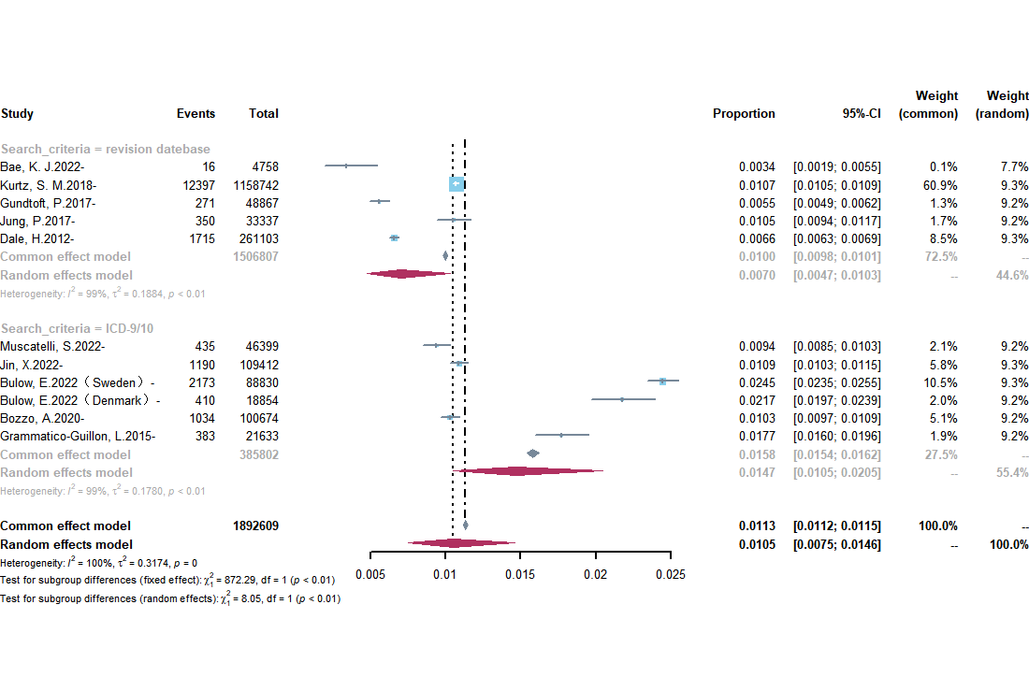Supplementary Figure 1. Forest plot of incidence of PJI by Search criteria in the database based studies
. 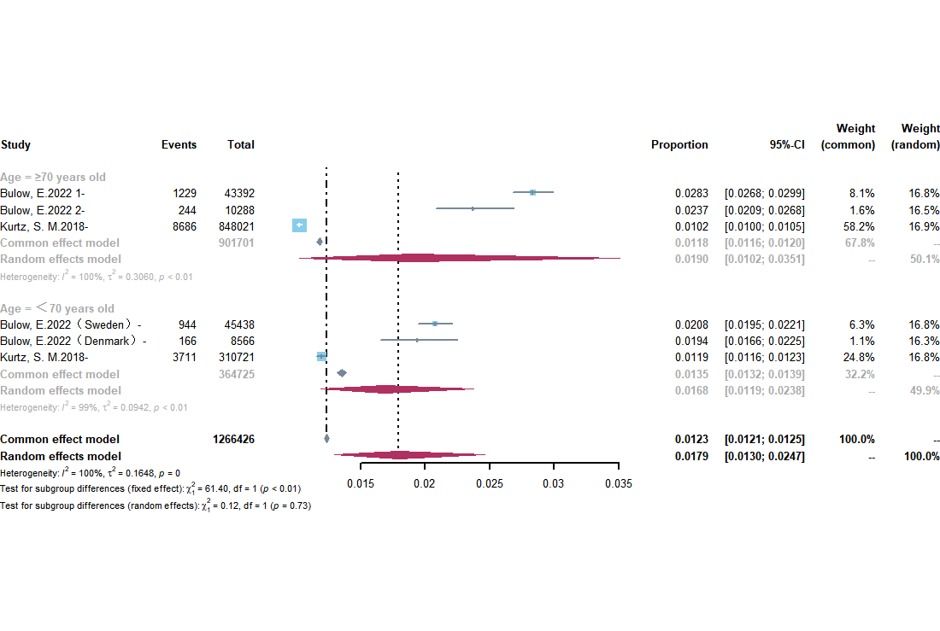
Supplementary Figure 2 Forest plot of incidence of PJI by age in the database based studies
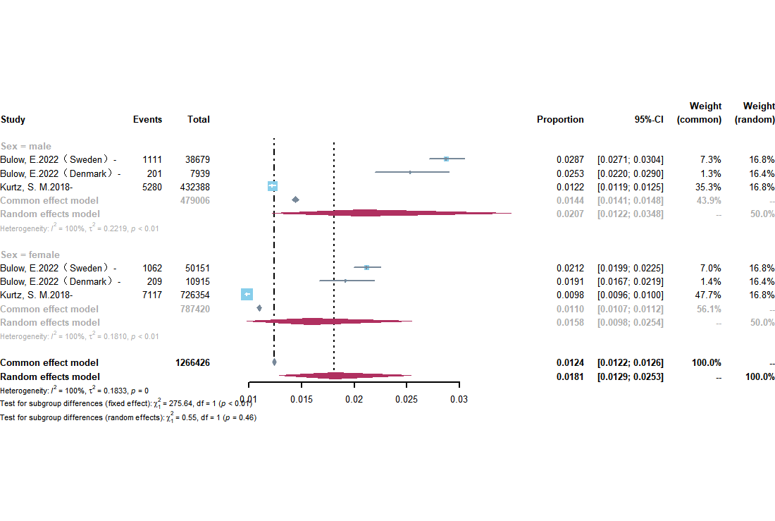
Supplementary Figure 3 Forest plot of incidence of PJI by sex in the database based studies
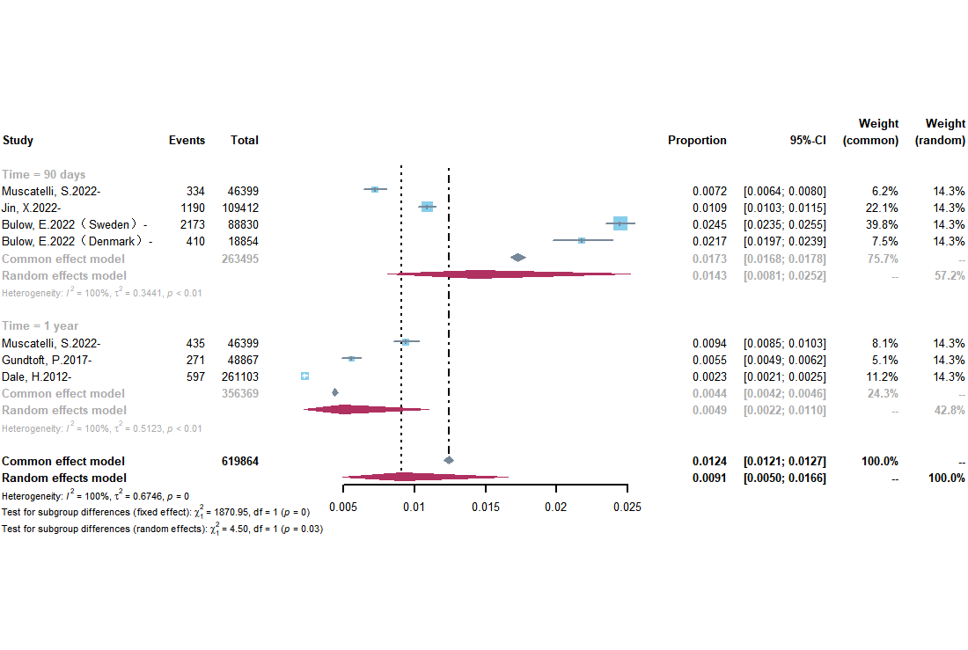
Supplementary Figure 4 Forest plot of incidence of PJI by time to post-THA infection in the database based studies
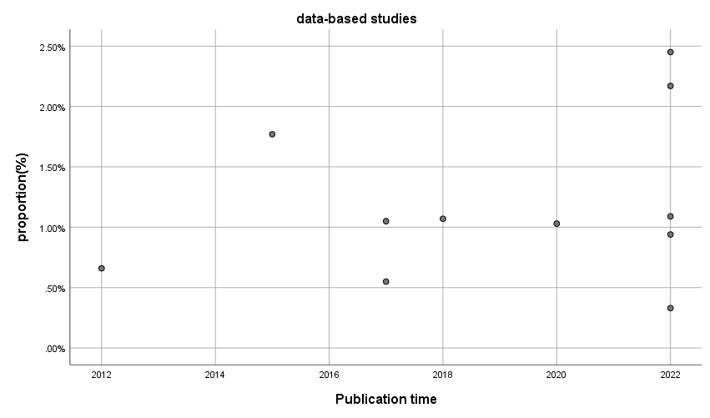
Supplementary Figure 5 Scatterplot of the incidence of PJI by publication time in the database-based studies
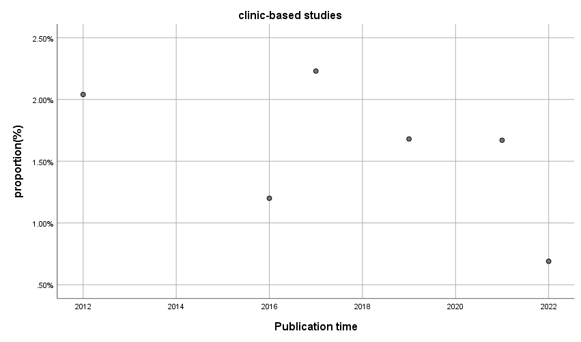
Supplementary Figure 6 Scatterplot of the incidence of PJI by publication time in the clinic-based studies
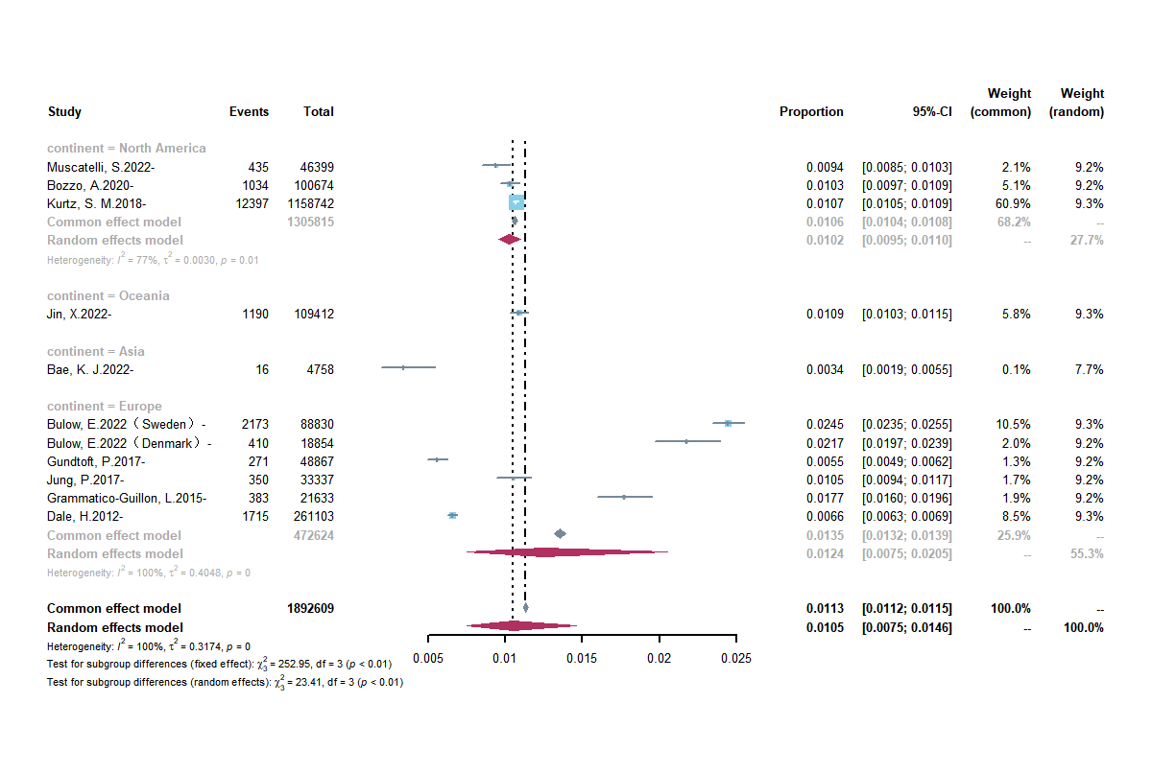
Supplementary Figure 7 Forest plot of incidence of PJI by continent in the database-based studies
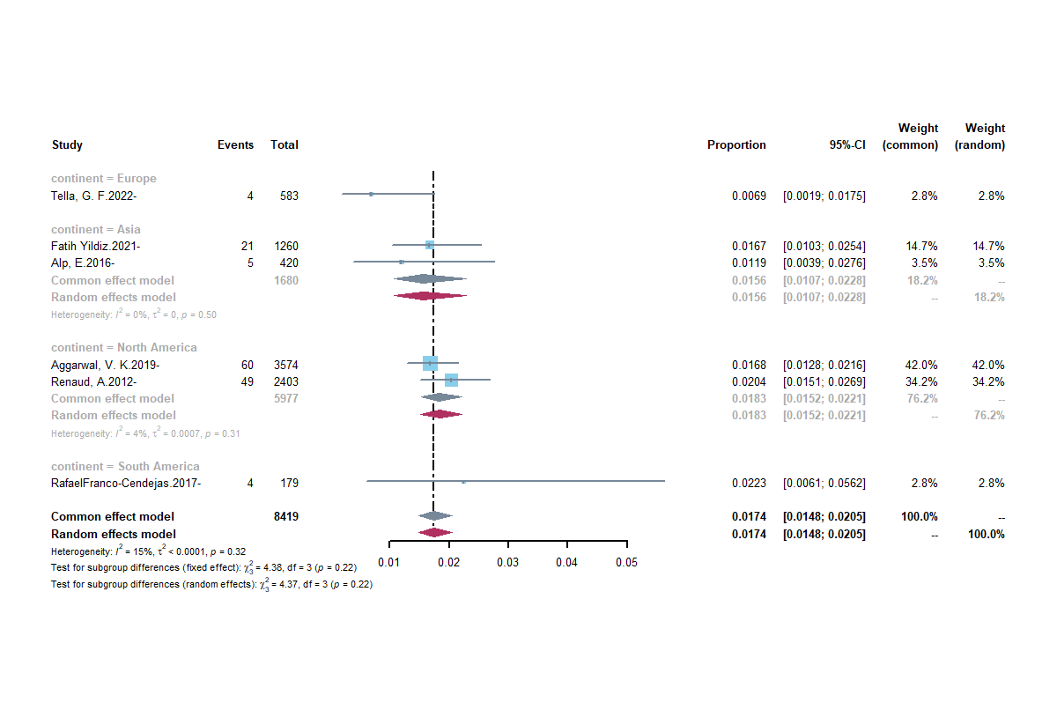
Supplementary Figure 8 Forest plot of incidence of PJI by continent in the clinic-based studies
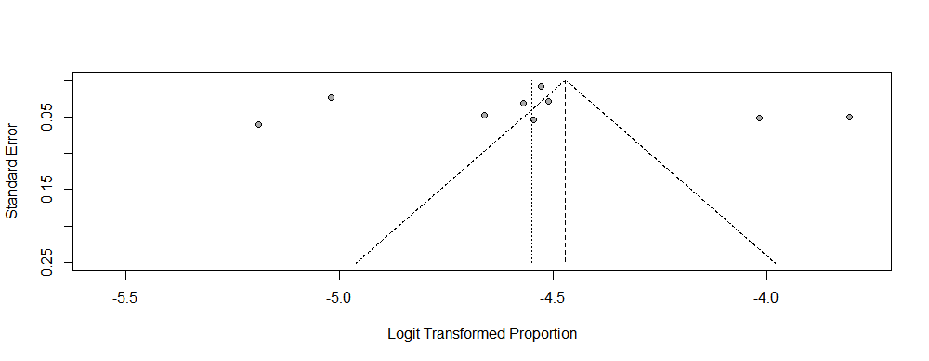
Supplementary Figure 9 Publication bias of the database-based studies incidence studies of PJI
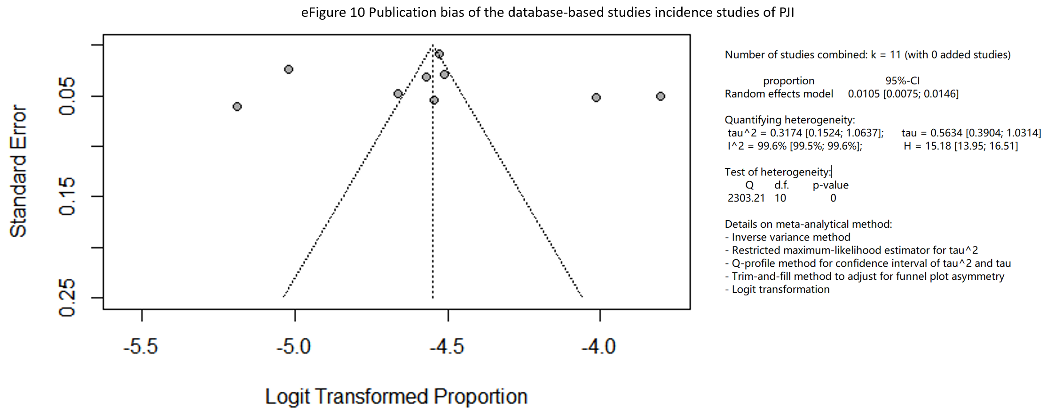
Supplementary Figure 10 Publication bias of the database-based studies incidence studies of PJI
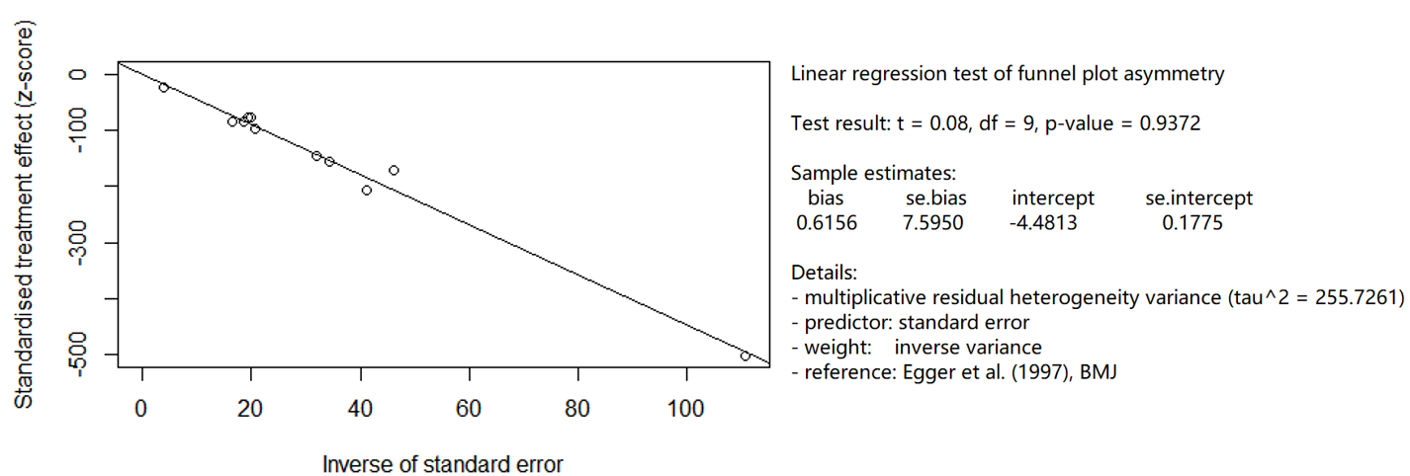
Supplementary Figure 11 Publication bias of the database-based studies incidence studies of PJI (Egger test)
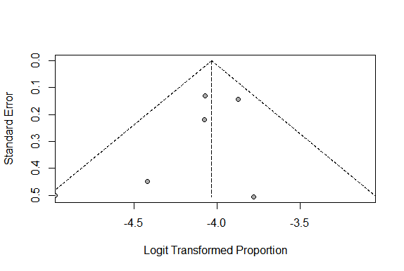
Supplementary Figure 12 Publication bias of the clinic-based studies incidence studies of PJI
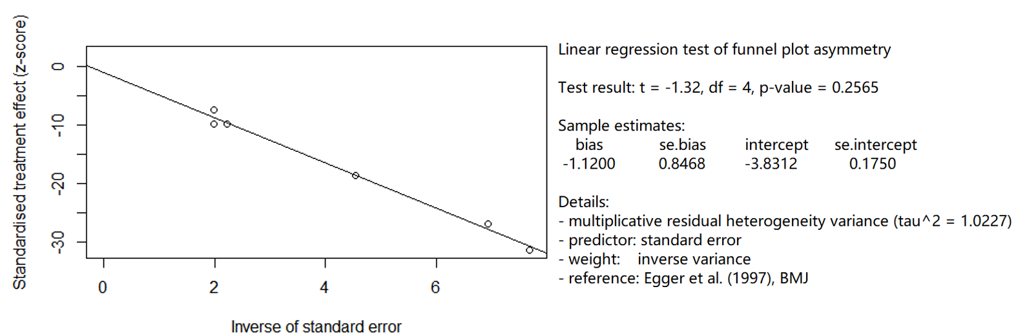
Supplementary Figure 13 Publication bias of the clinic-based studies incidence studies of PJI (Egger test)
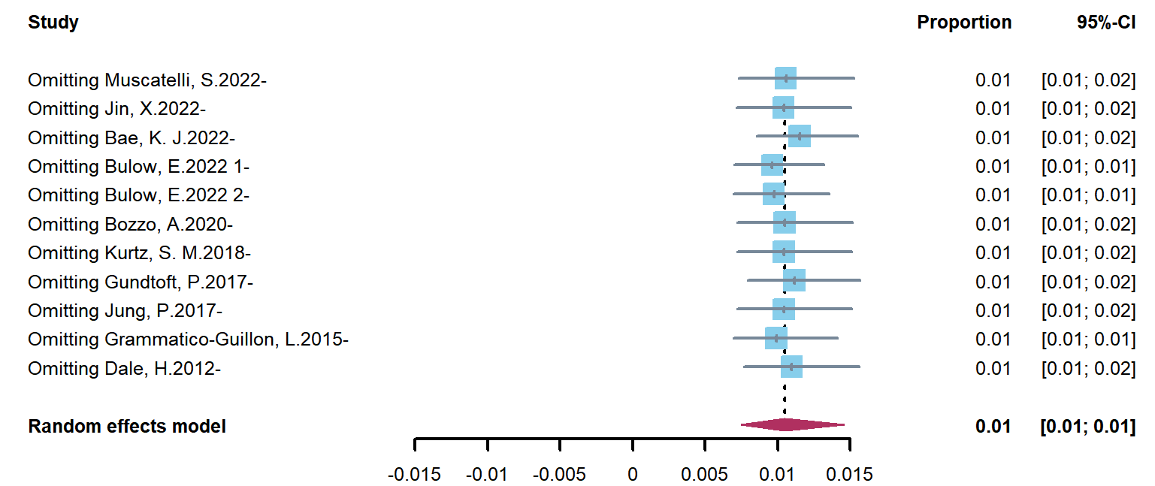
Supplementary Figure 14 Sensitivity Analysis of the database-based studies incidence studies of PJI
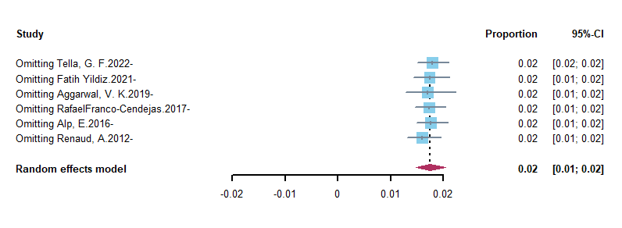
Supplementary Figure 15 Sensitivity Analysis of the clinic-based studies incidence studies of PJI

Supplementary Figure 16 The annual number of publications in the most influential
Journal. The horizontal coordinate is the year and the vertical coordinate is the cumulative number of articles issued.

Supplementary Table
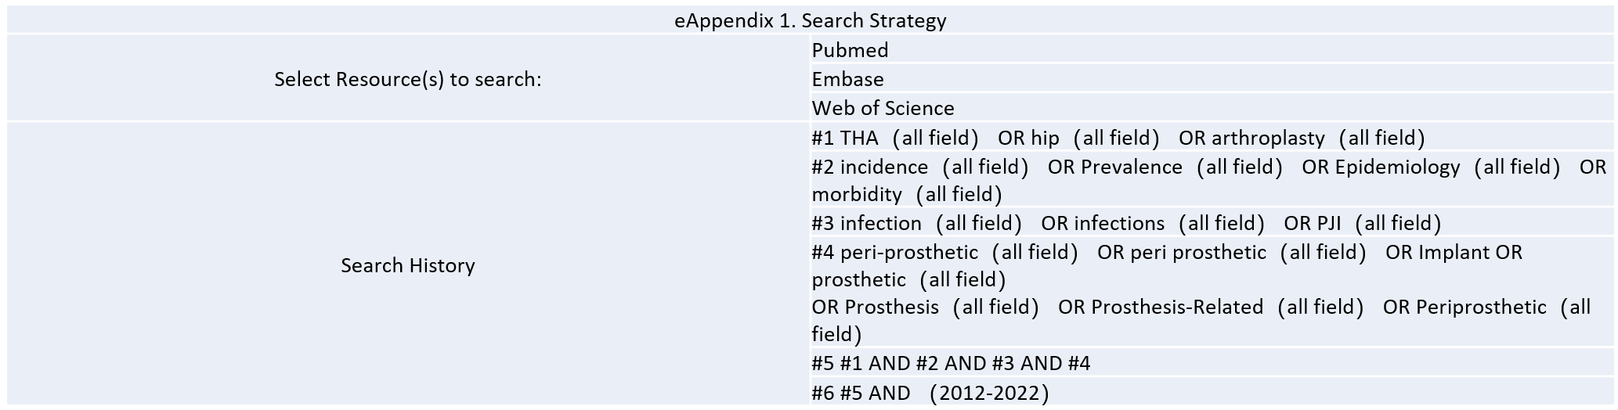
Supplementary Table 1 Search Strategy
Author,year | Q1 | Q2 | Q3 | Q4 | Q5 | Q6 | Q7 | Q8 | Q9 | Total(%) | Risk of Bias
Muscatelli, S.2022 | Y | U | Y | U | Y | Y | U | Y | Y | 66.67 | MODERATE
Tella, G. F.2022 | U | U | U | U | U | Y | Y | Y | Y | 44.44 | HIGH
Bae, K. J.2022 | U | Y | Y | U | U | Y | U | Y | U | 44.44 | HIGH
Bulow, E.2022 | Y | Y | Y | U | Y | Y | Y | Y | Y | 88.89 | LOW
Jin, X.2022 | Y | U | Y | U | Y | N | U | Y | U | 44.44 | HIGH
Fatih Yildiz.2021 | U | Y | U | U | U | Y | U | Y | U | 33.33 | HIGH
Bozzo, A.2020 | Y | Y | Y | U | Y | Y | U | Y | N | 66.67 | MODERATE
Aggarwal, V. K.2019 | U | Y | U |  | Y | U | Y | Y | Y | 66.67 | MODERATE
Kurtz, S. M.2018 | Y | Y | Y | Y | Y | Y | U | Y | U | 77.78 | LOW
Gundtoft, P. H.2017 | Y | U | Y | Y | Y | N | U | Y | U | 55.56 | MODERATE
Franco-Cendejas, R.2017 | U | Y | U | Y | U | Y | Y | Y | N | 55.56 | MODERATE
Jung, P.2017 | Y | Y | Y | U | Y | N | U | Y | Y | 66.67 | MODERATE
Alp, E.2016 | U | U | U | Y | U | Y | Y | Y | U | 44.44 | HIGH
Grammatico-Guillon, L.2015 | U | Y | Y | U | U | Y | N | Y | U | 44.44 | HIGH
Dale, H.2012 | Y | Y | Y | U | Y | N | Y | Y | U | 66.67 | MODERATE
Renaud, A.2012 | U | Y | U | Y | U | Y | Y | Y | U | 55.56 | MODERATE
Legend:Y=Yes;N=No;U=Unclear;NA=Not applicable
Risk of bias was categorized as high when the study reaches up to 49% score "yes" ,moderate wthen the study reached 50% to 69%
score "yes" ,and low when the study reached more than 70% score "yes".
Supplementary Table 2 Quality assessment
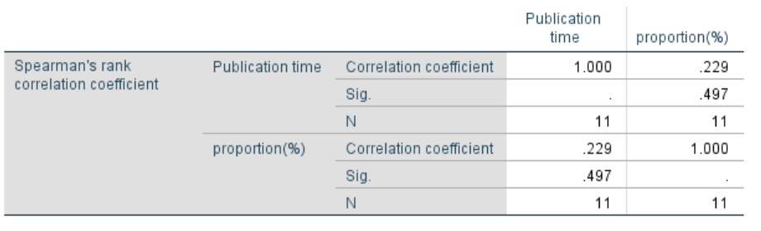
Supplementary Table 3 Dabtabase-based studies correlations Analysis
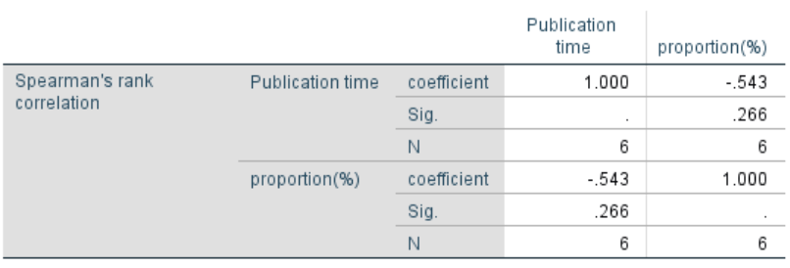
Supplementary Table 4 Clinic-based studies correlation Analysis
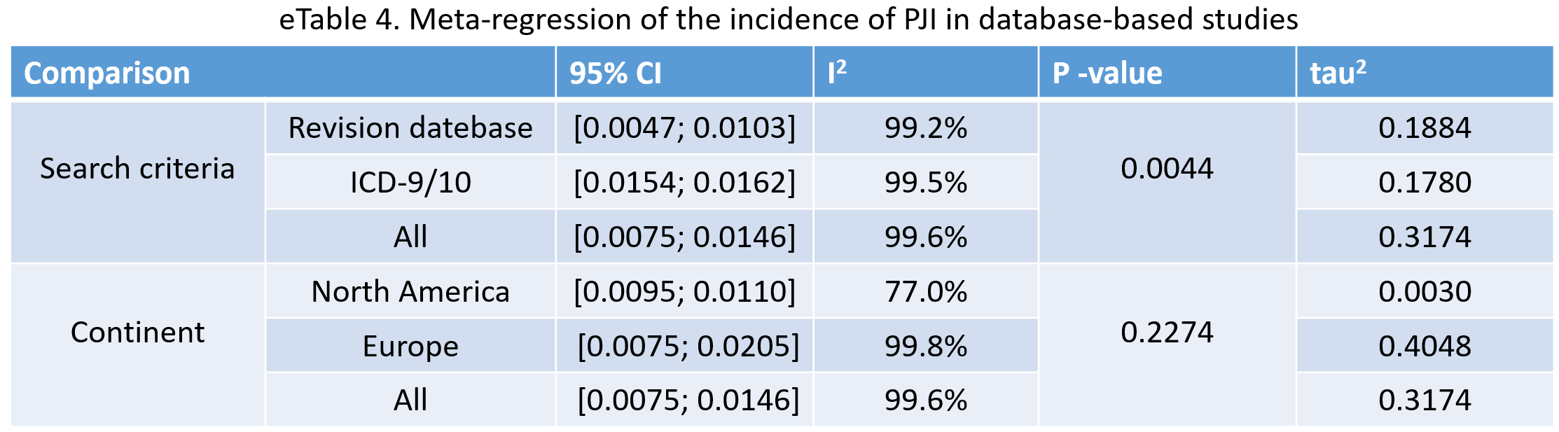
Supplementary Table 5 Meta-regression of the incidence of PJI in database-based studies
The top 10 most productive research institutions
Institution | Articles | Country
Mayo Clinic | 200 | US
Thomas Jefferson University | 161 | US
Hospital for Special Surgery | 132 | US
Rush University | 103 | US
Harvard Medical School | 78 | US
Cleveland Clinic | 75 | US
Duke University | 73 | US
Sichuan University | 73 | CN
University of Toronto | 62 | CA
University of Pennsylvania | 61 | US
Supplementary Table 6 The top 10 most productive research institutions
the top 10 journals with the highest number of publications
Journal Name | articles | Country of Publication | 2022 Impact Factor | 2023 Impact Factor | JCR Category
Journal of Arthroplasty | 914 | USA | 3.85 | 4.435 | Q1 (Surgery) Q2 (Orthopedics and Sports Medicine)
Bone & Joint Journal | 184 | UK | 4.306 | NA | Q1 (Surgery) Q1 (Orthopedics and Sports Medicine)
Hip International | 180 | UK | 1.802 | NA | Q3 (Surgery) Q3 (Orthopedics and Sports Medicine)
International Orthopaedics | 151 | Germany | 2.724 | NA | Q2 (Surgery) Q2 (Orthopedics and Sports Medicine)
Journal of Bone and Joint Surgery-American Volume | 147 | USA | 5.163 | NA | Q1 (Surgery) Q1 (Orthopedics and Sports Medicine)
Archives of Orthopaedic and Trauma Surgery | 115 | Germany | 1.977 | NA | Q3 (Surgery) Q3 (Orthopedics and Sports Medicine)
Clinical Orthopaedics and Related Research | 115 | USA | 4.154 | NA | Q1 (Surgery) Q1 (Orthopedics and Sports Medicine)
Orthopedics | 90 | USA | 0.862 | NA | Q4 (Surgery) Q4 (Orthopedics and Sports Medicine)
BMC Musculoskeletal Disorders | 82 | UK | 2.239 | NA | Q2（Orthopedics and Sports Medicine）
ACTA Orthopaedica | 71 | Sweden | 3.057 | NA | Q1（Surgery） Q1（Orthopedics and Sports Medicine）
Supplementary Table 7 the top 10 journals with the highest number of publications
The top 10 authors with the highest number of publications
Authors | Articles | citation | average citation/publication
Parvizi. J | 170 | 7615 | 44.79
Abdel. MP | 60 | 645 | 10.75
Chen. AF | 59 | 2019 | 34.22
Mont. MA | 58 | 1452 | 25.03
Della-Valle. CJ | 57 | 2096 | 36.77
Gehrke.T | 49 | 442 | 9.02
Berry. DJ | 47 | 1685 | 35.85
Tan. TL | 44 | 1880 | 42.73
Schwarzkopf. R | 43 | 496 | 11.53
Higuera. CA | 37 | 1079 | 29.16
Supplementary Table 8 The top 10 authors with the highest number of publications
the 50 most frequently occurring author keywords
keyword | occurrences
tha | 1017
pji | 887
arthroplasty | 423
infection | 371
complication | 330
tka | 324
revision | 265
hip | 238
total joint arthroplasty | 219
hip arthroplasty | 210
outcome | 147
ssi | 129
diagnosis | 104
systematic review | 103
risk factor | 100
knee | 92
revision tha | 92
two-stage revision | 84
dislocation | 79
obesity | 67
revision hip arthroplasty | 66
knee arthroplasty | 59
dair | 58
hip fracture | 56
biofilm | 52
aseptic loosening | 50
periprosthetic fracture | 50
mortality | 48
femoral neck fracture | 45
readmission | 43
antibiotic | 41
crp | 39
postoperative complications | 37
osteoarthritis | 36
treatment | 36
direct anterior approach | 34
orthopedic surgery | 33
tranexamic acid | 32
rheumatoid arthritis | 31
prevention | 30
staphylococcus aureus | 30
synovial fluid | 29
hemiarthroplasty | 28
antibiotic prophylaxis | 27
one-stage revision | 27
dual mobility | 26
spacer | 26
transfusion | 25
diabetes | 24
epidemiology | 24
sonication | 24
acetabular defect | 23
blood loss | 23
cementless | 23
instability | 23
survival | 23
surgery | 22
length of stay | 21
cost | 20
osteomyelitis | 20
septic arthritis | 20
survivorship | 20
Supplementary Table 9 the 50 most frequently occurring author keywords

