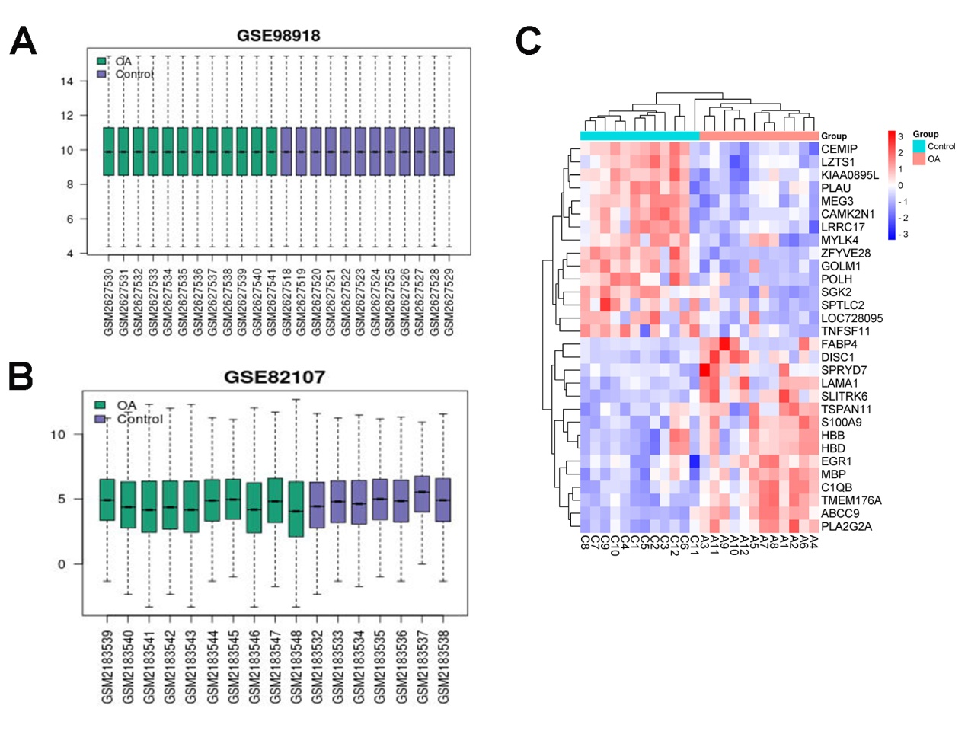
Supplement figure 1. DEGs analysis. A-B: Cross comparability evaluation of microarray data. C. Heat map of the DEGs; red represented highly expressed genes and blue represented low expressed genes.

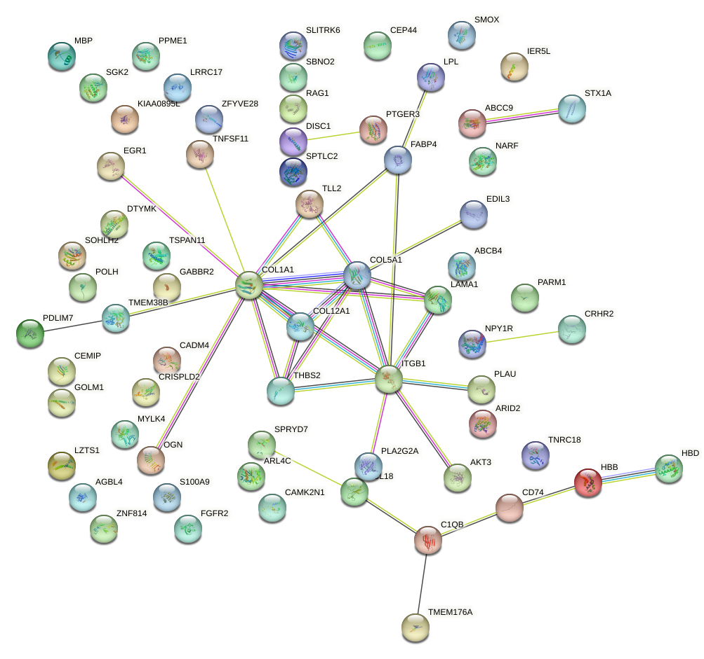
Supplement figure 2. Panorama of protein–protein interaction (PPI) network for DEGs. The PPI network constructed via STRING database representing the degree of gene interaction.

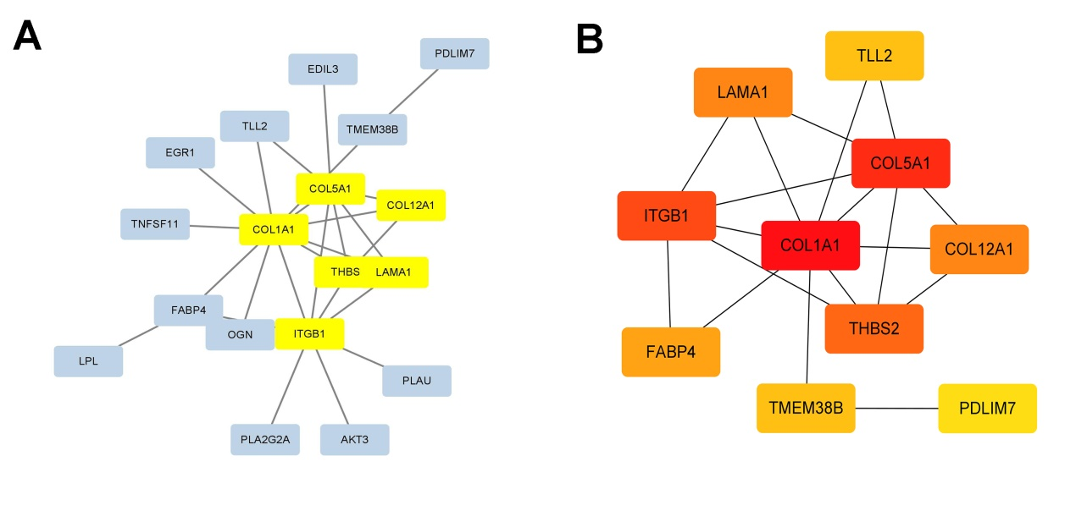
Supplement figure 3. Identification of hub genes using Cytoscape and MCODE plugin. The PPI network constructed via STRING database representing the degree of gene interaction and hub gene modules. A. Hub gene identified based on MCODE analysis. The lines between nodes represented interactions between genes. B. The top 10 genes scored based on MCC method, and the color depth of genes represented the score.

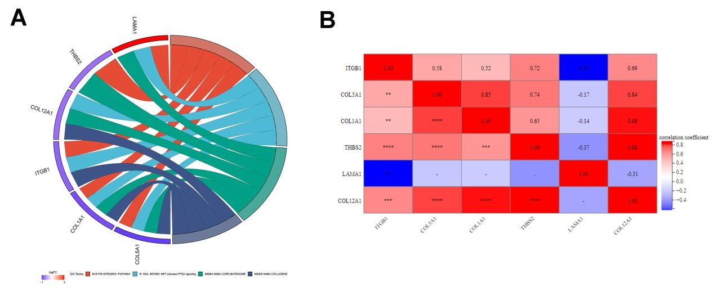
Supplement figure 4. Hub genes analysis. A. The chord plot using the GOplot R package. The data consists of 3 parts: genes; logFC, for sequencing and gene block color; and GO term. B. Matrix correlation analysis to demonstrate the correlation of genes between matrices.
Supplement Table 1. The sequence of primers
Primers | Sequence (5’-3’)
GAPDH-F | CTCATGACCACAGTCCATGC
GAPDH-R | TTCAGCTCTGGGATGACCTT
ITGB1-F | GCCAGTGTCACCTGGAAAAT
ITGB1-R | TGTGCCCACTGCTGACTTAG
LAMA1-F | GCTCCTGCAAGGAGAATGTC
LAMA1-R | TGTGAAACCACATGCAGGAT
COL1A1-F | TGACTGGAAGAGCGGAGAGT
COL1A1-R | GAATCCATCGGTCATGCTCT
COL5A1-F | GTGGCACAGAATTGCTCTCA
COL5A1-F | GTGGCACAGAATTGCTCTCA
THBS2-F | TCGTGCGCTTTGACTACATC
THBS2-R | GTGCCGTCAATCCAGTAGGT
COL12A1-F | GGAGACAGAGGCTTCACTGG
COL12A1-R | ACTGCTCGCATCATGTTCTG
Supplement Table 2. The top 15 differentially expressed genes
Genes | Description | log2FoldChange | pval | up/down
ABCC9 | ATP-binding cassette, sub-family C (CFTR/MRP), member 9 | 2.58 | 2.04E-07 | up
HBB | Hemoglobin, beta | 2.00 | 1.07E-02 | up
PLA2G2A | Phospholipase A2, group IIA (platelets, synovial fluid) | 1.88 | 5.36E-07 | up
S100A9 | S100 calcium binding protein A9 | 1.77 | 2.29E-04 | up
LAMA1 | Laminin, alpha 1 | 1.64 | 2.01E-04 | up
HBD | Hemoglobin, delta | 1.60 | 4.31E-03 | up
C1QB | Complement component 1, q subcomponent, B chain | 1.53 | 3.19E-06 | up
SPRYD7 | SPRY domain containing 7 | 1.45 | 8.70E-03 | up
TMEM176A | Transmembrane protein 176A | 1.42 | 1.05E-07 | up
EGR1 | Early growth response 1 | 1.42 | 1.10E-03 | up
SLITRK6 | SLIT and NTRK-like family, member 6 | 1.38 | 2.40E-05 | up
DISC1 | Disrupted in schizophrenia 1 | 1.38 | 2.28E-04 | up
TSPAN11 | Tetraspanin 11 | 1.33 | 1.53E-02 | up
FABP4 | Fatty acid binding protein 4, adipocyte | 1.31 | 9.55E-03 | up
MBP | Myelin basic protein | 1.26 | 2.34E-04 | up
GOLM1 | Golgi membrane protein 1 | -1.45 | 8.59E-06 | down
POLH | Polymerase (DNA directed), eta | -1.46 | 4.89E-04 | down
KIAA0895L | KIAA0895-like | -1.47 | 4.51E-05 | down
MYLK4 | Myosin light chain kinase family, member 4 | -1.51 | 1.04E-03 | down
SPTLC2 | Serine palmitoyltransferase, long chain base subunit 2 | -1.51 | 1.45E-03 | down
LRRC17 | Leucine rich repeat containing 17 | -1.53 | 3.34E-04 | down
TNFSF11 | Tumor necrosis factor (ligand) superfamily, member 11 | -1.56 | 3.34E-03 | down
CAMK2N1 | Calcium/calmodulin-dependent protein kinase II inhibitor 1 | -1.58 | 7.56E-05 | down
ZFYVE28 | Zinc finger, FYVE domain containing 28 | -1.59 | 4.74E-08 | down
LZTS1 | Leucine zipper, putative tumor suppressor 1 | -1.59 | 1.13E-04 | down
LOC728095 | uncharacterized LOC728095 | -1.85 | 2.93E-03 | down
PLAU | Plasminogen activator, urokinase | -1.97 | 9.31E-04 | down
MEG3 | Maternally expressed 3 (non-protein coding) | -1.99 | 3.52E-06 | down
SGK2 | Serum/glucocorticoid regulated kinase 2 | -2.06 | 6.26E-06 | down
CEMIP | Cell migration inducing protein, hyaluronan binding | -2.32 | 2.03E-05 | down
Supplement Table 3. The Top6 Go term
GO TERM | Term | Pvalue | Fold enrichment | Count | GeneRatio | Genes
GOTERM-BP-DIRECT | GO:0050729 positive regulation of inflammatory response | 4.17E-04 | 14.05 | 5 | 7.14 | FABP4, CAMK2N1, PLA2G2A, LPL, S100A9
GOTERM-BP-DIRECT | GO:2000343 positive regulation of chemokine (C-X-C motif) ligand 2 production | 7.47E-04 | 71.96 | 3 | 4.29 | CD74, LPL, MBP
GOTERM-BP-DIRECT | GO:0030199 collagen fibril organization | 9.00E-04 | 20.79 | 4 | 5.71 | COL1A1, COL5A1, COL12A1, TLL2
GOTERM-BP-DIRECT | GO:0007155 cell adhesion | 1.76E-03 | 4.49 | 8 | 11.43 | ITGB1, COL1A1, CADM4, COL5A1, LAMA1, COL12A1, THBS2, EDIL3
GOTERM-BP-DIRECT | GO:0001503 ossification | 2.46E-03 | 14.67 | 4 | 5.71 | COL1A1, LRRC17, TNFSF11, PDLIM7
GOTERM-BP-DIRECT | GO:0045582 positive regulation of T cell differentiation | 5.76E-03 | 25.99 | 3 | 4.29 | CD74, ARID2, RAG1
GOTERM-CC-DIRECT | GO:0005576 extracellular region | 2.02E-04 | 2.67 | 18 | 25.71 | C1QB, CEMIP, LAMA1, PLA2G2A, COL12A1, HBB, LPL, THBS2, COL1A1, COL5A1, CRISPLD2, PLAU, OGN, TLL2, TNFSF11, S100A9, STX1A, FGFR2
GOTERM-CC-DIRECT | GO:0005615 extracellular space | 7.24E-04 | 2.61 | 16 | 22.86 | GOLM1, LAMA1, PLA2G2A, COL12A1, LRRC17, HBB, LPL, COL1A1, COL5A1, CRISPLD2, PLAU, OGN, TLL2, TNFSF11, CCL18, S100A9
GOTERM-CC-DIRECT | GO:0005833 hemoglobin complex | 8.46E-04 | 67.85 | 3 | 4.29 | HBB, HBD
GOTERM-CC-DIRECT | GO:0031012 extracellular matrix | 1.29E-03 | 7.31 | 6 | 8.57 | COL1A1, COL5A1, CRISPLD2, LAMA1, OGN, LRRC17
GOTERM-CC-DIRECT | GO:0005581 collagen trimer | 2.96E-03 | 13.77 | 4 | 5.71 | C1QB, COL1A1, COL5A1, COL12A1
GOTERM-CC-DIRECT | GO:0009986 cell surface | 1.46E-02 | 3.45 | 7 | 10 | ITGB1, CD74, PLAU, SLITRK6, LPL, MBP, FGFR2
GOTERM-MF-DIRECT | GO:0005201 extracellular matrix structural constituent | 1.03E-03 | 11.05 | 5 | 7.14 | COL1A1, COL5A1, LAMA1, THBS2, EDIL3
GOTERM-MF-DIRECT | GO:0005344 oxygen transporter activity | 1.19E-03 | 57.18 | 3 | 4.29 | HBB, HBD
GOTERM-MF-DIRECT | GO:0008201 heparin binding | 2.50E-03 | 8.66 | 5 | 7.14 | COL5A1, CRISPLD2, LPL, THBS2, FGFR2
GOTERM-MF-DIRECT | GO:0019825 oxygen binding | 6.01E-03 | 25.41 | 3 | 4.29 | HBB, HBD
GOTERM-MF-DIRECT | GO:0030020 extracellular matrix structural constituent conferring tensile strength | 7.74E-03 | 22.31 | 3 | 4.29 | COL1A1, COL5A1, COL12A1
GOTERM-MF-DIRECT | GO:0031721 hemoglobin alpha binding | 1.60E-02 | 121.99 | 2 | 2.86 | HBB, HBD
Supplement Table 4. Top6 KEGG pathway
KEGG-PATHWAY | Term | Pvalue | Fold enrichment | Count | GeneRatio
KEGG-PATHWAY | hsa04510: Focal adhesion | 1.50E-03 | 6.8 | 6 | 8.57
KEGG-PATHWAY | hsa04923: Regulation of lipolysis in adipocytes | 1.87E-03 | 15.72 | 4 | 5.71
KEGG-PATHWAY | hsa04151: PI3K-Akt signaling pathway | 3.47E-03 | 4.51 | 7 | 10
KEGG-PATHWAY | hsa04512: ECM-receptor interaction | 6.09E-03 | 10.36 | 4 | 5.71
KEGG-PATHWAY | hsa04024: cAMP signaling pathway | 1.39E-02 | 5.16 | 5 | 7.14
KEGG-PATHWAY | hsa04611: Platelet activation | 1.55E-02 | 7.35 | 4 | 5.71

