Part 1. The funnel plot

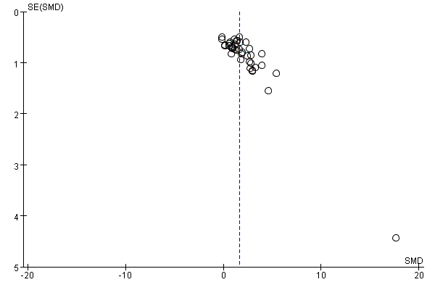
Figure 1. The funnel plot for BMD.
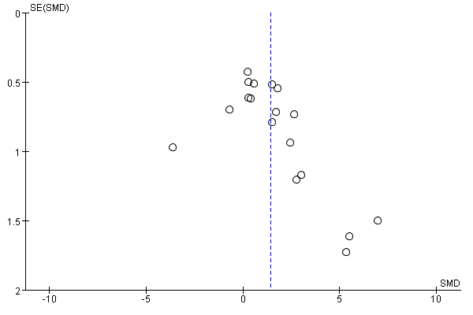
Figure 2. The funnel plot for BV/TV.
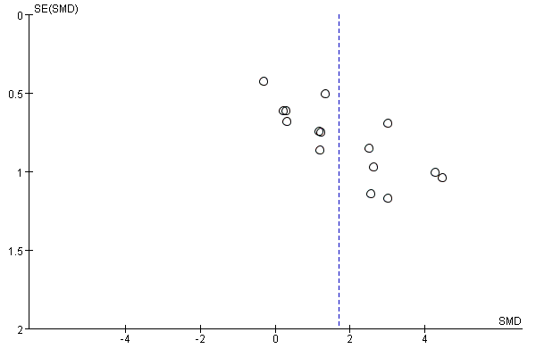
Figure 3. The funnel plot for Tb.N.
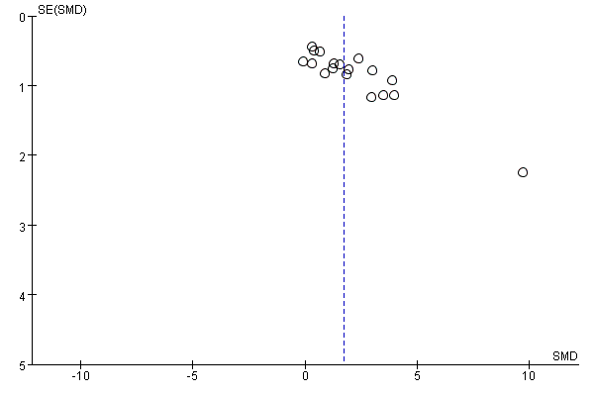
Figure 4. The funnel plot for Tb.Th.
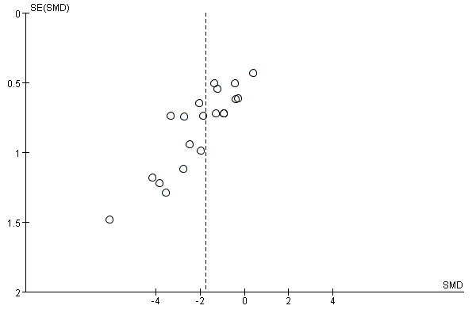
Figure 5. The funnel plot for Tb.Sp.
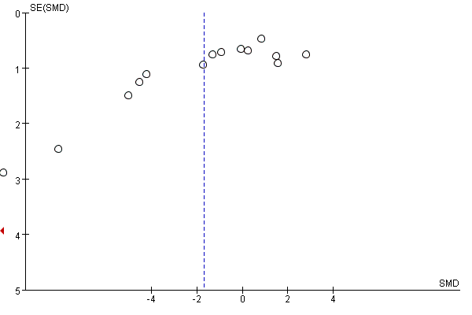
Figure 6. The funnel plot for ALP.
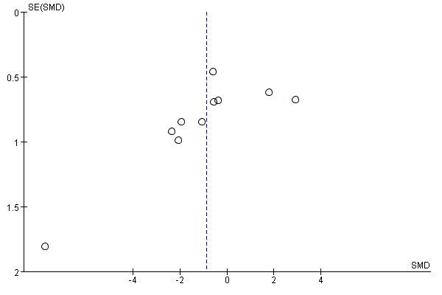
Figure 7. The funnel plot for OC.

Part 2.sensitivity analysis
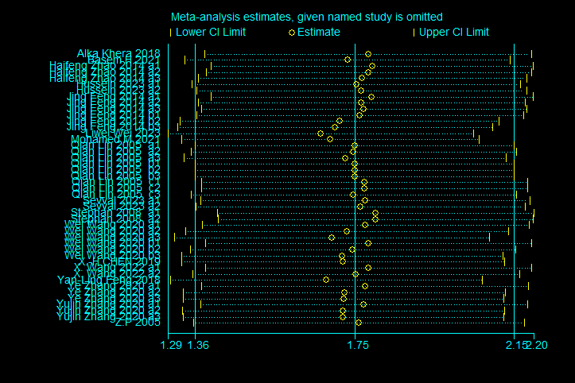

Figure 8.Sensitivity analysis for BMD.
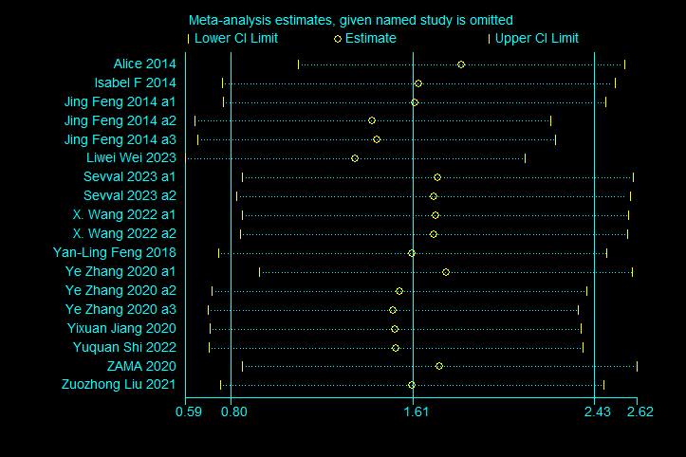
Figure 9.Sensitivity analysis for BV/TV.
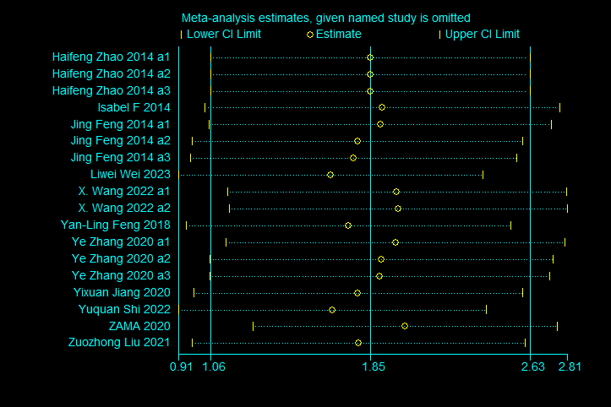
Figure 10.Sensitivity analysis for Tb.N.
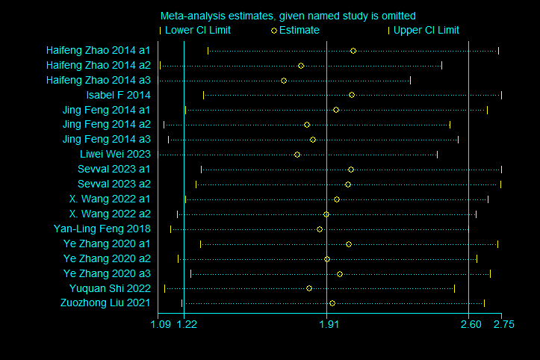
Figure 11.Sensitivity analysis for Tb.Th.
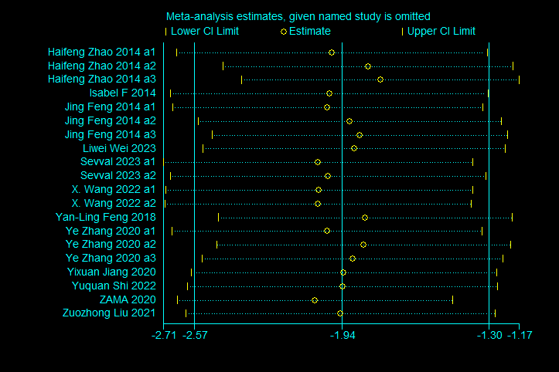
Figure 12.Sensitivity analysis for Tb.Sp.
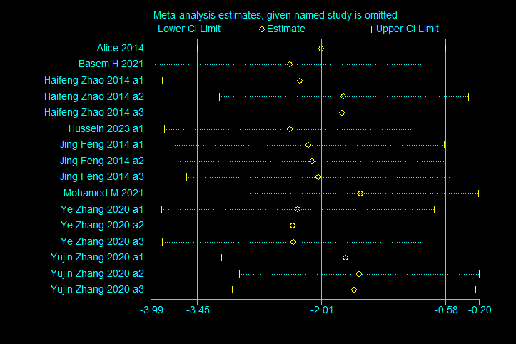
Figure 13.Sensitivity analysis for ALP.
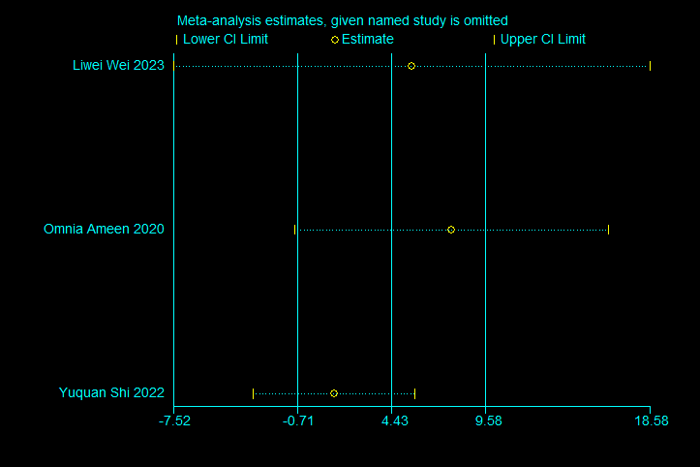
Figure 14.Sensitivity analysis for bALP.
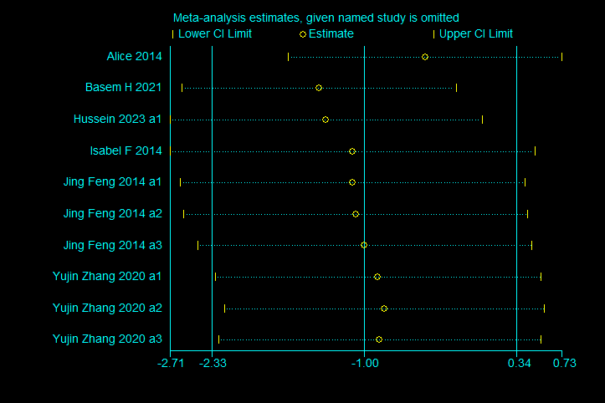
Figure 15.Sensitivity analysis for OC.
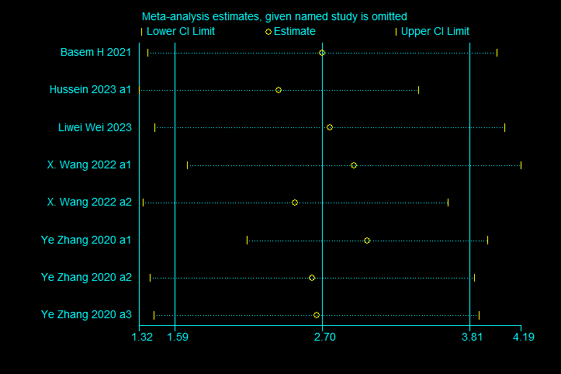
Figure 16.Sensitivity analysis for OPG.
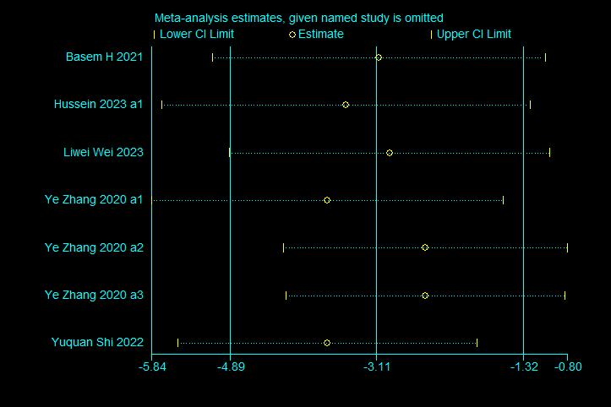
Figure 17.Sensitivity analysis for TRAP5b.

Part 3. Search strategies

Pubmed
(("Resveratrol"[Mesh]) OR ((((((((((((((((Resveratrol[Title/Abstract]) OR (3,5,4'-Trihydroxystilbene[Title/Abstract])) OR (3,4',5-Trihydroxystilbene[Title/Abstract])) OR (3,4',5-Stilbenetriol[Title/Abstract])) OR (trans-Resveratrol-3-O-sulfate[Title/Abstract])) OR (trans Resveratrol 3 O sulfate[Title/Abstract])) OR (SRT 501[Title/Abstract])) OR (SRT501[Title/Abstract])) OR (SRT-501[Title/Abstract])) OR (cis-Resveratrol[Title/Abstract])) OR (cis Resveratrol[Title/Abstract])) OR (Resveratrol, (Z)-[Title/Abstract])) OR (trans-Resveratrol[Title/Abstract])) OR (trans Resveratrol[Title/Abstract])) OR (Resveratrol-3-sulfate[Title/Abstract])) OR (Resveratrol 3 sulfate[Title/Abstract]))) AND (((((((((((((((((((((((Osteoporosis[Title/Abstract]) OR (Osteoporoses[Title/Abstract])) OR (Osteoporosis, Post-Traumatic[Title/Abstract])) OR (Osteoporosis, Post Traumatic[Title/Abstract])) OR (Post-Traumatic Osteoporoses[Title/Abstract])) OR (Post-Traumatic Osteoporosis[Title/Abstract])) OR (Osteoporosis, Senile[Title/Abstract])) OR (Osteoporoses, Senile[Title/Abstract])) OR (Senile Osteoporoses[Title/Abstract])) OR (Osteoporosis, Involutional[Title/Abstract])) OR (Senile Osteoporosis[Title/Abstract])) OR (Osteoporosis, Age-Related[Title/Abstract])) OR (Osteoporosis, Age Related[Title/Abstract])) OR (Bone Loss, Age-Related[Title/Abstract])) OR (Age-Related Bone Loss[Title/Abstract])) OR (Age-Related Bone Losses[Title/Abstract])) OR (Bone Loss, Age Related[Title/Abstract])) OR (Osteoporoses, Age-Related[Title/Abstract])) OR (Bone Losses, Age-Related[Title/Abstract])) OR (Age-Related Osteoporoses[Title/Abstract])) OR (Age Related Osteoporosis[Title/Abstract])) OR (Age-Related Osteoporosis[Title/Abstract])) OR ("Osteoporosis"[Mesh]))

Cochrane
#1 MeSH descriptor: [Resveratrol] explode all trees
#2 (Resveratrol):ti,ab,kw OR (trans Resveratrol):ti,ab,kw OR (trans-Resveratrol):ti,ab,kw OR (cis-Resveratrol):ti,ab,kw OR (cis Resveratrol):ti,ab,kw
#3 (trans Resveratrol 3 O sulfate):ti,ab,kw OR (SRT501):ti,ab,kw OR (SRT-501):ti,ab,kw OR (SRT 501):ti,ab,kw OR (Resveratrol 3 sulfate):ti,ab,kw
#4 #1 or #2 or #3
#5 MeSH descriptor: [Osteoporosis] explode all trees
#6 (Osteoporosis):ti,ab,kw OR (Osteoporoses, Senile):ti,ab,kw OR (Osteoporosis, Involutional):ti,ab,kw OR (Senile Osteoporosis):ti,ab,kw OR (Senile Osteoporoses):ti,ab,kw
#7 (Osteoporosis, Senile):ti,ab,kw OR (Osteoporosis, Age-Related):ti,ab,kw OR (Age-Related Osteoporosis):ti,ab,kw OR (Osteoporosis, Age Related):ti,ab,kw OR (Osteoporoses, Age-Related):ti,ab,kw
#8 (Bone Losses, Age-Related):ti,ab,kw OR (Bone Loss, Age-Related):ti,ab,kw OR (Age-Related Bone Loss):ti,ab,kw OR (Age-Related Osteoporoses):ti,ab,kw OR (Age-Related Bone Losses):ti,ab,kw
#9 (Bone Loss, Age Related):ti,ab,kw OR (Age Related Osteoporosis):ti,ab,kw OR (Osteoporoses):ti,ab,kw OR (Post-Traumatic Osteoporosis):ti,ab,kw OR (Osteoporosis, Post Traumatic):ti,ab,kw
#10 (Post-Traumatic Osteoporoses):ti,ab,kw OR (Osteoporosis, Post-Traumatic):ti,ab,kw
#11 #5 or #6 or #7 or #8 or #9 or #10
#12 #4 and #11

Embase
#9. ('resveratrol'/exp OR ('3, 4`, 5
stilbenetriol':ab,ti OR '3, 4`, 5
trihydroxystilbene':ab,ti OR '5 (4 hydroxystyryl)
benzene 1, 3 diol':ab,ti OR 'srt 501':ab,ti OR
'srt501':ab,ti OR 'trans resveratrol':ab,ti OR
'trans-resveratrol':ab,ti OR
'resveratrol':ab,ti)) AND ('osteoporosis'/exp OR
('decalcification, pathologic':ab,ti OR
'endocrine osteoporosis':ab,ti OR 'osteoporotic
decalcification':ab,ti OR 'pathologic
decalcification':ab,ti OR 'osteoporosis':ab,ti))
#8. 'osteoporosis'/exp OR ('decalcification,
pathologic':ab,ti OR 'endocrine
osteoporosis':ab,ti OR 'osteoporotic
decalcification':ab,ti OR 'pathologic
decalcification':ab,ti OR 'osteoporosis':ab,ti)
#7. 'resveratrol'/exp OR ('3, 4`, 5
stilbenetriol':ab,ti OR '3, 4`, 5
trihydroxystilbene':ab,ti OR '5 (4 hydroxystyryl)
benzene 1, 3 diol':ab,ti OR 'srt 501':ab,ti OR
'srt501':ab,ti OR 'trans resveratrol':ab,ti OR
'trans-resveratrol':ab,ti OR 'resveratrol':ab,ti)
#6. 'decalcification, pathologic':ab,ti OR 'endocrine
osteoporosis':ab,ti OR 'osteoporotic
decalcification':ab,ti OR 'pathologic
decalcification':ab,ti OR 'osteoporosis':ab,ti
#5. '3, 4`, 5 stilbenetriol':ab,ti OR '3, 4`, 5
trihydroxystilbene':ab,ti OR '5 (4 hydroxystyryl)
benzene 1, 3 diol':ab,ti OR 'srt 501':ab,ti OR
'srt501':ab,ti OR 'trans resveratrol':ab,ti OR
'trans-resveratrol':ab,ti OR 'resveratrol':ab,ti
#4. 'decalcification, pathologic' OR 'endocrine
osteoporosis' OR 'osteoporotic decalcification'
OR 'pathologic decalcification' OR 'osteoporosis'
#3. 'osteoporosis'/exp
#2. '3, 4`, 5 stilbenetriol' OR '3, 4`, 5
trihydroxystilbene' OR '5 (4 hydroxystyryl)
benzene 1, 3 diol' OR 'srt 501' OR 'srt501' OR
'trans resveratrol' OR 'trans-resveratrol' OR
'resveratrol'
#1. 'resveratrol'/exp

Web of science

#5 #4 AND #3

#4 #2 OR #1

#3 ((((((((((((((((((((((TS=(Osteoporosis)) OR ALL=(Osteoporosis)) OR ALL=(Osteoporoses, Age-Related)) OR ALL=(Age-Related Osteoporoses )) OR ALL=(Age Related Osteoporosis )) OR ALL=(Age-Related Osteoporosis )) OR ALL=(Bone Losses, Age-Related )) OR ALL=(Bone Loss, Age Related )) OR ALL=(Age-Related Bone Losses )) OR ALL=(Age-Related Bone Loss )) OR ALL=(Bone Loss, Age-Related )) OR ALL=(Osteoporosis, Age Related )) OR ALL=(Osteoporosis, Age-Related )) OR ALL=(Senile Osteoporosis )) OR ALL=(Osteoporosis, Involutional )) OR ALL=(Senile Osteoporoses )) OR ALL=(Osteoporoses, Senile )) OR ALL=(Osteoporosis, Senile )) OR ALL=(Post-Traumatic Osteoporosis )) OR ALL=(Post-Traumatic Osteoporoses )) OR ALL=(Osteoporosis, Post Traumatic )) OR ALL=(Osteoporosis, Post-Traumatic )) OR ALL=(Osteoporoses )

#2 (((((((((((((((ALL=(3,5,4'-Trihydroxystilbene)) OR ALL=(3,4',5-Trihydroxystilbene)) OR ALL=(3,4',5-Stilbenetriol)) OR ALL=(trans-Resveratrol-3-O-sulfate)) OR ALL=(trans Resveratrol 3 O sulfate)) OR ALL=(SRT-501)) OR ALL=(SRT501 )) OR ALL=(SRT 501 )) OR ALL=(Resveratrol, (Z)-)) OR ALL=(cis Resveratrol )) OR ALL=(cis-Resveratrol )) OR ALL=(Resveratrol 3 sulfate)) OR ALL=(Resveratrol-3-sulfate )) OR ALL=(trans Resveratrol )) OR ALL=(trans-Resveratrol )) OR ALL=(Resveratrol)

#1 TS=(resveratrol)

