A biodegradable PVA coating constructed on the surface of the implant for preventing bacterial colonization and biofilm formation

Zhonghua Lei^{1,2#}, Haifeng Liang^{1,3#}, Wei Sun¹, Yan Chen⁴, Zhi Huang⁵*, and Bo Yu¹*,
1. Orthopedic and traumatology department, Zhujiang Hospital, Southern Medical University, Guangzhou, China 510282;
2. Department of Orthopedics, The Sixth Peoples Hospital of Huizhou, Huizhou, China 516211;
3. Department of Orthopedics, The Third Affiliated Hospital of Guangzhou Medical University, Guangzhou, China 510150;
4. Ultrasound Medical Center, Zhujiang Hospital, Southern Medical University, Guangzhou, China 510282;
5. Institute of Biomedical Engineering, School of Basic Medical Sciences, Central South University, Changsha, China 410083;
#The first two authors contributed equally to this manuscript.
* Correspondence: Zhi Huang, biomaterials@csu.edu.cn; Tel.: +86-13117512783. Bo Yu, gzyubo@smu.edu.cn; Tel.: +86-13828434375.

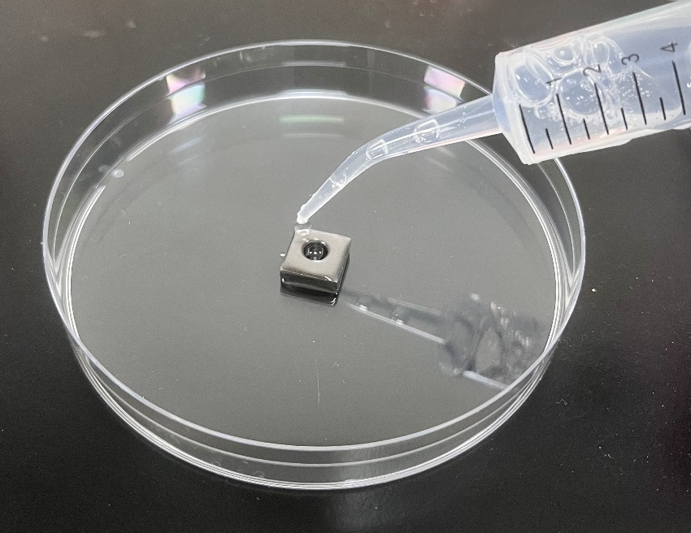
Figure S1 The process of coating titanium plate with 5% PVA

Figure S2 In Vivo Assessment of PVA Coating on Implants 2h after operation. A Plate coating two weeks after the operation, bar=10mm. B Crystal violet staining of the implant. C and D Quantitative results of colony formation around the implant. E and F Quantitative results of crystal violet staining on the implant Data are represented as means ± SD. Significant differences are indicated as ** (p < 0.05).

Figure S3 In Vivo Assessment of PVA Coating on Implants 24h after operation. A Plate coating two weeks after the operation, bar=10mm. B Crystal violet staining of the implant. C and D Quantitative results of colony formation around the implant. E and F Quantitative results of crystal violet staining on the implant Data are represented as means ± SD. Significant differences are indicated as ** (p < 0.05).

