Supplementary Material: Examples of Endplate Rounding

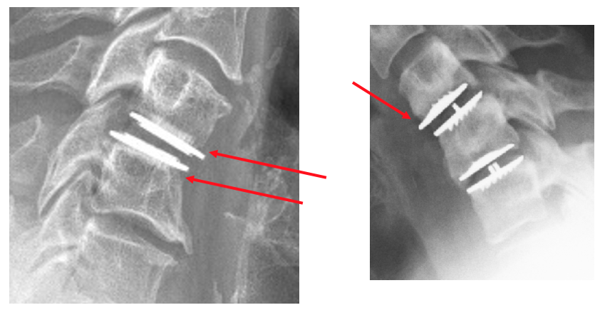
Figure S1: Examples of endplate rounding.

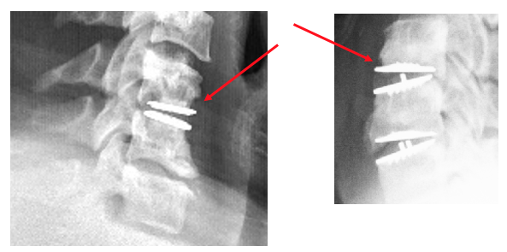
Figure S2: Examples of cystic erosion with diffuse margin adjacent to endplate.

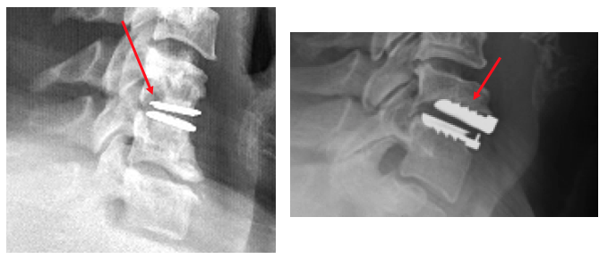
Figure S3: Examples of cystic erosion with sclerotic margin adjacent to endplate.

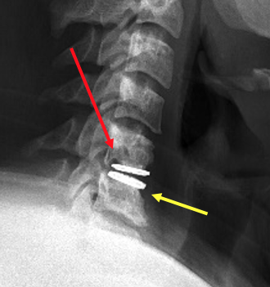
Figure S4: Example of cystic erosion (red arrow) along with endplate rounding (yellow arrow).

