Fig.S1 GO and KEGG enrichment analysis of DEGs. (A) The top 10 GO terms of biological processes, cellular components, and molecular functions. (B) KEGG enrichment analysis of DEGs.
Fig.S2 The fasting blood glucose(A) and body weight (B) were measured every 2 weeks. ***P< 0.001 vs. the con group.
Fig.S3 High glucose (HG) activated the ferroptosis of MCST3-E1 cells. MC3T3-E1 cells were cultured with various glucose concentrations (5.5, 11, 22, or 33 mM). (A) Cell viability was measured using CCK8. (B-C) Relative protein levels of GPX4, SLC7A11, and FTH. (D) Representative images of the DCFH-DA staining (scale: 100μm) and C11-BODIPY staining (scale bar: 100μm) images. Red images represented nonoxidized lipids, while green images represented oxidized lipids. (E) GSH levels and (F) MDA contents. *P < 0.05, **P< 0.01, ***P < 0.001 vs. the 5.5mm group.
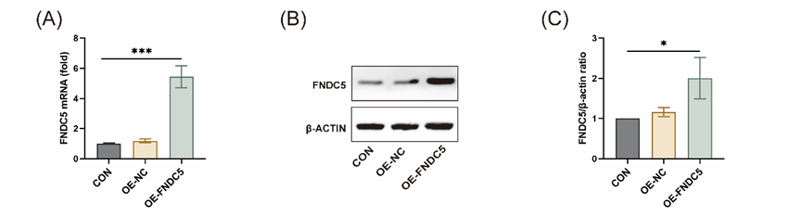
Fig.S4Transfection efficiency was verified after transfection of the FNDC5 overexpression plasmid. (A) Relative mRNA expression of FNDC5. (B-C) Relative protein level of FNDC5. OE-NC means negative control, and OE-FNDC5 means overexpression of FNDC5. *P < 0.05, ***P < 0.001 vs. the con group.

Fig.S5 HG activated the eIF2α-ATF4-CHOP pathway and GSK treatment inhibited the eIF2α-ATF4-CHOP pathway. (A-B) Relative protein levels of p-eIF2a, ATF4, and CHOP in MC3T3-E1 cells cultured with various glucose concentrations (5.5, 11, 22, or 33 mM). *P < 0.05, **P < 0.01, ***P < 0.001 vs. the 5.5mm group. (C-D) Relative protein levels s of p-eIF2a, ATF4, and CHOP in MC3T3-E1 cells treated with or without GSK. *P < 0.05, ***P < 0.001 vs. the con group. #P < 0.05, ##P < 0.01 vs. the HG group.

