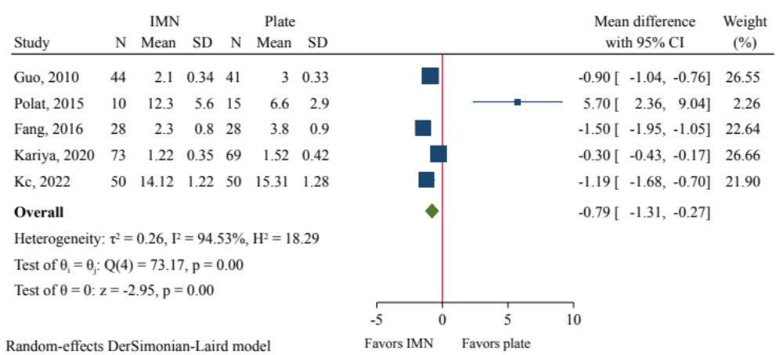
Figure S1. Meta-anlaysis of radiation time comparing nail to plate fixation.

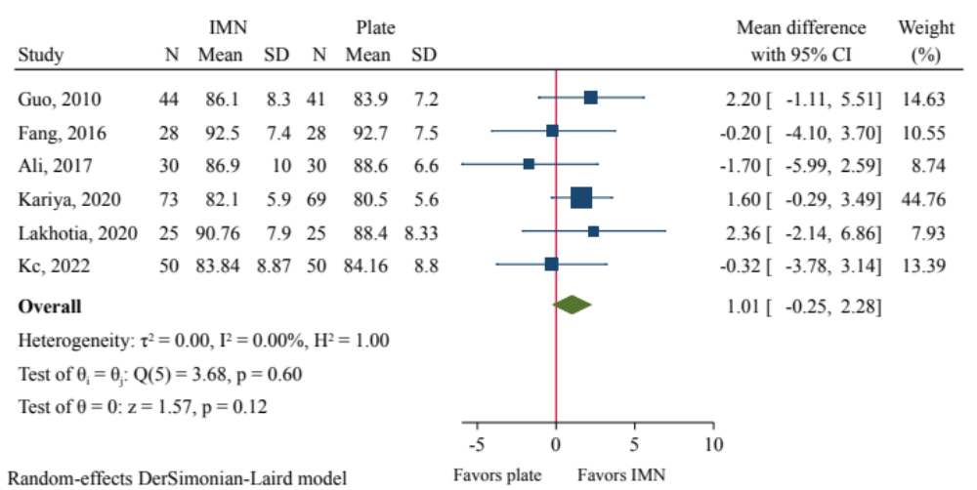
Figure S2. Meta-anlaysis of AOFAS scores comparing nail to plate fixation.

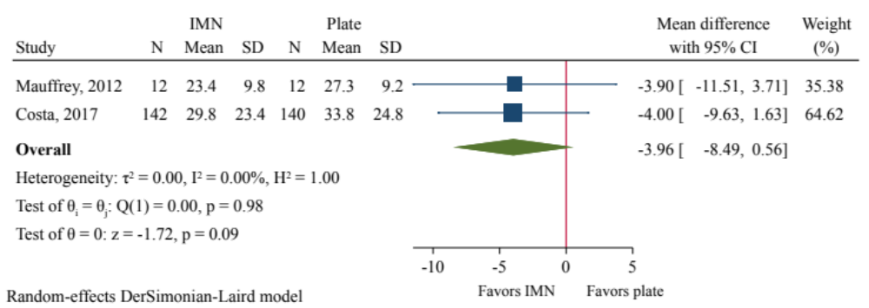
Figure S3. Meta-anlaysis of DRI scores comparing nail to plate fixation.

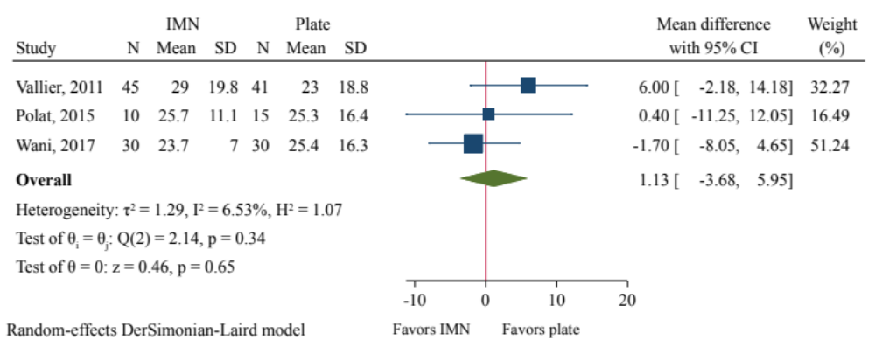
Figure S4. Meta-anlaysis of FFI scores comparing nail to plate fixation.

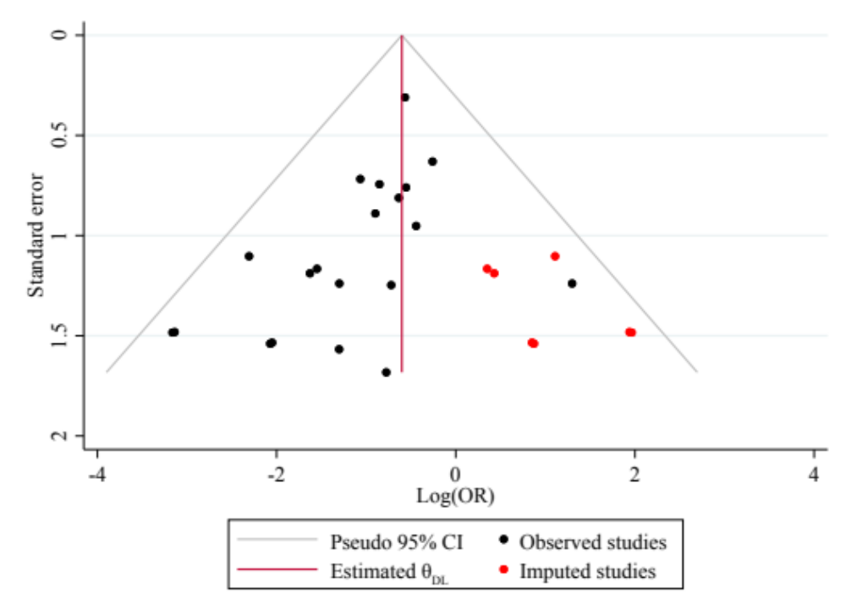
Figure S5. Funnel plot of trim-and-fill analysis of wound infection.

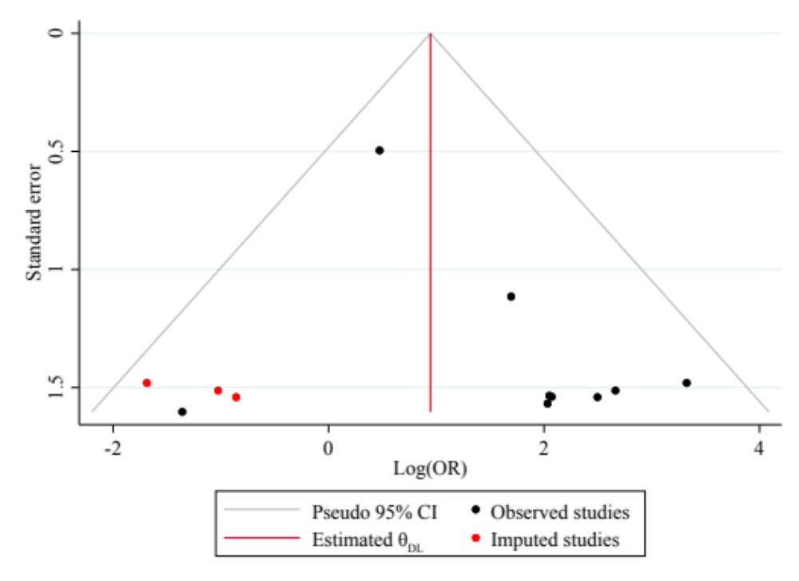
Figure S6. Funnel plot of trim-and-fill analysis of anterior knee pain.

