Supplementary Figure1. Assessment of µCT at each week.
Comparison of trabecular bone structure and bone formation at each time. There was always no significant difference of trabecular bone structure and bone formation, and trabecular bone structure did not show obvious changes from week to week.
µCT, micro-computed tomography; BV, bone volume; Tb.N, trabecular number; Tb.Sp, Trabecular separation; Tb.Th, trabecular thickness; TV, tissue volume
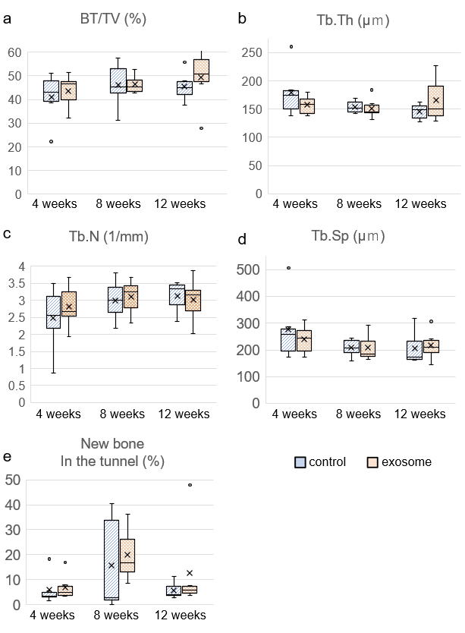

Supplementary Figure2. Results of histological and immunohistochemical analysis at each week.
(a, b) Comparison of percentage of empty lacunae. Empty lacunae were significantly suppressed in the exosome group starting from 4 weeks. In the subchondral area, there was an observable increase in empty lacunae from 8 to 12 weeks. (c) The Modified Mankin score was predominantly lower in exosome from 4 weeks onwards. (d, e) Quantification of the number of CD31-positive vessels.
