Supplementary Materials
The impact of patellofemoral joint diseases on functional outcomes and prosthesis survival in patients undergoing unicompartmental knee arthroplasty: A Systematic Review and Meta-analysis

Fig. S1 Publication years and study locations. (A) The proportion of locations in included studies. The most published location was in USA (32.6%), followed by UK (27.9%). (B) The number of studies in relation to the years from 2007 to 2023.
Fig. S2 Risk of bias graph. (A) Overall quality assessment of case series studies according to MINORS criteria. (B) Overall quality assessment of cohort studies according to MINORS criteria. (Green, 2 score; Yellow, 1 score; Red, 0 score)
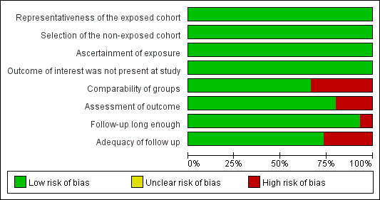
Fig. S3 Risk of bias graph in Meta analysis.

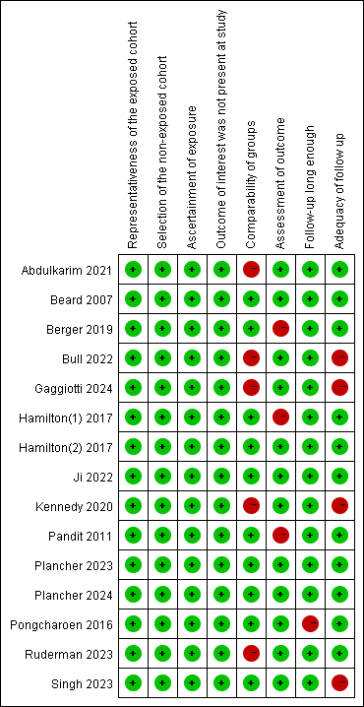
Fig. S4 Risk of bias summary in Meta analysis.
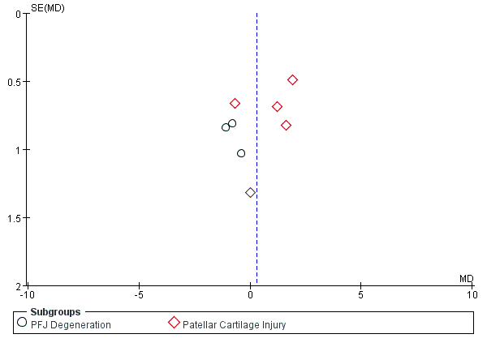
Fig. S5a Funnel plot of OKS, being stratified by PFJ disease types
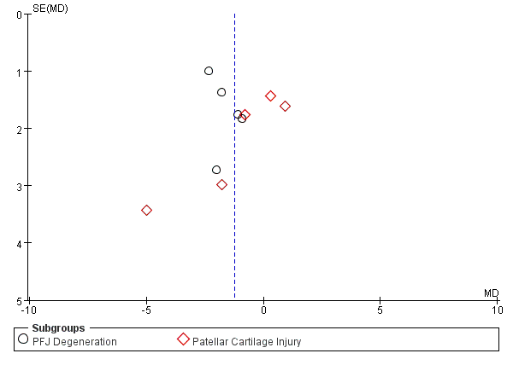
Fig. S5b Funnel plot of KSS, being stratified by PFJ disease types

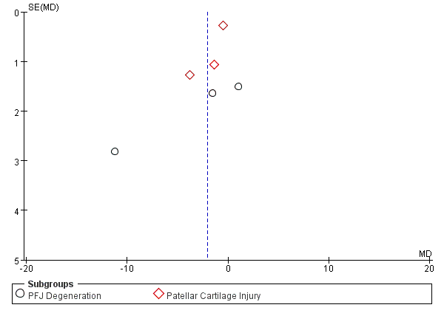
Fig. S5c Funnel plot of Flexion ROM, being stratified by PFJ disease types
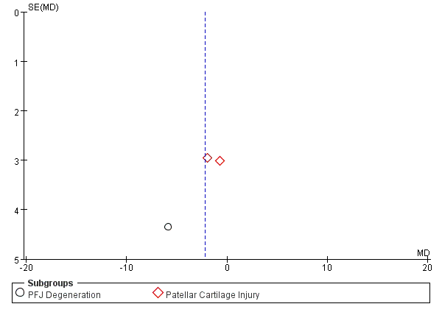
Fig. S5d Funnel plot of FJS, being stratified by PFJ disease types

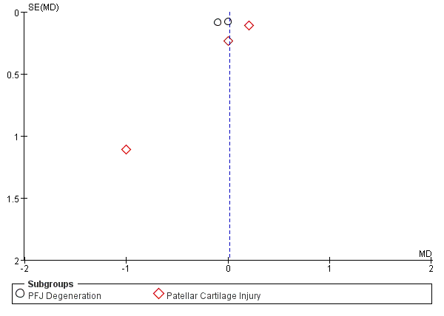
Fig. S5e Funnel plot of Tegner activity score, being stratified by PFJ disease types
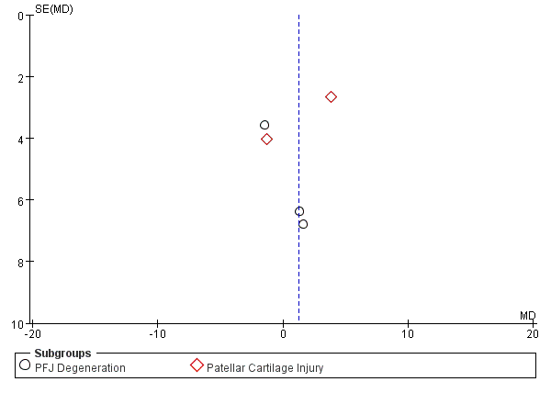
Fig. S5f Funnel plot of Prosthesis survival rate, being stratified by PFJ disease types

Table S1 Search strategy for PubMed
Keywords |  | Result
#35 | #7 AND #34 | 1, 633
#34 | #8 OR #9 OR # 10 OR #11 OR #12 OR #13 OR #14 OR #15 OR #16 OR #17 OR #18 OR #19 OR # 20 OR #21 OR #22 OR #23 OR #24 OR #25 OR #26 OR #27 OR #28 OR #29 OR # 30 OR #31 OR #32 OR #33 | 52107
#33 | Knee Replacement, Unicompartmental [All Fields]
#32 | Unicompartmental Knee Replacement [All Fields]
#31 | Knee Replacement, Partial [All Fields]
#30 | Partial Knee Replacement [All Fields]
#29 | Knee Replacement, Unicondylar [All Fields]
#28 | Unicondylar Knee Replacement [All Fields]
#27 | Knee Arthroplasty, Partial [All Fields]
#26 | Arthroplasty, Partial Knee [All Fields]
#25 | Partial Knee Arthroplasty [All Fields]
#24 | Knee Arthroplasty, Unicondylar [All Fields]
#23 | Arthroplasty, Unicondylar Knee [All Fields]
#22 | Unicondylar Knee Arthroplasty [All Fields]
#21 | Knee Arthroplasty, Unicompartmental [All Fields]
#20 | Arthroplasty, Unicompartmental Knee [All Fields]
#19 | Unicompartmental Knee Arthroplasty [All Fields]
#18 | Arthroplasty, Replacement, Partial Knee [All Fields]
#17 | Replacement Arthroplasty, Knee [All Fields]
#16 | Arthroplasties, Knee Replacement [All Fields]
#15 | Arthroplasty, Knee [All Fields]
#14 | Knee Arthroplasty [All Fields]
#13 | Replacement Arthroplasties, Knee [All Fields]
#12 | Knee Replacement Arthroplasty [All Fields]
#11 | Knee Replacement Arthroplasties [All Fields]
#10 | Arthroplasty, Knee Replacement [All Fields]
#9 | Arthroplasties, Replacement, Knee [All Fields]
#8 | Unicompartmental Knee Arthroplasty [All Fields]
#7 | #1 OR #2 OR #3 OR # 4 OR #5 OR #6 | 7616
#6 | Patellofemoral joint osteoarthritis [All Fields]
#5 | Patellofemoral joint [All Fields]
#4 | Patellofemoral degenerative Changes [All Fields]
#3 | Patellofemoral disease [All Fields]
#2 | Patellofemoral chondral lesion [All Fields]
#1 | Patellofemoral osteoarthritis [All Fields]

Table S2 Search strategy for Embase
Keywords |  | Result
#34 | #7 AND #33 | 486
#33 | #8 OR #9 OR # 10 OR #11 OR #12 OR #13 OR #14 OR #15 OR #16 OR #17 OR #18 OR #19 OR # 20 OR #21 OR #22 OR #23 OR #24 OR #25 OR #26 OR #27 OR #28 OR #29 OR # 30 OR #31 OR #32 | 39431
#32 | 'knee replacement, unicompartmental':ab,ti
#31 | 'unicompartmental knee replacement':ab,ti
#30 | 'knee replacement, partial':ab,ti
#29 | 'partial knee replacement':ab,ti
#28 | 'knee replacement, unicondylar':ab,ti
#27 | 'unicondylar knee replacement':ab,ti
#26 | 'knee arthroplasty, partial':ab,ti
#25 | 'arthroplasty, partial knee':ab,ti
#24 | 'partial knee arthroplasty':ab,ti
#23 | 'knee arthroplasty, unicondylar':ab,ti
#22 | 'arthroplasty, unicondylar knee':ab,ti
#21 | 'unicondylar knee arthroplasty':ab,ti
#20 | 'knee arthroplasty, unicompartmental':ab,ti
#19 | 'arthroplasty, unicompartmental knee':ab,ti
#18 | 'unicompartmental knee arthroplasty':ab,ti
#17 | 'arthroplasty, replacement, partial knee':ab,ti
#16 | 'replacement arthroplasty, knee':ab,ti
#15 | 'arthroplasties, knee replacement':ab,ti
#14 | 'arthroplasty, knee':ab,ti
#13 | 'knee arthroplasty':ab,ti
#12 | 'replacement arthroplasties, knee':ab,ti
#11 | 'knee replacement arthroplasty':ab,ti
#10 | 'knee replacement arthroplasties':ab,ti
#9 | 'arthroplasty, knee replacement':ab,ti
#8 | 'arthroplasties, replacement, knee':ab,ti
#7 | #1 OR #2 OR #3 OR #4 OR #5 OR #6 | 3265
#6 | 'patellofemoral joint osteoarthritis':ab,ti
#5 | 'patellofemoral joint':ab,ti
#4 | 'patellofemoral osteoarthritis':ab,ti
#3 | 'patellofemoral degenerative changes':ab,ti
#2 | 'patellofemoral disease':ab,ti
#1 | 'patellofemoral chondral lesion':ab,ti

Table S3 Search strategy for Web of Science
Keywords |  | Result
#3 | #1 AND #2 | 2099
#2 | TS=(Unicompartmental Knee Arthroplasty or Arthroplasties, Replacement, Knee or Arthroplasty, Knee Replacement or Knee Replacement Arthroplasties or Knee Replacement Arthroplasty or Replacement Arthroplasties, Knee or Knee Arthroplasty or Arthroplasty, Knee or Arthroplasties, Knee Replacement or Replacement Arthroplasty, Knee or Arthroplasty, Replacement, Partial Knee or Unicompartmental Knee Arthroplasty or Arthroplasty, Unicompartmental Knee or Knee Arthroplasty, Unicompartmental or Unicondylar Knee Arthroplasty or Arthroplasty, Unicondylar Knee or Knee Arthroplasty, Unicondylar or Partial Knee Arthroplasty or Arthroplasty, Partial Knee or Knee Arthroplasty, Partial or Unicondylar Knee Replacement or Knee Replacement, Unicondylar or Partial Knee Replacement or Knee Replacement, Partial or Unicompartmental Knee Replacement or Knee Replacement, Unicompartmental) | 74844
#1 | TS=(patellofemoral chondral lesion or Patellofemoral Disease or Patellofemoral Degenerative Changes or patellofemoral osteoarthritis or patellofemoral joint or Patellofemoral Joint Osteoarthritis) | 10971

Table S4 Quality assessment of included studies using the Methodological Index for Non-Randomized Studies (MINORS) criteria
Study | Study design | Journal | Level of  evidence | 1 | 2 | 3 | 4 | 5 | 6 | 7 | 8 | 9 | 10 | 11 | 12 | Total
Abdulkarim [38] | Cohort | J Knee Surg | III | 2 | 2 | 2 | 2 | 1 | 2 | 0 | 2 | 2 | 2 | 1 | 2 | 20
Adams [39] | Cohort | J Arthroplasty | III | 2 | 2 | 2 | 2 | 1 | 1 | 0 | 0 | 2 | 1 | 1 | 2 | 16
Beard [40] | Cohort | J Bone Joint Surg | IV | 2 | 1 | 2 | 2 | 1 | 1 | 1 | 2 | 1 | 1 | 1 | 2 | 17
Beard [41] | Cohort | J Bone Joint Surg | IV | 2 | 2 | 2 | 1 | 1 | 1 | 0 | 2 | 1 | 1 | 1 | 2 | 16
Berger [42] | Cohort | Clin Orthop Relat Res | III | 2 | 1 | 2 | 2 | 1 | 2 | 0 | 0 | 2 | 1 | 1 | 2 | 16
Carlo [43] | Cohort | Eur J Orthop Surg Traumatol | III | 2 | 0 | 2 | 2 | 1 | 2 | 0 | 0 | 1 | 1 | 1 | 2 | 14
Hamilton [44] | Cohort | J Arthroplasty | IV | 2 | 2 | 2 | 2 | 1 | 2 | 2 | 2 | 1 | 2 | 1 | 2 | 21
Hamilton [27] | Cohort | J Arthroplasty | II | 2 | 2 | 2 | 2 | 1 | 2 | 2 | 2 | 2 | 2 | 1 | 2 | 22
Konan [45] | Cohort | Bone Joint J | IV | 2 | 1 | 2 | 2 | 1 | 2 | 2 | 0 | 1 | 1 | 1 | 2 | 17
Lim [12] | Cohort | Knee Surg Sports Traumatol Arthrosc | III | 2 | 2 | 2 | 2 | 1 | 2 | 0 | 2 | 1 | 2 | 2 | 2 | 20
Munk [46] | Cohort | Acta Orthopaedica | III | 2 | 2 | 2 | 2 | 1 | 1 | 2 | 0 | 1 | 2 | 1 | 2 | 18
Pongcharoen [49] | Cohort | SpringerPlus | III | 2 | 2 | 2 | 2 | 1 | 1 | 2 | 2 | 2 | 2 | 1 | 2 | 21
Pandit [47] | Cohort | J Bone Joint Surg | IV | 2 | 2 | 2 | 2 | 1 | 2 | 2 | 0 | 2 | 2 | 1 | 2 | 20
Plancher [48] | Cohort | J Arthroplasty | IV | 2 | 1 | 2 | 2 | 1 | 2 | 2 | 0 | 2 | 2 | 1 | 2 | 19
Song [50] | Cohort | Knee Surg Sports Traumatol Arthrosc | III | 2 | 1 | 2 | 2 | 1 | 2 | 2 | 2 | 2 | 2 | 2 | 2 | 22
Wong [51] | Cohort | Biomed J | III | 2 | 1 | 2 | 2 | 1 | 2 | 2 | 2 | 1 | 1 | 1 | 2 | 19
Singh [52] | Cohort | Arch Orthop Trauma Surg | IV | 2 | 1 | 2 | 2 | 1 | 1 | 2 | 0 | 2 | 1 | 1 | 2 | 17
Liddle [53] | Cohort | Knee Surg Sports Traumatol Arthrosc | II | 2 | 2 | 2 | 2 | 1 | 1 | 0 | 0 | 1 | 1 | 2 | 2 | 16
Yue [54] | Cohort | J Knee Surg | IV | 2 | 1 | 2 | 2 | 1 | 1 | 2 | 2 | 1 | 1 | 1 | 2 | 18
Gerow [56] | Cohort | J Arthroplasty | IV | 2 | 2 | 2 | 2 | 1 | 0 | 0 | 2 | 2 | 2 | 1 | 2 | 18
Gaggiotti [55] | Cohort | J ISAKOS | IV | 2 | 1 | 2 | 2 | 1 | 2 | 0 | 0 | 2 | 2 | 0 | 2 | 16
Burger [58] | Case series | J Bone Joint Surg Am | III | 2 | 2 | 2 | 2 | 1 | 2 | 0 | 0 |  |  |  |  | 11
Burger [57] | Case series | Bone Joint J | III | 2 | 2 | 2 | 2 | 1 | 2 | 0 | 0 |  |  |  |  | 11
Deckard [59] | Case series | J Arthroplasty | IV | 2 | 1 | 2 | 2 | 1 | 1 | 2 | 2 |  |  |  |  | 13
Fujita [60] | Case series | J Knee Surg | IV | 2 | 1 | 2 | 2 | 1 | 1 | 0 | 0 |  |  |  |  | 9
Thein [61] | Case series | J Arthroplasty | III | 2 | 1 | 2 | 2 | 1 | 1 | 0 | 0 |  |  |  |  | 9
Kang [62] | Case series | J Bone Joint Surg | IV | 2 | 1 | 2 | 2 | 1 | 2 | 2 | 0 |  |  |  |  | 12
Wang [63] | Case series | Arthroplasty | IV | 2 | 2 | 2 | 2 | 1 | 2 | 2 | 0 |  |  |  |  | 13
Berend [64] | Case series | Orthopaedics | IV | 2 | 2 | 2 | 2 | 1 | 1 | 2 | 0 |  |  |  |  | 12
Berend [65] | Case series | Orthopaedics | IV | 2 | 2 | 2 | 2 | 1 | 1 | 2 | 0 |  |  |  |  | 12
Kuipers [66] | Case series | Knee | IV | 2 | 1 | 2 | 2 | 1 | 1 | 2 | 0 |  |  |  |  | 11
Ji [67] | Case series | Medicine (Baltimore) | IV | 2 | 1 | 2 | 2 | 1 | 1 | 2 | 0 |  |  |  |  | 11
Mofidi [68] | Case series | Eur J Orthop Surg Traumatol | III | 2 | 1 | 2 | 2 | 1 | 1 | 2 | 0 |  |  |  |  | 11
Seyler [69] | Case series | J Orthop Surg Res | IV | 2 | 1 | 2 | 2 | 1 | 2 | 2 | 0 |  |  |  |  | 12
Hutt [70] | Case series | BMC Musculoskelet Disord | III | 2 | 2 | 2 | 2 | 1 | 2 | 0 | 0 |  |  |  |  | 11
Andronic [71] | Case series | Int Orthop | IV | 2 | 1 | 2 | 2 | 1 | 2 | 0 | 2 |  |  |  |  | 12
Bull [72] | Case series | Knee | IV | 2 | 1 | 2 | 2 | 1 | 2 | 2 | 2 |  |  |  |  | 14
Sébilo [73] | Case series | Orthop Traumatol Surg Res | IV | 2 | 1 | 2 | 2 | 1 | 2 | 0 | 0 |  |  |  |  | 10
Song [74] | Case series | The Knee | III | 2 | 1 | 2 | 2 | 1 | 1 | 2 | 0 |  |  |  |  | 11
Kennedy [75] | Case series | Bone Joint J | IV | 2 | 2 | 2 | 2 | 1 | 2 | 0 | 0 |  |  |  |  | 11
Neogi [76] | Case series | J Orthopaed Traumatol | IV | 2 | 1 | 2 | 2 | 1 | 2 | 0 | 0 |  |  |  |  | 10
Naal [77] | Case series | Arch Orthop Trauma Surg | III | 2 | 1 | 2 | 2 | 1 | 1 | 0 | 0 |  |  |  |  | 9
Xing [78] | Case series | J Knee Surg | IV | 2 | 1 | 2 | 2 | 2 | 1 | 0 | 0 |  |  |  |  | 10
Hurst [79] | Case series | J Arthroplasty | IV | 2 | 1 | 2 | 2 | 1 | 2 | 2 | 0 |  |  |  |  | 12
Carender [80] | Case series | Arthroplast Today | IV | 2 | 1 | 2 | 2 | 1 | 2 | 0 | 0 |  |  |  |  | 10
Ruderman [83] | Case series | Knee Surg Sports Traumatol Arthrosc | IV | 2 | 0 | 2 | 2 | 1 | 1 | 0 | 0 |  |  |  |  | 8
Myatt [81] | Case series | J Orthop | IV | 2 | 0 | 2 | 2 | 1 | 2 | 0 | 0 |  |  |  |  | 9
Plancher [82] | Case series | J Arthroplasty | IV | 2 | 1 | 2 | 2 | 1 | 2 | 2 | 2 |  |  |  |  | 14

Table S5 Newcastle-Ottawa quality assessment of the included studies
Study | Selection | Comparability | Exposure | Total | Quality rating
Abdulkarim [38] | 3 | 1 | 3 | 7 | High quality
Beard [40] | 3 | 2 | 3 | 8 | High quality
Berger [42] | 3 | 2 | 2 | 8 | High quality
Gaggiotti [55] | 3 | 1 | 2 | 6 | High quality
Hamilton [27] | 3 | 2 | 2 | 7 | High quality
Hamilton [44] | 3 | 2 | 3 | 8 | High quality
Pongcharoen [49] | 3 | 2 | 2 | 7 | High quality
Pandit [47] | 3 | 2 | 2 | 7 | High quality
Plancher [48] | 3 | 2 | 3 | 8 | High quality
Plancher [82] | 3 | 2 | 3 | 8 | High quality
Ruderman [83] | 3 | 1 | 3 | 7 | High quality
Singh [52] | 3 | 2 | 2 | 7 | High quality
Ji [67] | 3 | 2 | 3 | 8 | High quality
Bull [72] | 3 | 1 | 2 | 6 | High quality
Kennedy [75] | 3 | 1 | 2 | 6 | High quality

Table S6 Overview of clinical and functional outcomes (scores) at last follow-up following UKAª
Authors | Group | OKS^{b} | KSS^{b} | Flexion range of motion°^{b} | Extension range of motion°^{b} | KOOS^{b} | FJS^{b} | Tegner activity  score^{b} | VAS^{b} | Prosthesis  survival rate  (%)^{b}
Beard [40] | Patellar Cartilage Injury | 40.9  (8.5)  P=0.04  n=128 | 85.8 (18.2)  P=0.67 | NR | NR | NR | NR | NR | NR | NR
Beard [40] | N- Patellar Cartilage Injury | 39.3  (8.7)  n=696 | 86.6 (18.5)
Beard [41] | Patellar Cartilage Injury | 40.9  (6.6)  P=0.49  n=54 | 90.7 (13.1)  P=0.28 | NR | NR | NR | NR | NR | NR | NR
Beard [41] | N- Patellar Cartilage Injury | 39.8  (7.7)  n=46 | 91.0 (9.6)
Berend [64] | PFJ Degeneration | NR | 91  P=0.04 | NR | NR | NR | NR | NR | NR | NR
Berend [64] | N- PFJ Degeneration | NR | 89
Naal [77] | Patella Baja | NR | 185.0 (23.8)  P= 0.788 | 127.5  (6.5)  P= 0.893 | NR | NR | NR | NR | 3.0  (4.2)  P= 0.686 | NR
Naal [77] | N- Patella Baja | NR | 187.6 (18.0) | 128.4  (7.1) |  |  |  |  | 2.0  (2.5) | NR
Berend[65] | PFJ Degeneration | NR | NR | NR | NR | NR | NR | NR | NR | 97.9  P=0.1
Berend[65] | N- PFJ Degeneration |  |  |  |  |  |  |  |  | 93.8
Kuipers[66] | PFJ Degeneration | NR | NR | NR | NR | NR | NR | NR | NR | NR
Kuipers[66] | N- PFJ Degeneration
Seyler [69] | PFJ Degeneration | NR | NR | NR | NR | NR | NR | NR | NR | NR
Seyler [69] | N- PFJ Degeneration
Pandit [47] | Patellar Cartilage Injury | 42.2 (7.9)  P=0.61  n=158 | 84.1 (18.1)  P=0.59 | NR | NR | NR | NR | 3.0  (1.3)  P= 0.26 | NR | 98.8  (93.2 - 100.0)  P=0.071
Pandit [47] | N- Patellar Cartilage Injury | 41.0 (7.9)  n=842 | 83.2 (20.6) |  |  |  |  | 2.8  (1.2) | NR | 95.0  (91.1 - 99.0)
Munk [46] | Lateral Patellar Subluxation | NR | NR | NR | NR | NR | NR | NR | NR | NR
Munk [46] | N- Lateral Patellar Subluxation
Xing [78] | PFJ Degeneration | NR | NR | NR | NR | NR | NR | NR | NR | NR
Xing [78] | N- PFJ Degeneration
Kang [62] | PFJ Degeneration | 25.5  P=0.22 | NR | NR | NR | NR | NR | NR | NR | NR
Kang [62] | N- PFJ Degeneration | 28
Song [74] | PFCM | NR | NR | NR | NR | NR | NR | NR | NR | NR
Song [74] | N- PFCM
Mofidi [68] | PFJ Degeneration | 36  (8)  P = 0.87 | 90  （10）  P=0.81 | NR | NR | NR | NR | NR | NR | NR
Mofidi [68] | N- PFJ Degeneration | 37  (7) | 81  (17)
Hurst [79] | PFJ Degeneration | NR | 78.5  n.s. | NR | NR | NR | NR | NR | NR | NR
Hurst [79] | N- PFJ Degeneration | NR | 80.0
Liddle [53] | Anterior Knee Pain | NR | NR | NR | NR | NR | NR | NR | NR | NR
Liddle [53] | N- Anterior Knee Pain
Sébilo [73] | Anterior Knee Pain | NR | NR | NR | NR | NR | NR | NR | NR | NR
Sébilo [73] | N- Anterior Knee Pain
Neogi [76] | Patella Baja | NR | NR | NR | NR | NR | NR | NR | NR | NR
Neogi [76] | N- Patella Baja
Song [50] | Anterior Knee Pain | NR | NR | 140  (100-140)  n.s | NR | NR | NR | NR | 1.9  (0-4)  n.s. | NR
Song [50] | N- Anterior Knee Pain | NR | NR | 140  (110-140) |  |  |  |  | 1.9  (0-4) | NR
Thein [61] | PFJ Degeneration | NR | NR | NR | NR | NR | NR | NR | NR | NR
Thein [61] | N- PFJ Degeneration
Wong [51] | PFJ Degeneration | NR | 92.6  (10.37)  P=0.225 | NR | NR | NR | NR | NR | NR | NR
Wong [51] | N- PFJ Degeneration | NR | 87.0  (12.2)
Konan [45] | Anterior Knee Pain | 39.6 (7.5)  P=0.21 | NR | NR | NR | NR | NR | NR | 3.2  (1.1)  P=0.42 | NR
Konan [45] | N- Anterior Knee Pain | 40.0 (7.1) |  |  |  |  |  |  | 1.1  (1.5) | NR
Pongcharoen [49] | PFJ Degeneration | NR | 94.43 (4.50)  P=0.02  n=26 | 117.69 (14.02)  P＜0.001 | NR | NR | NR | NR | 0.12  (0.59)  P=0.98 | NR
Pongcharoen [49] | N- PFJ Degeneration | NR | 96.78 (4.56)  n=88 | 128.92 (5.79) |  |  |  |  | 0.11  (0.56) | NR
Adams [39] | PFCM | NR | NR | NR | NR | NR | 67.6  P=0.471  n=31 | NR | NR | NR
Adams [39] | N- PFCM |  |  |  |  |  | 70.5  n=52 | NR | NR | NR
Hamilton [27] | PFJ Degeneration | 38.8 (10)  P=0.91  n=158 | 75.2 (21)  P=0.69 | NR | NR | NR | NR | 2.4 (1)  P=0.52 | NR | 93.4  (78.8 – 100)  P=0.61
Hamilton [27] | N- PFJ Degeneration | 39.9  (8)  n=842 | 76.1 (22) |  |  |  |  | 2.5 (1) | NR | 92.1  (86.0 – 98.1)
Yue [54] | BME in the patella | NR | NR | 130.3  (9.15)  n.s. | NR | NR | NR | NR | 2.5  (0.73)  P< 0.05 | NR
Yue [54] | N- BME in the patella | NR | NR | 134.0  (10.55) |  |  |  |  | 1.8  (0.81) | NR
Hamilton [44] | PFJ Degeneration | 38.9  (10) P=0.86  n=190 | 75.0 (21)  P=0.58 | NR | NR | NR | NR | 2.5 (1)  P=0.94 | NR | 94.2  (78 to 100)  P=0.68
Hamilton [44] | N- PFJ Degeneration | 39.7  (9)  n=615 | 76.1 (22) |  |  |  |  | 2.5 (1) | NR | 92.  (85 to 100)
Lim [12] | PFJ Degeneration | 20.0  (7.9)  n.s. | 80.0  (21.0)  n.s. | 127.3  (11.9)  n.s. | 3.4  (5.1)  n.s. | NR | NR | NR | NR | 97.6  n.s.
Lim [12] | N- PFJ Degeneration | 20.0  (7.0) | 70.6  (21.1) | 129.6  (10.5) | 2.6  (4.4) |  |  |  |  | 94.6
Hutt [70] | PFJ Degeneration | 40.2  P=0.01 | NR | NR | NR | NR | NR | NR | NR | NR
Hutt [70] | N- PFJ Degeneration | 37.6
Berger [42] | PFJ Degeneration | 42.1  (6.8)  P=0.77  n=57 | NR | NR | NR | NR | 70.9  (29.3)  P=0.27 | NR | NR | 98  (85.8–99.7)  P = 0.352
Berger [42] | PFJ Degeneration | 42.5  (6.7)  n=183 |  |  |  |  | 76.8  (26.1) | NR | NR | 99.5  (96.0–99.2)
Burger [58] | PFJ Degeneration | NR | NR | NR | NR | 85.3 (16.2)  P=0.40 | NR | NR | NR | NR
Burger [58] | N- PFJ Degeneration |  |  |  |  | 84.1 (15.6) |  |  | NR
Abdulkarim [38] | PFJ Degeneration | NR | 85.49 (8.61)  P=0.40  n=69 | 132.54 (10.20)  P=0.0738 | -2.61 (3.28)  P=0.0004 | NR | NR | NR | NR | NR
Abdulkarim [38] | N- PFJ Degeneration | NR | 87.27 (7.95)  n=78 | 134.10 (9.69) | -0.96 (2.56)
Burger [57] | PFJ Degeneration | NR | NR | NR | NR | 86.3 (13.5)  P=0.378 | NR | NR | NR | NR
Burger [57] | N- PFJ Degeneration |  |  |  |  | 83.2 (16.1)
Deckard [59] | PFJ Degeneration | NR | NR | NR | NR | NR | NR | NR | NR | NR
Deckard [59] | N- PFJ Degeneration
Fujita [60] | PFJ Degeneration | NR | NR | NR | NR | NR | NR | NR | NR | NR
Fujita [60] | N- PFJ Degeneration
Kennedy [75] | Patellar Cartilage Injury | 43  (36-47)  P=0.852  n=46 | 75  (65-90)  P=0.61 | NR | NR | NR | NR | 3  (2 - 4)  P=0.281 | NR | 92.7  (85 - 100)  P=0.670
Kennedy [75] | N- Patellar Cartilage Injury | 43  (37-46)  n=239 | 80  (60-100) |  |  |  |  | 3  (2 - 3) | NR | 94.0  (91 - 97)
Wang [63] | PFJ Degeneration | NR | NR | NR | NR | NR | NR | NR | NR | 96.0  P=0.244
Wang [63] | N- PFJ Degeneration |  |  |  |  |  |  |  |  | 98.9
Carlo [43] | PFJ Degeneration | NR | 83  (10.5)  P=0.197 | NR | NR | NR | NR | NR | 2.0  （1.5）  P=0.313 | NR
Carlo [43] | N- PFJ Degeneration | NR | 85  (7.5) |  |  |  |  |  | 1.7  （1.9） | NR
Ji [67] | Patellar Cartilage Injury | 21.5  (4.2)  n.s.  n=105 | NR | 137.0  (0.37)  n.s. | NR | NR | 75.0 (25.8)  n.s. | NR | 1.8  (0.39)  P＜0.05 | NR
Ji [67] | N- Patellar Cartilage Injury | 19.6  (4.0)  n=232 | NR | 137.5  (4.1) | NR | NR | 75.7  (24.9) | NR | 1.6  (0.43) | NR
Bull [72] | Patellar Cartilage Injury | 44.5 (5.8)  n.s.  n=125 | NR | NR | NR | 84.3  (16.7)  n.s. | 81.5  (23.4)  n.s. | NR | NR | NR
Bull [72] | N- Patellar Cartilage Injury | 45.2  (4.2)  n=106 | NR | NR | NR | 84.5  (14.4) | 83.5  (21.4) | NR | NR | NR
Plancher [48] | PFJ Degeneration | NR | 84.6  (15)  P= 0.52  n=44 | 130  (118 to 150)  P=0.74 | 0  (-1 to 3)  P=0.38 | 90  (14)  P=0.81 | NR | NR | NR | NR
Plancher [48] | N- PFJ Degeneration | NR | 86.6  (16)  n=112 | 129  (90 to 145) | 1  (-1 to 15) | 90  (14)
Andronic [71] | PFJ Degeneration | NR | NR | NR | NR | NR | NR | NR | NR | NR
Andronic [71] | N- PFJ Degeneration
Carender [80] | PFJ Degeneration | NR | NR | NR | NR | NR | NR | NR | NR | NR
Carender [80] | N- PFJ Degeneration
Singh [52] | Patellar Cartilage Injury | NR | 78  (19.6)  P=0.223  n=51 | 119.1  (8.4)  P=0.003 | NR | NR | NR | NR | NR | NR
Singh [52] | N- Patellar Cartilage Injury | NR | 79.8  (18.5)  n=266 | 122.9  (7.9)
Ruderman [83] | Patellar incongruence  N-Patellar incongruence | NR | NR | NR | NR | 82.5  (16.1)  n.s.  n=125  85.3  (16.0)  n=390 | NR | NR | NR | NR
Gerow [56] | Patellar Cartilage Injury | NR | NR | NR | NR | NR | NR | NR | NR | NR
 | N- Patellar Cartilage Injury
Myatt  [81] | Patellar Cartilage Injury | 38.33  (19.36 to 57.31)  n.s. | NR | NR | NR | NR | NR | NR | NR | NR
 | N- Patellar Cartilage Injury | 38.64 (33.16 to 44.11)
Plancher  [82] | Patellar Cartilage Injury | NR | NR | NR | NR | 97.1 (84.5 to 100)  P=0.24 | NR | 3  (2 to 6)  P=0.30 | NR | NR
 | N- Patellar Cartilage Injury |  |  |  |  | n=27  98.5 (91.9 to 100)  n=31 |  | 4  (3 to 7)
Gaggiotti  [55] | Patellar Cartilage Injury | NR | 86.7  (5.2)  P=0.277  n=29 | 124.8  (3.7)  P=0.212 | NR | NR | NR | NR | NR | NR
 | N- Patellar Cartilage Injury |  | 86.4  (5.0)  n=22 | 126.2  (3.8)
ªOKS, Oxford Knee Score; SD, standard deviation; CI, confidence interval; KSS, Knee Society Score; KOOS, Knee Injury and Osteoarthritis Outcome Score; FJS, Forgotten Joint Score; VAS, Visual Anglog Score; N- PFJ, no patellofemoral joint; NR, not reported; PFJ, Patellofemoral joint; n.s., not significant; PFCM, Patellofemoral chondromalacia; BME, Bone marrow edema
^{b}Data are expressed as mean or mean ± SD, or mean (range) unless otherwise indicated. P values for differences at each annual follow-up when compared with preoperative values for patient-reported outcome measures. Bold denotes statistically significant difference (P< 0.05)

Table S7. Egger's test for the risk of biasª
Stratified analysis factors | No. of Studies | Egger's test (P value)
OKS | 8 | 0.948
KSS | 10 | 0.227
Flexion ROM | 6 | 0.583
FJS | 3 | 0.090
Tegner activity score | 5 | 0.556
Prosthesis survival rate | 5 | 0.072
ªOKS, Oxford Knee Score; KSS, Knee Society Score; ROM, Range of motion; FJS, Forgotten Joint Score

