Efficacy and safety of three-dimensional printing technology assisted open reduction and internal fixation versus conventional surgery in the treatment of acetabular fractures: a meta-analysis of randomized controlled trials
Wenzheng Liu ^{1, 2, 3†}, Chaoyi Zhang ^{1, 2, 3 †}, Jixi Liu ^{1, 2†}, Pengrui Feng ^{1, 2, 3}, Ping Yi ⁴*, Zhencheng Xiong ⁵*, Guanglin Wang ^{1, 2, 3}*
¹ Department of Orthopedic Surgery, Orthopedic Research Institute, West China Hospital, Sichuan University, Chengdu 610041, China
² Trauma Medical Center, West China Hospital, Sichuan University, Chengdu 610041, China
³ Med-X Center for Manufacturing Sichuan University, Chengdu 610041, China
⁴Department of Orthopaedic Surgery, China-Japan Friendship Hospital, Beijing 100029, China
⁵Department of Thoracic Surgery, Peking University Third Hospital, Beijing 100191, China
†Wenzheng Liu, Chaoyi Zhang and Jixi Liu contributed equally to this work.
*Correspondence: 13811758985@139.com; xiongzc0527@163.com; wgllfrank@163.com

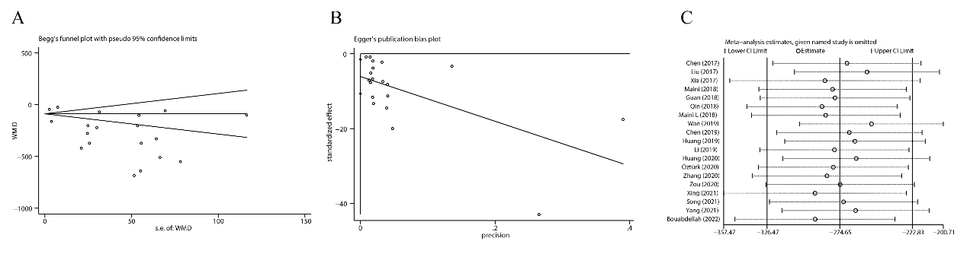
Fig. S1: Publication bias and sensitivity analysis of intraoperative blood loss. A: Begg’s test, B: Egger's test, and C: sensitivity analysis.
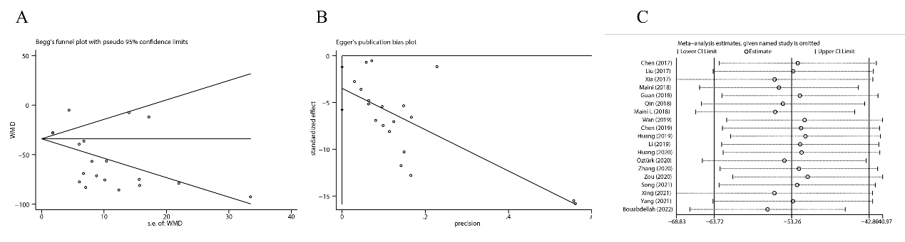
Fig. S2: Publication bias and sensitivity analysis of operation time. A: Begg’s test, B: Egger's test, and C: sensitivity analysis.

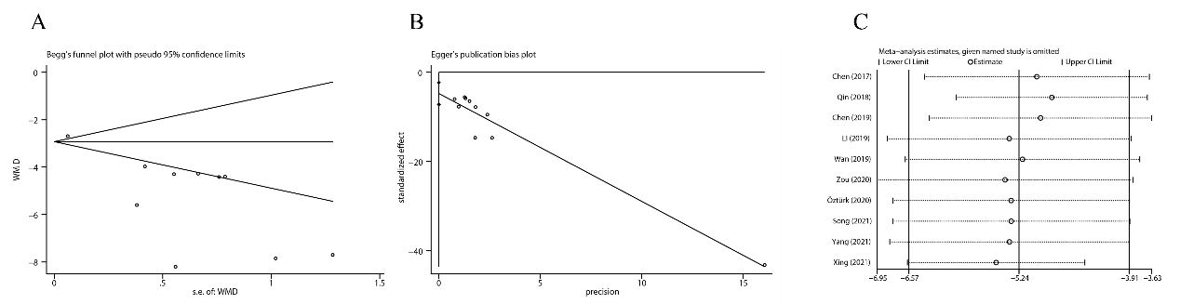
Fig. S3: Publication bias and sensitivity analysis of times of intraoperative fluoroscopy. A: Begg’s test, B: Egger's test, and C: sensitivity analysis.

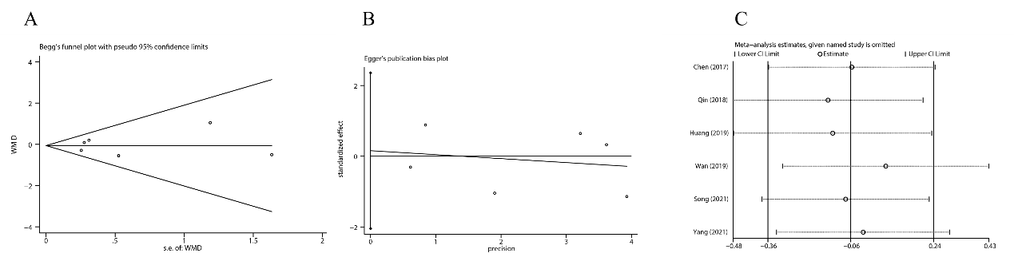
Fig. S4: Publication bias and sensitivity analysis of time from injury to operation. A: Begg’s test, B: Egger's test, and C: sensitivity analysis.

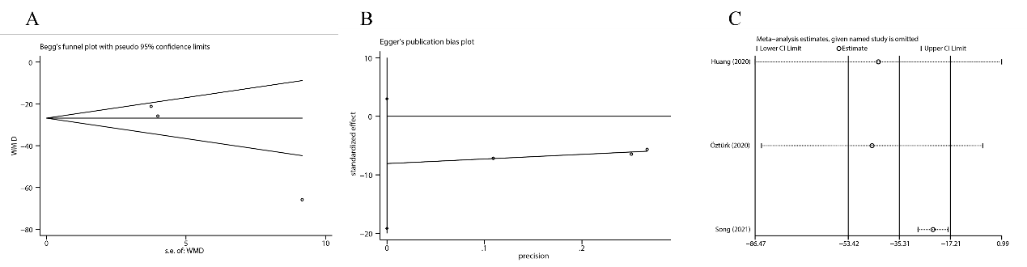
Fig. S5: Publication bias and sensitivity analysis of instrumentation time. A: Begg’s test, B: Egger's test, and C: sensitivity analysis.

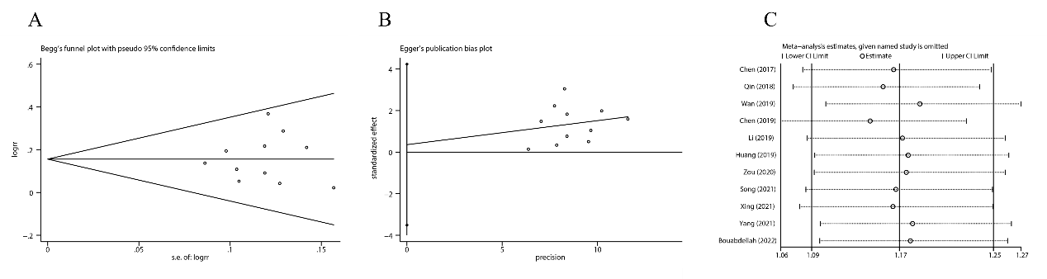
Fig. S6: Publication bias and sensitivity analysis of post-surgery Matta score. A: Begg’s test, B: Egger's test, and C: sensitivity analysis.

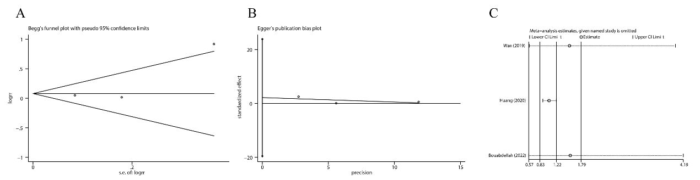
Fig. S7: Publication bias and sensitivity analysis of Harris score. A: Begg’s test, B: Egger's test, and C: sensitivity analysis.

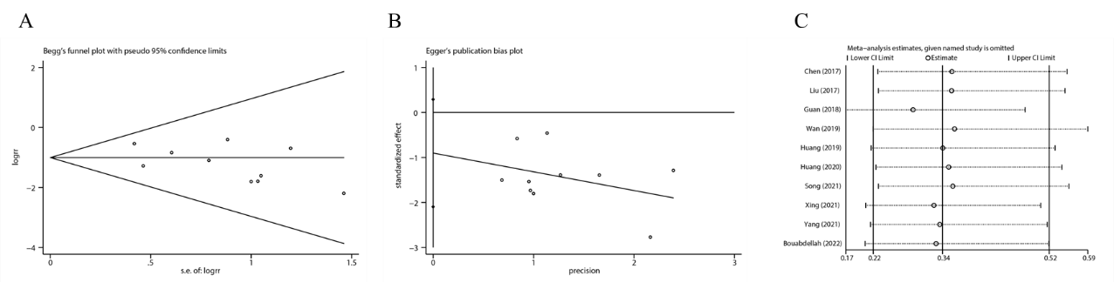
Fig. S8: Publication bias and sensitivity analysis of complications. A: Begg’s test, B: Egger's test, and C: sensitivity analysis.

