Supplementary Figure 1. The model’s performance against the prevalence of revision surgery and mortality rates post-total knee arthroplasty (TKA)

Supplementary Figure 2. The model’s performance against the prevalence of revision surgery and mortality rates post-unilateral knee arthroplasty (UKA)

Supplementary Figure 3. The model’s performance against the prevalence of revision surgery and mortality rates post-high tibial osteotomy (HTO)

Supplementary Figure 1. The model’s performance against the prevalence of revision surgery and mortality rates post-total knee arthroplasty (TKA)

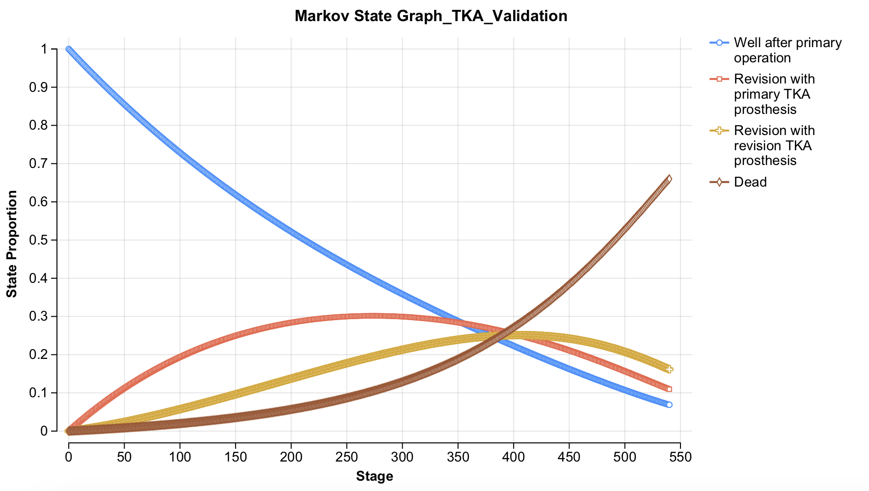
Supplementary Figure 2. The model’s performance against the prevalence of revision surgery and mortality rates post-unilateral knee arthroplasty (UKA)
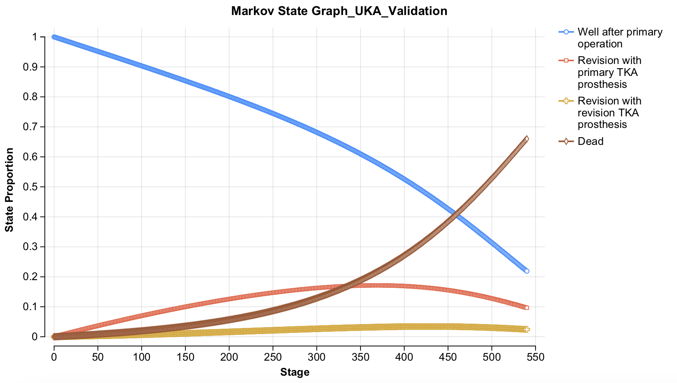
Supplementary Figure 3. The model’s performance against the prevalence of revision surgery and mortality rates post-high tibial osteotomy (HTO)
