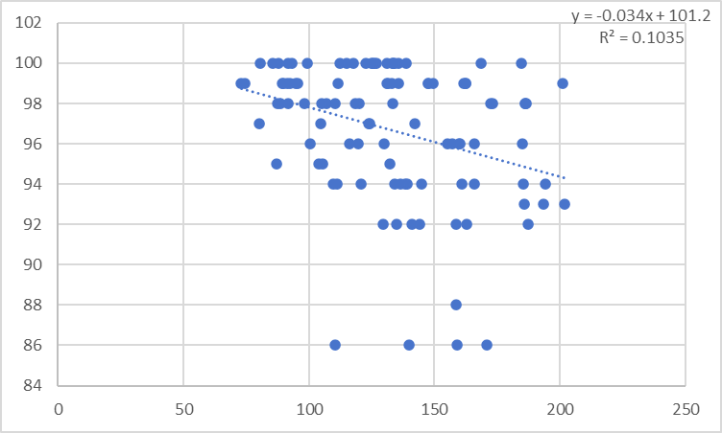
HSS Score
Tibia Medial HUs

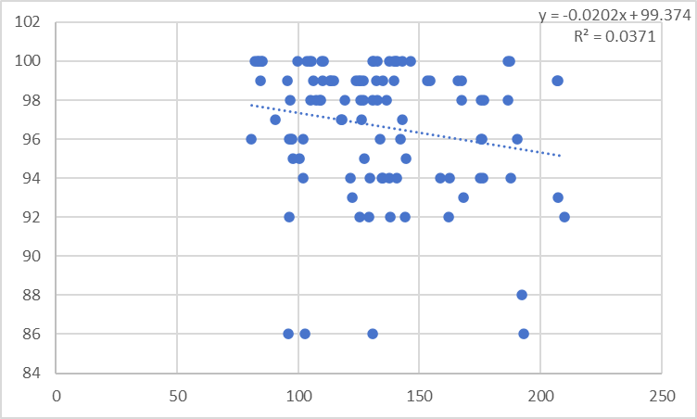
HSS Score
Tibia Lateral HUs

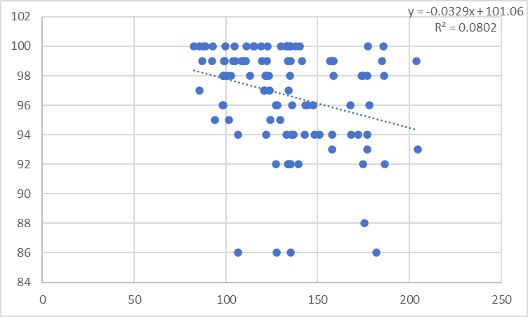
HSS Score
Mean Tibia HUs

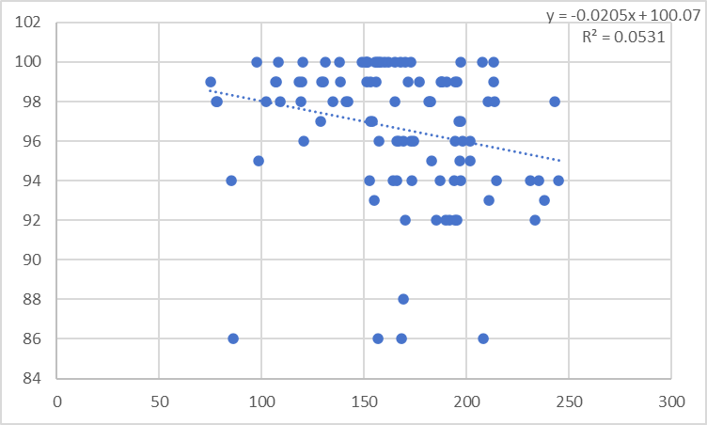
HSS Score
Femur Medial HUs

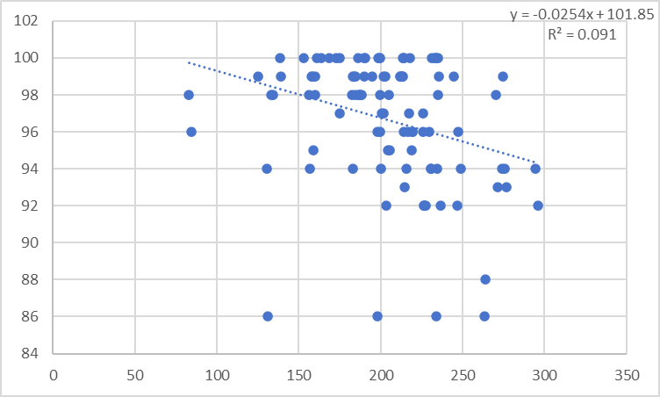
Femur Lateral HUs
HSS Score

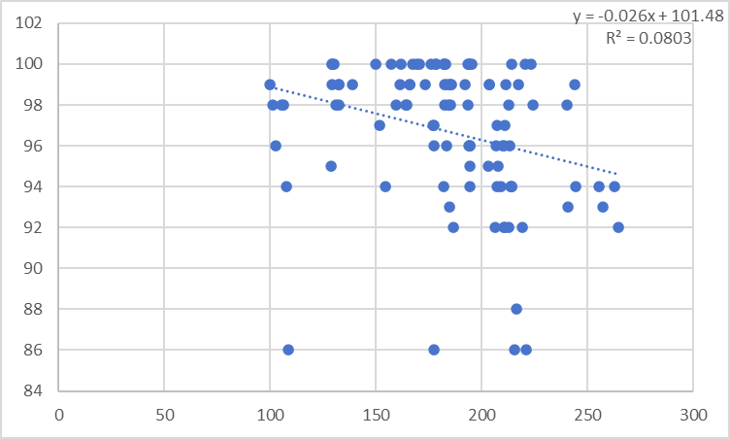
HSS Score
Mean Femur HUs
胫骨内侧HUs-SF-36
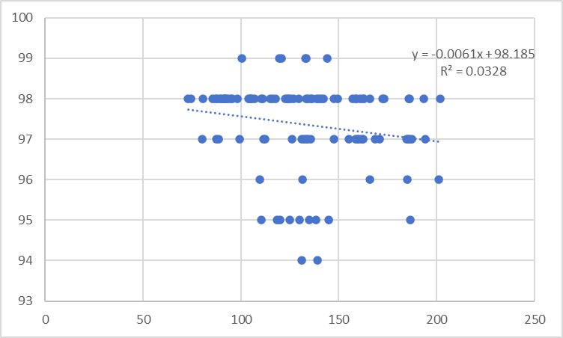
Tibia Medial HUs
SF-36 Score

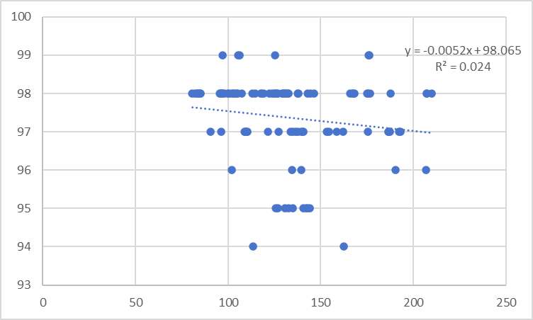
Tibia Lateral HUs
SF-36 Score

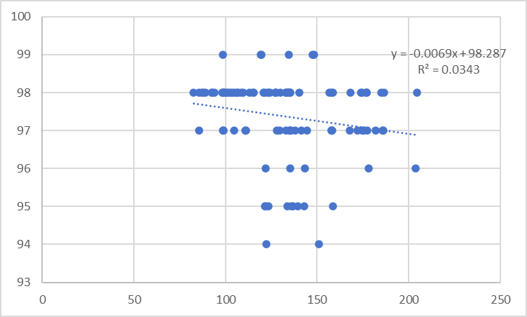
Mean Tibia HUs
SF-36 Score

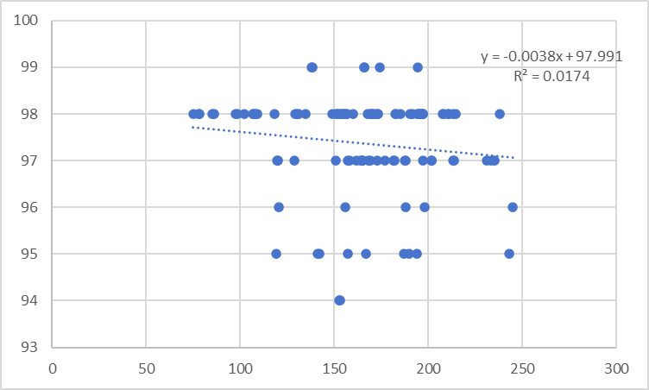
SF-36 Score
Femur Medial HUs
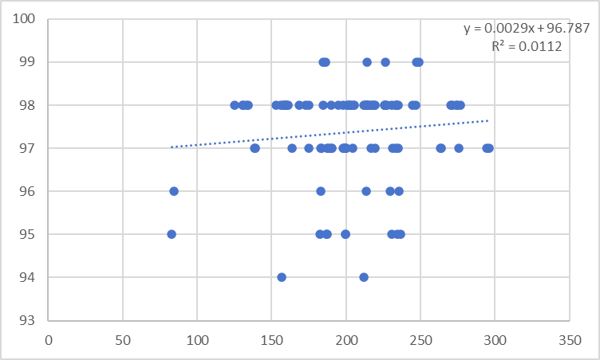
SF-36 Score
Femur Lateral HUs

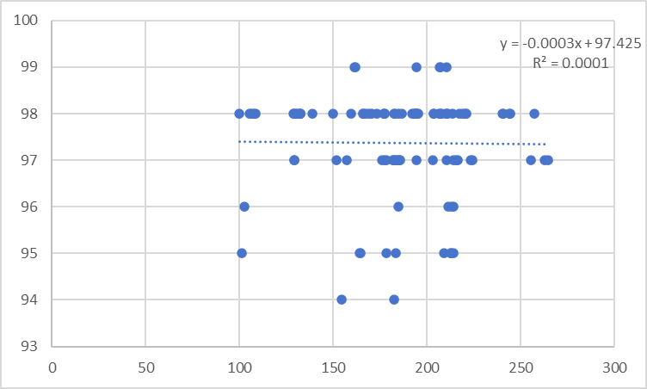
Mean Femur HUs
SF-36 Score

