The cds sequences of the genes LOC100354980 and LOC100339314

>ENSOCUT00000028925.2 cds chromosome:OryCun2.0:19:53155605:53155991:1 gene:ENSOCUG00000021439.2 gene_biotype:protein_coding transcript_biotype:protein_coding
ATGGCGCCCGTGAAAAAGCTTGTGGCGAAGGGGGGCAAAAAAAAGAAGCAGGTCCTGAAG
TTCACCCTGGACTGCACCCACCCTGTGGAAGACAGGATCATGGACGAGGCCAACTCCGAG
CAGTTTCTCCAGGAGAGAATCAAAGTGAACGGAAAAGCCAGGAACCTCGGGGGCGGGGCC
GTGACCATCGAGAGGAGCAAGAGCAAGATCACAGTGACTTCTGAGGTGCCTTTTTCCAAA
AGGTATTTGAAATATCTCACCAAAAAGTATTTGAAGAAGAATAATCTACATGATTGGTTG
CGTGTAGTTGCTAACAGCAAAGAGAGTTATGAATTACGATACTTCCAGATTAACCAGGAC
GAAGAAGAGGAGGAAGATGAGGATTAA

>ENSOCUT00000000081.3 cds chromosome:OryCun2.0:2:27709552:27710115:-1 gene:ENSOCUG00000022888.2 gene_biotype:protein_coding transcript_biotype:protein_coding
CCTGCGAAAATGGTTCGCTACTCACTGGACCCAGAAAACCCCACAAAATCATGCAAATCA
AGAGGCTCGAATCTTCGCGTTCACTTTAAGAACACTCGAGAAACTGCCCAGGCCATCAAG
GGTATGCATATCCGAAAAGCCACCAAATACCTGAAAGACGTCACGTTAAAGAAGCAGTGT
GTGCCATTCCGTCGGTACAATGGCGGAGTTGGTAGATGTGCCCAGGCCAAGCAGTGGGGT
TGGACCCAGGGTCGTTGGCCCAAAAAAAGTGCCGAGTTTCTGCTGCACATGCTTAAAAAT
GCAGAGAGTAATGCTGAGCTGAAGGGTTTGGATGTAGATTCTCTGGTCATTGAGCACATC
CAGGTGAACAAGGCCCCCAAGATGCGCCGCCGGACCTACAGAGCCCACGGCCGGATCAAC
CCGTACATGAGCTCCCCGTGCCACATCGAGATGATCCTCACTGAGAAGGAACAGATAGTT
CCTAAGCCAGAAGAGGAGGTGGCACAAAAGAAAAAGATATCCCAGAAGAAACTAAAGAAG
CAAAAACTTATGGCTCGGGAATAA

The latest annotations for the genes LOC100354980 and LOC100339314 in the Ensembl database

gene: ENSOCUG00000021439
https://asia.ensembl.org/Oryctolagus_cuniculus/Gene/Summary?db=core;g=ENSOCUG00000021439;r=19:53155605-53155991;t=ENSOCUT00000028925
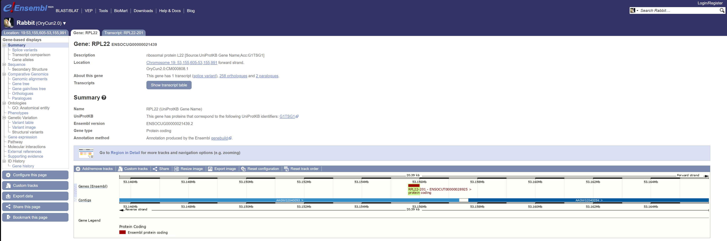

gene: ENSOCUG00000022888
https://asia.ensembl.org/Oryctolagus_cuniculus/Gene/Summary?db=core;g=ENSOCUG00000022888;r=2:27709552-27710115;t=ENSOCUT00000000081
