Supplementary
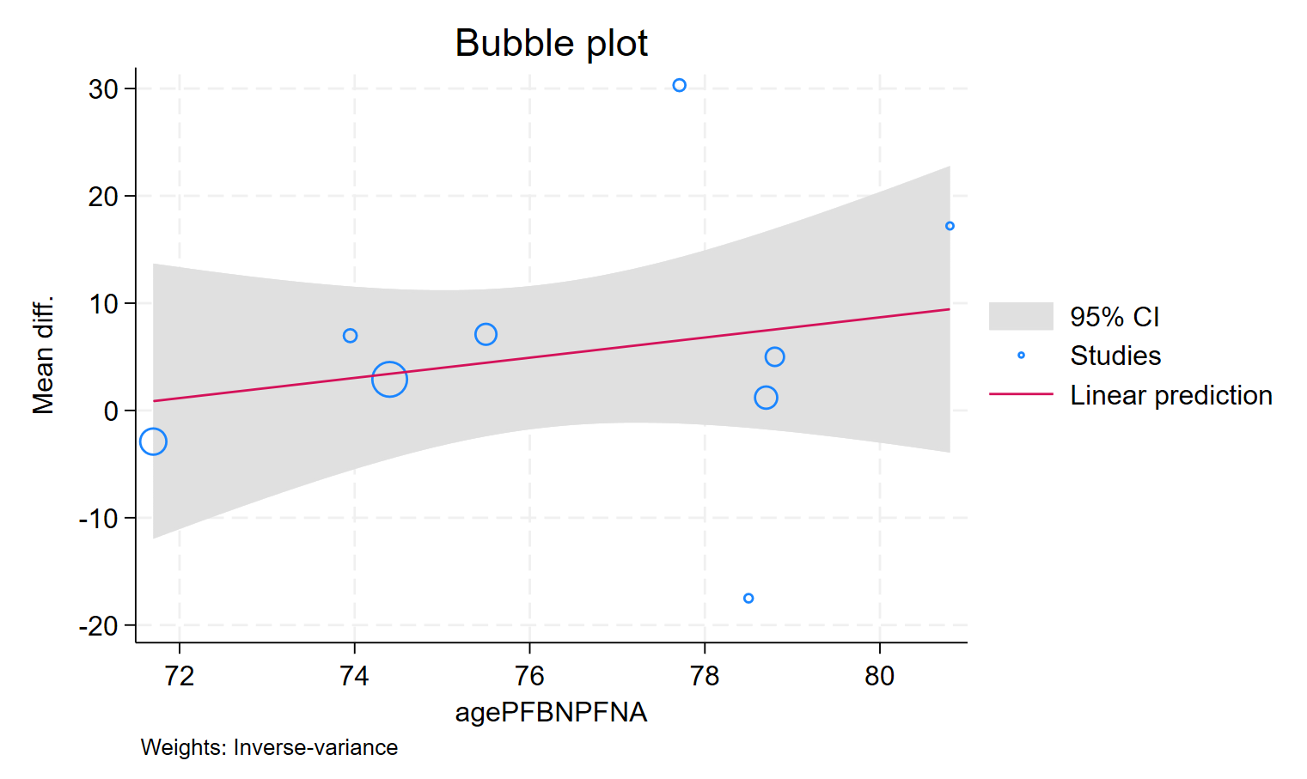
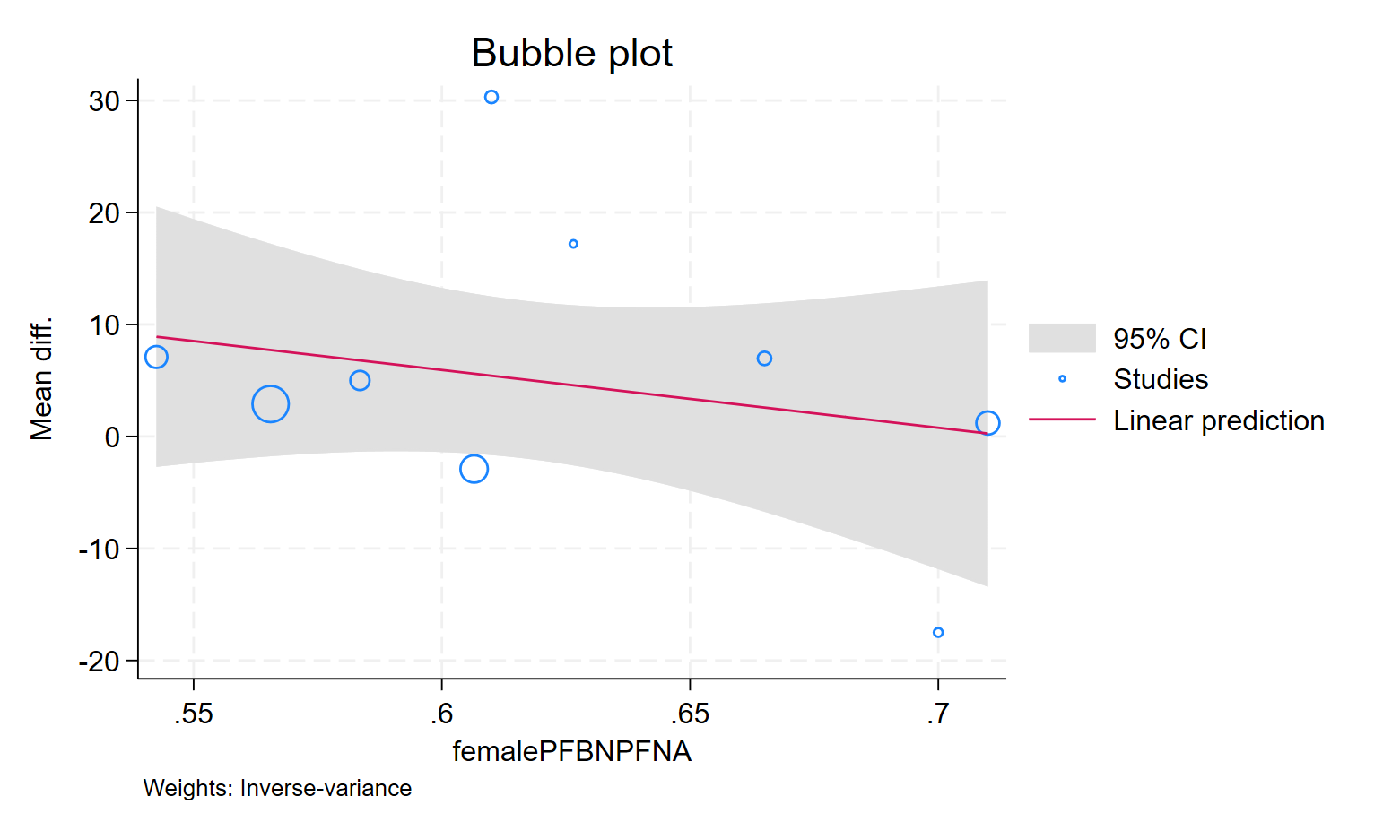
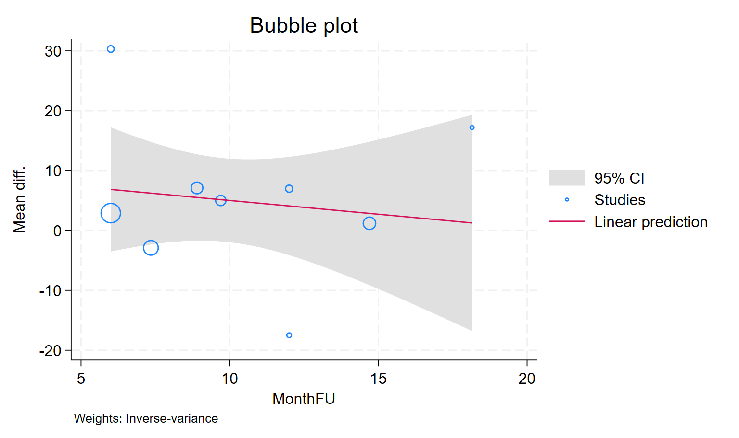
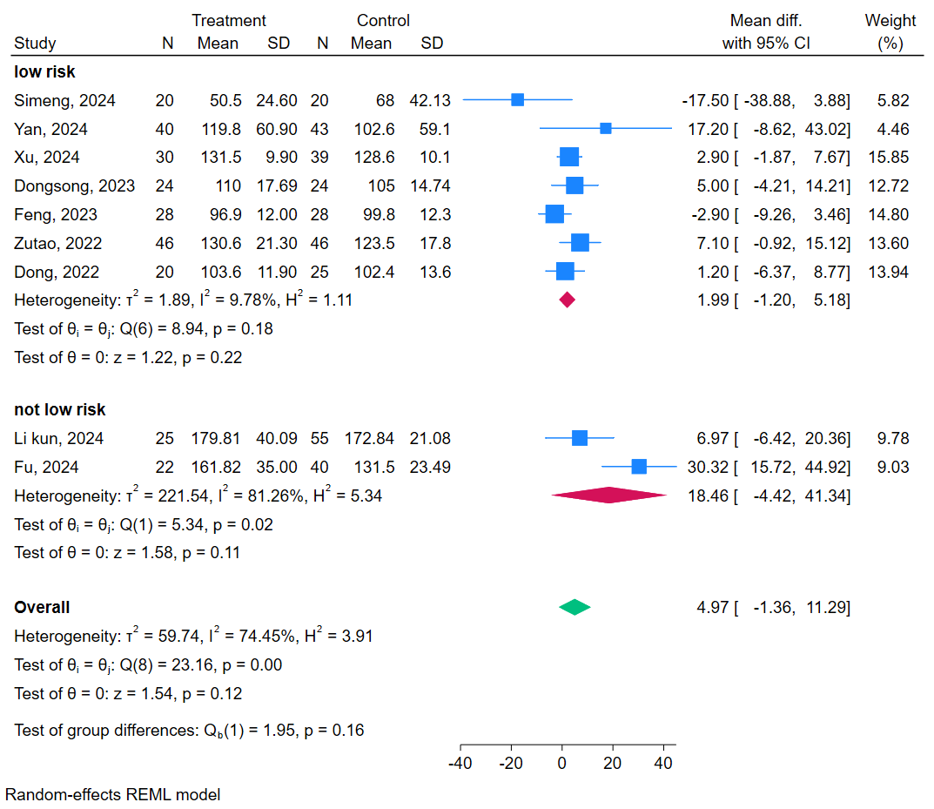
Figure S1. Bubble plot for meta-regression for comparison of intraoperative bleeding between Proximal Femoral Bionic Nail (PFBN) and Proximal Femoral Nail Antirotation (PFNA) based on: A) age B) female proportion C) follow-up duration; S1D) sub group analysis based on quality of the included studies
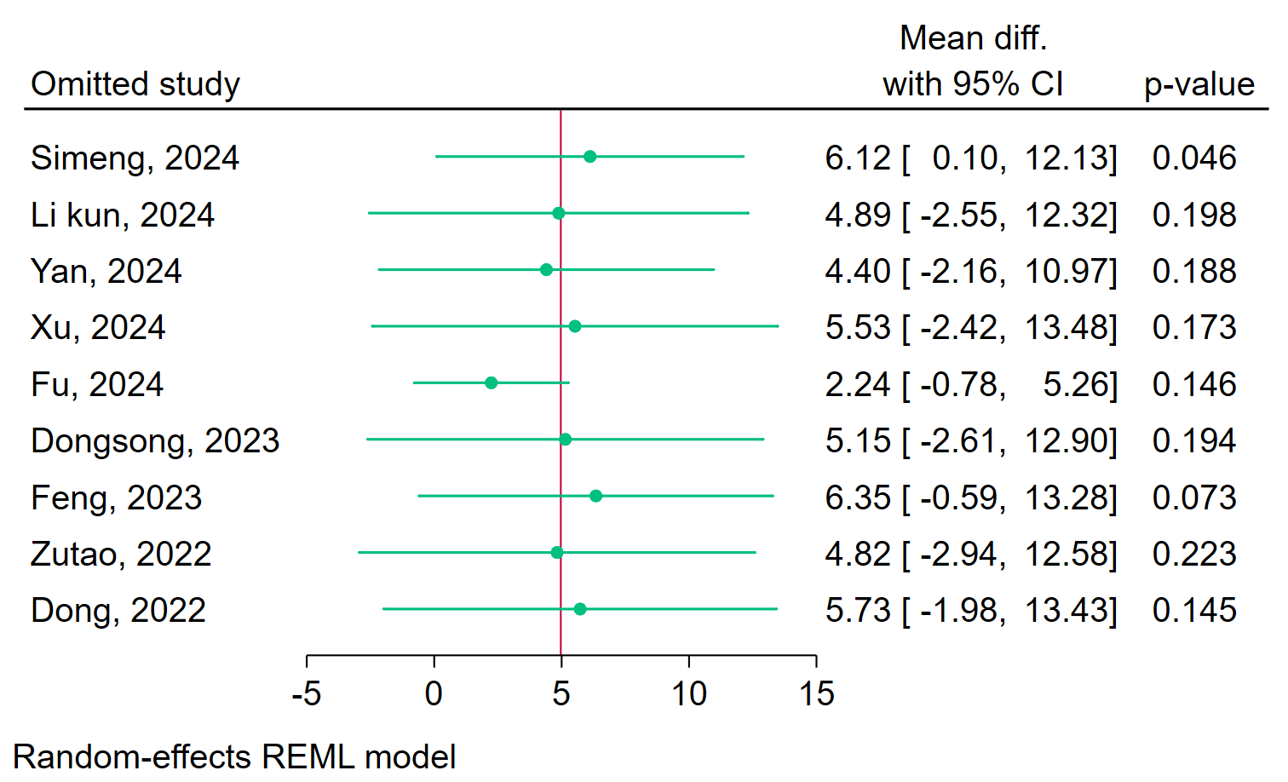
Figure S2. Sensitivity analysis using the leave-one-out method for comparison of intraoperative blood loss between Proximal Femoral Bionic Nail (PFBN) and Proximal Femoral Nail Antirotation (PFNA)
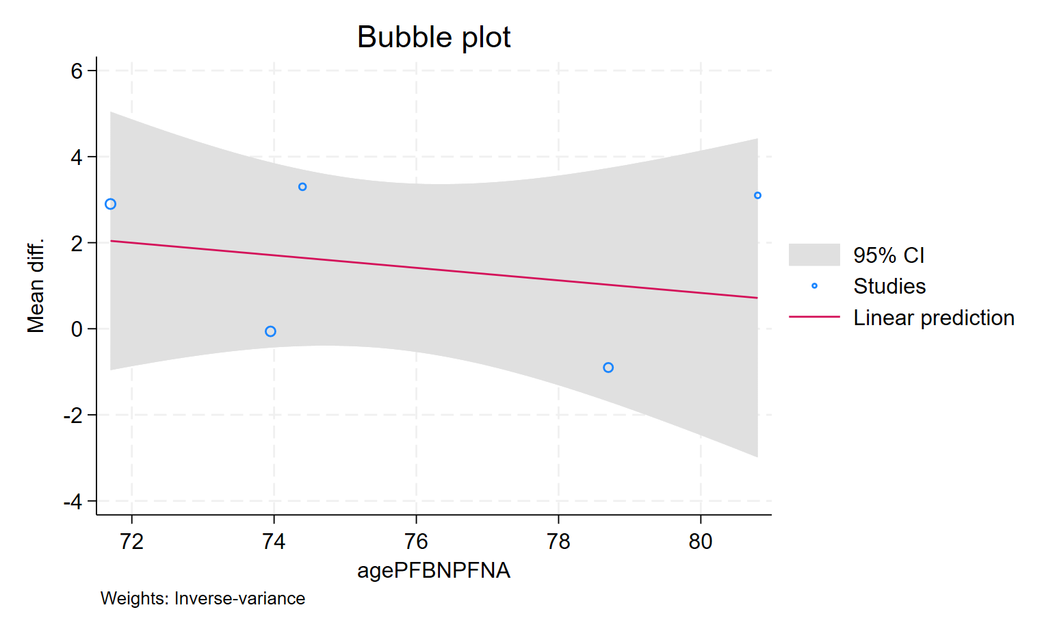
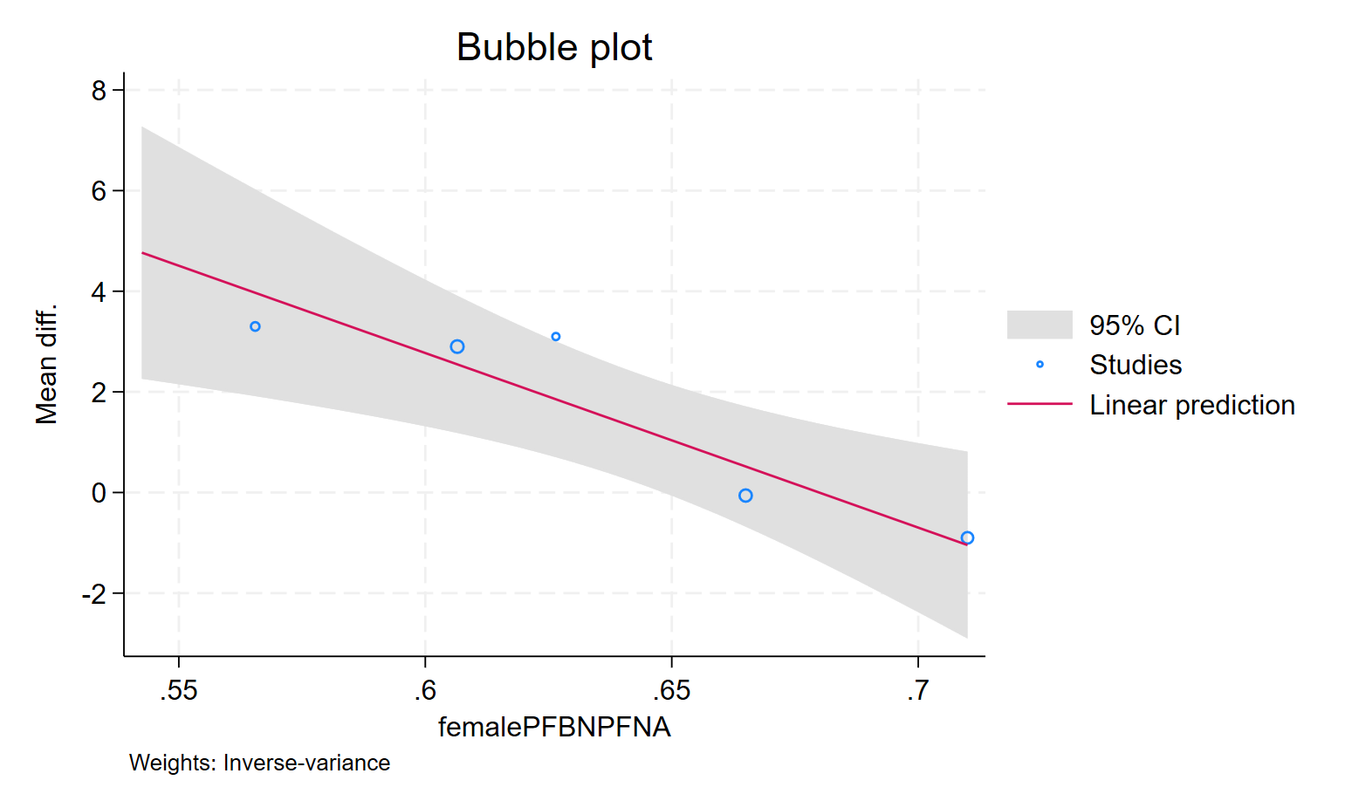
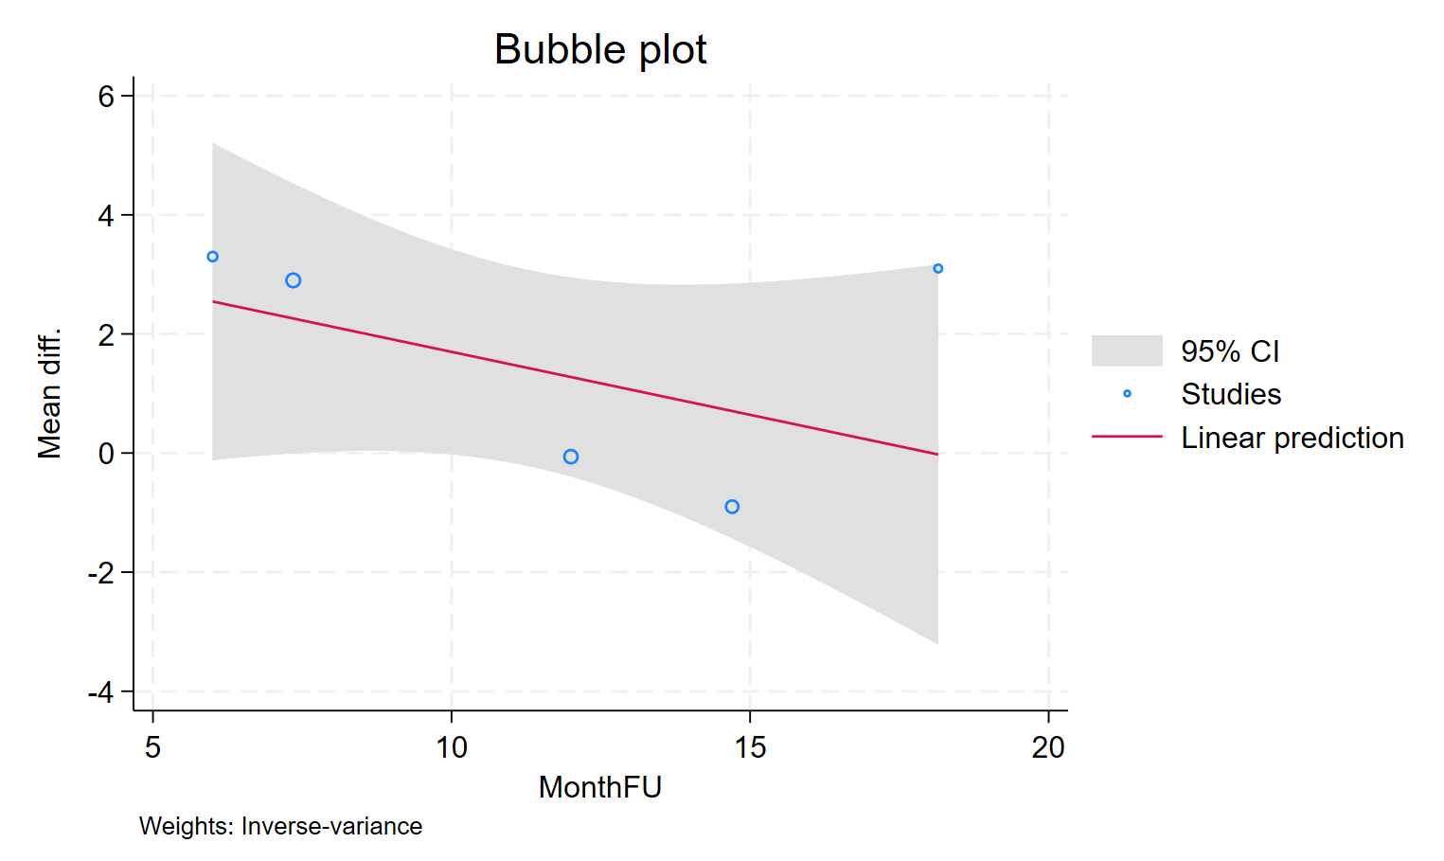
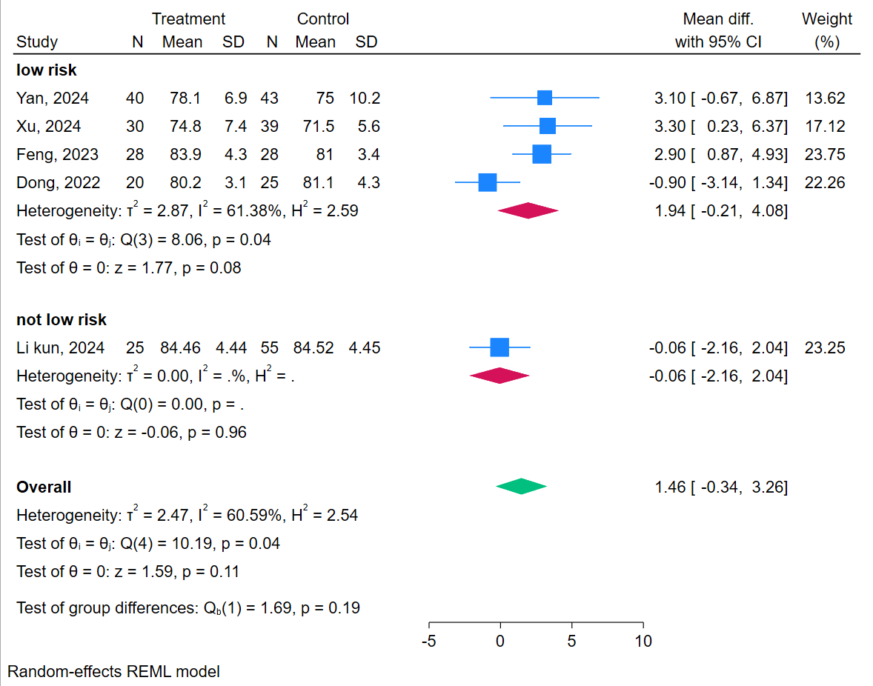
Figure S3. Bubble plot for meta-regression for comparison of postoperative Hip Harris Score (HHS) between Proximal Femoral Bionic Nail (PFBN) and Proximal Femoral Nail Antirotation (PFNA) based on: A) age B) female proportion C) follow-up duration; S1D) sub group analysis based on quality of the included studies
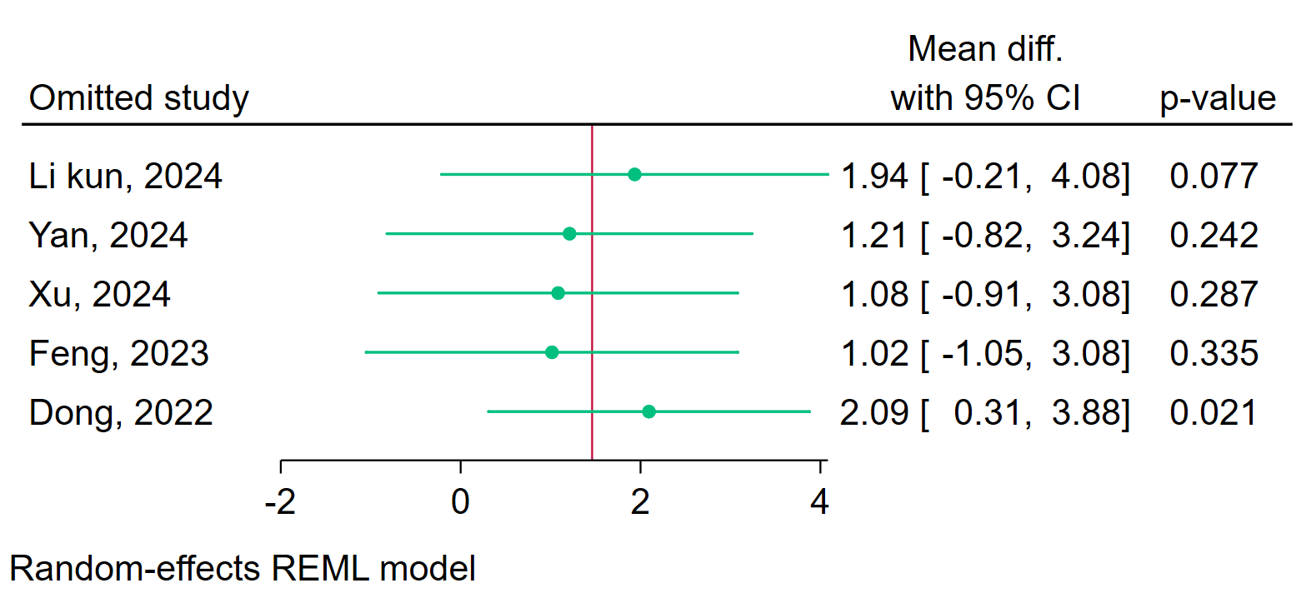
Figure S4. Sensitivity analysis using the leave-one-out method for comparison of postoperative Hip Harris Score (HHS) between Proximal Femoral Bionic Nail (PFBN) and Proximal Femoral Nail Antirotation (PFNA)

