Supplementary Materials and Methods
Bioinformatic analysis
The scRNA-seq data of 4 early OA and 4 end-stage OA synovial tissue specimens were obtained from GSE176308. The data were preprocessed using the Seurat package (5.3.0), and those cells were filtered out if they apply one of the following criteria: 1. the number of expressed genes lower than 200 or larger than 7000; 2. more than 10% of UMIs mapped to mitochondrial genes. After quality control of data, we used the “FindVariableFeatures” function to identify the top 2,000 highly variable genes, then performed principal component analysis (PCA) and uniform manifold approximation and projection (UMAP) to analyze the data. Cell types were annotated using the SingleR (2.8.0) package, leveraging the CellMarker dataset and referring to previous studies. Finally, Gene Ontology (GO) and Kyoto Encyclopedia of Genes and Genomes (KEGG) pathway enrichment analyses were implemented by the ClusterProfiler (4.14.6).
The bulk RNA-seq data were obtained from 34 normal and 55 OA human synovial tissue samples from GSE3698, GSE77298, GSE82107, GSE55235, GSE55457, and GSE55584. Using the platform's annotation data, probes were mapped and converted into gene symbols. Samples from the normal and OA groups were combined, and non-matching or excess multi-probe sets were removed or averaged. The Limma package (3.62.2) was used to remove batch effects and identify differentially expressed genes (DEGs), with a |log2FoldChange| > 2 and an adjusted P-value < 0.05 considered statistically significant. The ClusterProfiler package in R language was then used to conduct GO and KEGG enrichment analyses. The DEGs were annotated regarding biological processes (BP), cellular components (CC), and molecular functions (MF), and further analyzed the enriched pathways. Finally, we analyzed the protein-protein interaction (PPI) network and selected hub genes using STRING (http://string-db.org) and Cytoscape (v3.7.1). GO and KEGG analyses were performed on these hub genes.
Alcian blue staining and Alizarin red staining
Cells were washed three times with PBS and then fixed with 4% paraformaldehyde for 30 minutes (min). For the alcian blue staining, the cells were incubated with alcian acidifying solution for 3 min, followed by staining with 1% alcian staining solution at pH 2.5 (Solarbio, China) for 30 min. For the alizarin red staining, the cells were stained with 1% alizarin red S solution at pH 4.2 (Solarbio, China) for 5 to 10 min. After washing off the excess dye, the stained cells were observed under a microscope to verify the differentiation results.
RNA extraction and real-time quantitative PCR (RT-qPCR)
Total RNA from cells and tissues was extracted using the Trizol method (Thermo Fisher Scientific, USA). cDNA synthesis was performed using the 5×All-in-one qRT SuperMix and Enzyme Mix (Vazyme, China). RT-qPCR was conducted to detect RNA expression using the 2×Taq Pro Universal SYBR qPCR Master Mix (Vazyme, China). Relative gene expression levels were quantified using the 2^{(–ΔΔCt)} method, with GAPDH serving as the reference gene. The primers used for RT-qPCR are listed in Supplementary Table 1.
Supplementary Table 1. RT-qPCR primers
Primer | Sequence
IL-6 Forward | GTCCTTCCTACCCCAATTTCC
IL-6 Reverse | GCACTAGGTTTGCCGAGTAGA
JAK1 Forward | CTCTCTGTCACAACCTCTTCGC
JAK1 Reverse | TTGGTAAAGTAGAACCTCATGCG
JAK2 Forward | TTGTGGTATTACGCCTGTGTATC
JAK2 Reverse | ATGCCTGGTTGACTCGTCTAT
STAT3 Forward | CAGCAGCTTGACACACGGTA
STAT3 Reverse | AAACACCAAAGTGGCATGTGA
MMP13 Forward | TGTTTGCAGAGCACTACTTGAA
MMP13 Reverse | CAGTCACCTCTAAGCCAAAGAAA
ADAMTS5 Forward | GGAGCGAGGCCATTTACAAC
ADAMTS5 Reverse | CGTAGACAAGGTAGCCCACTTT
COL2A1 Forward | TTGAGACAGCACGACGTGGAG
COL2A1 Reverse | AGCCAGGTTGCCATCGCCATA
ACAN Forward | GTCTGACGGACACTCTCTGC
ACAN Reverse | GTCGTTCCATTCGCCTCT
GAPDH Forward | TGGCCTTCCGTGTTCCTAC
GAPDH Reverse | GAGTTGCTGTTGAAGTCGCA
Flow Cytometric Analysis of Macrophage Phenotypes
To evaluate the polarization of macrophage phenotypes, flow cytometry was performed according to standard procedures. Briefly, cells treated under different conditions were collected and washed twice with ice-cold PBS. Then, cells were stained with the following fluorescently conjugated antibodies for 30 minutes at 4°C in the dark: anti-F4/80 (Cat. No. 123109, clone BM8, BioLegend, USA) to identify the macrophage population; anti-CD86 (Cat. No. 105005, clone GL-1, BioLegend, USA) to detect M1-type macrophages. After incubation, cells were washed twice with PBS containing 1% bovine serum albumin (BSA) to remove unbound antibodies. Subsequently, cells were resuspended in cold PBS and analyzed immediately on flow cytometer (BD Biosciences, USA), and data analysis was performed using the FlowJo software (Treestar, USA).
Cell treatment
ATDC5 chondrogenic cells were subjected to a chondrogenic differentiation protocol for 14D, which involved culturing in medium supplemented with 1% insulin-transferrin-selenium (ITS-G, Procell, China) and reducing the fetal bovine serum (FBS) concentration from 10% to 5%. After ATDC5 chondrogenic cells differentiate into chondrocytes, the cells were treated with 10 μM Ruxolitinib (a JAK inhibitor) 12 hours and/or a single application of PBM intervention.
Animal model
Osteoarthritis was induced via the surgical destabilization of the medial meniscus (DMM) model. Mice were anesthetized with isoflurane (induction 3%, maintenance 1.5%), and a medial para-patellar arthrotomy was performed on the right knee joint. The medial meniscotibial ligament was identified and then transected using micro-surgical scissors to destabilize the medial meniscus. In contrast, mice in the sham group received the same surgical procedure without the transection of the medial meniscotibial ligament. In both groups, the joint capsule was subsequently sutured with 6-0 nylon, and the skin was closed with wound clips. All surgical procedures were performed under aseptic conditions.
Von frey test
The mechanical pain threshold was assessed using the von frey test, where acclimatized mice were placed on an elevated mesh platform and stimulated on the plantar hindpaw with calibrated filaments (0.16–6.0 g force range, North Coast, USA) using the up-down method to determine the 50% paw withdrawal threshold.
Hot plate test
Thermal pain sensitivity was evaluated using a hot plate apparatus (Shanghai Yuyan Instruments, China) maintained at 52–55°C, where mice were confined in a plexiglass cylinder and the latency to hindpaw licking, guarding, shaking or jumping was recorded with a 30-second cutoff to prevent tissue damage.
Blinding procedures
To minimize potential bias in experimental procedures and outcome assessments, rigorous blinding protocols were implemented throughout this study. During treatment administration, the investigator performing intra-articular injections (CLD Lips or CTRL Lips) was blinded to the content of the syringes, which were prepared and coded by an independent researcher. To mitigate potential bias, the PBM device parameters (wavelength, power density and treatment duration) were pre-programmed and standardized across all sessions to eliminate operator-induced variability. Furthermore, all outcome assessments were conducted by investigators blinded to group assignments. Histological evaluation of cartilage/synovium and subchondral bone analysis via micro-CT were conducted in a blinded fashion and confirmed by an independent blinded observer. Behavioral pain tests were carried out with the experimenter unaware of the group identities. Statistical analysis was performed by a blinded biostatistician, with group codes only revealed after completion of all analyses.
Supplementary figure
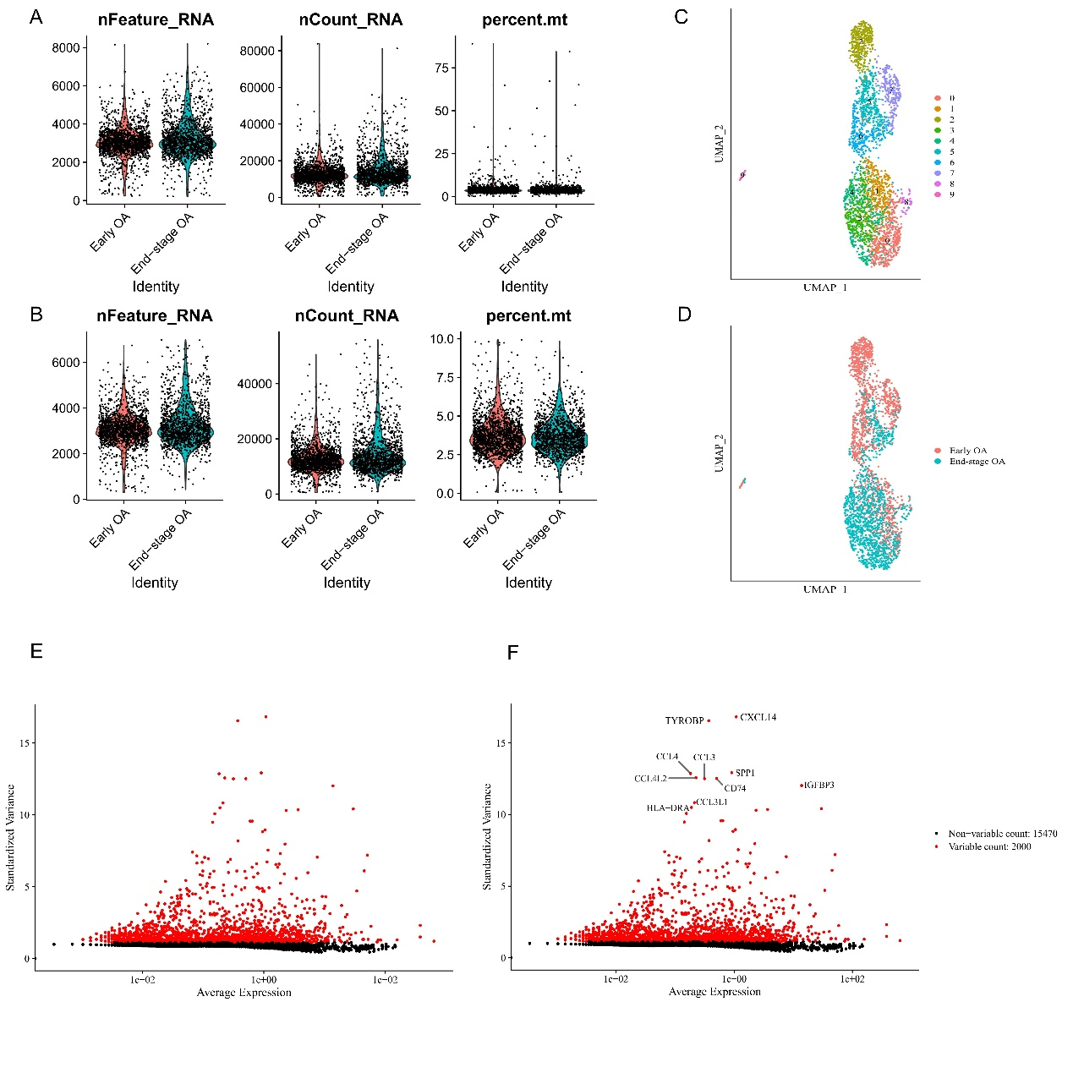
Fig.S1 Single-cell RNA-seq data preprocessing. (A) Visualization of the dataset before quality control process. (B) Visualization of the dataset after quality control process. (C) Cell Cluster Map. (D) The sample origin of the cells. (E) and (F) Highly Variable Genes.

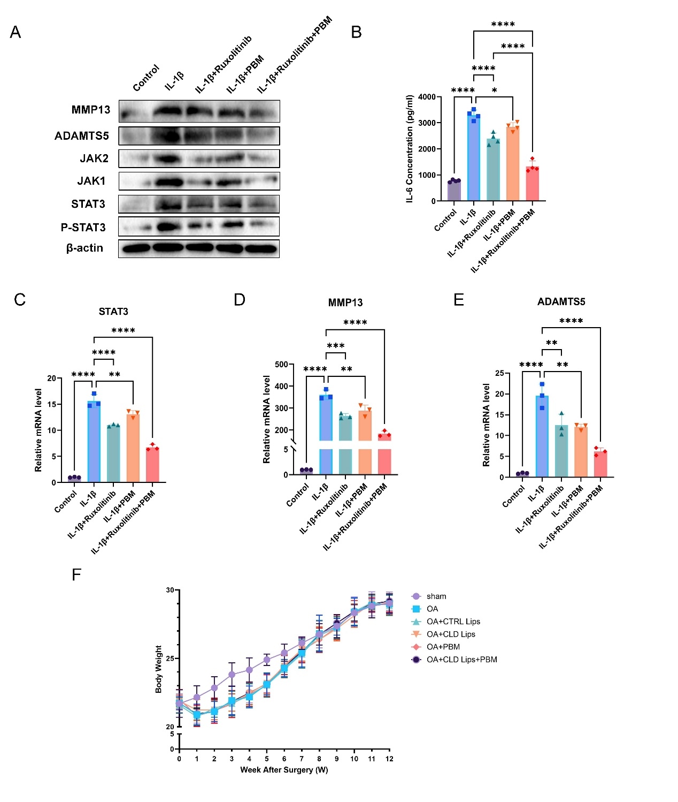
Fig.S2 (A) The protein levels of MMP13, ADAMTS5, JAK1, JAK2, STAT3, P-STAT3. β-actin was used as an internal loading control (n=3). (B) The contents of IL-6 in the supernatant were tested by ELISA (n=4). (C-E) The mRNA relative expression of STAT3, MMP13, ADAMTS5. GAPDH was used as a reference gene (n=3). (F) Body weight of animals during the experimental period (n=10). (Data are presented as mean ± SD; Statistical significance was determined by one-way ANOVA followed by Tukey's post-hoc test; *P < 0.05, **P < 0.01, ***P < 0.001, ****P < 0.0001)

