Table S1. Descriptive statistics and group differences for clinical variables
Variable | Young MI | Aging MI | P.value | Significance
Age | 27.00 [10.50, 38.50] | 55.00 [51.50, 63.50] | <0.001 | ***
BMI | 20.40 [19.30, 21.90] | 24.40 [23.10, 26.00] | 0.001 | **
Symptoms duration | 12.00 [2.50, 24.00] | 24.00 [12.00, 42.00] | 0.03 | *
Operation duration | 32.00 [24.50, 41.00] | 30.00 [24.50, 34.00] | 0.289 | ns
Hospital stay | 4.00 [3.00, 4.00] | 3.00 [3.00, 3.50] | 0.15 | ns
Pre VAS score | 3.00 [3.00, 4.00] | 5.00 [3.50, 5.00] | 0.012 | *
Pre lysholm score | 72.00 [66.00, 74.00] | 65.00 [57.00, 68.00] | 0.011 | *
Sex | Female: 7 (46.7%)  Male: 8 (53.3%) | Female: 10 (66.7%)  Male: 5 (33.3%) | 0.462 | ns
Involved knee | Left: 8 (53.3%)  Right: 7 (46.7%) | Left: 5 (33.3%)  Right: 10 (66.7%) | 0.462 | ns
Tear location | White/central zone: 3 (20%)  Red zone: 6 (40%)  Red-white zone: 6 (40%) | White/central zone: 8 (53.3%)  Red zone: 1 (6.7%)  Red-white zone: 6 (40%) | 0.055 | ns
Tear type | Horizontal tear: 7 (46.7%)  Longitudinal tear: 6 (40%)  Variant tear: 2 (13.3%) | Horizontal tear: 1 (6.7%)  Longitudinal tear: 5 (33.3%)  Variant tear: 9 (60%) | 0.015 | *
Surgical method | Meniscoplasty: 10 (66.7%)  Meniscoplasty with repair: 5 (33.3%) | Meniscoplasty: 9 (60%)  Meniscoplasty with repair: 6 (40%) | 1 | ns
Pre MRI ICRS grade | Grade 0: 5 (33.3%)  Grade 1: 9 (60%)  Grade 2: 1 (6.7%)  Grade 3: 0 (0%) | Grade 0: 1 (6.7%)  Grade 1: 6 (40%)  Grade 2: 5 (33.3%)  Grade 3: 3 (20%) | 0.032 | *
Pre K-L grade | Grade 0: 4 (26.7%)  Grade 1: 11 (73.3%)  Grade 2: 0 (0%) | Grade 0: 0 (0%)  Grade 1: 6 (40%)  Grade 2: 9 (60%) | <0.001 | ***
MI, meniscus injury; Pre, Preoperative; BMI, Body mass index; VAS, Visual analog scale; MRI, Magnetic resonance imaging; ICRS, International Cartilage Repair Society; K-L, Kellgren-Lawrence; Significance: ns p > 0.05, * p < 0.05, ** p < 0.01, *** p < 0.001. Continuous variables were presented as median [Q1, Q3], and categorical variables as count (percentage).

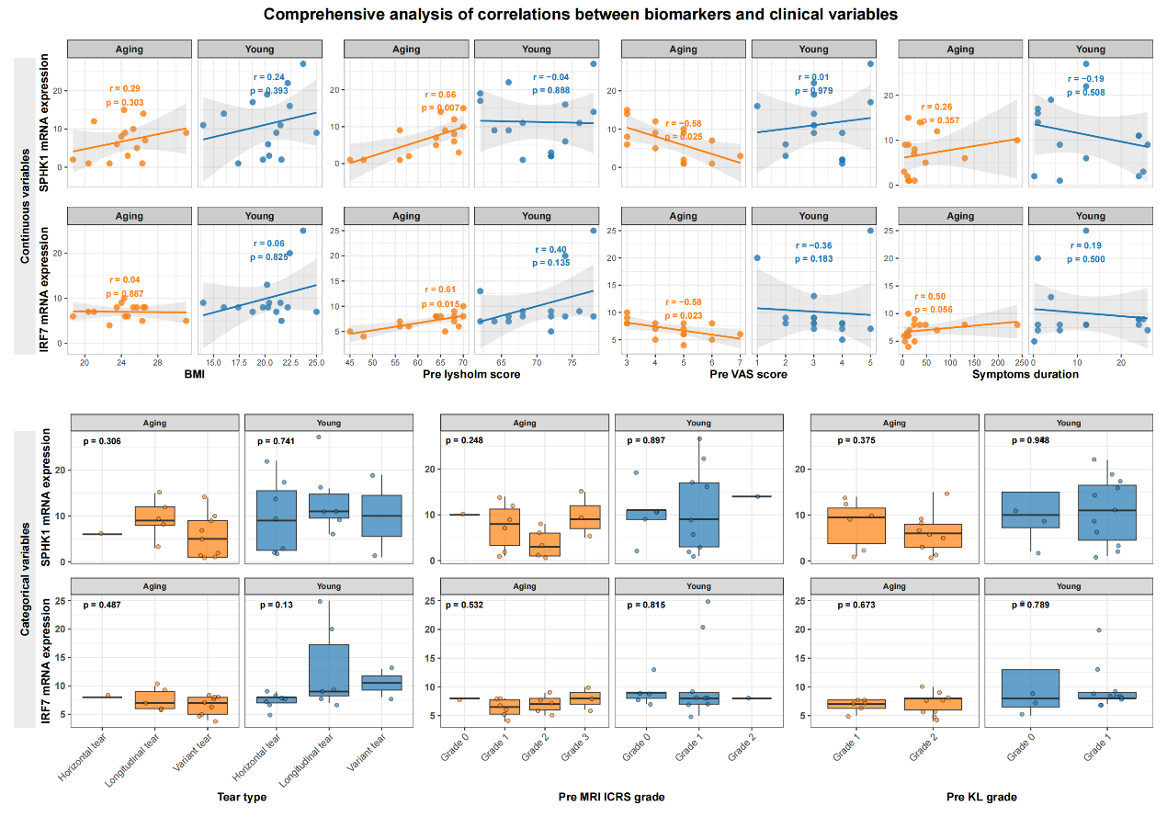
Figure S1. The correlation charts between biomarkers and clinical variables in aging group and young group. Scatter plots showed the correlation between biomarkers and the continuous variables (the upper panel), and boxplots showed the correlation between biomarkers and the categorical variables (the lower panel). Pre, Preoperative; MRI, Magnetic resonance imaging; ICRS, International Cartilage Repair Society; K-L, Kellgren-Lawrence.

