Appendix:

eTable1 Baseline characteristics of the 1,117 patients by PNI
eTable2 List of variables included in logistic regression full model

eTable3 Multivariate Analysis for Periprosthetic Joint Infection

eTable4 eTable4 Patient Characteristics Before and After Propensity Score Matching by Best Cutoff of PNI (≥ 45.00 VS < 45.00)

eTable5 Patient Characteristics Before and After Propensity Score Matching by Four Classifications of PNI ( > 50 VS 45 - 50 )

eTable6 Patient Characteristics Before and After Propensity Score Matching by four classifications of PNI ( > 50 VS 40 - 45 )

eTable7 Patient Characteristics Before and After Propensity Score Matching by Four Classifications of PNI ( > 50 VS < 40 )

eFigure1 Probability density distribution map before and after matching by

PNI (≥ 45.00 VS < 45.00 )
eFigure2 Probability density distribution map before and after matching by PNI ( > 50 VS 45 - 50 )
eFigure3 Probability density distribution map before and after matching by PNI ( > 50 VS 40 - 45 )
eFigure4 Probability density distribution map before and after matching by PNI ( > 50 VS < 40 )

eFigure5 Subgroup Analysis of the Association Between PNI and Periprosthetic Joint Infection After Propensity Score Matching
eFigure6 LASSO Coefficient Paths with 入* and 1-SE (5-fold CV)
eFigure7 LASSO Cross-Validation Curve (5-fold)
eFigure8 ROC curve of preoperative GNRI for predicting PJI in re-revision arthroplasty.

eTable1 Baseline characteristics of the 1,117 patients by PNI
Characteristics | All Patients  (N =1,117) | Normal Admission PNI  ≥ 45.00 (N =744) | LOW Admission PNI  < 45.00 (N = 373) | P value
Demographic
Age, year (Mean ± SD) | 62.03 ± 14.18 | 60.85 ± 14.18 | 64.38 ± 13.88 | < 0.001
Male gender (n, %) | 501 (44.85) | 329 (44.22) | 172 (46.11) | 0.549
BMI, kg/m² (Mean ± SD) | 24.14 ± 4.62 | 24.36 ± 4.17 | 23.70 ± 5.40 | 0.025
Smoking (n, %) | 223 (19.96) | 161 (21.64) | 62 (16.62) | 0.048
Alcohol (n, %) | 196 (17.55) | 134 (18.01) | 62 (16.62) | 0.565
Comorbidities

Elixhauser score, (Mean ± SD) | 0.85 ± 3.73 | 0.72 ± 3.70 | 1.10 ± 3.80 | 0.106
Diabetes, (n, %) | 141 (12.62) | 96 (12.90) | 45 (12.06) | 0.691
Hypertension, (n, %) | 409 (36.62) | 272 (36.56) | 137 (36.73) | 0.956
Rheumatoid arthritis | 72 (6.45) | 41 (5.51) | 31 (8.31) | 0.072
Prior PJI | 466 (41.72) | 301 (40.46) | 165 (44.24) | 0.227
Operation

Admission - surgery, day (Mean ± SD) | 4.64 ± 4.03 | 4.40 ± 3.37 | 5.11 ± 5.07 | 0.014
Length of stay, day (Mean ± SD) | 11.84 ± 9.36 | 11.38 ± 9.67 | 12.75 ± 8.67 | 0.022
Surgery time, hour (Mean ± SD) | 2.46 ± 0.43 | 2.47 ± 0.44 | 2.44 ± 0.41 | 0.361
Surgical type (n, %) |  |  |  | 0.211
Hip | 869 (77.80) | 587 (78.90) | 282 (75.60)
Knee | 248 (22.20) | 157 (21.10) | 91 (24.40)
ASA Classification (n, %) |  |  |  | 0.157
Ⅰ - Ⅱ | 638 (57.12) | 436 (58.60) | 202 (54.16)
Ⅲ - IV | 479 (42.88) | 308 (41.40) | 171 (45.84)
Labora-ry Indica-rs
WBC, 10⁹/L (Mean ± SD) | 7.16 ± 2.97 | 6.92 ± 2.61 | 7.65 ± 3.53 | < 0.001
Neutrophils, 10⁹/L (Mean ± SD) | 5.12 ± 2.92 | 4.69 ± 2.48 | 5.96 ± 3.50 | < 0.001
Lymphocyte, 10⁹/L (Mean ± SD) | 1.47 ± 0.60 | 1.63 ± 0.59 | 1.14 ± 0.46 | < 0.001
RBC, 10¹²/L (Mean ± SD) | 4.29 ± 0.67 | 4.40 ± 0.64 | 4.06 ± 0.67 | < 0.001
HB, g/L (Mean ± SD) | 126.27 ± 19.84 | 130.31 ± 18.29 | 118.20 ± 20.38 | < 0.001
PLT, 10⁹/L (Mean ± SD) | 207.04 ± 90.21 | 205.40 ± 84.00 | 210.32 ± 101.51 | 0.420
CRP, mg/L (Mean ± SD) | 22.83 ± 45.11 | 14.25 ± 28.55 | 39.97 ± 63.52 | < 0.001
ESR, mm/h (Mean ± SD) | 40.67 ± 31.07 | 37.29 ± 28.59 | 47.42 ± 34.56 | < 0.001
Albumin, g/L (Mean ± SD) | 40.18 ± 5.68 | 43.11 ± 3.70 | 34.33 ± 4.24 | < 0.001
Exposure
PNI | 47.51 ± 6.69 | 51.26 ± 4.05 | 40.03 ± 4.17 | < 0.001
Outcome
PJI | 40 (3.58) | 9 (1.21) | 31 (8.31) | < 0.001
Abbreviations: PNI, Prognostic Nutritional Index; BMI, Body Mass Index; ASA, the American Society of Anesthesiologists physical status classification; WBC, White Blood Cells; RBC, Red Blood Cells; HB, Hemoglobin; PLT, Platelet; CRP, C-Reactive Protein; ESR, Erythrocyte Sedimentation Rate; PJI, Periprosthetic Joint Infection.
eTable2 List of variables included in logistic regression full model
Demographic
Age
Gender
BMI
Smoking
Alcohol
Comorbidities

Diabetes
Hypertension
Rheumatoid arthritis
Prior PJI
Elixhauser score*
- Congestive heart failure
- Cardiac arrhythmias
- Valvular heart disease
- Pulmonary circulation disorders
- Peripheral vascular disorders
- Hypertension, uncomplicated
- Hypertension, complicated
- Paralysis
- Other neurological disorders
- Chronic pulmonary disease
- Diabetes, uncomplicated
- Diabetes, complicated
- Hypothyroidism
- Renal failure
- Liver disease
- Peptic ulcer disease, excluding bleeding
- AIDS/HIV
- Lymphoma
- Metastatic cancer
- Solid tumor without metastasis
- Rheuma-id arthritis/collagen vascular diseases
- Coagulopathy
- Obesity
- Weight loss
- Fluid and electrolyte disorders
- Blood loss anemia
- Deficiency anemia
- Alcohol abuse
- Drug abuse
- Psychoses
- Depression
Operation

Admission - surgery
Length of stay
Surgery time
Surgical type
ASA Classification
Laboratory Indicators
WBC

Neutrophils

Lymphocyte

RBC

HB

PLT
CRP

ESR

Albumin

Exposure
PNI
Outcome
PJI
*Note: The Elixhauser score is calculated based on the incidence of these comorbidities in patients from 1 - 31.

Abbreviations: BMI, Body Mass Index; AIDS, acquired immunodeficiency syndrome; HIV, human immunodeficiency virus; ASA, the American Society of Anesthesiologists physical status classification; WBC, White Blood Cells; RBC, Red Blood Cells; HB, Hemoglobin; PLT, Platelet; CRP, C-Reactive Protein; ESR, Erythrocyte Sedimentation Rate; PNI, Prognostic Nutritional Index; PJI, Periprosthetic Joint Infection.

eTable3 Univariate and Multivariate Analysis for Periprosthetic Joint Infection
Characteristics | Univariate |  |  | Multivariate
Characteristics | OR | 95%CI | P-value | OR | 95%CI | P-value
Age, per year | 0.98 | 0.96 ~ 0.99 | 0.028 | 0.97 | 0.95 ~ 0.99 | 0.032
Male gender | 1.24 | 0.66 ~ 2.33 | 0.506
BMI, per kg/m² | 0.93 | 0.85 ~ 1.02 | 0.109
Smoking | 0.85 | 0.37 ~ 1.94 | 0.692
Alcohol | 1.18 | 0.54 ~ 2.61 | 0.678
Elixhauser score, per score | 1.05 | 0.98 ~ 1.12 | 0.157
Diabetes | 2.08 | 0.97 ~ 4.46 | 0.061
Hypertension | 0.83 | 0.42 ~ 1.62 | 0.583
Rheumatoid arthritis | 1.65 | 0.57 ~ 4.77 | 0.356
Prior PJI | 4.41 | 2.13 ~ 9.12 | <.001 | 3.33 | 1.47 ~ 7.54 | 0.004
Admission - surgery, per day | 1.03 | 0.97 ~ 1.10 | 0.369
Length of stay, per day | 1.02 | 1.01 ~ 1.05 | 0.014 | 1.02 | 0.99 ~ 1.04 | 0.210
Surgery time, per hour | 4.18 | 2.25 ~ 7.78 | < 0.001 | 5.63 | 2.63 ~ 12.06 | <0.001
Surgical type (Knee) | 1.94 | 1.00 ~ 3.77 | 0.051
ASA Classification | 1.09 | 0.58 ~ 2.06 | 0.783
WBC, per 10⁹/L | 1.02 | 0.92 ~ 1.13 | 0.709
Neutrophils, per 10⁹/L | 1.02 | 0.92 ~ 1.13 | 0.761
RBC, per 10¹²/L | 1.09 | 0.68 ~ 1.75 | 0.717
HB, per g/L | 0.99 | 0.98 ~ 1.01 | 0.278
PLT，per 10⁹/L | 1.01 | 1.01 ~ 1.01 | 0.039 | 1 | 1.00 ~ 1.00 | 0.796
CRP, per mg/L | 1.01 | 1.01 ~ 1.01 | 0.006 | 1 | 0.99 ~ 1.00 | 0.341
ESR, per mm/h | 1.01 | 1.01 ~ 1.02 | 0.001 | 1 | 0.99 ~ 1.02 | 0.412
PNI, per score | 0.85 | 0.82 ~ 0.89 | < 0.001 | 0.85 | 0.81 ~ 0.90 | < 0.001

Abbreviations: OR, Odds Ratio; CI, Confidence Interval; PNI, Prognostic Nutritional Index; BMI, Body Mass Index; ASA, the American Society of Anesthesiologists physical status classification; WBC, White Blood Cells; RBC, Red Blood Cells; HB, Hemoglobin; PLT, Platelet; CRP, C-Reactive Protein; ESR, Erythrocyte Sedimentation Rate; PNI, Prognostic Nutritional Index.

eTable4 Patient Characteristics Before and After Propensity Score Matching by Best Cut-off of PNI (≥ 45.00 VS < 45.00)
Characteristics | Before matching |  |  | After matching
Characteristics | PNI ≥ 45.00  (n=744) | PNI < 45.00  (n=373) | SMD | PNI ≥ 45.00  (n=333) | PNI < 45.00  (n=333) | SMD
Age, year (Mean ± SD) | 60.85 ± 14.18 | 64.38 ± 13.88 | 0.255 | 64.95 ± 12.87 | 64.26 ± 13.88 | -0.050
PLT, 10⁹/L (Mean ± SD) | 205.40 ± 84.00 | 210.32 ± 101.51 | 0.048 | 208.98 ± 97.47 | 208.06 ± 100.24 | -0.009
CRP, mg/L (Mean ± SD) | 14.25 ± 28.55 | 39.97 ± 63.52 | 0.405 | 22.75 ± 40.11 | 25.39 ± 43.56 | 0.061
ESR, mm/h (Mean ± SD) | 37.29 ± 28.59 | 47.42 ± 34.56 | 0.293 | 43.75 ± 31.61 | 43.49 ± 32.21 | -0.008
Length of stay, day (Mean ± SD) | 11.38 ± 9.67 | 12.75 ± 8.67 | 0.157 | 12.09 ± 12.22 | 12.43 ± 8.65 | 0.039
Surgery time, hour (Mean ± SD) | 2.47 ± 0.44 | 2.44 ± 0.41 | -0.061 | 2.42 ± 0.48 | 2.44 ± 0.41 | 0.053
Prior PJI | 301 (40.46) | 165 (44.24) | 0.076 | 148 (45.95) | 127 (39.94) | -0.123

eFigure1 Probability density distribution map before and after matching by

PNI (≥ 45.00 VS < 45.00 )

eTable5 Patient Characteristics Before and After Propensity Score Matching by Four Classifications of PNI ( > 50 VS 45 - 50 )
Characteristics | Before matching |  |  | After matching
Characteristics | PNI > 50  (n=434) | PNI 45 - 50  (n=316) | SMD | PNI > 50  (n=286) | PNI 45 - 50  (n=286) | SMD
Age, year (Mean ± SD) | 59.35 ± 14.33 | 63.00 ± 13.66 | 0.267 | 61.27 ± 13.20 | 62.05 ± 13.75 | 0.057
PLT, 10⁹/L (Mean ± SD) | 207.65 ± 78.13 | 203.47 ± 92.76 | -0.045 | 202.46 ± 76.52 | 205.09 ± 94.53 | 0.028
CRP, mg/L (Mean ± SD) | 13.70 ± 29.27 | 15.47 ± 28.90 | 0.061 | 14.46 ± 29.76 | 14.24 ± 24.56 | -0.009
ESR, mm/h (Mean ± SD) | 34.64 ± 26.80 | 41.28 ± 30.68 | 0.216 | 38.57 ± 28.89 | 39.09 ± 30.29 | 0.017
Length of stay, day (Mean ± SD) | 11.01 ± 10.25 | 11.91 ± 8.72 | 0.103 | 11.37 ± 11.62 | 11.81 ± 8.98 | 0.050
Surgery time, hour (Mean ± SD) | 2.44 ± 0.48 | 2.50 ± 0.37 | 0.164 | 2.53 ± 0.48 | 2.49 ± 0.38 | -0.086
Prior PJI | 185 (42.63) | 119 (37.66) | 0.125 | 174 (44.36) | 112 (39.16) | -0.052

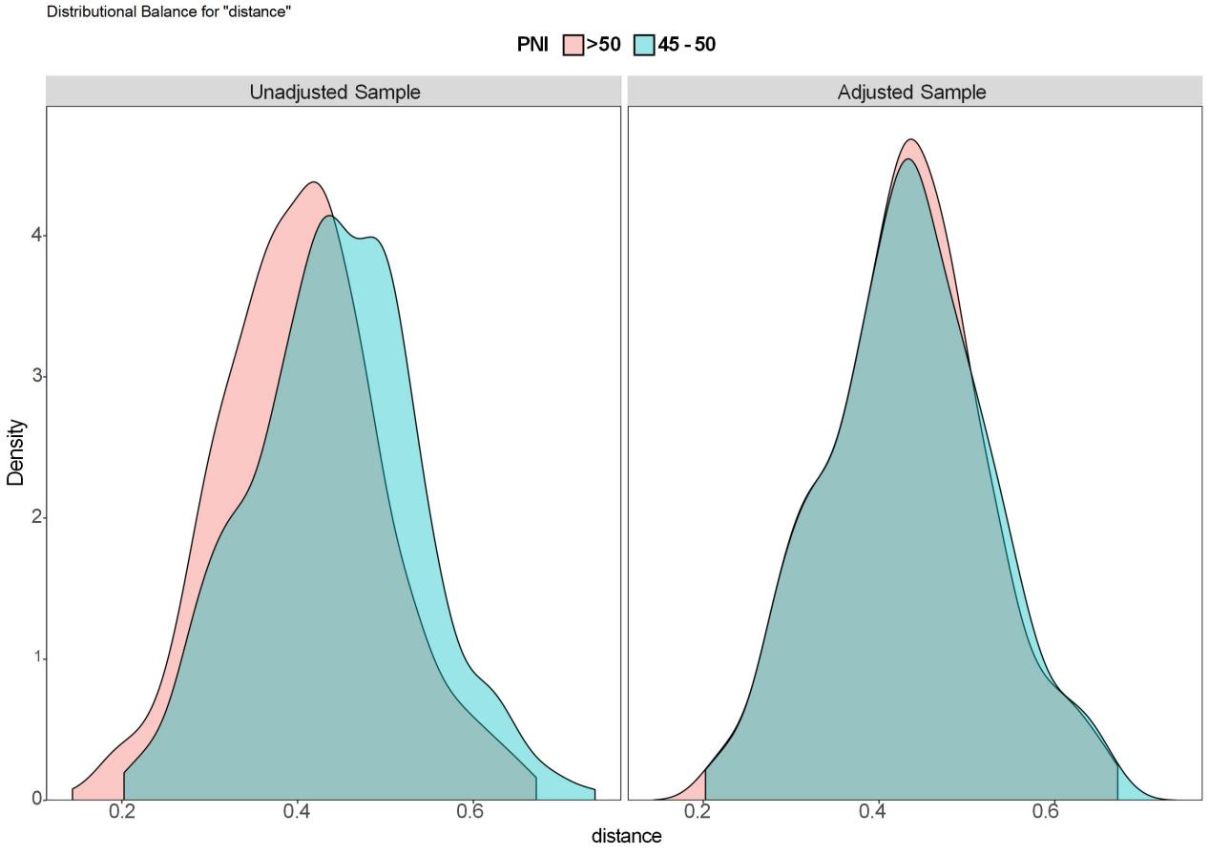

eFigure2 Probability density distribution map before and after matching by PNI ( > 50 VS 45 - 50 )

eTable6 Patient Characteristics Before and After Propensity Score Matching by Four Classifications of PNI ( > 50 VS 40 - 45 )
Characteristics | Before matching |  |  | After matching
Characteristics | PNI > 50  (n=434) | PNI 40 - 45  (n=218) | SMD | PNI > 50  (n=198) | PNI 40 - 45  (n=198) | SMD
Age, year (Mean ± SD) | 59.35 ± 14.33 | 64.55 ± 13.83 | 0.376 | 63.44 ± 13.70 | 64.04 ± 13.99 | 0.043
PLT, 10⁹/L (Mean ± SD) | 207.65 ± 78.13 | 201.31 ± 83.31 | -0.076 | 204.44 ± 85.13 | 201.60 ± 81.77 | -0.035
CRP, mg/L (Mean ± SD) | 13.70 ± 29.27 | 32.32 ± 59.01 | 0.316 | 21.85 ± 40.01 | 22.67 ± 38.59 | 0.021
ESR, mm/h (Mean ± SD) | 34.64 ± 26.80 | 44.39 ± 33.19 | 0.294 | 43.14 ± 29.49 | 40.72 ± 30.44 | -0.079
Length of stay, day (Mean ± SD) | 11.01 ± 10.25 | 12.56 ± 8.16 | 0.190 | 11.71 ± 13.46 | 12.11 ± 8.06 | 0.050
Surgery time, hour (Mean ± SD) | 2.44 ± 0.48 | 2.42 ± 0.38 | -0.042 | 2.45 ± 0.50 | 2.43 ± 0.38 | -0.046
Prior PJI | 185 (42.63) | 89 (40.83) | -0.319 | 134 (40.71) | 64 (42.86) | -0.038

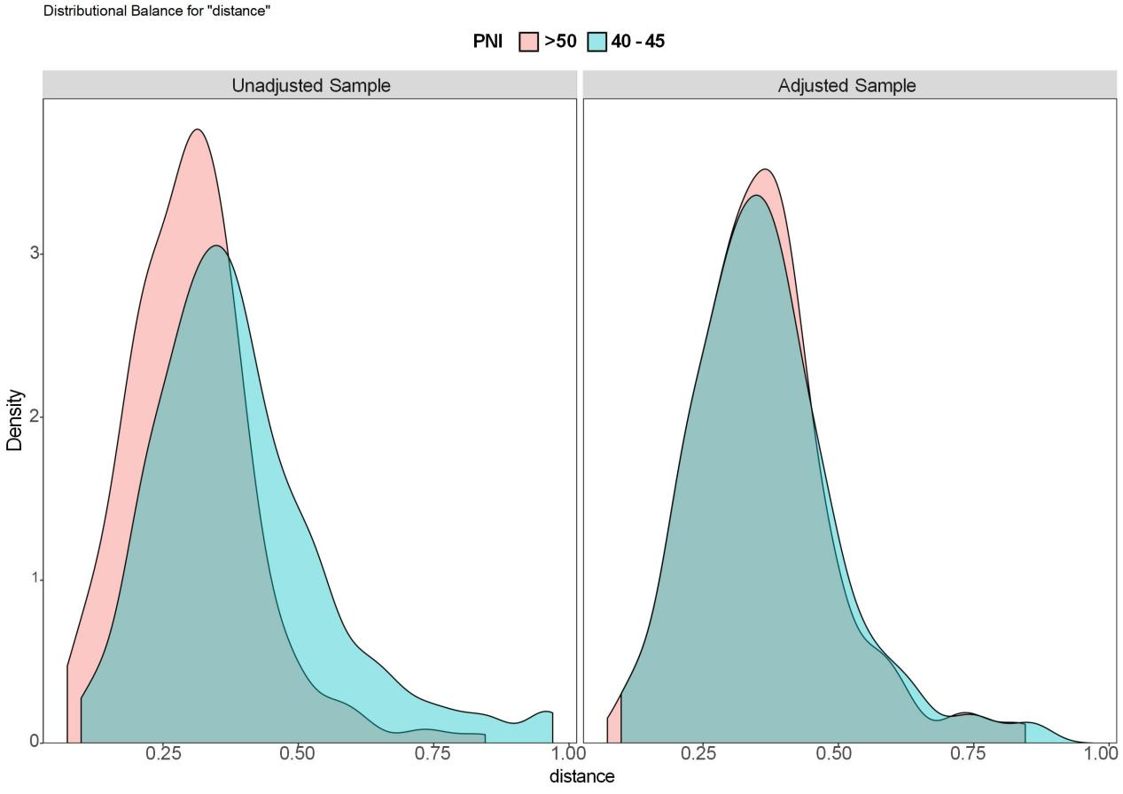

eFigure3 Probability density distribution map before and after matching by PNI ( > 50 VS 40 - 45 )

eTable7 Patient Characteristics Before and After Propensity Score Matching by Four Classifications of PNI ( > 50 VS < 40 )
Characteristics | Before matching |  |  | After matching
Characteristics | PNI > 50  (n=434) | PNI < 40  (n=149) | SMD | PNI > 50  (n=127) | PNI < 40  (n=127) | SMD
Age, year (Mean ± SD) | 59.35 ± 14.33 | 64.07 ± 14.17 | 0.333 | 66.23 ± 12.40 | 63.74 ± 13.99 | -0.178
PLT, 10⁹/L (Mean ± SD) | 207.65 ± 78.13 | 221.23 ± 121.42 | 0.112 | 206.48 ± 88.69 | 206.00 ± 94.60 | -0.005
CRP, mg/L (Mean ± SD) | 13.70 ± 29.27 | 51.18 ± 68.21 | 0.550 | 26.91 ± 47.27 | 32.15 ± 48.14 | 0.109
ESR, mm/h (Mean ± SD) | 34.64 ± 26.80 | 51.50 ± 36.22 | 0.465 | 45.87 ± 33.55 | 46.52 ± 34.96 | 0.018
Length of stay, day (Mean ± SD) | 11.01 ± 10.25 | 13.07 ± 9.49 | 0.217 | 11.13 ± 6.17 | 11.52 ± 6.56 | 0.060
Surgery time, hour (Mean ± SD) | 2.44 ± 0.48 | 2.46 ± 0.43 | 0.037 | 2.45 ± 0.57 | 2.45 ± 0.44 | -0.005
Prior PJI | 185 (42.63) | 73(48.99) | 0.418 | 91 (45.19) | 36 (46.53) | 0.102

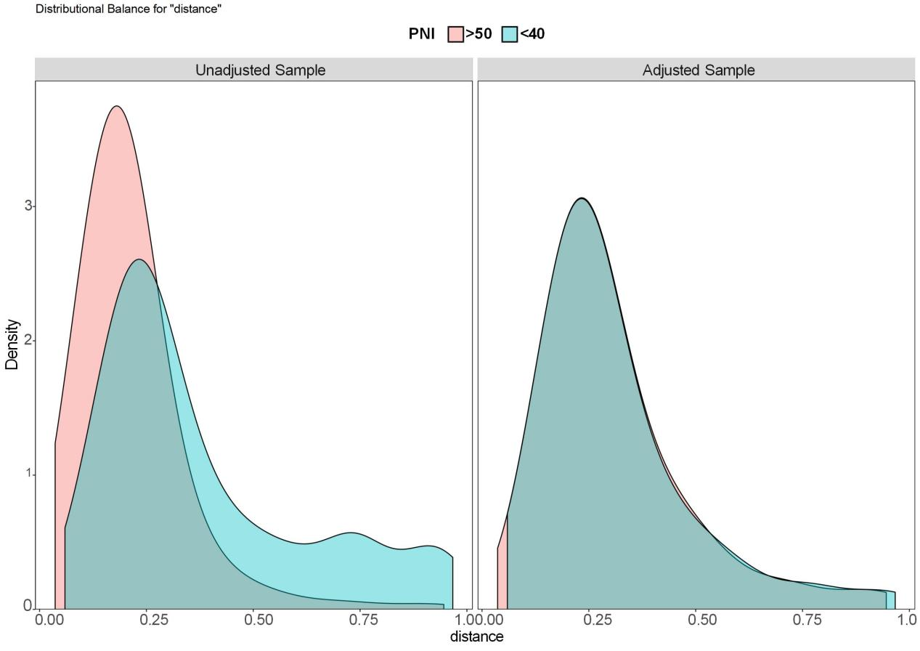

eFigure4 Probability density distribution map before and after matching by PNI ( > 50 VS < 40 )

eFigure5 Subgroup Analysis of the Association Between PNI and Periprosthetic Joint Infection After Propensity Score Matching
eFigure6 LASSO Coefficient Paths with 入* and 1-SE (5-fold CV)
eFigure7 LASSO Cross-Validation Curve (5-fold)
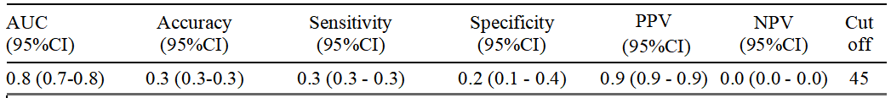
eFigure8 ROC curve of preoperative GNRI for predicting PJI in re-revision arthroplasty.

