SUPPLEMENTARY EXPERIMENTAL PROCEDURES

Cell viability assessment
Bone marrow-derived macrophages (BMMs) were plated in a 96-well culture plate at a seeding density of 2×10⁴ cells per well. The cells were then treated with varying concentrations of icariin (ICA) or left untreated, followed by incubation at 37°C in a 5% CO₂ atmosphere for durations of 24, 48 and 72 hours. Subsequently, 100 μL of CCK-8 reagent (APExBIO, USA) was introduced into each well, and the plates were further incubated at 37°C for 1 hour. Optical density (OD) was determined at a wavelength of 450 nm using a microplate reader.
SUPPLEMENTARY FIGURES

Supplementary figure 1

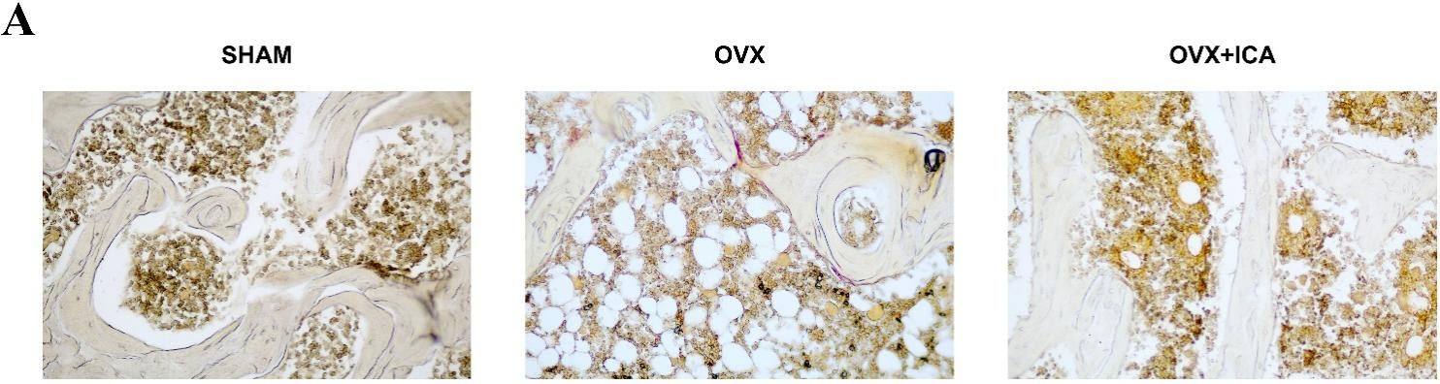
Figure S1. TRAP staining of lumbar vertebra in SHAM group, OVX group and OVX+ICA group.

Supplementary figure 2

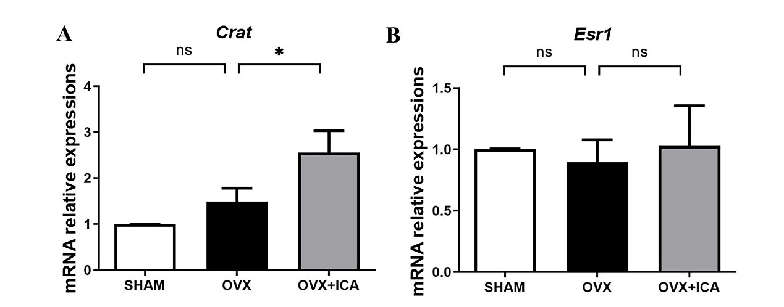
Figure S2. mRNA levels of Crat (A) or Esr1 (B) were tested by qPCR (n=3). Relative expressions of Crat and Esr1 were all normalized against Gapdh (n=3), *P=0.0153. All the data are shown as mean±SD (n=3) in three independent experiments.

Supplementary figure 3

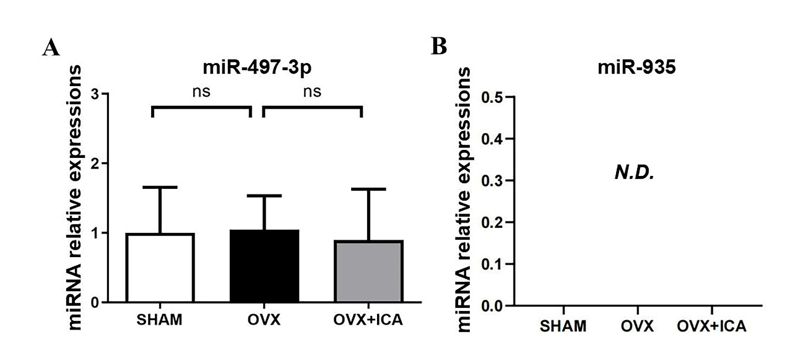
Figure S3. Expressions of miR-497-3p and miR-935 were tested by qPCR (n=3). Relative expression of miR-497-3p was all normalized against U6 (n=3). N.D. means not detected in the experiments.

Supplementary figure 4

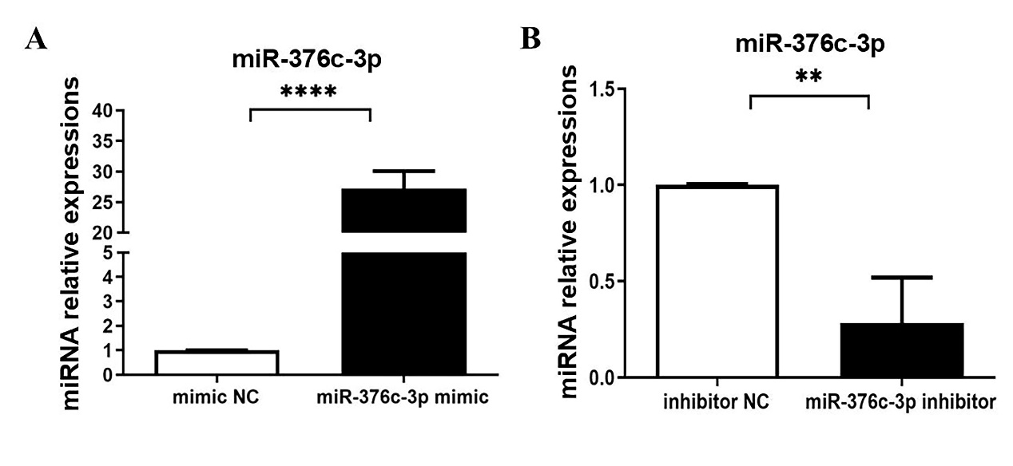
Figure S4. miR-376c-3p expressions were tested by qPCR (n=3) after transfected with the mimic (A) or inhibitor (B). Relative expression of miR-376c-3p was all normalized against U6 (n=3). P values are indicated as follows: ****P<0.0001; **P=0.0064. All the data are shown as mean±SD (n=3) in three independent experiments.

Supplementary figure 5

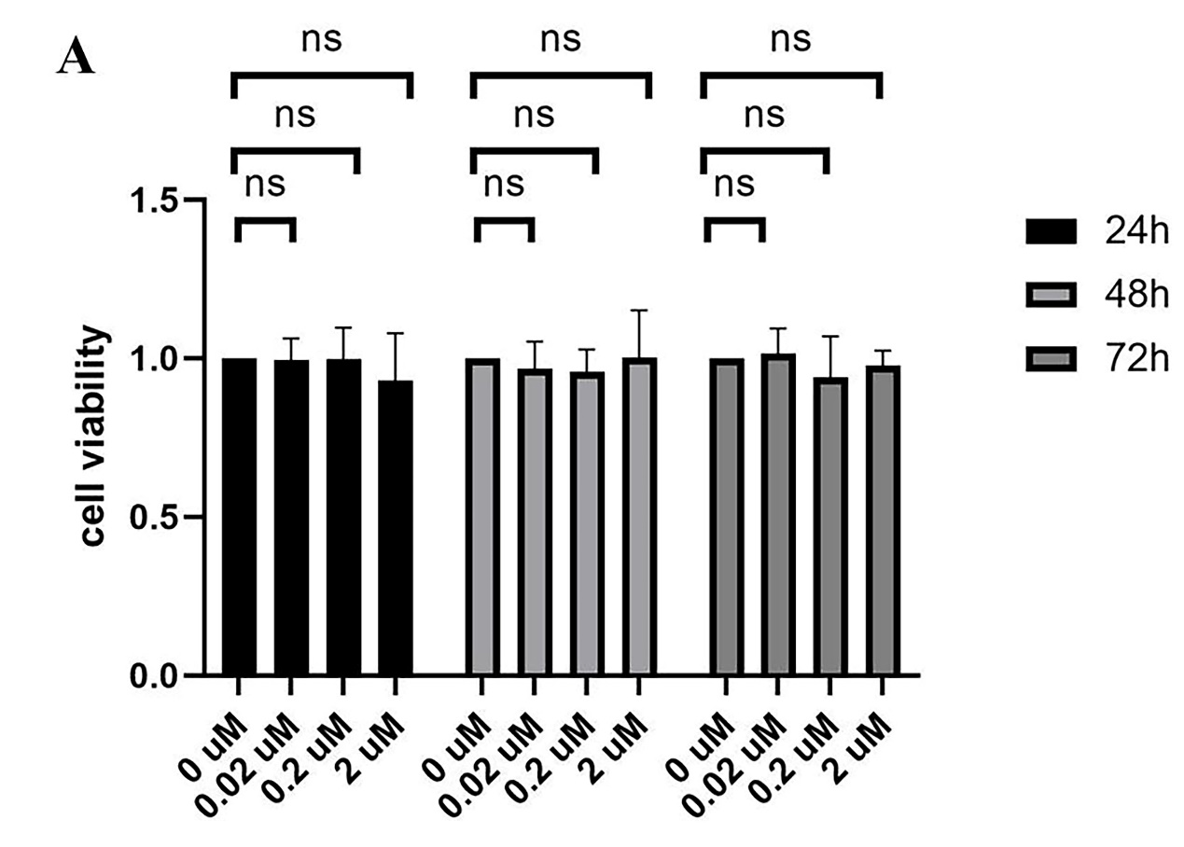
Figure S5. ICA showed no toxicity to BMMs. Cell viability of BMMs under different concentrations of ICA was measured by CCK8 assay for 24, 48 and 72 hours (n=3).

Supplementary figure 6
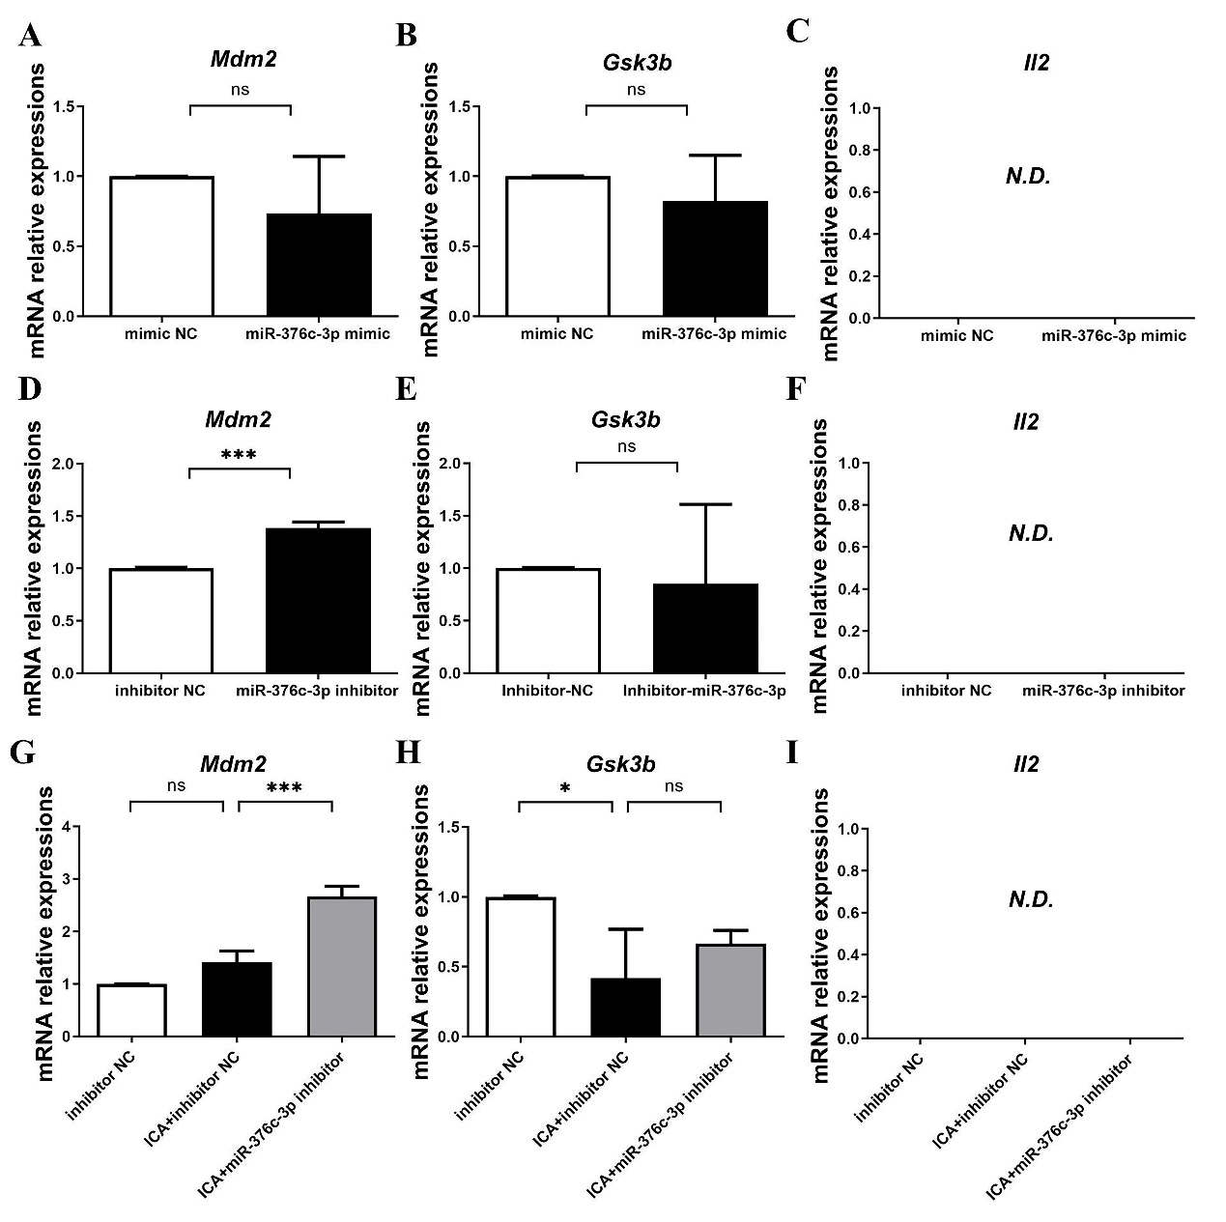

Figure S6. The expressions of Mdm2, Gsk3b and Il2 after transfection with miR-376c-3p mimics (A-C), inhibitors (D-F) and in inhibitor NC group, ICA+inhibitor NC group and ICA+miR-376c-3p inhibitor group (G-I). Relative expressions of Mdm2 and Gsk3b were all normalized against β-actin (n=3), ***P=0.0004, miR-376c-3p inhibitor versus inhibitor NC; ***P=0.0003, ICA+miR-376c-3p inhibitor versus ICA+inhibitor NC; *P=0.0328, ICA+inhibitor NC versus inhibitor NC. All the data are shown as mean±SD (n=3) in three independent experiments. N.D. means not detected in the experiments.

