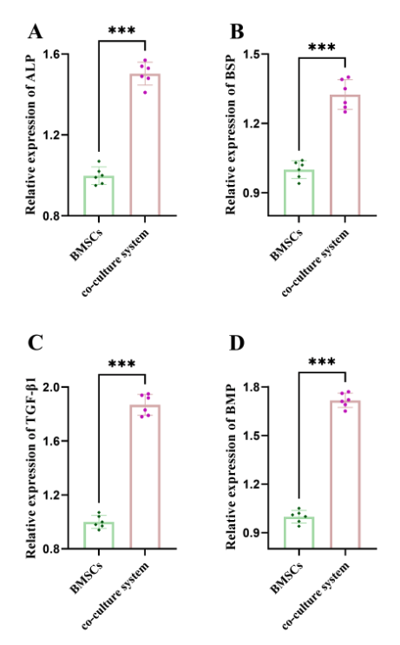
Supplementary Figure 1 Detection of osteogenic differentiation markers in BMSCs cultured alone and in co-culture with MG63. A-D. The expression levels of ALP, BSP, TGF-β1, and BMP. ***P<0.001.

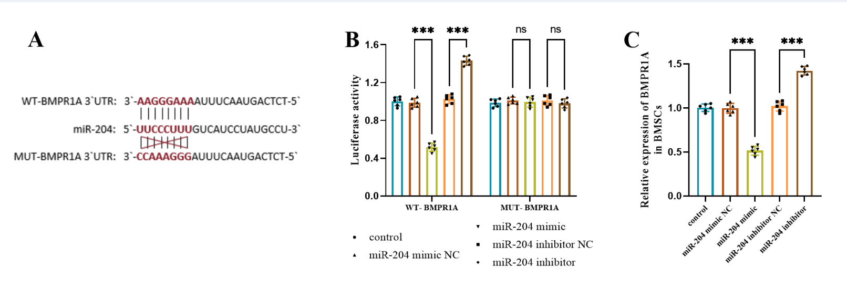
Supplementary Figure 2 Verification of the targeting relationship between BMPR1A and miR-204. A. The complementary sequence of BMPR1A 3'UTR and miR-204. B. The dual-luciferase reporter gene assay confirmed that BMPR1A was the target gene of miR-204. C. The expression of BMPR1A was decreased after miR-204 overexpression. ***P<0.001.

