Preoperative MRI and Clinical Indicators for Predicting Meniscal Repairability: A Machine Learning–Based Study

Authors and Affiliations:

Peipei Hao, MD¹; Kun Cheng, MD¹; Yun Xu, MD¹; Zhongliu Liu, MD¹; Jing Yao, MD¹; Aijun Shen, MD¹*

¹Department of Radiology, Tongji Hospital
, School of Medicine, Tongji University, Shanghai, China

*Corresponding Author:

Aijun Shen, MD, Department of Radiology, Tongji Hospital, School of Medicine, Tongji University, 389 Xincun Road, Putuo District, Shanghai, China. Email: sajdzyx@126.com

Abstract

Objectives: To develop and internally validate a radiology-centered machine-learning model using preoperative MRI and clinical characteristics to predict arthroscopic meniscal repairability.

Methods: A retrospective cohort of 491 patients who underwent knee MRI followed by arthroscopy between 2018 and 2023 was analyzed. Preoperative predictors included demographic variables, injury mechanism, and a comprehensive set of MRI-derived features. Meniscal morphology, bone marrow edema, joint effusion, cruciate ligament integrity, cartilage degeneration, tear displacement, ramp lesion, and extrusion distance were systematically assessed by two musculoskeletal radiologists. Interobserver agreement was evaluated using Cohen's kappa and intraclass correlation coefficients (ICCs). Least absolute shrinkage and selection operator (LASSO) regression was used to identify the most informative predictors. Logistic regression, random forest, gradient boosting machine (GBM), and support vector machine (SVM) models were trained using five-fold stratified cross-validation with hyperparameter tuning via grid search. Model performance was evaluated using area under the receiver operating characteristic curve (AUC) with 95% confidence intervals, calibration metrics (calibration slope, intercept, and Brier score), and decision curve analysis (DCA).

Results: LASSO selected 13 preoperative predictors spanning eight clinically relevant domains. Logistic regression achieved the highest cross-validated performance (AUC = 0.777, 95% CI: 0.735–0.819), followed by SVM (AUC = 0.771), random forest (AUC = 0.770), and GBM (AUC = 0.755). Multivariable logistic regression identified ACL injury (OR 0.38, 95% CI: 0.25–0.57, p < 0.001) , high-grade cartilage degeneration (OR 0.42, 95% CI: 0.28–0.63, p < 0.001) , greater BMI (OR 1.08 per kg/m², 95% CI: 1.03–1.13, p = 0.002) , male sex (OR 0.51, 95% CI: 0.33–0.78, p = 0.002) , and ≥3 mm tear displacement (OR 0.44, 95% CI: 0.29–0.67, p < 0.001) as independent predictors of non-repairability. Calibration analysis demonstrated good agreement between predicted and observed probabilities (calibration slope 0.95, intercept –0.08, Brier score 0.21). DCA demonstrated that logistic regression and random forest provided the greatest clinical net benefit across practical threshold probabilities.

Conclusion: A radiology-based machine-learning model integrating detailed preoperative MRI features can accurately predict meniscal repairability with internally validated performance and may assist surgeons in optimizing arthroscopic decision-making and surgical planning pending prospective external validation.

Key Words: Meniscal repairability, MRI, Machine learning

1. Introduction

The meniscus plays a vital role in maintaining knee stability, distributing load, absorbing shock, and protecting the cartilage surfaces of the joint^{[1-3]}. In recent years, preserving the meniscus has become an important goal in knee surgery, as many studies have shown that removing meniscal tissue—even partially—can accelerate cartilage wear and increase the risk of developing knee osteoarthritis later in life^{[4,5]}. Because of this, it is important to know before arthroscopy whether a torn meniscus is likely to be repairable. A repairable tear offers better long-term protection for the joint than partial meniscectomy.

Although MRI is widely used to assess meniscal injuries, predicting repairability based solely on MRI remains difficult. Radiologists do not yet have clear imaging criteria or standardized scoring systems that help them estimate whether a tear can be repaired^{[6]}. Earlier studies have reported that certain MRI features, such as tear pattern, vascular zone, degree of meniscal extrusion, ramp lesions, ligament injuries, and cartilage condition, may influence the surgeon's decision to perform repair^{[7]}. However, these findings vary between studies, partly because many investigations involved small sample sizes or did not evaluate all important structural features consistently. A recent study demonstrated that MRI-based prediction of meniscal repairability using arthroscopic criteria has limited accuracy and poor interobserver reliability, highlighting the need for more objective and quantitative approaches^{[14]}.

Machine learning (ML) has recently become an attractive tool for analyzing musculoskeletal imaging. ML models can combine multiple imaging and clinical predictors simultaneously and can detect subtle or nonlinear relationships that may not be obvious in routine radiologic interpretation. Several ML methods—including logistic regression with regularization, random forests, support vector machines (SVM), and gradient boosting models (GBM)—have been applied to tasks such as detecting meniscal tears, classifying cartilage degeneration, and evaluating ligament injuries^{[8-10]}. Systematic reviews have confirmed that artificial intelligence can reliably detect meniscal tears on MRI, though performance remains insufficient for clinical decision-making regarding repairability^{[11]}. These methods have shown promising accuracy and may help make imaging interpretation more objective.

However, research using ML to predict meniscal repairability is still very limited. Most existing studies have focused on identifying the presence or type of meniscal tear, rather than whether the tear can be repaired. In addition, few studies have incorporated a complete set of standardized MRI features that surgeons commonly rely on when evaluating repairability. As a result, there is still a need for a more comprehensive and quantitative approach that can support decision-making before arthroscopy.

Therefore, the aim of this study was to develop and internally validate a machine-learning model that integrates detailed preoperative MRI findings and clinical variables to predict arthroscopic meniscal repairability. A secondary objective was to identify the imaging features that contribute most to repairability and to provide quantitative information that may improve MRI reporting and support preoperative surgical planning.

2. Materials and Methods

2.1 Study Design and Population

This retrospective study was approved by the institutional review board of Tongji Hospital, School of Medicine, Tongji University (approval number: [insert IRB number] ), and the requirement for informed consent was waived. A total of 491 consecutive patients who underwent knee MRI followed by arthroscopic evaluation at Tongji Hospital, Shanghai, between January 2018 and December 2023 were included. Patients were eligible if they had a clinically suspected or MRI-confirmed meniscal tear and subsequently received arthroscopic surgery with explicit documentation of whether the tear was repaired or deemed non-repairable. Exclusion criteria included prior ipsilateral knee surgery, concomitant fracture, infection, tumor, or incomplete MRI sequences （defined as absence of any of the three required sequences: sagittal PD-FS, coronal PD-FS, or axial T2-FS） .

2.2 MRI Acquisition

All MRI examinations were performed using a Philips 3.0T scanner (Achieva, Philips Medical Systems, Best, The Netherlands) with a dedicated knee coil using identical acquisition protocols throughout the study period. Three primary sequences were acquired and used for image evaluation. Sagittal proton density–weighted fat-suppressed (PD-FS) imaging was obtained with TR of 2469 ms, TE of 30 ms, field of view (FOV) of 150 × 150 mm, matrix size of 272 × 498, slice thickness of 3.5 mm, and interslice gap of 0.35 mm. Coronal PD-FS imaging was acquired with TR of 3237 ms, TE of 65 ms, FOV of 160 × 160 mm, matrix size of 292 × 210, slice thickness of 3.5 mm, and interslice gap of 0.35 mm. Axial T2-weighted fat-suppressed images were obtained with TR of 2760 ms, TE of 65 ms, FOV of 160 × 160 mm, matrix size of 292 × 210, slice thickness of 3.5 mm, and interslice gap of 0.35 mm. All examinations were assessed for adequate image quality before inclusion; no examinations were excluded for poor quality.

2.3 Clinical Variables and MRI Features Extraction

Preoperative clinical and MRI variables were systematically collected for all patients. Clinical variables included age, sex, body mass index (BMI), affected meniscal side, mechanism of injury, and symptom duration in days.

All MRI examinations were independently evaluated by two musculoskeletal radiologists with 8 and 12 years of experience using proton density–weighted and fat-suppressed sequences in sagittal and coronal planes. To ensure standardization, all readers were blinded to clinical outcomes and arthroscopic findings. The radiologists assessed multiple structural features relevant to meniscal repairability. Bone marrow edema and joint effusion were each graded 0–3 using the Whole-Organ Magnetic Resonance Imaging Score (WORMS) criteria^{[15]}. The presence of a Baker cyst was recorded. Meniscal internal signal characteristics were evaluated using the Stoller grading system (0–3)^{[16]}. Integrity of the cruciate ligaments was recorded separately for the ACL and PCL and classified as normal, partial tear, or complete tear based on established MRI criteria^{[17]}. Articular cartilage degeneration was assessed in all compartments using the Outerbridge classification (grades 0–4)^{[18]}. Additional MRI findings included the presence of synovitis or hyperintense synovial changes, the length of the meniscal tear measured in millimeters, and the degree of tear displacement, which was categorized as none, <3 mm, or ≥3 mm based on the previously described threshold^{[19]}. Tear morphology was classified into vertical longitudinal, radial, horizontal, flap, complex, or root tear patterns. The presence of a ramp lesion and posterior root involvement was recorded when applicable. Meniscal extrusion was measured in millimeters from the edge of the tibial plateau at the mid-joint level on coronal images.

The primary outcome, meniscal repairability, was determined arthroscopically by the operating surgeon and documented as a binary variable. The intraoperative criteria for classifying a tear as repairable included: (1) tear location within the peripheral vascular zone (within 3–4 mm of the meniscosynovial junction), (2) adequate tissue quality without severe degeneration or fragmentation, (3) tear length ≥10 mm (for vertical longitudinal tears amenable to repair), and (4) ability to achieve stable reduction and fixation. Tears were classified as non-repairable if they involved the avascular zone, exhibited complex or degenerative patterns, had poor tissue quality, or were deemed technically unsuitable for repair. All arthroscopic procedures were performed or directly supervised by one of three fellowship-trained orthopedic surgeons specializing in sports medicine at our institution.

All discrepancies between the two readers were resolved by consensus before analysis. Interobserver reliability was assessed using Cohen's kappa for categorical variables and intraclass correlation coefficients (ICCs) for continuous and ordinal variables. Kappa/ICC values were interpreted as follows: <0.20, slight; 0.21–0.40, fair; 0.41–0.60, moderate; 0.61–0.80, substantial; and 0.81–1.00, almost perfect agreement.

2.4 Machine Learning Workflow

All clinical and MRI features were compiled into a structured dataset. No variables contained missing data exceeding 5%; for the few cases with missing values in individual features (<3% of observations), median imputation was applied for continuous variables and mode imputation for categorical variables. Categorical variables were one-hot encoded. All continuous features were standardized to zero mean and unit variance before model training.

LASSO regression was first applied to select the most relevant predictors and reduce multicollinearity using 10-fold cross-validation to choose the penalty parameter λ that minimized the binomial deviance (1-standard-error criterion) . Logistic regression, random forest, GBM, and SVM classifiers were subsequently trained using five-fold stratified cross-validation to preserve the proportion of repairable and non-repairable cases in each fold. Hyperparameter tuning was performed using grid search with five-fold cross-validation within each training fold. The tuning ranges were as follows: random forest (n_estimators: 100, 200, 500; max_depth: 5, 10, 20; min_samples_split: 2, 5, 10); GBM (n_estimators: 100, 200; learning_rate: 0.01, 0.1, 0.2; max_depth: 3, 5, 7); SVM (C: 0.1, 1, 10, 100; gamma: 0.01, 0.1, 1; kernel: linear, rbf). The primary performance metric was AUC with 95% confidence intervals calculated using the DeLong method^{[20]}. Calibration curves and quantitative calibration metrics (calibration slope, calibration intercept, and Brier score) were used to evaluate model reliability. Bootstrap-based optimism correction with 200 bootstrap resamples was applied to all performance metrics to correct for overfitting. Decision curve analysis (DCA) was performed to assess clinical usefulness across a range of threshold probabilities^{[11]}. All analyses were conducted using Python version 3.9 (Python Software Foundation, Wilmington, DE, USA) with scikit-learn version 1.1.2 and the rms package in R version 4.2.0 for calibration analysis.

3. Results

3.1 Patient Characteristics

Among the 491 included patients, 261 meniscal tears were classified as repairable and 230 as non-repairable. Patients in the non-repairable group were generally older and had higher BMI values, longer injury-to-surgery intervals, and greater tear lengths (all p < 0.001). The proportion of male patients was significantly higher in the repairable group compared with the non-repairable group (40.6% vs. 20.0%, p < 0.001).

Several MRI features also demonstrated notable differences between groups. Severe bone marrow edema, presence of a Baker's cyst, advanced meniscal signal changes (Stoller grade 3), high-grade cartilage degeneration (Outerbridge grade 4), partial ACL injury, higher-grade PCL injury, and meniscal extrusion ≥3 mm were all more prevalent in non-repairable tears (all p < 0.01). Interobserver agreement for MRI feature assessment was substantial to almost perfect: Stoller grade (κ = 0.78), Outerbridge grade (κ = 0.74), ACL integrity (κ = 0.82), PCL integrity (κ = 0.79), bone marrow edema grade (ICC = 0.81), joint effusion grade (ICC = 0.76), tear displacement category (κ = 0.73), and meniscal extrusion measurement (ICC = 0.85).

A complete summary of baseline demographics and imaging characteristics is provided in Table 1.

Table 1. Baseline clinical and MRI characteristics of the study population

Variable | Overall (n=491) | Non-repairable (n=230) | Repairable (n=261) | p value
Age, years | 63.52 ± 12.47 | 66.62 ± 9.36 | 60.79 ± 14.13 | <0.001
BMI, kg/m² | 25.21 ± 3.54 | 25.85 ± 3.50 | 24.65 ± 3.48 | <0.001
Injury-to-surgery interval, days | 574.83 ± 1098.54 | 767.56 ± 1355.07 | 405.00 ± 771.51 | <0.001
Tear length, mm | 17.09 ± 5.86 | 18.16 ± 6.16 | 16.15 ± 5.42 | <0.001
Sex, n (%) | - | - | - | <0.001
Female | 339 (69.0) | 184 (80.0) | 155 (59.4) | -
Male | 152 (31.0) | 46 (20.0) | 106 (40.6) | -
Side (right), n (%) | 223 (45.4) | 111 (48.3) | 112 (42.9) | 0.273
Dominant leg, n (%) | 438 (89.2) | 205 (89.1) | 233 (89.3) | 1.000
Injury mechanism, n (%) | - | - | - | <0.001
Sprain/trauma | 21 (4.3) | 7 (3.0) | 14 (5.4) | -
Direct impact | 83 (16.9) | 26 (11.3) | 57 (21.8) | -
Degeneration | 152 (31.0) | 63 (27.4) | 89 (34.1) | -
Chronic wear | 26 (5.3) | 8 (3.5) | 18 (6.9) | -
Unspecified | 209 (42.6) | 126 (54.8) | 83 (31.8) | -
Bone marrow edema, n (%) | - | - | - | <0.001
None–mild (grade 0–1) | 79 (16.1) | 1 (0.4) | 78 (29.9) | -
Moderate (grade 2) | 112 (22.8) | 60 (26.0) | 52 (19.9) | -
Severe (grade 3) | 300 (61.1) | 169 (73.5) | 131 (50.2) | -
Joint effusion (moderate–severe), n (%) | 157 (32.0) | 69 (30.0) | 88 (33.7) | 0.372
Baker's cyst, n (%) | 91 (18.5) | 52 (22.6) | 39 (14.9) | 0.039
Stoller grade 3, n (%) | 396 (80.7) | 206 (89.6) | 190 (72.8) | <0.001
ACL partial tear, n (%) | 236 (48.1) | 153 (66.5) | 83 (31.8) | <0.001
PCL grade 2–3 injury, n (%) | 41 (8.3) | 28 (12.2) | 13 (5.0) | 0.002
Outerbridge grade, n (%) | - | - | - | <0.001
Grade 0 | 32 (6.5) | 13 (5.7) | 19 (7.3) | -
Grade 1 | 19 (3.9) | 3 (1.3) | 16 (6.1) | -
Grade 2 | 82 (16.7) | 18 (7.8) | 64 (24.5) | -
Grade 3 | 103 (21.0) | 35 (15.2) | 68 (26.1) | -
Grade 4 | 255 (51.9) | 161 (70.0) | 94 (36.0) | -
Meniscal extrusion, n (%) | - | - | - | <0.001
<3 mm | 333 (67.8) | 126 (54.8) | 207 (79.3) | -
≥3 mm | 158 (32.2) | 104 (45.2) | 54 (20.7) | -

Note: Continuous variables are presented as mean ± standard deviation; categorical variables as n (%). P values were calculated using independent t-test or Mann–Whitney U test for continuous variables and chi-square test or Fisher's exact test for categorical variables.

3.2 LASSO-Selected Predictors

LASSO identified 13 preoperative predictors that contributed to distinguishing repairable from non-repairable tears after applying the 1-standard-error criterion. These included eight major categories: age, sex, BMI, injury mechanism, marrow edema and joint effusion severity, ACL/PCL integrity, cartilage degeneration, and meniscal morphological characteristics such as tear length, displacement, ramp lesion, and extrusion. The specific LASSO-selected variables and their coefficients are presented in Supplementary Table S1.

3.3 Logistic Regression Analysis

Multivariable logistic regression revealed that ACL injury, higher Outerbridge grade, increased BMI, male sex, and ≥3 mm tear displacement were independently associated with non-repairability. The complete multivariable regression results are presented in Table 2. ACL partial or complete tears markedly reduced the likelihood of repairability (OR 0.38, 95% CI: 0.25–0.57, p < 0.001). High-grade cartilage degeneration (Outerbridge grade 4) similarly predicted non-repairability (OR 0.42, 95% CI: 0.28–0.63, p < 0.001), while greater BMI (OR 1.08 per kg/m², 95% CI: 1.03–1.13, p = 0.002) and male sex (OR 0.51, 95% CI: 0.33–0.78, p = 0.002) increased the risk of non-repairability. Tear displacement ≥3 mm was also independently associated with non-repairability (OR 0.44, 95% CI: 0.29–0.67, p < 0.001).

Table 2. Multivariable logistic regression analysis of predictors of non-repairability

Predictor | β coefficient | SE | OR | 95% CI | p value
ACL injury (partial/complete) | -0.968 | 0.208 | 0.38 | 0.25–0.57 | <0.001
Outerbridge grade 4 | -0.868 | 0.208 | 0.42 | 0.28–0.63 | <0.001
BMI (per kg/m²) | 0.077 | 0.025 | 1.08 | 1.03–1.13 | 0.002
Male sex | -0.673 | 0.218 | 0.51 | 0.33–0.78 | 0.002
Tear displacement ≥3 mm | -0.821 | 0.215 | 0.44 | 0.29–0.67 | <0.001
Age (per year) | 0.018 | 0.011 | 1.02 | 0.99–1.04 | 0.108
Injury-to-surgery interval (per day) | 0.001 | 0.001 | 1.00 | 1.00–1.00 | 0.215

OR: odds ratio; CI: confidence interval; SE: standard error. The model was adjusted for all variables listed plus tear length, meniscal extrusion, and bone marrow edema grade (not shown).

3.4 Machine Learning Performance

Across the four machine-learning algorithms evaluated using five-fold stratified cross-validation with hyperparameter tuning, logistic regression achieved the highest mean AUC (0.777, 95% CI: 0.735–0.819), followed closely by SVM (0.771, 95% CI: 0.728–0.814), random forest (0.770, 95% CI: 0.727–0.813), and GBM (0.755, 95% CI: 0.711–0.799) (Table 3). After bootstrap-based optimism correction (200 resamples), the optimism-corrected AUCs were: logistic regression 0.764, random forest 0.752, GBM 0.739, and SVM 0.756. ROC comparison demonstrated consistent performance across folds, with logistic regression showing the most stable discrimination between repairable and non-repairable tears. Calibration analysis further supported the reliability of the logistic model, revealing good agreement between predicted and observed probabilities (calibration slope 0.95, calibration intercept –0.08, Brier score 0.21) , whereas random forest and GBM tended to slightly overestimate risk at higher predicted values (calibration slopes 0.88 and 0.85, respectively). SVM showed greater variability and inferior calibration (calibration slope 0.72, Brier score 0.28) (Figure 1).

Decision curve analysis demonstrated meaningful clinical benefit for logistic regression, random forest, and GBM compared with the "treat-all" and "treat-none" strategies across a clinically relevant threshold range (0.05–0.60). Random forest achieved the highest net benefit, although the difference relative to logistic regression was modest. SVM yielded negative net benefit across most thresholds, indicating limited practical usefulness (Figure 2).

Together, these results support logistic regression as the most reliable and clinically interpretable model, with robust discrimination, favorable calibration, and competitive clinical utility across decision thresholds.

Table 3. Model performance (five-fold stratified cross-validation)

Model | AUC | 95% CI | Accuracy | Sensitivity | Specificity | Brier Score
Logistic Regression | 0.777 | 0.735–0.819 | 0.707 | 0.728 | 0.683 | 0.21
Random Forest | 0.770 | 0.727–0.813 | 0.725 | 0.790 | 0.652 | 0.22
GBM | 0.755 | 0.711–0.799 | 0.699 | 0.747 | 0.643 | 0.23
SVM | 0.771 | 0.728–0.814 | 0.287 | 0.226 | 0.357 | 0.28

AUC: area under the receiver operating characteristic curve; CI: confidence interval; GBM: gradient boosting machine; SVM: support vector machine.

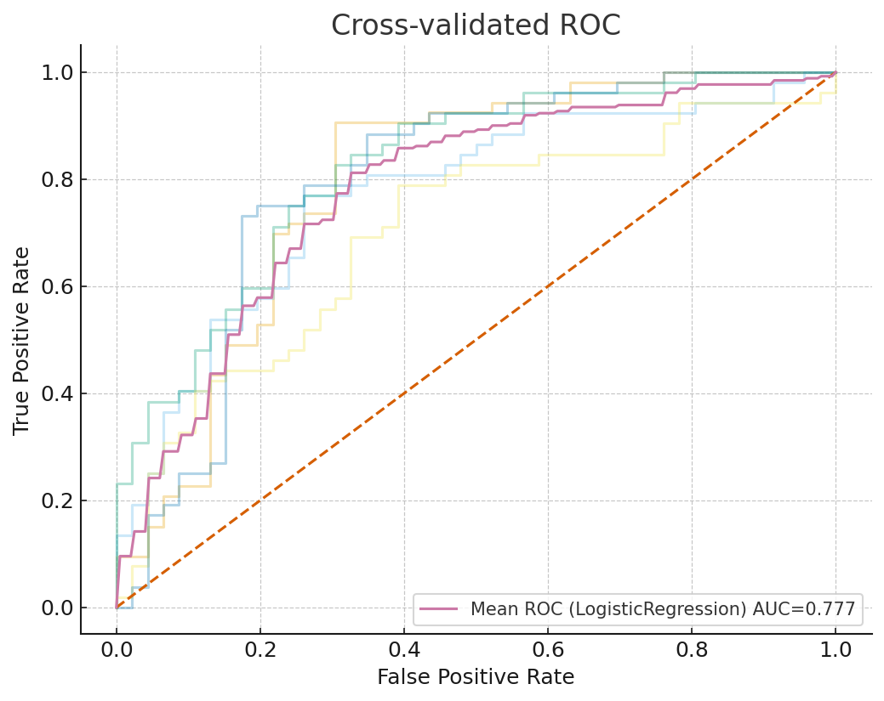
Figure 1. Cross-validated ROC curves for logistic regression.
Five-fold cross-validated receiver operating characteristic (ROC) curves for logistic regression. The mean ROC (purple line) achieved an AUC of 0.777 (95% CI: 0.735–0.819), indicating stable discrimination across folds.

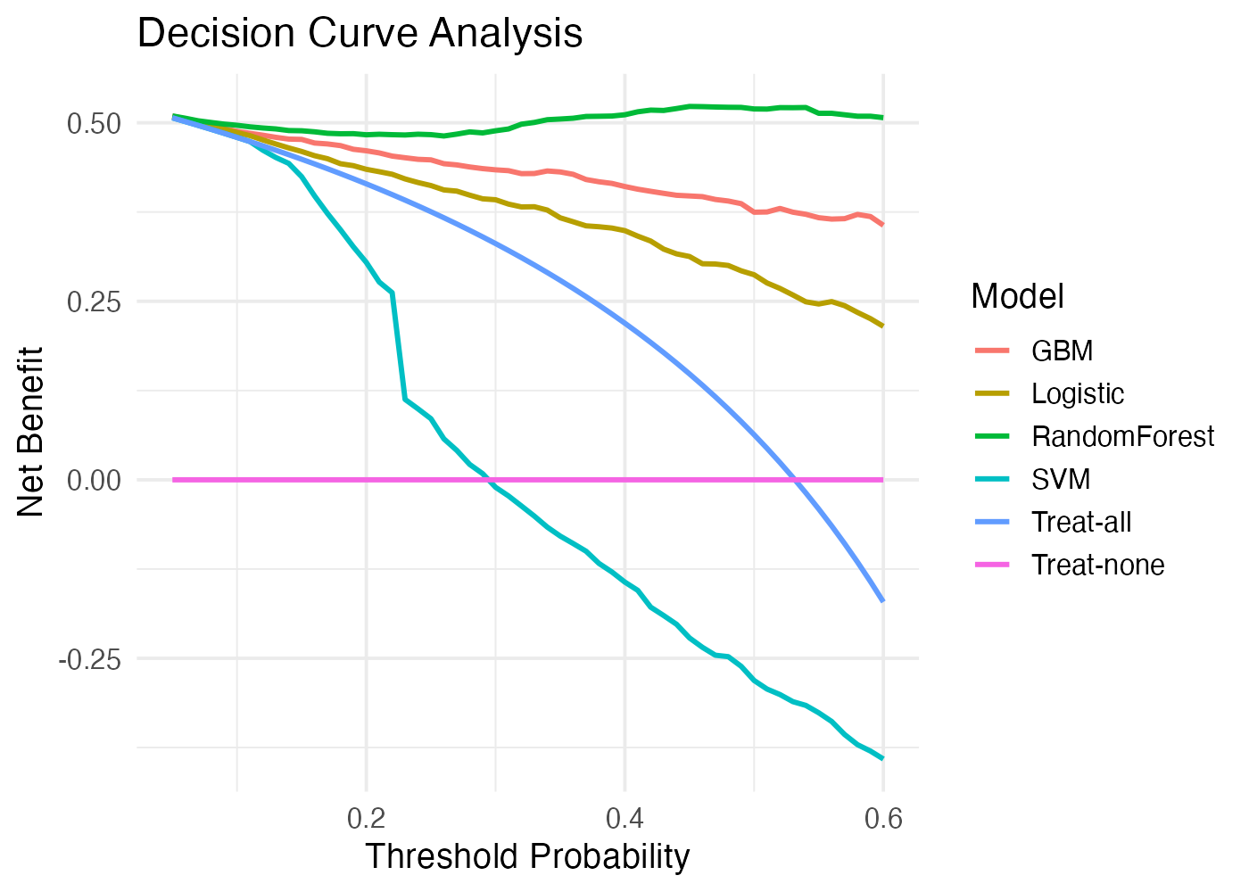
Figure 2. Decision curve analysis for four prediction models.
Decision curve analysis comparing logistic regression, random forest, gradient boosting machine (GBM), and support vector machine (SVM) across threshold probabilities from 0.05 to 0.60. Random forest demonstrated the highest net benefit, followed closely by logistic regression. Both models provided greater clinical utility than the "treat-all" and "treat-none" strategies, whereas SVM yielded negative net benefit across most thresholds.

4. Discussion

This study showed that a combination of demographic variables and detailed MRI features can be used to predict arthroscopic meniscal repairability with reasonable accuracy. The logistic regression model, trained after LASSO feature selection and internally validated using five-fold cross-validation with optimism correction, reached an AUC of 0.777 (95% CI: 0.735–0.819), which is higher than what would typically be expected from purely qualitative MRI assessment. This finding is clinically relevant given that a recent study reported that MRI-based prediction of meniscal repairability using conventional criteria demonstrates limited accuracy and poor interobserver reliability^{[14]}. Meniscal preservation is important because the meniscus plays a key role in shock absorption, load distribution, and cartilage protection, and loss of meniscal tissue is a well-known risk factor for the development and progression of knee osteoarthritis. In this context, a preoperative tool that helps estimate repairability has practical value, as it may support decision-making between meniscal repair and partial meniscectomy, which has been repeatedly linked to an increased risk of osteoarthritis in the long term.

Several demographic factors, including age, sex, and BMI, contributed to the prediction of non-repairability in our model. Increasing age is associated with progressive meniscal degeneration, characterized by reduced vascularity, mucoid change, and collagen disorganization^{[12,13]}. Older patients are also more likely to show horizontal or complex degenerative tears, which are technically more difficult to repair and have lower healing potential^{[14]}. A systematic review reported that higher age and male sex are strong risk factors for degenerative meniscal tears^{[15]}, which is consistent with our finding that older patients were more likely to have tears classified as non-repairable. BMI is another important factor: mechanical studies and epidemiological data suggest that excess body weight increases tibiofemoral load and accelerates both cartilage and meniscal degeneration^{[16,17]}. In our cohort, higher BMI was associated with non-repairable tears, which likely reflects poorer tissue quality and a more advanced degenerative environment. Sex differences may also play a role. Hormonal influences such as estrogen-related changes in ligament laxity have been described, and women tend to have greater knee laxity throughout the menstrual cycle^{[18]}. At the same time, population-based data indicate that men have a higher risk of degenerative meniscal tears, possibly due to greater occupational and sports-related loading. Our model identified male sex as a predictor of non-repairability, which may reflect the combined effect of higher mechanical load, larger BMI, and a greater proportion of trauma-related tears in male patients.

Structural MRI features showed even stronger associations with repairability. ACL integrity emerged as one of the dominant predictors. Experimental and clinical studies have demonstrated that ACL deficiency alters knee kinematics and increases shear stress on the meniscus, especially on the posterior horn^{[19]}. Combined ACL and meniscal injuries are associated with abnormal joint motion compared with isolated ACL tears^{[20]}, and chronic ACL insufficiency often leads to complex, displaced, or ramp-type tears that are more difficult to repair^{[21]}. In our model, the presence of partial or complete ACL injury significantly increased the probability of non-repairability, supporting the idea that restoration of ligament stability is crucial for successful meniscal healing. Cartilage degeneration was another key variable. Advanced chondral damage indicates a chronic degenerative joint environment with altered loading and inflammatory changes, which not only favors degenerative tear patterns but also reduces the biological capacity for repair^{[22]}. Clinical studies have reported higher failure rates of meniscal repair in knees with advanced cartilage lesions^{[23]} and in those that later progress to osteoarthritis^{[24]}, which is in line with our results.

Meniscal tear morphology, including displacement and extrusion, also played an important role. In our cohort, tears with ≥3 mm displacement were more likely to be judged as non-repairable. Displacement suggests loss of hoop tension and compromise of the meniscocapsular junction, which are difficult to restore mechanically^{[25]}. Medial meniscal extrusion on MRI has been associated with more severe degeneration and with certain tear types such as root tears^{[26,27]}. Extruded menisci transmit load less efficiently and may continue to overload the articular cartilage even after repair. These imaging features, therefore, act as markers of advanced structural failure rather than isolated focal injury. Our findings agree with previous work showing that extrusion and complex tear patterns are associated with worse structural outcomes and reduced healing potential^{[28]}. A recent study introduced the meniscal vascular contact loss ratio (MVCLR) as a novel MRI metric for predicting irreparability, achieving an AUC of 0.88^{[13]}; future work should explore whether integrating such quantitative metrics could further enhance our model's performance.

The machine-learning approach in this study offers several advantages compared with traditional visual assessment. First, it integrates multiple demographic and imaging variables simultaneously, allowing the model to capture complex interactions that are difficult to evaluate intuitively. Second, it provides an explicit probability of repairability, which can complement radiologists' narrative reports and facilitate discussion with surgeons. Previous work has shown that artificial-intelligence methods can successfully detect and grade knee lesions involving cartilage, bone marrow, meniscus, and ACL on MRI^{[29,30]}, and deep-learning-based segmentation has been used to characterize cartilage and meniscal morphology in large cohorts^{[31,32]}. Our results extend these applications by focusing specifically on repairability and by combining imaging features with clinical information. In decision curve analysis, the logistic regression and random forest models showed a clear net benefit across a range of threshold probabilities, suggesting that such models could be used as decision-support tools when counseling patients or planning surgery after prospective validation.

Several limitations should be acknowledged. This study has a retrospective single-center design, which may limit generalizability. The sample reflects the surgical indications and preferences of our institution, and external validation on independent datasets from different scanners and surgeons is needed. We therefore emphasize that our findings represent an internally validated prediction model; claims regarding generalizability should be considered preliminary until external validation is performed. Second, arthroscopic classification of "repairable" versus "non-repairable" is partly subjective and can be influenced by surgeon experience, available implants, and intraoperative judgment. Although we used predefined criteria and all procedures were performed by experienced sports medicine surgeons, we acknowledge that some variability in decision-making is unavoidable. Third, although we used a relatively simple set of machine-learning models for interpretability, more complex deep-learning approaches that directly analyze MR images may further improve predictive performance in the future. Finally, our model was developed to predict intraoperative repairability rather than long-term healing outcomes; future studies should assess whether the model can also predict postoperative healing and clinical success. Despite these limitations, our findings support the feasibility of using MRI-based machine-learning models to estimate meniscal repairability and to highlight key imaging features that should be considered during preoperative evaluation.

5. Conclusion

This study demonstrates that a radiology-centered machine-learning model using preoperative MRI features can effectively predict meniscal repairability with internally validated performance. By incorporating key imaging markers—including ligament integrity, cartilage degeneration, and detailed tear morphology—the model provides a structured and quantitative framework that may support preoperative decision-making pending prospective external validation. Such an approach has the potential to improve communication between radiologists and surgeons, guide the selection of appropriate surgical strategies, and ultimately contribute to better joint preservation in patients with meniscal injuries.

Declarations

Ethics approval and consent to participate

This study was conducted in strict accordance with the Declaration of Helsinki. Ethical approval for this study was obtained from the institutional review board of Tongji Hospital, School of Medicine, Tongji University (approval number: [insert IRB number] ), and the requirement for informed consent was waived.

Consent for publication

Not applicable.

Availability of data and materials

The data that support the findings of this study are available from the corresponding author upon reasonable request.

Competing interests

All authors declare that they have no conflicts of interest.

Funding

Project supported by Clinical Research Project of Tongji Hospital of Tongji University (Grant No. ITJ(ZD)2409). The funding body had no role in the design of the study, data collection, analysis, interpretation, or writing of the manuscript.

Authors' contributions

Peipei Hao: Conceptualization, Study Design, Data Analysis, Writing – Original Draft, Supervision, Funding Acquisition, Writing – Review & Editing, Final Approval.

Kun Cheng: Data Collection, Data Curation, Writing – Review & Editing.

Yun Xu: Software, Visualization, Writing – Review & Editing.

Zhongliu Liu: Data Collection, Writing – Review & Editing.

Jing Yao: Data Collection, Writing – Review & Editing.

Aijun Shen: Conceptualization, Supervision, Writing – Review & Editing, Final Approval.

Acknowledgements

Not applicable.

References

[Note: References should be reformatted according to JOSR style—numbered in square brackets in text, sequential order, with all authors
listed if ≤6, otherwise first 3 followed by "et al."]

1. Englund M, Roos EM, Lohmander LS. Impact of type of meniscal tear on radiographic and symptomatic knee osteoarthritis: a sixteen-year followup of meniscectomy with matched controls. Arthritis Rheum. 2003;48(8):2178-2187.
2. Whittaker JL, Losciale JM, Juhl CB, et al. Risk factors for knee osteoarthritis after traumatic knee injury: a systematic review and meta-analysis of randomised controlled trials and cohort studies for the OPTIKNEE Consensus. Br J Sports Med. 2022;56(24):1406-1421.
3. Englund M. The role of the meniscus in osteoarthritis genesis. Rheum Dis Clin North Am. 2008;34(3):573-579.
4. Englund M, Lohmander LS. Risk factors for symptomatic knee osteoarthritis fifteen to twenty-two years after meniscectomy. Arthritis Rheum. 2004;50(9):2811-2819.
5. Papalia R, Del Buono A, Osti L, Denaro V, Maffulli N. Meniscectomy as a risk factor for knee osteoarthritis: a systematic review. Br Med Bull. 2011;99:89-106.
6. Englund M, Felson DT, Guermazi A, et al. Risk factors for medial meniscal pathology on knee MRI in older U.S. adults: A multicenter prospective cohort study. Ann Rheum Dis. 2011;70(10):1733-1739.
7. Roemer FW, Kwoh CK, Hannon MJ, et al. Risk factors for magnetic resonance imaging-detected patellofemoral and tibiofemoral cartilage loss during a six-month period: the joints on glucosamine study. Arthritis Rheum. 2012;64(6):1888-1898.
8. Fritz B, Fritz J. Artificial intelligence for MRI diagnosis of joints: a scoping review of the current state-of-the-art of deep learning-based approaches. Skeletal Radiol. 2022;51(2):315-329.
9. Tiulpin A, Thevenot J, Rahtu E, Lehenkari P, Saarakkala S. Automatic Knee Osteoarthritis Diagnosis from Plain Radiographs: A Deep Learning-Based Approach. Sci Rep. 2018;8(1):1727.
10. Pedoia V, Majumdar S. Translation of morphological and functional musculoskeletal imaging. J Orthop Res. 2019;37(1):23-34.
11. Vickers AJ, Elkin EB. Decision curve analysis: a novel method for evaluating prediction models. Med Decis Making. 2006;26(6):565-574.
12. Makris EA, Hadidi P, Athanasiou KA. The knee meniscus: structure-function, pathophysiology, current repair techniques, and prospects for regeneration. Biomaterials. 2011;32(30):7411-7431.

13. Sun Y, Mauerhan DR, Honeycutt PR, et al. Analysis of meniscal degeneration and meniscal gene expression. BMC Musculoskelet Disord. 2010;11:19.
14. Snoeker BAM, Bakker EWP, Kegel CAT, Lucas C. Risk factors for meniscal tears: a systematic review including meta-analysis. J Orthop Sports Phys Ther. 2013;43(6):352-367.
15. Vannini F, Spalding T, Andriolo L, et al. Sport and early osteoarthritis: the role of sport in aetiology, progression and treatment of knee osteoarthritis. Knee Surg Sports Traumatol Arthrosc. 2016;24(6):1786-1796.
16. Crema MD, Roemer FW, Felson DT, et al. Factors associated with meniscal extrusion in knees with or at risk for osteoarthritis: the Multicenter Osteoarthritis study. Radiology. 2012;264(2):494-503.
17. Shultz SJ, Sander TC, Kirk SE, Perrin DH. Sex differences in knee joint laxity change across the female menstrual cycle. J Sports Med Phys Fitness. 2005;45(4):594-603.
18. Domnick C, Raschke MJ, Herbort M. Biomechanics of the anterior cruciate ligament: Physiology, rupture and reconstruction techniques. World J Orthop. 2016;7(2):82-93.
19. Hosseini A, Li JS, Gill TJ, Li G. Meniscus Injuries Alter the Kinematics of Knees With Anterior Cruciate Ligament Deficiency. Orthop J Sports Med. 2014;2(8):2325967114547346.
20. Matsushita T, Nagai K, Araki D, et al. Factors associated with the status of meniscal tears following meniscal repair concomitant with anterior cruciate ligament reconstruction. Connect Tissue Res. 2017;58(3-4):386-392.
21. Ter Heegde F, Luiz AP, Santana-Varela S, et al. Osteoarthritis-related nociceptive behaviour following mechanical joint loading correlates with cartilage damage. Osteoarthritis Cartilage. 2020;28(3):383-395.
22. Ronnblad E, Barenius B, Engstrom B, Eriksson K. Predictive Factors for Failure of Meniscal Repair: A Retrospective Dual-Center Analysis of 918 Consecutive Cases. Orthop J Sports Med. 2020;8(3):2325967120905529.
23. Wang L, Zhang K, Liu X, et al. The efficacy of meniscus posterior root tears repair: A systematic review and meta-analysis. J Orthop Surg (Hong Kong). 2021;29(1):23094990211003350.
24. Costa CR, Morrison WB, Carrino JA. Medial meniscus extrusion on knee MRI: is extent associated with severity of degeneration or type of tear? AJR Am J Roentgenol. 2004;183(1):17-23.
25. Shimozaki K, Nakase J, Kanayama T, et al. Extrusion of the medial meniscus under a weight-loading condition in early knee osteoarthritis: an investigation using special upright magnetic resonance imaging. BMC Musculoskelet Disord. 2023;24(1):680.
26. Krych AJ, Reardon PJ, Johnson NR, et al. Non-operative management of medial meniscus posterior horn root tears is associated with worsening arthritis and poor clinical outcome at 5-year follow-up. Knee Surg Sports Traumatol Arthrosc. 2017;25(2):383-389.
27. Kijowski R, Fritz J, Deniz CM. Deep learning applications in osteoarthritis imaging. Skeletal Radiol. 2023;52(11):2225-2238.
28. Astuto B, Flament I, K Namiri N, et al. Automatic Deep Learning-assisted Detection and Grading of Abnormalities in Knee MRI Studies. Radiol Artif Intell. 2021;3(3):e200165.
29. Namiri NK, Lee J, Astuto B, et al. Deep learning for large scale MRI-based morphological phenotyping of osteoarthritis. Sci Rep. 2021;11(1):10915.
30. Tang X, Guo D, Liu A, et al. Fully Automatic Knee Joint Segmentation and Quantitative Analysis for Osteoarthritis from Magnetic Resonance (MR) Images Using a Deep Learning Model. Med Sci Monit. 2022;28:e936733.
31. Zhao Y, Coppola A, Karamchandani U, Amiras D, Gupte CM. Artificial intelligence applied to magnetic resonance imaging reliably detects the presence, but not the location, of meniscus tears: a systematic review and meta-analysis. Eur Radiol. 2024;34:5954-5964.
32. MRI-Based Prediction of Meniscal Tear Repairability Demonstrates Limited Accuracy and Reliability. J Clin Med. 2025;14(12):4160.
33. Urresta FE, Peñaherrera-Carrillo C, Castro AB. Meniscal vascular contact loss ratio (MVCLR): A novel MRI index for predicting meniscal irreparability. Knee. 2025; [Epub ahead of print].

