Deep learning and radiomics based on MRI predict recurrent lumbar disc herniation following percutaneous endoscopic lumbar discectomy

Kangle Song ^{1 #}, Deyang Qiao ^{2, 3#}, Xingkun Wang ^{1 #}, Xiangzhen Kong¹, Zhenchuan Liu¹, Yu Wang¹, Jilai Wang ^{2, 3 *}, Jianlu Wei ^{1 *}, Lei Cheng ^{1 *}

¹ Department of Orthopedics, Qilu Hospital of Shandong University, Jinan, Shandong, 250012, P. R. China.
² Key Laboratory of High Efficiency and Clean Mechanical Manufacture of Ministry of Education, School of Mechanical Engineering, Shandong University, Jinan, Shandong, 250061, P. R. China.
³ National Demonstration Center for Experimental Mechanical Engineering Education, Shandong University, Jinan, Shandong, 250061, P. R. China

# These authors contribute equally.

*To whom correspondence should be addressed:
Lei Cheng, Department of Orthopedics, Qilu Hospital of Shandong University, 107 Wenhuaxi Road, Jinan, P. R. China 250012. Email: chenglei@email.sdu.edu.cn.
Jianlu Wei, Department of Orthopedics, Qilu Hospital of Shandong University, 107 Wenhuaxi Road, Jinan, P. R. China 250012. Email: drjianluwei@163.com
Jilai Wang, Key Laboratory of High Efficiency and Clean Mechanical Manufacture of Ministry of Education, School of Mechanical Engineering, Shandong University, Jinan, Shandong, P. R. China 250061. Email:
National Demonstration Center for Experimental Mechanical Engineering Education, Shandong University, Jinan, Shandong, P. R. China 250061. Email: jlwang@sdu.edu.cn

Table S1 Univariate and multivariate regression analyses of variables included in the combined prediction Model.
Variables | univariate analysis |  |  |  |  |  | multivariate analysis
Variables | β | S.E | Z | P | OR (95%CI) |  | β | S.E | Z | P | OR (95%CI)
DPZ | 0.08 | 0.01 | 8.10 | <.001 | 1.09 (1.07 ~ 1.11) |  | 0.10 | 0.01 | 6.88 | <.001 | 1.10 (1.07 ~ 1.13)
Rad-Score | -1.51 | 0.23 | -6.59 | <.001 | 0.22 (0.14 ~ 0.35) |  | -1.81 | 0.31 | -5.79 | <.001 | 0.16 (0.09 ~ 0.30)
PMFI | 0.09 | 0.03 | 3.13 | 0.002 | 1.09 (1.03 ~ 1.16) |  | 0.12 | 0.04 | 2.94 | 0.003 | 1.13 (1.04 ~ 1.22)
Srom | 0.22 | 0.05 | 4.54 | <.001 | 1.25 (1.13 ~ 1.37) |  | 0.31 | 0.08 | 4.09 | <.001 | 1.37 (1.18 ~ 1.58)
Preoperative Vas Score | 0.73 | 0.13 | 5.52 | <.001 | 2.08 (1.60 ~ 2.70)
OR: Odds Ratio, CI: Confidence Interval

Figure S1 Web Tool: Dynamic Nomogram.
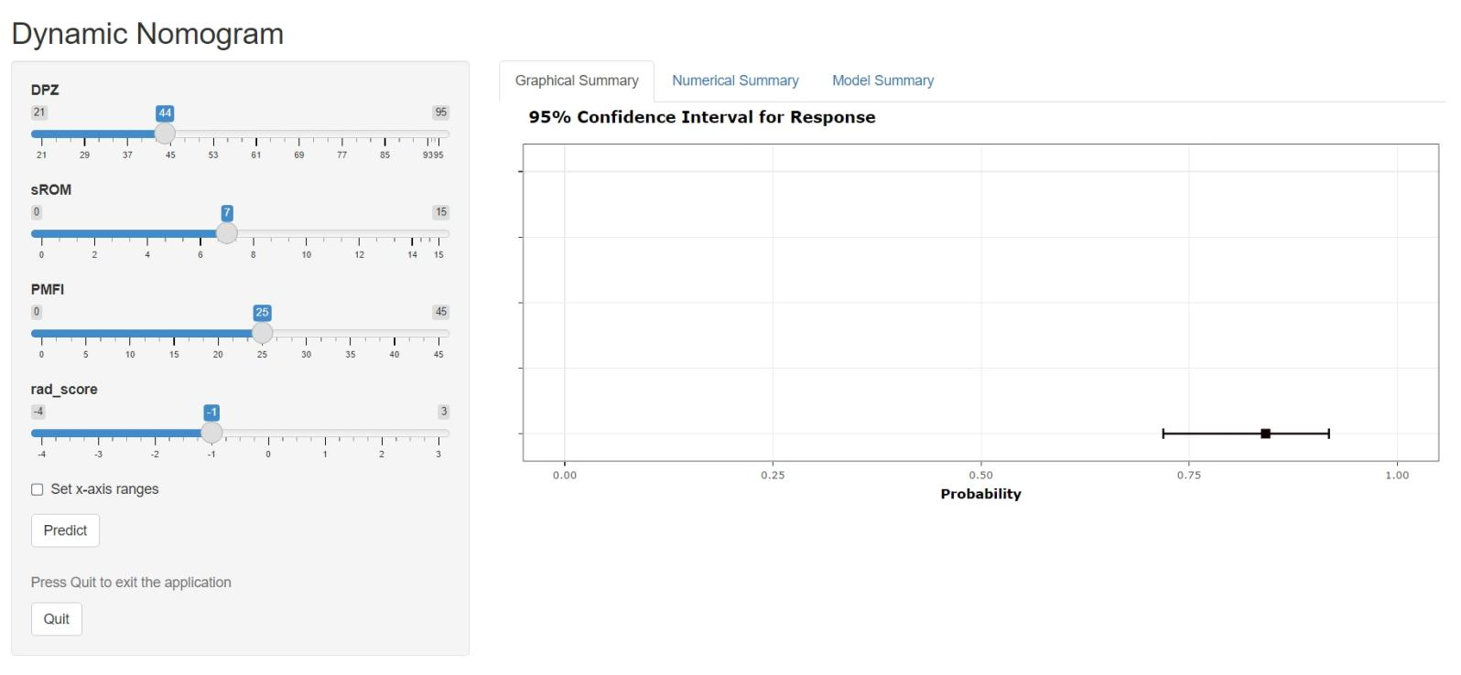

Figure S2 MRI findings from the representative patient.

Figure S3 Grad-CAM visualization of the ResNet18 model. (A) Original sagittal T2-weighted MRI image. (B) Grad-CAM heatmap overlaid on the original image, showing the attention regions of the model for recurrence prediction.

