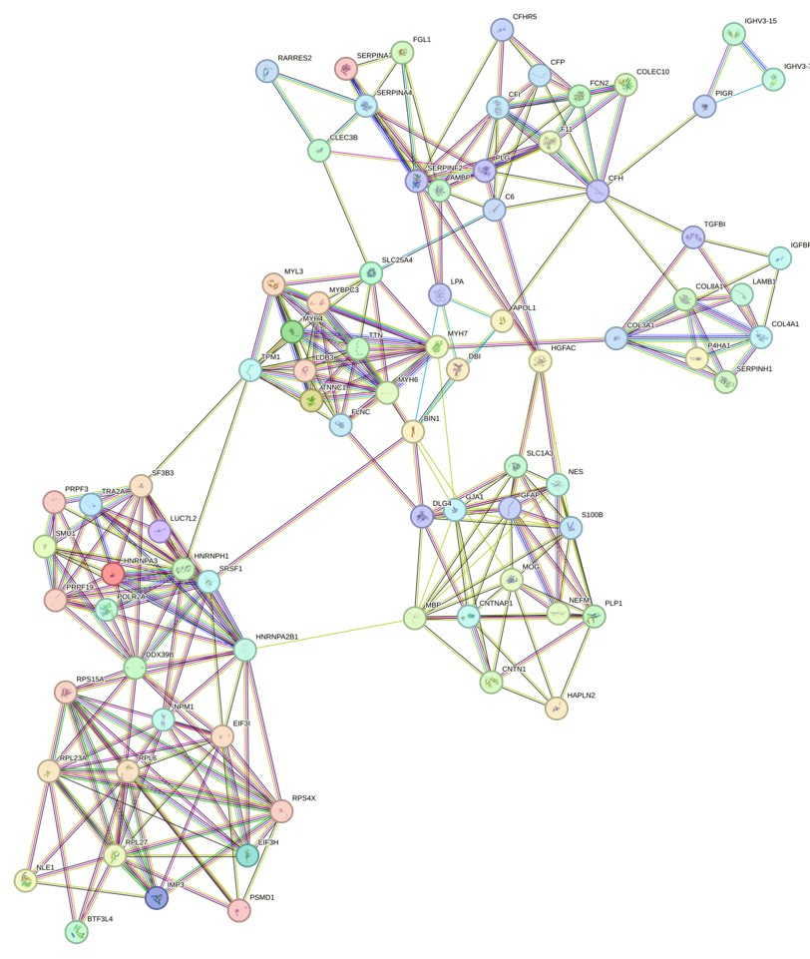Supplementary Figure 1. The main modules of differentially expressed proteins in the Protein–protein interaction (PPI) network analysis. Different colors represent the level of evidence.

