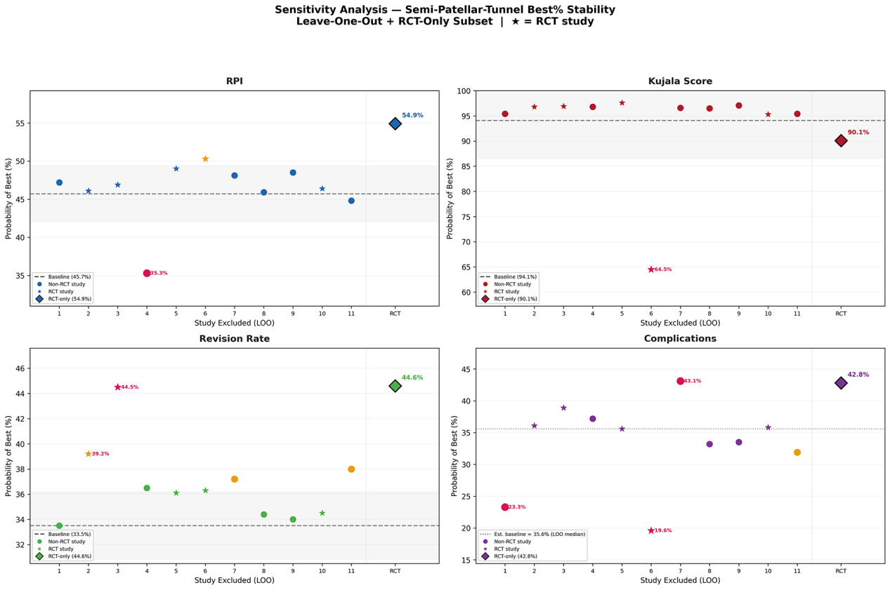
Supplementary Figure. 1 Sensitivity analysis of NMA results via leave-one-out approach. The semi-patellar tunnel technique demonstrated the best ranking stability for recurrent patellar instability and revision rate across all scenarios. Each data point represents the probability of ranking as the best treatment after sequentially excluding one study from the network.

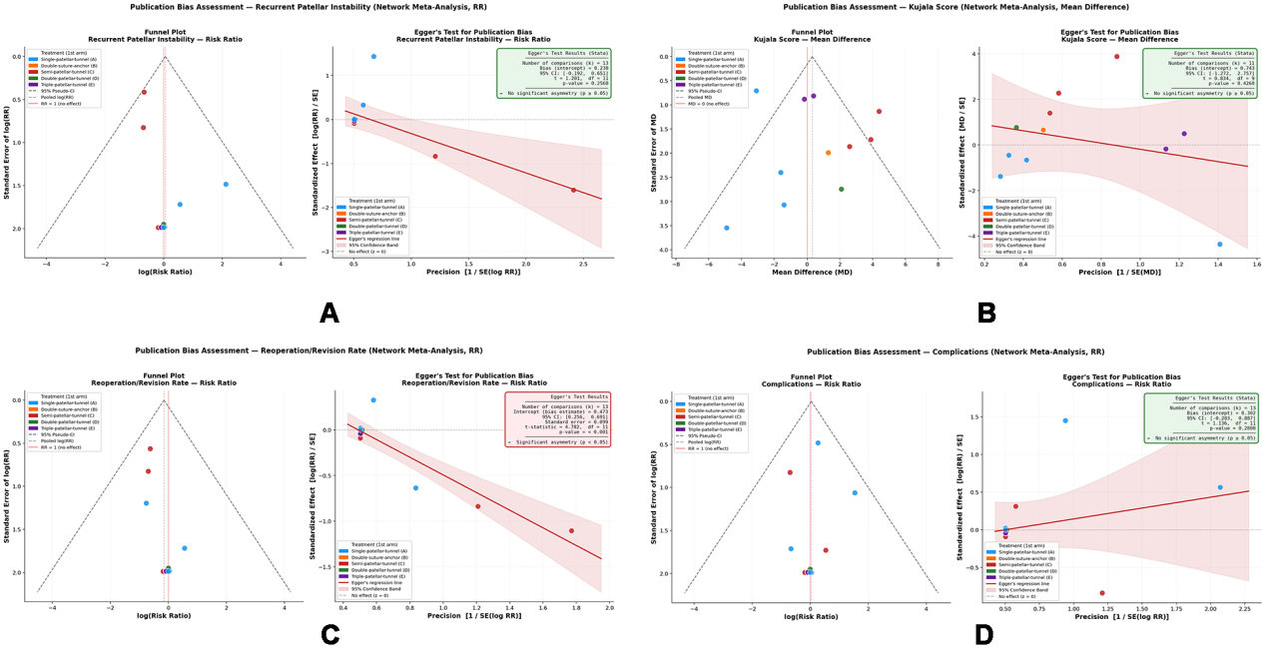
Supplementary Figure. 2 Funnel plots and Egger's test results for publication bias assessment. Egger's test indicated significant publication bias for revision rate (P = 0.002); no significant publication bias was detected for the other three outcomes (all P > 0.05).

