SUPPLEMENTARY MATERIAL
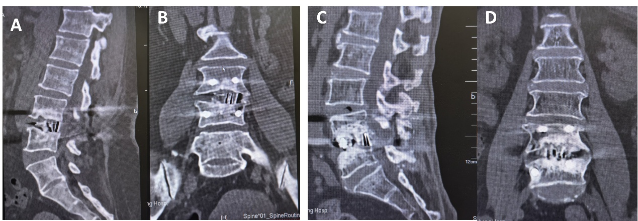
Supplementary Figure S1. Representative 12-month postoperative CT images illustrating Bridwell fusion grades in Type D revision cases. (A) Sagittal and (B) coronal views of a Type D patient with Bridwell Grade II (stable, potential fusion). The cage-endplate interface shows incomplete bone remodeling without continuous bridging, but no periprosthetic lucency is present. (C) Sagittal and (D) coronal views of a Type D patient with Bridwell Grade I (solid fusion), demonstrating continuous trabecular bridging across the intervertebral space (arrows) with complete graft incorporation. Scale bars = 10 mm.
Supplementary Table S1. Cross-tabulation of Index Surgery, Scar Pattern Type, Clinical Subtype, and Dural Tears
Scar Pattern Type | Index Surgery | Type A (n=28) | Type B (n=21) | Type C (n=14) | Type D (n=9) | Type E (n=15) | Total | Dural Tear (n)
I | Transforaminal endoscopic/mini-open discectomy | 8 | 0 | 7 | 0 | 0 | 15 | 0
II | Interlaminar endoscopic/unilateral laminotomy | 16 | 0 | 5 | 0 | 0 | 21 | 0
III | MIS-TLIF/unilateral fusion | 0 | 10 | 0 | 5 | 8 | 23 | 0
IV | Wide laminectomy / open PLIF | 4 | 11 | 2 | 4 | 7 | 28 | 4
Total |  | 28 | 21 | 14 | 9 | 15 | 87 | 4
Footnote: Scar pattern type IV reflects either a prior wide laminectomy (decompression) or an open PLIF (fusion). Therefore, Type IV cases may appear in clinical subtypes A and C when the index procedure was a wide laminectomy, and in subtypes B, D, and E when the index procedure was an open PLIF. All four dural tears occurred in Type IV scar pattern cases, and all were in clinical Type D patients.

