Supplementary Material
Manuscript: Age- and Sex-Specific Patterns, Seasonality and Temporal Trends of Acute Pediatric Fracture Admissions in China: A Pooled Multicenter Hospital-Based Cohort of 6,206 Children.
Supplementary Methods 1. Negation / uncertainty term list
A flagged record was counted as a confirmed acute fracture only if at least one mention of “骨折” (fracture) remained after removing all of the following negation/uncertainty expressions.
Supplementary Table M1. Negation/uncertainty terms.
Chinese term | English gloss
未见骨折 | no fracture seen
未见明显骨折 | no obvious fracture seen
排除骨折 | fracture excluded
骨折待排 | fracture to be ruled out
骨折待查 | fracture to be investigated
骨折？ | fracture? (full-width)
骨折? | fracture? (half-width)
无骨折 | no fracture
除外骨折 | fracture excluded

Supplementary Methods 2. Site-parsing lexicon and supracondylar rule
Fracture site(s) were parsed from the concatenated admission and discharge diagnosis text by substring matching against the lexicon below; a child could match several sites, and sites were grouped into four regions. Supracondylar humeral fracture was flagged when the diagnosis text contained the substring “髁上” (supracondylar) and a humeral term (肱骨); records in which “髁上” referred to the femur (股骨髁上骨折, n = 9 children) were not counted as supracondylar humeral fractures. Pathological fractures were flagged by 病理性骨折, 病理骨折, 骨肉瘤, 尤文, 骨囊肿, 骨巨细胞, 转移, 成骨不全; old/healed fractures by 陈旧性骨折, 陈旧骨折, 陈旧性. Records whose diagnosis text contained “骨折” but no lexicon term (e.g., “多发骨折” without a named site) were retained in the cohort with no region assigned (n = 211 children, 3.4%).
Supplementary Table M2. Site-parsing keyword lexicon.
Region | Site | Keywords (matched substrings)
Upper limb | Clavicle | 锁骨
Upper limb | Scapula | 肩胛
Upper limb | Humerus | 肱骨
Upper limb | Forearm (radius/ulna) | 尺骨, 桡骨, 前臂, 孟氏, 盖氏
Upper limb | Carpal (scaphoid/lunate) | 腕舟, 舟骨骨折, 月骨
Upper limb | Hand (metacarpal/phalanx) | 掌骨, 指骨, 手部
Lower limb | Femur | 股骨
Lower limb | Patella | 髌骨
Lower limb | Tibia/fibula | 胫骨, 腓骨
Lower limb | Ankle | 踝, 内踝, 外踝
Lower limb | Foot (metatarsal/phalanx/calcaneus/talus) | 跖骨, 趾骨, 跟骨, 距骨, 骰骨, 足舟, 足部
Axial | Spine/vertebra | 椎体, 脊柱, 椎弓, 棘突, 横突, 寰椎, 枢椎
Axial | Pelvis/hip | 骨盆, 髋臼, 耻骨, 坐骨, 髂骨, 骶, 尾骨
Axial | Rib | 肋骨
Axial | Sternum | 胸骨
Craniofacial | Skull | 颅骨, 颅底, 枕骨, 额骨, 顶骨, 颞骨, 蝶骨
Craniofacial | Nasal | 鼻骨
Craniofacial | Maxillofacial (maxilla/mandible/orbit/zygoma) | 下颌, 上颌, 颌骨, 眼眶, 眶, 颧, 牙槽

Supplementary Methods 3. Validation sampling protocol
Positive predictive value (original submission). A random sample of 200 flagged records was re-classified into acute traumatic, pathological, old/healed or uncertain/suspected; 177/200 (88.5%; Wilson 95% CI 83.3–92.2%) were acute traumatic fractures.
Additional validation (this revision). From the 251,385 pediatric admissions, three review sets were drawn with a fixed random seed: (A) 200 random flagged (acute) records, in which fracture identification and the parsed anatomical site(s) and supracondylar flag were reviewed separately; (B) 200 random non-flagged records; and (C) 300 non-flagged records enriched for fracture-related terms — negated or uncertain fracture mentions (n = 20 in the whole dataset) and fracture-synonym terms (epiphyseal separation/injury, bone crack, avulsion, greenstick, cortical, collapse, bone contusion, dislocation, displacement, comminution; n = 601 in the whole dataset; enriched pool n = 621). Reviewers recorded, for each record, whether a fracture was present, its type (acute traumatic / pathological / old-healed / none), the correct anatomical site(s) and the supracondylar status. Sensitivity was estimated as the proportion of true acute fractures captured by the flag, using the random and enriched non-flagged samples to bound the number of missed fractures. [Author to insert results: number of true fractures found in set B and set C; site-parsing agreement in set A; estimated sensitivity.]
Radiology linkage. Linkage of admissions to the radiology-report table (1,751,244 reports) as an independent reference standard was attempted but was not feasible: the imaging system used a different patient-identifier scheme and only 4,313 reports (0.25%) could be matched to a pediatric admission identifier.
Supplementary Table S1. Distribution of fractures by anatomical site (n = 6,206 children; a child may contribute to more than one site).
Fracture site | Region | n | % of children | % male
Humerus | Upper limb | 1,341 | 21.6 | 69.6
Forearm (radius/ulna) | Upper limb | 968 | 15.6 | 79.6
Skull | Craniofacial | 922 | 14.9 | 63.7
Tibia/fibula | Lower limb | 886 | 14.3 | 69.6
Femur | Lower limb | 640 | 10.3 | 69.2
Hand (metacarpal/phalanx) | Upper limb | 441 | 7.1 | 77.6
Ankle | Lower limb | 435 | 7.0 | 64.4
Clavicle | Upper limb | 410 | 6.6 | 75.6
Maxillofacial | Craniofacial | 310 | 5.0 | 67.7
Foot | Lower limb | 309 | 5.0 | 58.9
Pelvis/hip | Axial | 301 | 4.9 | 65.8
Spine/vertebra | Axial | 212 | 3.4 | 54.7
Rib | Axial | 156 | 2.5 | 66.7
Patella | Lower limb | 139 | 2.2 | 68.3
Nasal | Craniofacial | 53 | 0.9 | 69.8
Scapula | Upper limb | 38 | 0.6 | 78.9
Carpal | Upper limb | 29 | 0.5 | 82.8
Sternum | Axial | 14 | 0.2 | 42.9

Supplementary Table S2. Sex-specific site predilection (age-adjusted logistic regression, one model per site; exploratory, not adjusted for multiplicity).
Site | n | % male | Age-adjusted OR, male vs female (95% CI) | p
Humerus | 1,341 | 69.6 | 1.10 (0.96–1.26) | 0.178
Forearm | 968 | 79.6 | 1.60 (1.35–1.90) | <0.001
Skull | 922 | 63.7 | 0.94 (0.80–1.10) | 0.414
Tibia/fibula | 886 | 69.6 | 0.77 (0.66–0.90) | 0.001
Femur | 640 | 69.2 | 0.92 (0.77–1.10) | 0.354
Hand | 441 | 77.6 | 1.38 (1.09–1.74) | 0.007
Ankle | 435 | 64.4 | 0.47 (0.38–0.59) | <0.001
Clavicle | 410 | 75.6 | 1.24 (0.98–1.57) | 0.070
Maxillofacial | 310 | 67.7 | 0.91 (0.71–1.16) | 0.440
Foot | 309 | 58.9 | 0.46 (0.36–0.59) | <0.001
Pelvis/hip | 301 | 65.8 | 0.68 (0.53–0.87) | 0.002
Spine | 212 | 54.7 | 0.40 (0.30–0.53) | <0.001
Patella | 139 | 68.3 | 0.63 (0.43–0.91) | 0.013

Supplementary Table S3. Patient-identifier-format strata (data-source proxy).
Characteristic | Identifier format 1 (8-digit) | Identifier format 2 (letter-prefixed)
Children, n (%) | 4,987 (80.4) | 1,219 (19.6)
Male, % | 69.3 | 77.3
Median age, years | 9.0 | 12.1
Upper-limb involvement, % | 48.3 | 51.5
Lower-limb involvement, % | 31.0 | 35.0
Craniofacial involvement, % | 19.5 | 9.5
Children by year 2020/2021/2022/2023/2024 | 339/1513/1095/1088/952 | 88/370/307/246/208
Trend rate ratio per year, NB (95% CI)* | 0.83 (0.79–0.87) | 0.79 (0.74–0.84)
Stratum effect in limb model, OR (95% CI) | reference | 0.93 (0.80–1.08)
*Because the pediatric-admission denominator could not be split by identifier format, the within-stratum trend models use the pooled denominator (proportional-share assumption). Hospital-number series: the main numeric series contained 99.8% of acute-fracture admissions; two minor series (R- and L-prefixed; 10.3% of pediatric admissions overall, 3.0% in 2020 rising to 12.7% in 2024) contributed 16 fracture admissions — restricting the denominator to the main series gave a trend rate ratio of 0.82 (0.79–0.86).

Supplementary Table S4. Fracture pattern by COVID-19 period (exploratory; partial year 2020 excluded; p values only for the two pre-specified comparisons, Mann–Whitney U and χ²).
Characteristic | Restriction period (2021–2022) | Post-restriction period (2023–2024) | p
Children, n | 3,285 | 2,494 | —
Male, % | 70.9 | 71.0 | —
Median age, years | 9.4 | 11.1 | <0.001
Upper-limb involvement, % | 50.9 | 45.8 | —
Lower-limb involvement, % | 30.2 | 34.4 | 0.001
Supracondylar, % | 10.6 | 8.2 | —
Multiple-region, % | 7.6 | 9.7 | —

Supplementary Table S5. Exploratory machine-learning benchmark for lower-only vs upper-only limb fracture (n = 4,728).
Model (5-fold cross-validation) | AUC
Gradient-boosted classifier (age, sex, season, year, weekend, hour) | 0.629
Logistic regression (same features) | 0.643

Supplementary Table S6. Full output of the cosinor seasonal-trend models (50 months, October 2020 – November 2024).
Model | Harmonic amplitude A | Relative amplitude % (95% CI) | Peak-to-trough ratio (95% CI) | Peak month (95% CI) | Seasonality p | Trend RR/year (95% CI) | Trend p
Episode level, negative-binomial (α = 0.038) | 0.133 | 14.3 (6.7–24.5) | 1.31 (1.14–1.55) | 10.50 (9.13–11.79) | 0.00746 | 0.823 (0.783–0.864) | 9.4e-15
Episode level, quasi-Poisson (scale = 6.82) | 0.135 | 14.5 (6.0–25.7) | 1.31 (1.12–1.58) | 10.72 (9.41–0.10) | 0.016 | 0.817 (0.776–0.861) | 5.1e-14
Episode level, Poisson | 0.135 | 14.5 (10.8–18.5) | 1.31 (1.23–1.40) | 10.72 (10.26–11.19) | 3.69e-14 | 0.817 (0.801–0.834) | 4.2e-86
Index admissions, negative-binomial (α = 0.057) | 0.143 | 15.3 (6.6–28.0) | 1.33 (1.14–1.64) | 10.47 (8.92–11.96) | 0.017 | 0.830 (0.783–0.879) | 3.5e-10
Index admissions, quasi-Poisson (scale = 8.78) | 0.148 | 15.9 (5.8–29.8) | 1.34 (1.12–1.69) | 10.70 (9.22–0.27) | 0.0334 | 0.824 (0.773–0.878) | 2.8e-09
Index admissions, Poisson | 0.148 | 15.9 (11.9–20.3) | 1.34 (1.25–1.45) | 10.70 (10.25–11.16) | 1.06e-14 | 0.824 (0.807–0.842) | 2.1e-69
Single-joinpoint model (episode level, negative-binomial): joinpoint at 2023.6; annual percentage change -22.7% before and 0.0% after. Crude fracture-admission rate per 1,000 pediatric admissions by season: spring 29.1, summer 22.6, autumn 36.8, winter 27.8. Acute-fracture admission episodes / children by year: 2020 (Oct–Dec) 437/427; 2021 2,139/1,883; 2022 1,795/1,402; 2023 1,497/1,334; 2024 (Jan–Nov) 1,274/1,160.

Supplementary Figures
Supplementary Figure S1. Study flow chart showing the two units of analysis (admission episodes and children) and the analytic subsets.
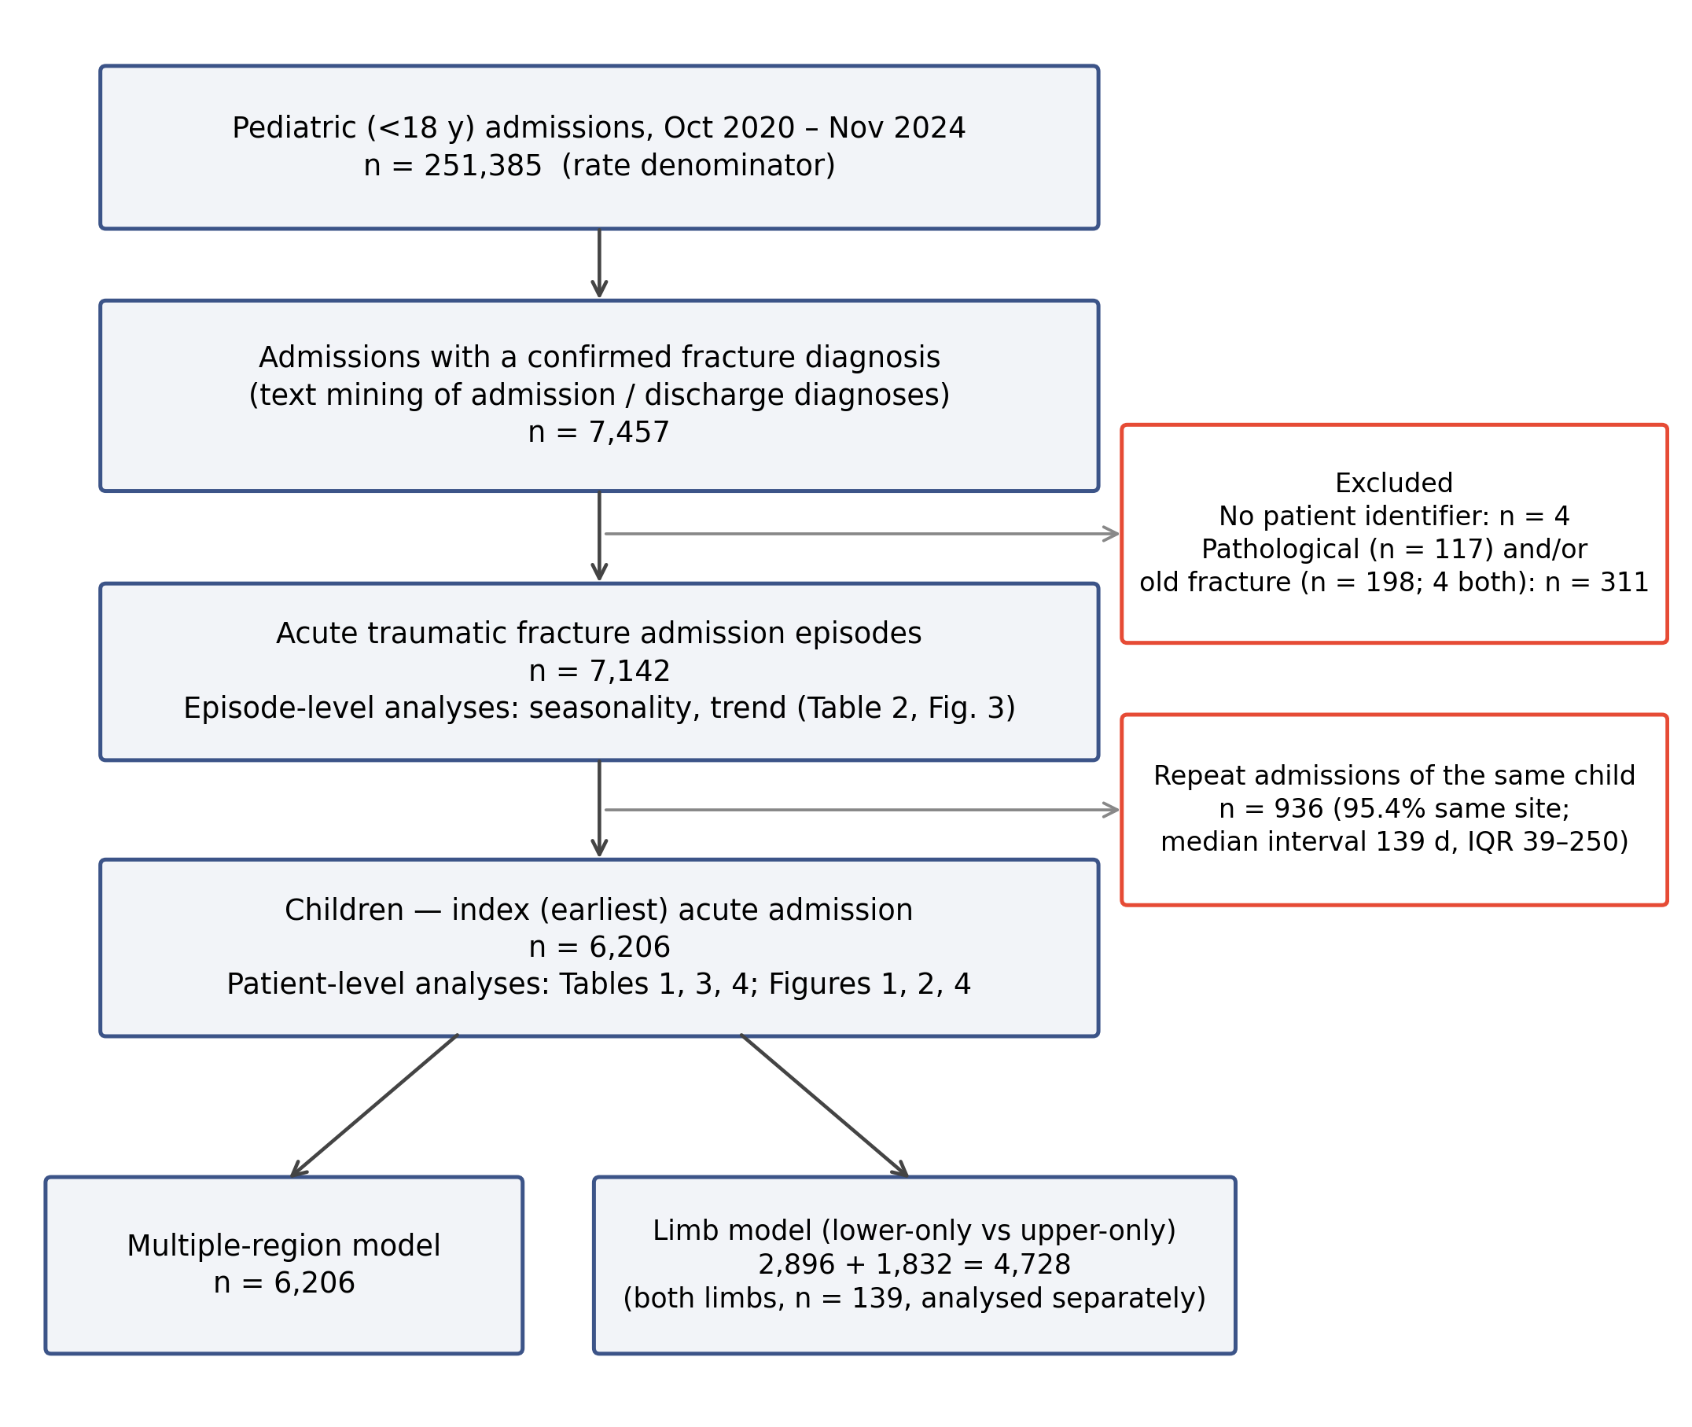

Supplementary Figure S2. Anatomical region composition by age group (100% stacked; regions not mutually exclusive).
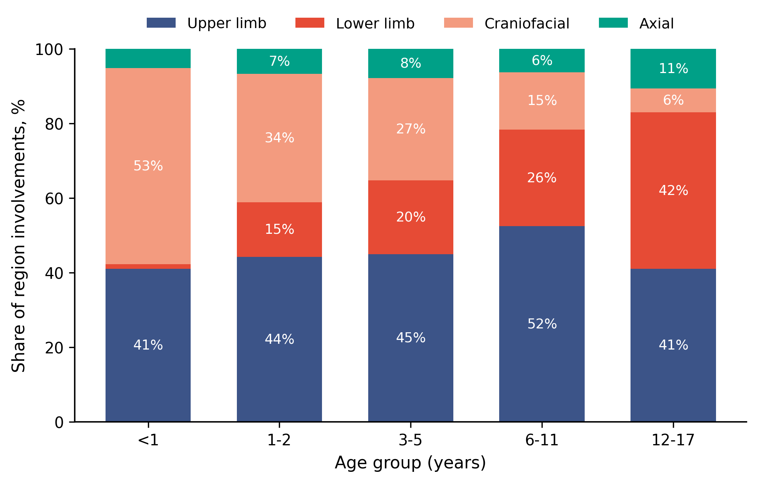

Supplementary Figure S3. Site involvement (% of children in each age group) for the eight most common sites.
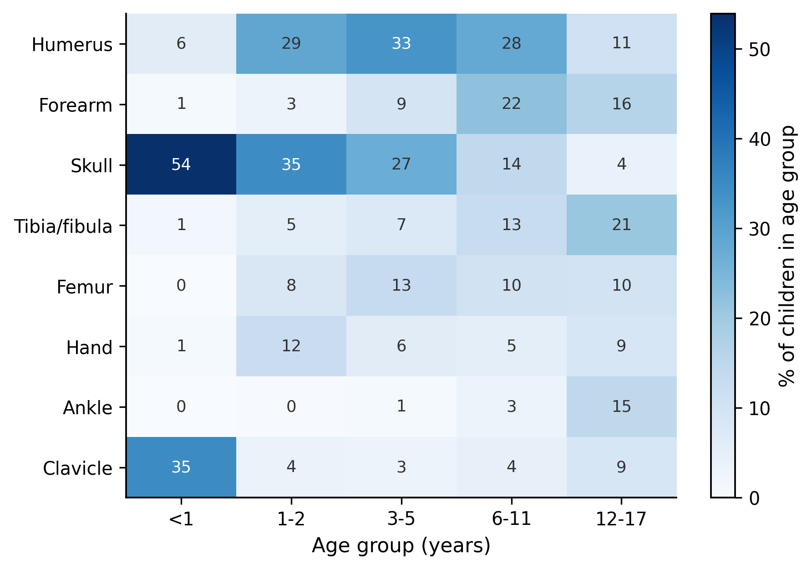

Supplementary Figure S4. Time-of-day and day-of-week distribution of acute-fracture admissions (weekend highlighted).
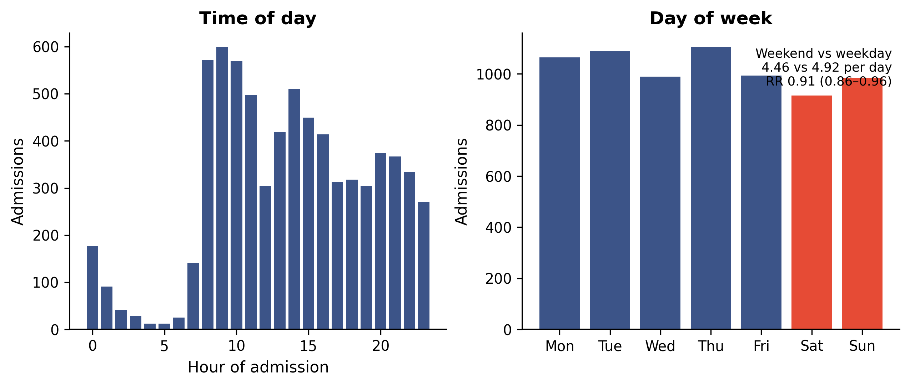

Supplementary Figure S5. Single-joinpoint segmentation of the monthly fracture-admission rate (negative-binomial cosinor fit shown for reference).
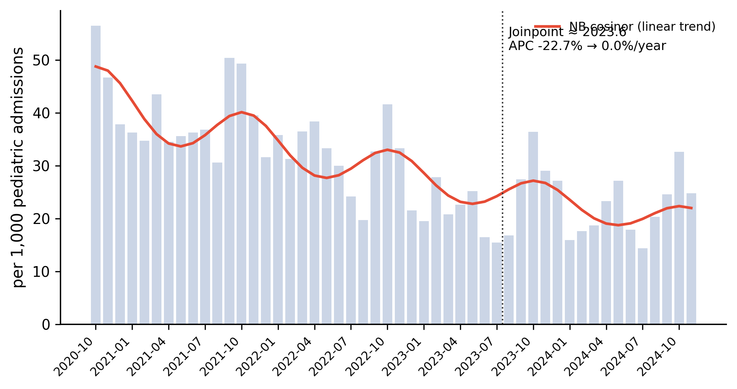

Supplementary Figure S6. Fracture pattern in the COVID-19 restriction (2021–2022) versus post-restriction (2023–2024) period (exploratory).
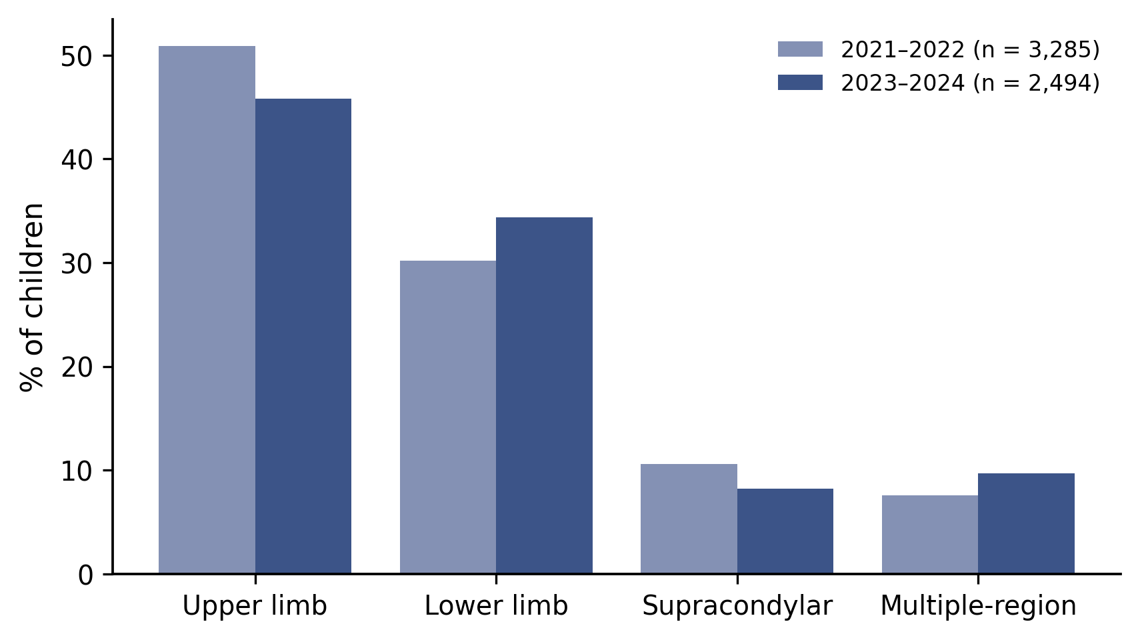

STROBE Statement — checklist for cohort studies
Supplementary Table S7. STROBE checklist.
Item | Recommendation | Section in revised manuscript
1 | Title and abstract — informative title; structured abstract | Title; Abstract
2 | Background/rationale | Introduction, paras 1–2
3 | Objectives | Introduction, para 3 (aims 1–3)
4 | Study design | Methods 2.1
5 | Setting, locations, dates | Methods 2.1 (three hospitals; Oct 2020–Nov 2024)
6 | Participants/eligibility; unit of analysis | Methods 2.2; Supplementary Figure S1
7 | Variables (outcomes, exposures, confounders) | Methods 2.4
8 | Data sources/measurement | Methods 2.2–2.3; Supplementary Methods 1–3
9 | Bias | Methods 2.3 (validation); Discussion 4.1 (referral bias, center identifier)
10 | Study size | Methods 2.2 (all eligible cases)
11 | Quantitative variables / groupings | Methods 2.4
12 | Statistical methods (incl. subgroups, sensitivity, missing data) | Methods 2.5; Supplementary Table S6
13 | Participants (numbers at each stage) | Results 3.1; Supplementary Figure S1
14 | Descriptive data | Results 3.1–3.2; Table 1; Figure 1
15 | Outcome data | Results 3.2–3.5; Tables 1–3
16 | Main results (adjusted estimates, CIs) | Results 3.3–3.5; Tables 2–3; Figures 2–4
17 | Other analyses (interactions, sensitivity, exploratory) | Results 3.3, 3.6; Table 4; Supplementary Tables S2–S5
18 | Key results | Discussion, para 1
19 | Limitations | Discussion 4.1
20 | Interpretation | Discussion, paras 2–7
21 | Generalisability | Discussion 4.1 (hospital-based; pooled cohort)
22 | Funding | Declarations (Funding)
Section references refer to the revised manuscript; item 6 (participants/unit of analysis) is addressed in Methods 2.2; item 9 (bias) in Methods 2.3 and Limitations; item 12(e) (sensitivity analyses) in Methods 2.5 and Results 3.6.

