Additional file 1: Supplementary methods and results
Association of admission-to-surgery timing with 90-day readmission after cauda equina syndrome: a Nationwide Readmissions Database retrospective cohort study

Table S1. Reproducible definitions and analysis specification
Domain | Definition
Source and unit | 2020-2022 NRD CES/readmission extract; first CES record within YEAR × NRD_VisitLink. Complete reanalysis of 44,895 source discharge records.
CES | ICD-10-CM G83.4 in any diagnosis field; not a chart-validated neurologic phenotype.
Index eligibility | Age ≥18; DIED=0; DQTR in {1,2,3}; valid linkage/admission coordinate; LOS≥0. DQTR is discharge quarter.
Qualifying procedure prefixes | 00NY, 01NB, 01NR, 0SB2, 0ST2, 0SB3, 0ST3, 0SB4, 0ST4
Lumbar/lumbosacral fusion | 0SG0, 0SG1, 0SG3 during index hospitalization; other 0SG lower-joint fusions are not included.
Timing | Earliest non-negative PRDAY paired to a qualifying procedure. Day 0 is the admission calendar day. Negative qualifying times are ignored; records without a valid non-negative time are excluded.
Readmission | Same YEAR × NRD_VisitLink; 0 < subsequent admission coordinate − (index NRD_DaysToEvent + LOS) ≤90. Same-day continuations are excluded.
Resident status | RESIDENT: patient resides in the hospital state.
Patient urban-rural classification | PL_NCHS: urban-rural category of the patient’s county of residence.
Combined records | SAMEDAYEVENT>0, coded as a binary indicator of a combined same-day/transfer record.
ED association | HCUP_ED>0.
Nonroutine discharge | DISPUNIFORM other than 1, among records with observed disposition.
Regression variance frame | DISCWT in descriptions and regression; YEAR × HOSP_NRD clusters and YEAR × NRD_STRATUM strata; 4,053 source hospital-years and 279 year-specific strata.
Scope of variance inference | Conditional on hospital-years represented in the source extract; hospital-years absent from the extract are not represented. Finite-population correction was not applied.
Table S1 (continued). Selected condition and coded-event definitions
Indicator | ICD-10-CM prefixes unless noted
Essential-hypertension coding | I10
Type 2 diabetes | E11
Obesity | E66
Tobacco use/history | F17, Z720, Z87891
COPD | J44
Heart failure | I50
Dialysis dependence | Z992
Sleep-apnea coding | G473
Other/unspecified-anemia coding | D64
Depression/anxiety | F32, F33, F40, F41
Alcohol-related coding | F10
Selected drug-related coding | F11, F12, F14, F15, F16, F18, F19
Fibromyalgia | M797
Acute kidney injury | N17
Urinary tract infection | N390
Sepsis/SIRS coding | A40, A41, R65
Selected pneumonia/lower respiratory infection | J189, J159, J22
Respiratory failure | J96
ARDS | J80
Pulmonary embolism | I26
Other venous thrombosis/embolism | I82
Coded red-cell transfusion | ICD-10-PCS 30233N0 or 30233N1 (exact code)
All listed diagnosis indicators were reproduced from the 40 diagnosis fields and matched the source flags for all 44,895 records. Legacy labels “OSA,” “CHRONIC_ANEMIA,” and “SEPSIS” were interpreted by their actual code content, not as clinically adjudicated obstructive apnea, chronic anemia, or exclusively infectious sepsis. The selected-condition count includes the first 13 rows. The count is descriptive and is not added alongside its components in regression. These definitions are not a complete Elixhauser algorithm.
Table S1 (continued). Sensitivity code sets and statistical details
Item | Specification
Malignancy | C*
Spinal infection | M46.2*, M46.3*, M46.4*, M46.5*, G06.1*
Trauma/fracture | S12*, S22*, S32*, S14*, S24*, S34* (broad spinal/adjacent-region trauma categories)
Degenerative spine/disc coding | M43.1*, M47*, M48*, M51*
Bladder-related coding | R33*, N31*
Principal CES restriction | G83.4 in I10_DX1
Primary adjustment model | age10 + FEMALE + AWEEKEND + ed + RESIDENT + same + fusion + C(PAY1) + C(ZIPINC_QRTL) + C(PL_NCHS) + C(YEAR) + HTN + DM2 + OBESITY + SMOKING + COPD + CHF + DIALYSIS_DEPENDENCE + OSA + CHRONIC_ANEMIA + DEPRESSION_ANXIETY + ALCOHOL_ABUSE + DRUG_ABUSE + FIBROMYALGIA
PS model additions | Age squared; malignancy, spinal infection, trauma/fracture, and degenerative coding indicators. Separate day ≥2 versus day 0 and versus day 0/1 models.
PS model and matching | Unweighted logistic propensity model; common support by calendar year; exact matching on year, not hospital; descending-logit greedy 1:1 nearest neighbor without replacement; KEY_NRD tie-break; caliper 0.10 of pooled pre-match logit SD.
Balance | All propensity-model columns assessed; binary or continuous pooled pre-match SD remains fixed before/after matching. Absolute SMD <0.10 criterion.
Matched outcome model | Unweighted logit(readmission) = intercept + timing-group indicator; marginal matched-sample OR. Two-way cluster covariance = pair + hospital-year − pair×hospital-year intersection, with small-sample corrections.
Inference | Regression uses t intervals with 4,053−279 degrees of freedom in the observed frame. PSM uses t intervals with min(number of pairs, number of hospital-years)−1 degrees of freedom, conditional on selected matches.
An asterisk denotes all complete codes with the stated prefix. Pathology indicators are non-exclusive sensitivity flags and may reflect comorbidity rather than the cause of CES. Additional file 2 specifies the complete transformations and analysis.

Regression covariance specification
Discharge weights enter both coefficient estimation and score contributions. Weighted score vectors are summed within YEAR × HOSP_NRD clusters. For strata containing m>1 observed hospital-years, cluster scores are centered at the within-stratum mean and their cross-products are multiplied by m/(m−1). The resulting stratum contributions are summed and premultiplied and postmultiplied by the inverse weighted information matrix. The full observed source frame is retained, assigning zero score vectors to hospital-years outside the fitted analytic subgroup.
The frame contains 4,053 hospital-years in 279 year-specific strata. A singleton observed stratum contributes its uncentered cluster-score outer product. Confidence intervals use a t reference with 3,774 degrees of freedom. This is a with-replacement sandwich calculation; no finite-population correction is applied.
Full annual NRD Hospital files were not included in the source extract. Consequently, hospital-years absent from the entire extract could not be represented as zero-contribution domain units. The reported regression confidence intervals are conditional on the available hospital frame, not full-NRD design-based domain variance estimates. This affects the scope of variance inference without changing which CES admissions enter the regression.

Table S1 (continued). Additional implementation and interpretation details
The primary-model formula in Table S1 lists the covariate component. Outcome models additionally contain an intercept and categorical surgery timing, with day 0 as the reference.

Missing-category sensitivity analysis
The primary model used complete records. In the sensitivity model, missing values in PAY1, ZIPINC_QRTL, and PL_NCHS were assigned the sentinel 0 before constructing the design matrix; each variable remained inside a categorical C(...) term. Zero therefore represents a separate unknown level, not a measured zero or an observed payer/income/location category. The same day-0 reference comparison, remaining covariates, DISCWT, hospital-year clusters, year-specific strata, and observed variance frame were retained. All 8,269 primary-cohort admissions were included. Hospital charges were not imputed or entered as a covariate. This is a missing-category check, not multiple imputation, and cannot establish that the missingness mechanism is ignorable or remove all residual confounding (main-text reference 25). The result is shown in Table S3; missingness and complete-case comparisons are in Table S5. The implementation is in fit_model(..., missing_categories=True) in analyze_ces_r2.py.

Selection and matching details retained outside the main text
Within YEAR × NRD_VisitLink, CES records were sorted by NRD_DaysToEvent and KEY_NRD broke tied admission dates. The first record was retained before index eligibility restrictions. Matching was restricted to the intersection of the groups’ propensity-logit ranges separately in each year. Records in the day ≥2 group were processed in descending logit order, with KEY_NRD used for tie-breaking. A record was not matched outside support or without an unused eligible comparator within the caliper. SMD denominators were fixed pooled pre-match standard deviations. Matched covariance combines the pair and hospital-year contributions and subtracts their intersection, with finite-cluster corrections and a t reference based on the smaller cluster count minus one.

Covariate timing and selection
Measured demographics, pre-existing health and socioeconomic/access/calendar context were treated as candidate common causes, not as a proven sufficient adjustment set. Diagnosis and same-day/transfer fields are imperfect proxies whose timing cannot always be established. Index fusion can reflect operative indication, but may also be downstream of admission-time decisions. Conditioning on a mediator can block part of a pathway, and conditioning on a collider can induce bias. Figure S2 contrasts these possibilities rather than selecting one as empirically verified. Restriction to operated survivors, same-state capture, and unmeasured neurologic severity limit causal identification. The no-fusion analyses assess model sensitivity; they do not identify direct or total effects.

Software and inference
The underlying R2 analysis used Python 3.13.5, pandas 2.2.3, NumPy 2.3.5, SciPy 1.17.0, statsmodels 0.14.6, and patsy. R3 preserves those fitted estimates. The new Table S7 arithmetic is independent of the patient-level data and uses the rounded, previously reported group risks. Its standard-library script is included in Additional file 2.

Table S2A. Propensity-score balance: day ≥2 versus day 0
Covariate | Before ≥2 | Before early | Before SMD | After ≥2 | After early | After SMD
Payer category 2 | 16.8% | 19.8% | -0.079 | 19.1% | 20.2% | -0.027
Payer category 3 | 25.2% | 41.8% | -0.357 | 32.6% | 33.1% | -0.010
Payer category 4 | 2.3% | 4.3% | -0.117 | 3.0% | 3.1% | -0.006
Payer category 5 | Suppressed | Suppressed | Suppressed | Suppressed | Suppressed | Suppressed
Payer category 6 | 4.6% | 7.4% | -0.116 | 5.7% | 5.9% | -0.007
ZIP-income quartile 2 | 24.8% | 25.3% | -0.010 | 24.7% | 25.3% | -0.014
ZIP-income quartile 3 | 25.5% | 26.4% | -0.020 | 26.2% | 25.8% | 0.008
ZIP-income quartile 4 | 25.2% | 24.5% | 0.016 | 24.8% | 24.0% | 0.018
Patient-county category 2 | 27.0% | 24.4% | 0.059 | 25.8% | 25.5% | 0.006
Patient-county category 3 | 21.5% | 21.8% | -0.008 | 21.5% | 21.5% | 0.000
Patient-county category 4 | 7.0% | 11.4% | -0.149 | 8.8% | 9.1% | -0.010
Patient-county category 5 | 7.0% | 8.5% | -0.057 | 8.1% | 8.6% | -0.019
Patient-county category 6 | 4.8% | 5.6% | -0.037 | 5.4% | 5.5% | -0.005
Calendar year 2021 | 33.7% | 34.3% | -0.014 | 32.5% | 32.5% | 0.000
Calendar year 2022 | 35.1% | 34.2% | 0.018 | 36.2% | 36.2% | 0.000
Age, years | 61.99 | 49.84 | 0.722 | 57.16 | 56.42 | 0.044
Female | 47.2% | 45.9% | 0.026 | 46.9% | 45.7% | 0.023
Weekend admission | 23.9% | 23.5% | 0.010 | 24.1% | 23.0% | 0.025
ED association | 84.5% | 82.1% | 0.065 | 81.9% | 81.8% | 0.003
Resident of hospital state | 94.5% | 93.5% | 0.044 | 93.8% | 93.8% | 0.000
Index lumbar/lumbosacral fusion | 40.4% | 19.6% | 0.465 | 29.9% | 28.2% | 0.040
Essential-hypertension coding | 47.2% | 38.8% | 0.171 | 47.6% | 47.9% | -0.005
Unweighted summaries; exact matching on year. Matched pairs: 1,801. Maximum absolute SMD: 0.722 before and 0.046 after matching; no model covariate had post-match |SMD| ≥0.10. Category indicators are shown relative to the model reference category. SMD denominators are fixed pooled pre-match SDs. Values based on 1-10 observations, and associated SMDs, are suppressed. Suppression does not change the fit or matching. Balance is not evidence of balance in unmeasured neurologic severity.
Table S2A. Propensity-score balance: day ≥2 versus day 0 (continued)
Covariate | Before ≥2 | Before early | Before SMD | After ≥2 | After early | After SMD
Type 2 diabetes | 32.0% | 20.2% | 0.271 | 26.9% | 26.5% | 0.010
Obesity | 33.0% | 32.2% | 0.018 | 33.1% | 33.1% | -0.001
Tobacco use/history | 36.6% | 36.7% | -0.003 | 38.4% | 38.1% | 0.006
COPD | 10.2% | 5.4% | 0.178 | 7.6% | 7.5% | 0.004
Heart failure | 12.8% | 3.9% | 0.324 | 6.5% | 5.8% | 0.024
Dialysis dependence | Suppressed | Suppressed | Suppressed | Suppressed | Suppressed | Suppressed
Sleep-apnea coding | 11.9% | 10.6% | 0.041 | 11.9% | 12.5% | -0.019
Other/unspecified-anemia coding | 11.7% | 7.4% | 0.146 | 9.3% | 9.2% | 0.006
Depression/anxiety | 28.2% | 25.3% | 0.067 | 27.2% | 28.1% | -0.020
Alcohol-related coding | 4.3% | 3.2% | 0.056 | 3.9% | 3.8% | 0.006
Selected drug-related coding | 8.9% | 7.1% | 0.066 | 8.5% | 8.1% | 0.016
Fibromyalgia | 2.4% | 2.2% | 0.016 | 2.7% | 2.7% | 0.004
(Age/10)² | 41.04 | 27.90 | 0.707 | 35.47 | 34.60 | 0.046
Malignancy code | 13.4% | 5.4% | 0.275 | 8.9% | 7.9% | 0.036
Spinal-infection code | 14.3% | 6.4% | 0.260 | 10.0% | 9.6% | 0.015
Trauma/fracture code | 9.3% | 6.6% | 0.101 | 7.9% | 8.3% | -0.014
Degenerative-spine code | 89.7% | 92.0% | -0.079 | 90.4% | 90.2% | 0.010
Combined same-day/transfer record | 20.6% | 12.4% | 0.223 | 16.2% | 15.7% | 0.014
Unweighted summaries; exact matching on year. Matched pairs: 1,801. Maximum absolute SMD: 0.722 before and 0.046 after matching; no model covariate had post-match |SMD| ≥0.10. Category indicators are shown relative to the model reference category. SMD denominators are fixed pooled pre-match SDs. Values based on 1-10 observations, and associated SMDs, are suppressed. Suppression does not change the fit or matching. Balance is not evidence of balance in unmeasured neurologic severity.
Table S2B. Propensity-score balance: day ≥2 versus day 0/1
Covariate | Before ≥2 | Before early | Before SMD | After ≥2 | After early | After SMD
Payer category 2 | 16.8% | 19.4% | -0.070 | 17.8% | 17.7% | 0.001
Payer category 3 | 25.2% | 40.0% | -0.321 | 27.1% | 27.5% | -0.009
Payer category 4 | 2.3% | 4.1% | -0.107 | 2.4% | 2.8% | -0.020
Payer category 5 | Suppressed | Suppressed | Suppressed | Suppressed | Suppressed | Suppressed
Payer category 6 | 4.6% | 6.3% | -0.074 | 5.0% | 5.5% | -0.024
ZIP-income quartile 2 | 24.8% | 25.4% | -0.013 | 25.0% | 25.6% | -0.014
ZIP-income quartile 3 | 25.5% | 26.5% | -0.021 | 25.6% | 25.5% | 0.002
ZIP-income quartile 4 | 25.2% | 24.9% | 0.008 | 25.1% | 24.7% | 0.009
Patient-county category 2 | 27.0% | 26.8% | 0.003 | 27.3% | 27.9% | -0.013
Patient-county category 3 | 21.5% | 22.1% | -0.014 | 21.5% | 21.9% | -0.010
Patient-county category 4 | 7.0% | 9.9% | -0.102 | 7.4% | 7.7% | -0.009
Patient-county category 5 | 7.0% | 8.0% | -0.039 | 7.3% | 7.4% | -0.006
Patient-county category 6 | 4.8% | 5.7% | -0.041 | 5.0% | 5.3% | -0.016
Calendar year 2021 | 33.7% | 33.7% | 0.000 | 32.7% | 32.7% | 0.000
Calendar year 2022 | 35.1% | 34.5% | 0.013 | 36.4% | 36.4% | 0.000
Age, years | 61.99 | 51.53 | 0.623 | 60.50 | 60.28 | 0.013
Female | 47.2% | 46.1% | 0.022 | 46.6% | 45.6% | 0.020
Weekend admission | 23.9% | 21.3% | 0.064 | 23.5% | 23.2% | 0.008
ED association | 84.5% | 82.4% | 0.057 | 83.7% | 83.1% | 0.016
Resident of hospital state | 94.5% | 93.6% | 0.039 | 94.3% | 94.2% | 0.002
Index lumbar/lumbosacral fusion | 40.4% | 24.1% | 0.354 | 37.4% | 37.4% | 0.000
Essential-hypertension coding | 47.2% | 40.9% | 0.127 | 48.7% | 50.1% | -0.029
Unweighted summaries; exact matching on year. Matched pairs: 2,524. Maximum absolute SMD: 0.623 before and 0.030 after matching; no model covariate had post-match |SMD| ≥0.10. Category indicators are shown relative to the model reference category. SMD denominators are fixed pooled pre-match SDs. Values based on 1-10 observations, and associated SMDs, are suppressed. Suppression does not change the fit or matching. Balance is not evidence of balance in unmeasured neurologic severity.
Table S2B. Propensity-score balance: day ≥2 versus day 0/1 (continued)
Covariate | Before ≥2 | Before early | Before SMD | After ≥2 | After early | After SMD
Type 2 diabetes | 32.0% | 21.2% | 0.247 | 29.6% | 29.5% | 0.004
Obesity | 33.0% | 32.3% | 0.015 | 32.4% | 33.8% | -0.030
Tobacco use/history | 36.6% | 38.2% | -0.033 | 37.9% | 38.1% | -0.004
COPD | 10.2% | 5.7% | 0.166 | 9.0% | 9.0% | 0.000
Heart failure | 12.8% | 3.7% | 0.335 | 8.2% | 7.4% | 0.028
Dialysis dependence | 0.9% | 0.2% | 0.090 | 0.5% | 0.5% | 0.000
Sleep-apnea coding | 11.9% | 10.6% | 0.040 | 11.8% | 12.4% | -0.018
Other/unspecified-anemia coding | 11.7% | 7.4% | 0.147 | 10.7% | 10.4% | 0.009
Depression/anxiety | 28.2% | 25.4% | 0.063 | 28.2% | 28.7% | -0.012
Alcohol-related coding | 4.3% | 3.0% | 0.069 | 4.2% | 4.1% | 0.006
Selected drug-related coding | 8.9% | 7.4% | 0.057 | 8.7% | 8.9% | -0.007
Fibromyalgia | 2.4% | 2.3% | 0.008 | 2.5% | 2.5% | -0.005
(Age/10)² | 41.04 | 29.58 | 0.614 | 39.25 | 38.92 | 0.017
Malignancy code | 13.4% | 6.5% | 0.232 | 11.3% | 11.0% | 0.011
Spinal-infection code | 14.3% | 6.4% | 0.261 | 11.8% | 11.1% | 0.026
Trauma/fracture code | 9.3% | 6.5% | 0.103 | 8.9% | 8.7% | 0.007
Degenerative-spine code | 89.7% | 92.5% | -0.099 | 90.4% | 90.3% | 0.001
Combined same-day/transfer record | 20.6% | 11.3% | 0.257 | 17.4% | 16.9% | 0.013
Unweighted summaries; exact matching on year. Matched pairs: 2,524. Maximum absolute SMD: 0.623 before and 0.030 after matching; no model covariate had post-match |SMD| ≥0.10. Category indicators are shown relative to the model reference category. SMD denominators are fixed pooled pre-match SDs. Values based on 1-10 observations, and associated SMDs, are suppressed. Suppression does not change the fit or matching. Balance is not evidence of balance in unmeasured neurologic severity.

Table S2C. Propensity-score overlap and matching flow
Comparison | Quantity | Value
Day ≥2 vs day 0 | Complete records | 5,622
Day ≥2 vs day 0 | Within year-specific support | 5,571
Day ≥2 vs day 0 | Matched pairs | 1,801
Day ≥2 vs day 0 | Logit caliper | 0.104370
Day ≥2 vs day 0 | 2020: common propensity range | 0.097-0.938
Day ≥2 vs day 0 | 2021: common propensity range | 0.118-0.924
Day ≥2 vs day 0 | 2022: common propensity range | 0.089-0.915
Day ≥2 vs day 0/1 | Complete records | 8,133
Day ≥2 vs day 0/1 | Within year-specific support | 8,103
Day ≥2 vs day 0/1 | Matched pairs | 2,524
Day ≥2 vs day 0/1 | Logit caliper | 0.089215
Day ≥2 vs day 0/1 | 2020: common propensity range | 0.071-0.870
Day ≥2 vs day 0/1 | 2021: common propensity range | 0.077-0.921
Day ≥2 vs day 0/1 | 2022: common propensity range | 0.066-0.860
Common support is the intersection of observed logit ranges within each calendar year, then reported on the probability scale. Matching further excludes records without an available comparator within the caliper. These quantities do not imply national representativeness of the matched sample.
Table S3. Sensitivity analyses for day ≥2 versus day 0
Analysis | Observed n | OR (95% CI) | P
All surgical admissions | 11,816 | 1.81 (1.59-2.06) | <0.001
ED-associated admissions | 6,763 | 1.62 (1.37-1.91) | <0.001
Exclude combined same-day/transfer records | 6,946 | 1.70 (1.45-2.00) | <0.001
PRDAY <=7 | 7,762 | 1.56 (1.33-1.82) | <0.001
PRDAY <=3 | 6,842 | 1.43 (1.21-1.70) | <0.001
Exclude malignancy/spinal-infection/trauma codes | 6,163 | 1.60 (1.34-1.92) | <0.001
Degenerative spine/disc/stenosis codes | 7,442 | 1.55 (1.33-1.82) | <0.001
Exclude 2020 | 5,559 | 1.62 (1.36-1.94) | <0.001
Resident of index state only | 7,639 | 1.66 (1.42-1.93) | <0.001
Principal CES diagnosis | 1,311 | 1.82 (1.22-2.73) | 0.003
Urinary-retention/neurogenic-bladder codes | 2,231 | 1.43 (1.09-1.88) | 0.010
No fusion covariate | 8,133 | 1.65 (1.42-1.91) | <0.001
No lumbar/lumbosacral fusion | 5,704 | 1.53 (1.29-1.83) | <0.001
Additional pathology adjustment | 8,133 | 1.52 (1.31-1.76) | <0.001
Nonlinear age (quadratic) | 8,133 | 1.63 (1.41-1.90) | <0.001
Exclude any negative qualifying PRDAY | 8,121 | 1.64 (1.41-1.90) | <0.001
Missing-category covariates | 8,269 | 1.62 (1.40-1.87) | <0.001
Unweighted hospital-stratum model | 8,133 | 1.64 (1.42-1.89) | <0.001
Unless labeled unweighted, models use DISCWT and the hospital-year/stratum covariance estimator specified in Table S1. Core covariates are retained unless constant within the subgroup or intentionally omitted in the named analysis. Each model was fitted separately in its stated population.
Table S4. More granular admission-to-surgery timing
Timing | Observed n | Readmissions, n | Weighted readmission, % | Adjusted OR (95% CI)
Day 0 | 2,779 | 410 | 14.6 | Reference
Day 1 | 2,551 | 422 | 16.3 | 1.07 (0.91-1.26)
Day 2 | 1,013 | 233 | 22.4 | 1.40 (1.16-1.70)
Day 3 | 604 | 151 | 24.1 | 1.48 (1.17-1.88)
Day ≥4 | 1,322 | 416 | 31.0 | 1.92 (1.60-2.29)
Descriptive denominator: 8,269 admissions; model denominator: 8,133 complete records. Day 0 is the reference. The adjustment set and covariance approach match the primary regression. Ordered point estimates do not constitute a formal trend or threshold test.

Table S5. Missingness and complete-case comparison
Variable | Missing n | Missing %
Payer | <11 | Suppressed
ZIP income | 87 | 1.1%
Patient-county classification | 50 | 0.6%
Hospital charges | 129 | 1.6%
Missingness overlaps; 136 admissions (1.6%) are excluded from complete-case regression. Charges are not a regression covariate. Counts of 1-10 are suppressed.
Characteristic | Included (n=8,133) | Excluded (n=136)
Age, years | 55.23 | 56.05
Female | 46.5% | 31.6%
Combined same-day/transfer record | 14.6% | 10.3%
Index lumbar/lumbosacral fusion | 29.9% | 27.9%
Resident of hospital state | 93.9% | 88.2%
Observable readmission | 19.7% | 20.6%
Selected-condition count | 2.13 | 2.41
Unweighted means or percentages. The missing-category sensitivity analysis is provided in Table S3.
Table S6. Ordered principal-diagnosis grouping for first readmission
Category (first matching row wins) | ICD-10-CM prefixes
Infection/sepsis/wound | A, B, T813, T814, T846, T847, T845, M462, M463, M464, M465, G061
Spine/neurologic/pain | G, M40, M41, M42, M43, M45, M47, M48, M49, M50, M51, M53, M54, R52
Cardiopulmonary/vascular | I, J
Gastrointestinal | K
Genitourinary/renal | N
Metabolic/hematologic | D50-D89; E*
Musculoskeletal/trauma | M, S, T
Aftercare/health-service contact | Z
Other/unspecified | All remaining principal diagnosis codes
Periods are removed before code matching, and each prefix includes its complete descendants. First-match assignment makes the categories exhaustive and mutually exclusive. Organ-specific infections outside the first row remain in their organ-system category. This descriptive hierarchy is not a validated postoperative-complication or surgical-site infection classification.

Examples
A41.9 is assigned to infection/sepsis/wound; G83.4 to spine/neurologic/pain; I26.* to cardiopulmonary/vascular; K56.* to gastrointestinal; N39.0 to genitourinary/renal; E11.* to metabolic/hematologic. These examples illustrate category assignment only, not the presumed reason for an individual readmission.
Figure S1. Propensity-score distributions before and after matching
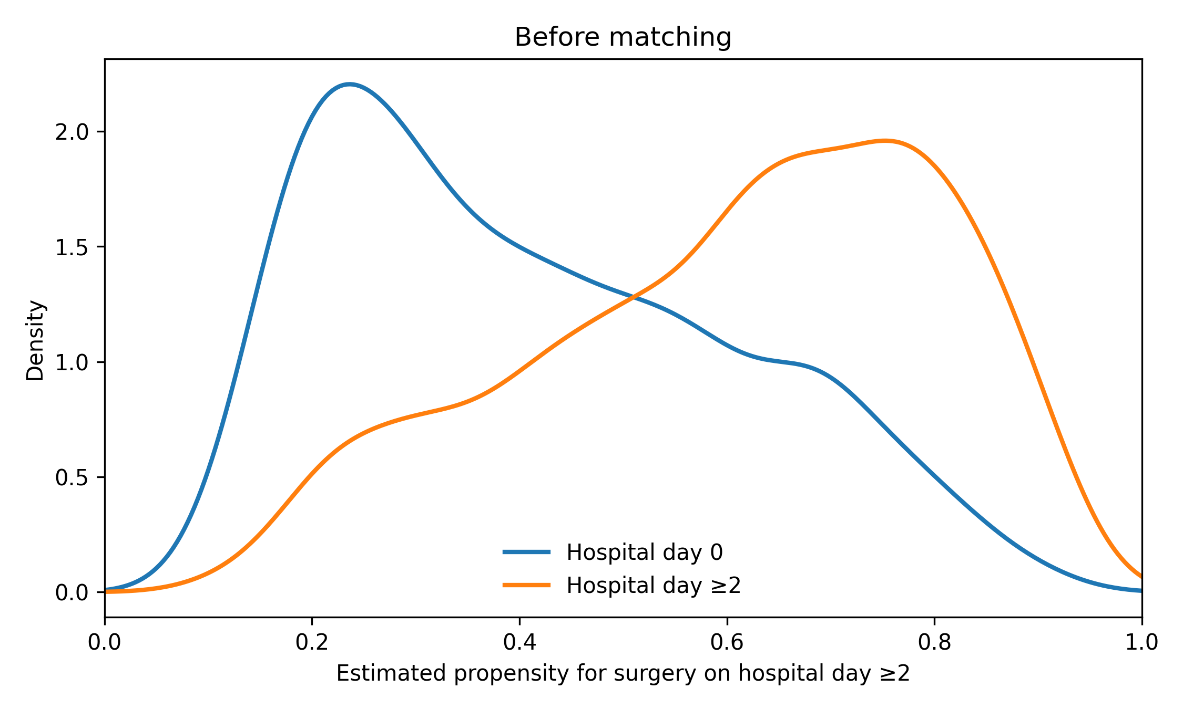
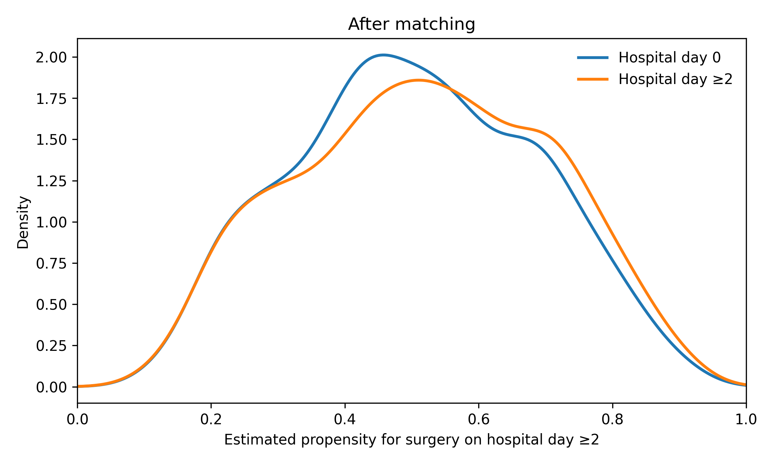
Day ≥2 versus day 0 comparison. Curves show smooth unweighted kernel-density estimates on the propensity-probability scale; they contain no individual records. Exact matching and common-support restrictions were applied by calendar year; year-specific support limits and cohort flow are in Table S2C. All propensity-model covariates were evaluated for balance in Table S2A.

Table S7. Illustrative differential readmission-capture scenarios
These scenarios quantify assumptions, not the actual frequency of out-of-state readmission. No additional patient-level outcomes were observed, and no adjusted regression estimate was recalculated.
Let q_g be the observed crude readmission risk, p_g the underlying risk of any qualifying 90-day inpatient readmission, and s_g the probability that at least one such readmission is captured among genuinely readmitted patients in group g. Assuming no false-positive readmission, q_g = s_g × p_g, so p_g = q_g / s_g. The inputs are rounded discharge-weighted risks q_0 = 0.146 and q_≥2 = 0.267.
With equal capture in both groups, the absolute risk difference is attenuated, while the crude risk ratio is unchanged. Differential capture may exaggerate or attenuate the group contrast. These calculations neither correct an adjusted odds ratio nor address confounding, model misspecification, sampling-frame limitations, or false-positive coding.
Scenario | Assumed capture: day 0 | Assumed capture: day ≥2 | Implied risk: day 0 | Implied risk: day ≥2 | Difference, pp
No missed readmission | 100.0% | 100.0% | 14.60% | 26.70% | 12.10
Equal 95% capture | 95.0% | 95.0% | 15.37% | 28.11% | 12.74
Equal 90% capture | 90.0% | 90.0% | 16.22% | 29.67% | 13.44
Lower day-0 capture | 90.0% | 95.0% | 16.22% | 28.11% | 11.88
Lower day-2-or-later capture | 95.0% | 90.0% | 15.37% | 29.67% | 14.30
Equal underlying crude risks | 54.7%* | 100.0% | 26.70% | 26.70% | 0.00
*For the equal-risk illustration, the exact ratio s_0/s_≥2 = 0.146/0.267 = 0.546816 was used. Setting s_≥2 = 1 gives p_0 = p_≥2 = 26.70%. The 54.7% displayed capture value is rounded. It is not an estimate that this degree of loss occurred.
pp, percentage points. The 90% and 95% capture assumptions are illustrative choices, not plausible ranges estimated from NRD. Confidence intervals are not shown because the calculation holds the rounded source risks fixed. The state-resident sensitivity (Table S3: OR 1.66, 95% CI 1.42-1.93) is empirical, but state residents can also receive cross-state care and this restriction cannot identify s_g.

Figure S2. Alternative causal assumptions concerning fusion
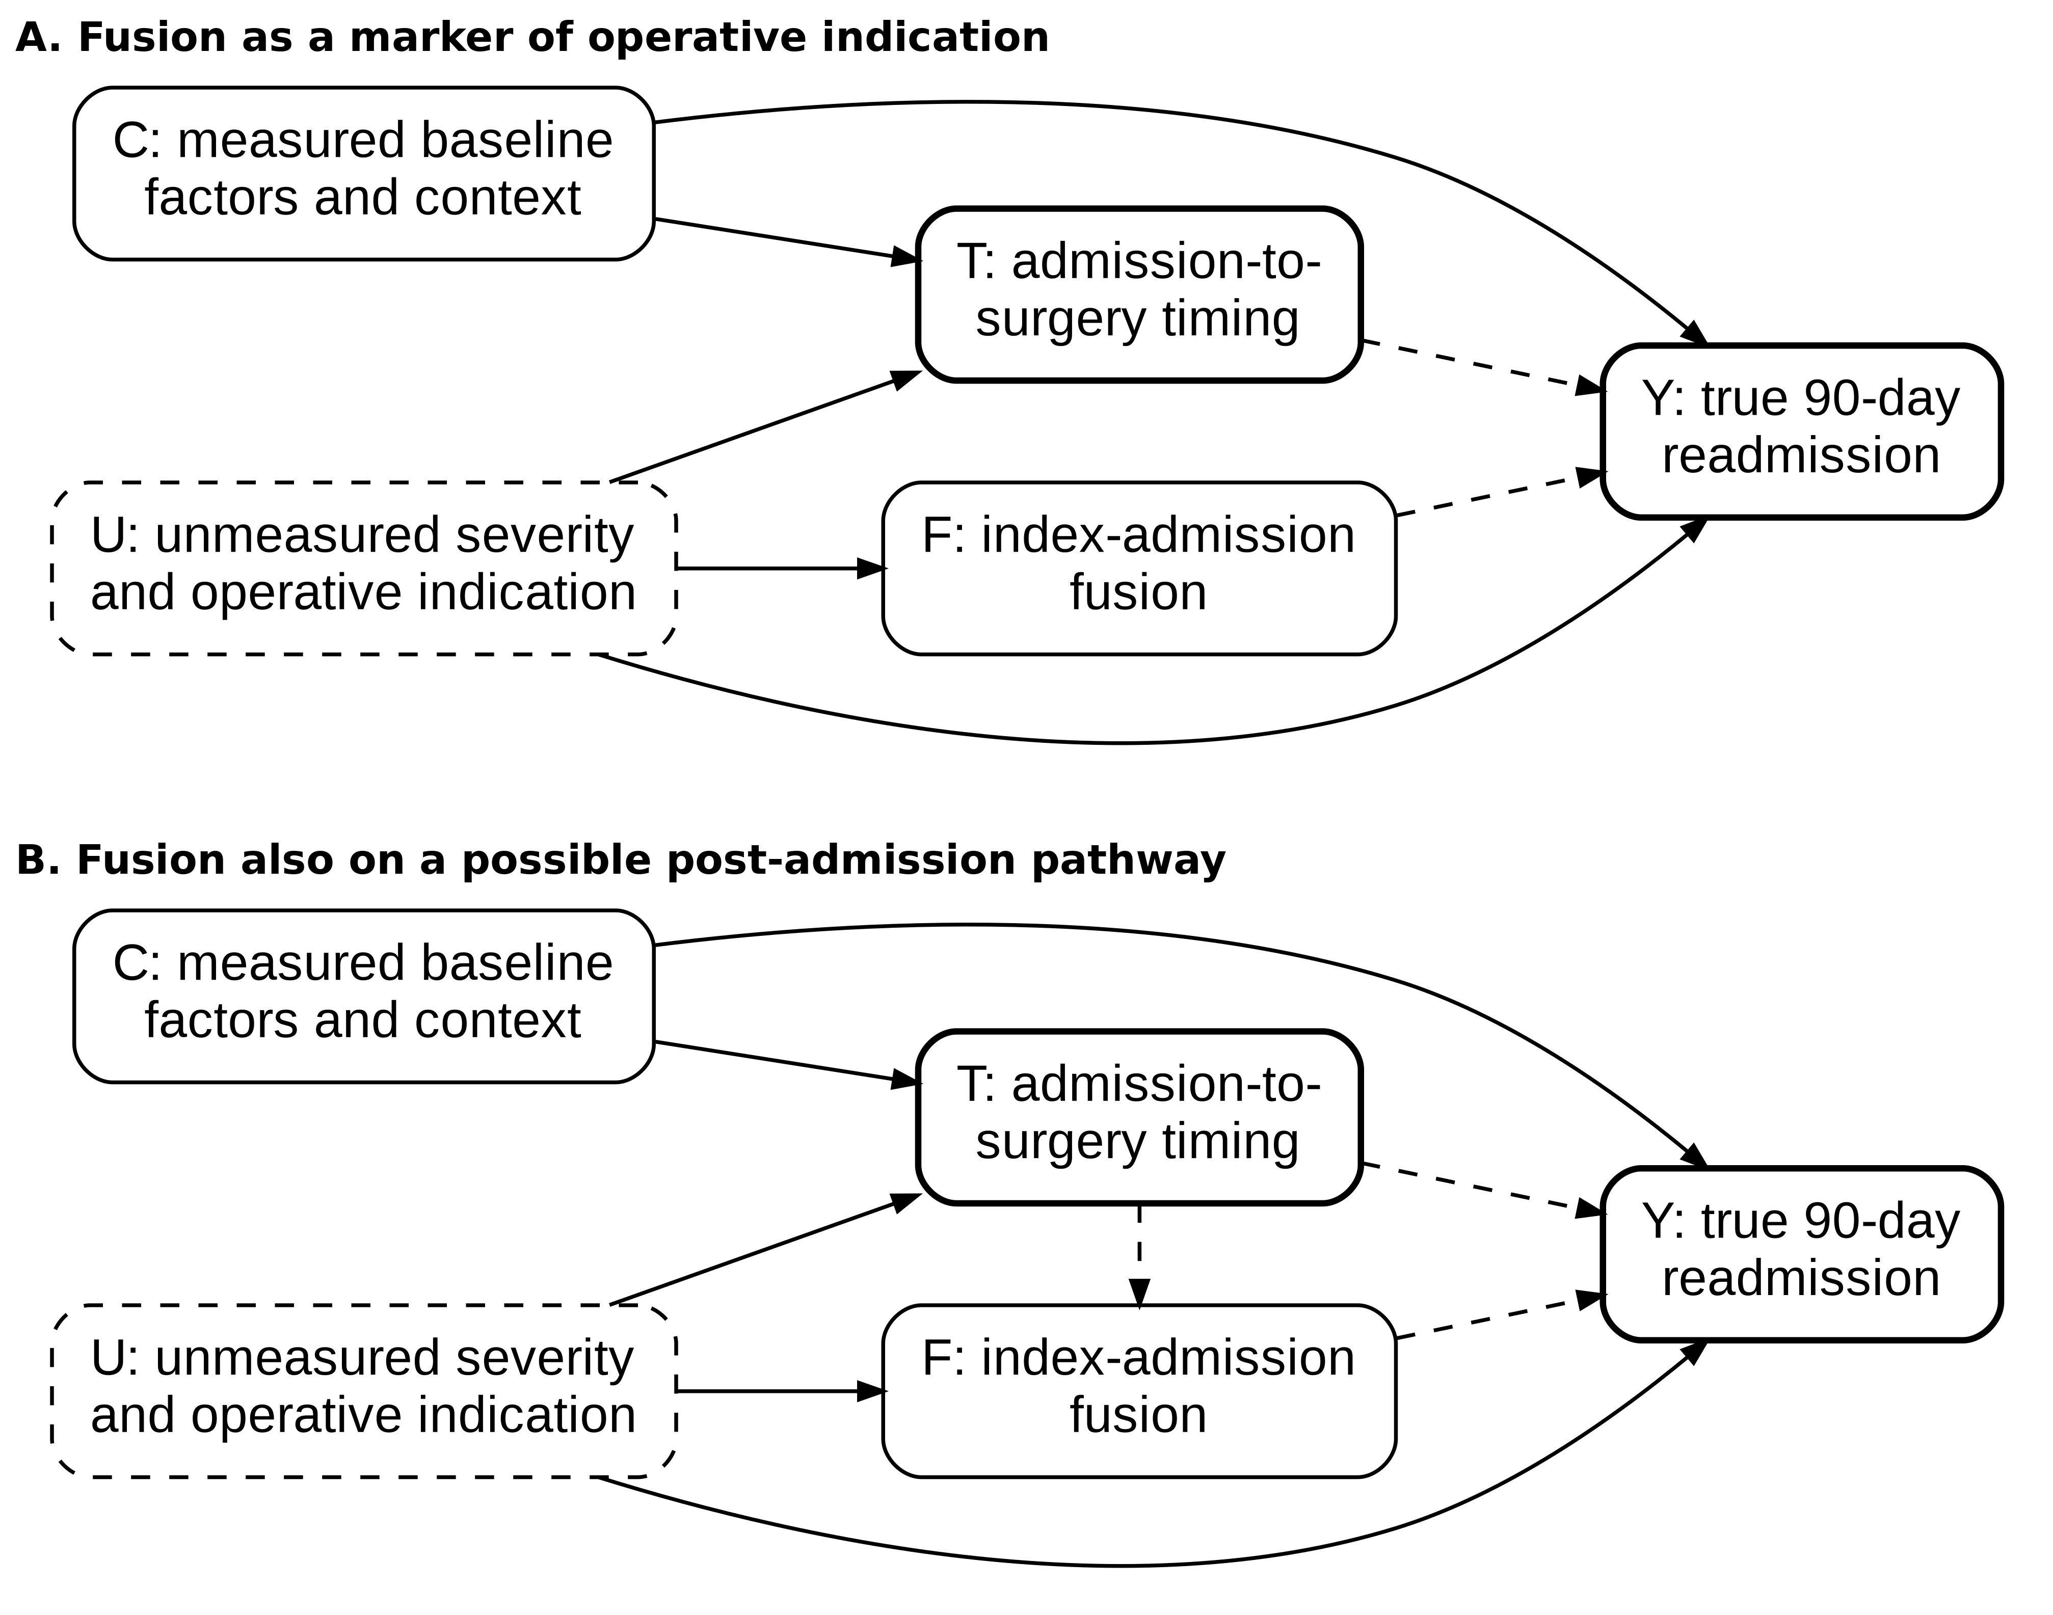
C denotes conceptual pre-timing determinants: demographics, pre-existing health and access/calendar context. Recorded diagnosis and admission-context covariates are imperfect proxies and are not all proven pre-exposure measurements. U denotes unmeasured neurologic/medical severity and operative indication. T is admission-to-surgery timing; F is index-admission fusion; Y is true 90-day inpatient readmission, imperfectly captured by NRD.
Panel A: fusion is a marker of operative indication; U influences both timing and readmission. Conditioning on F does not establish control of U. Panel B additionally allows timing-related decisions to influence fusion. In this alternative graph, F can lie on T → F → Y and can be a collider on T → F ← U. Adjustment may therefore block a pathway or induce bias.
Solid arrows denote assumed relationships among antecedent determinants and downstream variables. Dashed arrows denote possible timing/procedure pathways whose presence and ordering are not established by these data; the dashed U border identifies an unmeasured node. Both diagrams were developed during this revision as explanatory assumptions, not as prespecified or validated causal models. They omit other mechanisms, cohort-selection nodes and the readmission-capture process for clarity. Neither supplies an identifiable causal effect or a sufficient measured adjustment set (main-text reference 24).

