Records excluded
N = 474
Full-text articles assessed for eligibility
n = 75
Records screened
n = 549
Records after duplicates removed
n = 549

Additional records identified through reference check
N = 4
Records Identified through Database Searches
n = 596

Identification

Screening

Eligibility
Reasons for exclusion (59)
Full text not available (2)
Wrong study design (39)
Wrong comparison (3)
Wrong age thresholds (13)
Wrong indication (2)

Studies included in qualitative synthesis
N = 16

Included

Supplementary Figure 1. PRISMA flow-chart summarizing the search strategy for relevant publications.

Supplementary table 1: Study Quality
Authors | Years of Inclusion | Country | Study Design | Was the primary outcome a comparison | Octogenarian Baseline Characteristics Reported | Operative details provided | Cerebral protection method provided | Consecutive Recruitment of Octogenarians | Long term follow up reported | Overall Quality
Benedetto et al 2021 | 2009-2018 | UK | R | No | No | No | No | NR | No | Poor
Bojko et al 2020 | 2002-2017 | USA | R | Yes (octogenarians to septuagenarians) | Yes | Yes | No | NR | Yes | Average
Chavaron et al 2006 | 1990-2005 | France | R | Yes | No | Yes | No | Yes | No | Average
Goda et al 2010 | 1997-2007 | Japan | R | No | No | Yes (not age stratified) | Yes (not age stratified) | Yes | No | Poor
Hsu et al 2020 | 2005-2013 | Taiwan | R | Yes | Yes | Yes | No | NR | Yes | Good
Kawahito et al 2017 | 1990-2016 | Japan | R | Yes | Yes | Yes | No | Yes | Yes | Good
Neri et al 2001 | 1985-1999 | France | R | Yes | Yes | Yes | Yes | Yes | No | Average
Ohnuma et al 2016 | 2011-2013 | Japan | R | Yes | Yes | Yes | No | NR | No | Average
Omura et al 2017 | 2001-2015 | Japan | R | Yes | Yes | Yes | Yes | Yes | Yes | Good
Rylski et al 2011 | 2006-2009 | Germany | R | Yes | Yes | Yes | No | NR | No | Average
Shiono et al 2006 | 1995-2005 | Japan | R | Yes | Yes | Yes | No | Yes | Yes | Good
Suenaga et al 2016 | 2000-2013 | Japan | R | Yes | Yes-minimal | No | No | Yes | Yes | Average
Suzuki et al 2019 | 2004-2017 | Japan | R | Yes | Yes | Yes | No | Yes | Yes | Good
Tang et al 2013 | 2005-2011 | USA | R | Yes | Yes | Yes | No | Yes | Yes | Good
Tochii et al 2016 | 2005-2015 | Japan | R | Yes | Yes-minimal | Yes | No | NR | Yes | Average
Trimarchi et al 2010 | 1996-2004 | Multicentre | R | Yes (primarily over 70 to under 70) | No | No | No | NR | No | Poor

Supplementary Table 2: Preoperative and Operative Patient Characteristics
Authors | CCT > 80  (min) | CCT < 80  (min) | CPBT > 80  (min) | CPBT < 80  (min) | Root replacement > 80 | Root replacement < 80 | Arch Replacement > 80 | Arch Replacement < 80 | FET > 80 | FET < 80 | DHCA > 80 | DHCA < 80 | ACP > 80 | ACP < 80 | Malperfusion | Tamponade | HTN | Male
Benedetto et al 2021 | - | - | - | - | - | - | - | - | - | - | - | - | - | - | - | - | 2483 (67%) | 2464 (70%)
Bojko et al 2020 | 141 (113-159) | 143 (113-175) | 197 (172-230) | 211 (180-250) | 6 (3%) | 33 (14%) | 1 (<1%) | 14 (6%) | - | - | 31 (27-39) | 35 (27-39) | - | - | 53 (23%) | 36 (15.3%) | 213 (91%) | 112 (48%)
Chavaron et al 2006 | - | - | - | - | - | - | - | - | - | - | - | - | - | - | 19 (8.8%) | 37 (17%) | 121 (56%) | 150 (69%)
Goda et al 2010 | - | - | - | - | - | - | - | - |  |  |  |  |  |  | - | 83 (28%) | 196 (65%) | 163 (54%)
Hsu et al 2020 | - | - | - | - | 13 (6%) | 347 (11%) | 67 (33%) | 945 (29%) | 1 (0.5%) | 85 (2.6%) | - | - | - | - | - | - | 2355 (69%) | 2351 (69%)
Kawahito et al 2017 | - | - | - | - | 1 (1%) | 53 (6%) | 12 (11%) | 161 (18%) |  |  |  |  |  |  | 313 (31%) | 236 (23%) | - | 534 (52%)
Neri et al 2001 | 71 ± 27 | 65 ± 33 | 178 ±28 | 167 ±31 | 6 (25%) | 37 (21%) | 3 (12%) | 37 (22%) | - | - | 32 ±11 | 31 ±12 | 0 | 29 (17%) | - | 91 (46%) | 178 (90%) | 130 (66%)
Ohnuma et al 2016 | - | - | - | - | 16 (1.7%) | 132 (3.1%) | 275 (30%) | 1874 (44%) | - | - | - | - | - | - | - | - | 3157 (61%) | 2639 (51%)
Omura et al 2017 | 101 ± 32 | 124 ± 51 | 168 ± 48 | 192 ± 72 | 0 | 19 (6.7%) | 9 (14.3%) | 86 (30.4%) | - | - | - | - | - | - | 79 (23%) | - | - | 178 (52%)
Rylski et al 2011 | - | - | - | - | 9 (11%) | 56 (15%) | 8 (9%) | 54 (14%) | - | - | 29 ± 18.7 | 29.7 ± 20.3 | 55 (66.27%) | 289 (75.85%) | - | 115 (25%) | - | 210 (45%)
Shiono et al 2006 | 112 ± 34 | 137 ± 51 | 185 ± 35 | 218 ± 60 | 0 | 9 (8.2%) | 1 (4.2%) | 28 (25%) | - | - | - | - | 24 (100%) | 110 (100%) | - | 57 (43%) | 119 (89%) | 62 (46%)
Suenaga et al 2016 | 70 ± 15 | 70 ± 17 | 150 ± 32 | 144 ± 19 | - | - | - | - |  |  | 30 ±4.9 | 33 ± 7.6 | - | - | 22 (28%) | - | 54 (47%) | 24 (30%)
Suzuki et al 2019 | - | - | 111 (101 – 126) | 109 (93 – 137) | 0 | 7 (2.7%) | 4 (7.3%) | 19 (7.2%) | - | - | - | - | 0 | 0 | 82 (26%) | 91 (29%) | 200 (63%) | 155 (49%)
Tang et al 2013 | 94 ± 42 | 103 ± 49 | 177 ± 51 | 186 ± 48 | 1 (5%) | 23 (29%) | 0 | 2 (3%) | - | - | - | - | - | - | 33 (33%) | 21 (21%) | 79 (78%) | 63 (62%)
Tochii et al 2016 | 135 ± 27 | 161 ± 53 | 193 ± 31 | 235 ± 68 | 0 | 18 (13%) | 1 (4%) | 36 (27%) | - | - | - | - | - | - | 13 (8%) | - | - | 75 (49%)
Trimarchi et al 2010 | - | - | - | - | - | - | - | - | - | - | - | - | - | - | - | - | 629 (67%) | 312 (33%)

Supplementary table 3: Primary and Secondary Endpoint data
Authors | # > 80 surgically managed | # < 80 Surgically managed | Early Mortality > 80 | Early Mortality < 80 | CVA > 80 | CVA < 80 | AKI > 80 | AKI < 80 | Re-exploration > 80 | Re-exploration < 80 | ICU LOS > 80 | ICU LOS < 80
Benedetto et al 2021 | 250 (7%) | 3430 (93%) | 69 (27.6%) | 573 (17%) | 16 (6.4%) | 322 (9%) | 35 (15.2%) | 475 (14%) | 19 (8.7%) | 359 (10%) | NR | NR
Bojko et al 2020 | 70 (30%) | 165 (70%) | 20 (28.6%) | 35 (21.2%) | 9 (12.9%) | 23 (13.9) | 11 (15.7%) | 31 (18.8%) | 6 (8.6%) | 10 (6.1%) | NR | NR
Chavaron et al 2007 | 16 (56%) | 211 (16%) | 9 (56%) | 34 (16%) | NR | NR | NR | NR | NR | NR | NR | NR
Goda et al 2010 | 18 (6%) | 283 (94%) | 3 (17%) | 38 (13%) | NR | NR | NR | NR | NR | NR | NR | NR
Hsu et al 2020 | 206 (6%) | 3217 (94%) | 70 (34%) | 649 (20.2%) | 16 (7.8%) | 376 (11.7%) | NR | NR | 14 (6.8%) | 248 (7.7%) | 12.9+-14.9 | 10.1 +-12.2
Kawahito et al 2017 | 112 (11%) | 914 (89%) | 7 (6.3%) | 68 (7.4%) | 14 (12.5%) | 87 (9.5%) | 5 (4.5%) | 69 (7.5%) | 5 (4.5%) | 42 (4.6%) | 8 +- 8 | 9 +- 8
Neri et al 2001 | 24 (12%) | 143 (88%) | 20 (83%) | 28 (16%) | 6 (25%) | 31 (18%) | 9 (37%) | 28 (16%) | 6 (25%) | 11 (6%) | NR | NR
Ohnuma et al 2016 | 917 (18%) | 4258 (82%) | 93 (10.1%) | 396 (9.3%) | NR | NR | 111 (12.1%) | 545 (12.8%) | 48 (5.2%) | 281 (6.6%) | 7.6 +-4.6 | 6.7 +- 4.1
Omura et al 2017 | 63 (18%) | 282 (82%) | 9 (14.3%) | 25 (8.9%) | 3 (4.8%) | 14 (5%) | NR | NR | NR | NR | NR | NR
Rylski et al 2011 | 83 (35%) | 381 (16%) | 29 (34.9%) | 60 (15.7%) | 15 (18.1%) | 52 (13.6%) | NR | NR | 19 (22.9%) | 78 (20.5%) | 12.5 (161) | 10.2 (NR)
Shiono et al 2006 | 24 (18%) | 110 (82%) | 3 (12.5%) | 5 (5.5%) | 2 (8.3%) | 8 (7.3%) | 3 (12.5%) | 16 (14.5%) | 3 (12.5%) | 6 (5.5%) | NR | NR
Suenaga et al 2016 | 25 (21%) | 92 (79%) | 2 (8%) | 3 (5%) | 2 (8%) | 9 (16%) | 1 (4%) | 3 (5%) | 3 (12%) | 4 (7%) | NR | NR
Suzuki et al 2019 | 55 (17%) | 264 (83%) | 6 (10.9%) | 27 (10.2%) | 7 (12.7%) | 30 (11.4%) | 4 (7.3%) | 38 (14.4%) | 5 (9.1%) | 14 (5.3%) | NR | NR
Tang et al 2013 | 21 (21%) | 80 (79%) | 0 | 9 (11.2%) | 0 | 2 (3%) | 0 | 6 (8%) | 2 (10%) | 7 (9%) | NR | NR
Tochii et al 2016 | 24 (15%) | 134 (85%) | 0 | 10 (7.5%) | 0 | 17 (12.7%) | 0 | 15 (11.2%) | 0 | 7 (5.2%) | 7 +-6 | 10 +- 10
Trimarchi et al 2010 | 30 (4%) | 739 (96%) | 12 (6.4%) | 174 (23.5%) | NR | NR | NR | NR | NR | NR | NR | NR

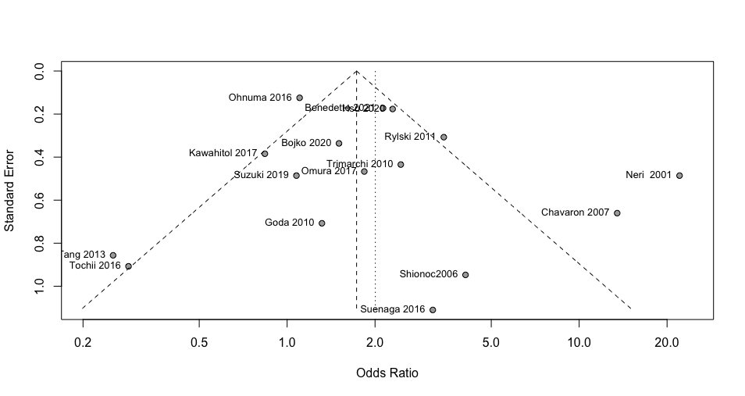
Supplementary figure 2. Funnel plot of impact of age on early mortality post-acute type A aortic dissection repair

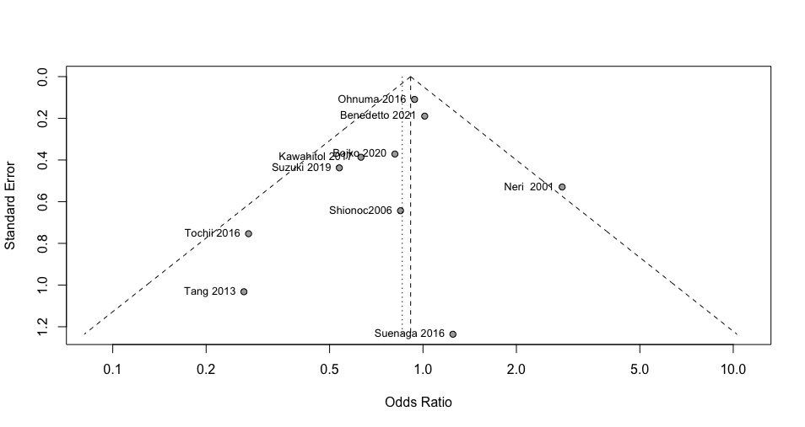
Supplemental figure 3. Funnel plot of impact of age on occurrence of acute renal failure post-acute type A aortic dissection repair

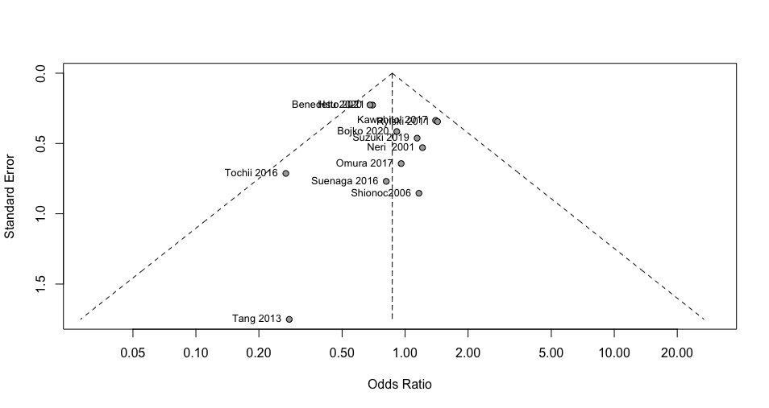
Supplemental figure 4. Funnel plot of impact of age on occurrence of stroke post-acute type A aortic dissection repair

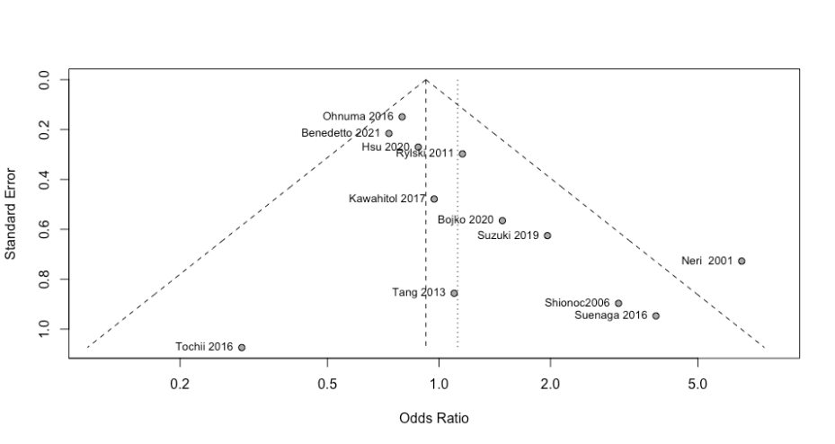
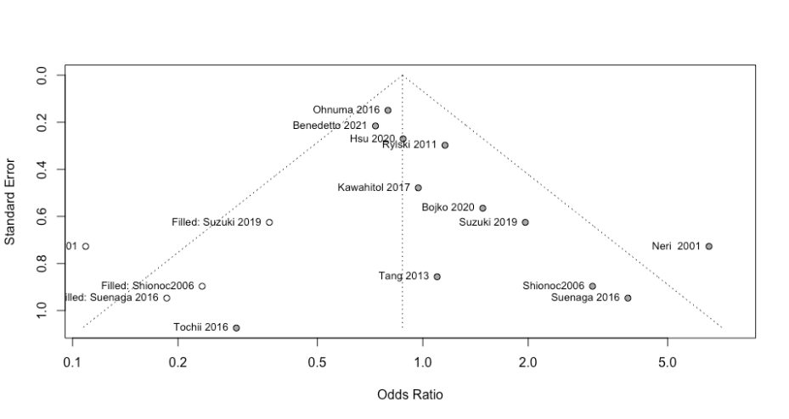
b
a

Supplemental figure 5. A – Unconnected Funnel plot of impact of age on occurrence of re-exploration post-acute type A aortic dissection repair, B – Trim and fill funnel plot of impact of age on occurrence of re-exploration post-acute type A aortic dissection repair

