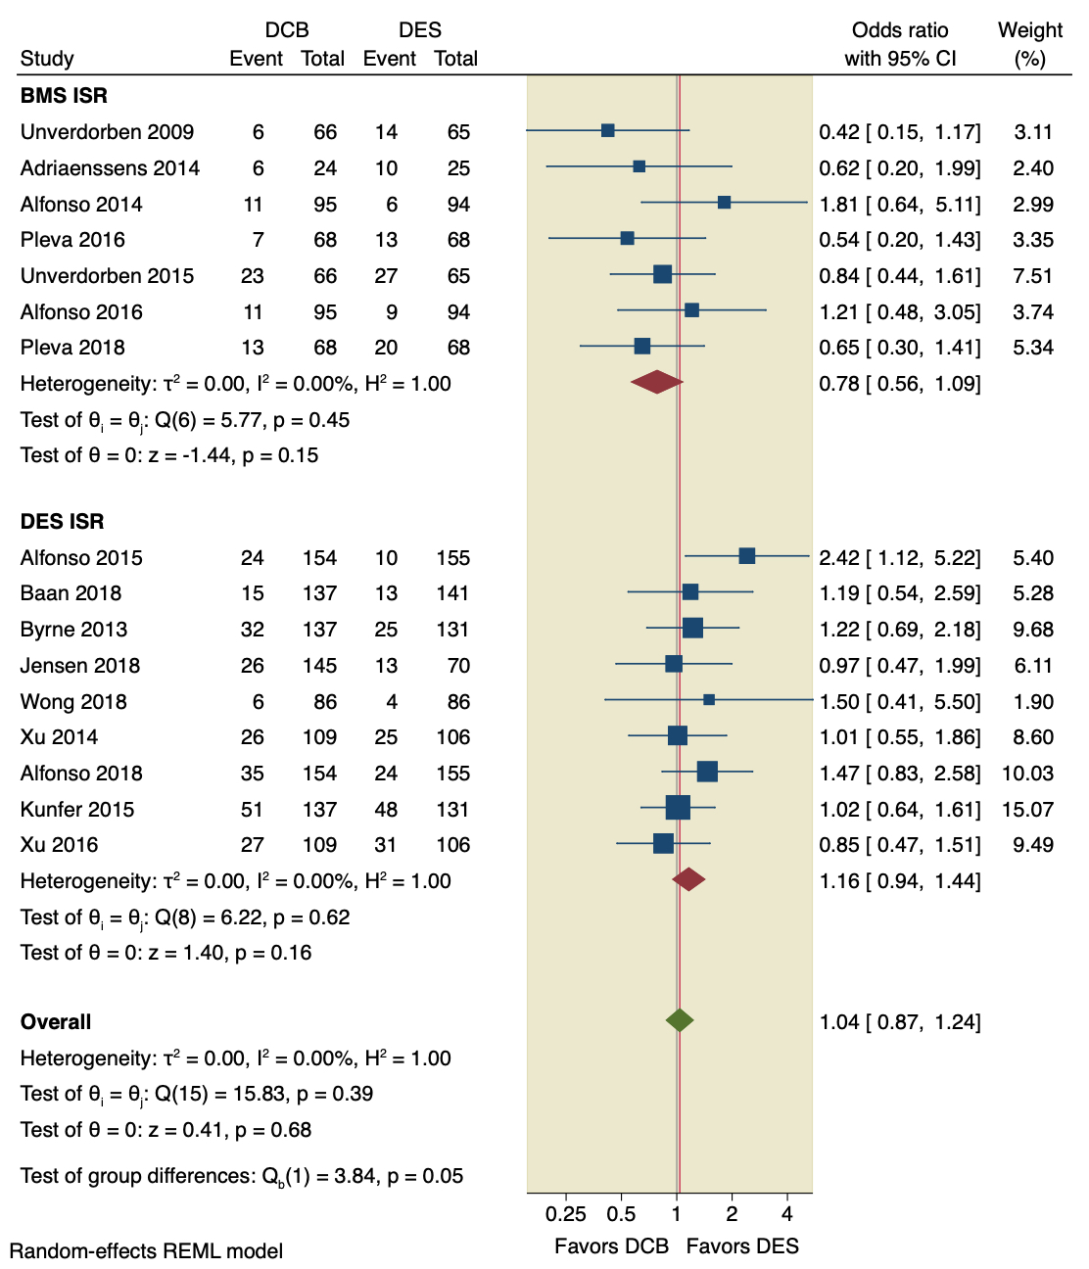
Supplementary Figure 1: Pooled estimates from RCTs evaluating the effect of DCB on the incidence of MACE with a random-effects model according to the intervention used. DCB: Drug-coated balloons; DES: drug-eluting stents; CI: confidence interval.

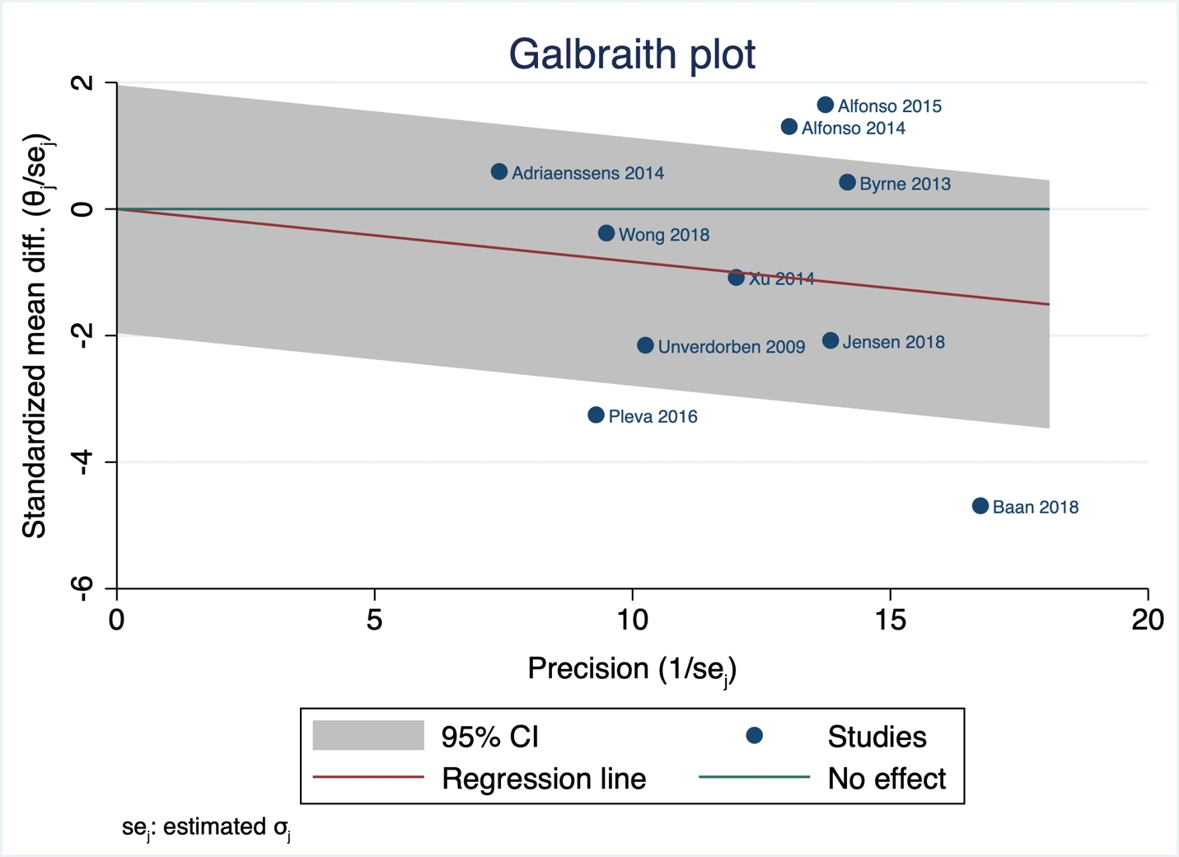
Supplementary Figure 2: Galbraith plot of LLL.

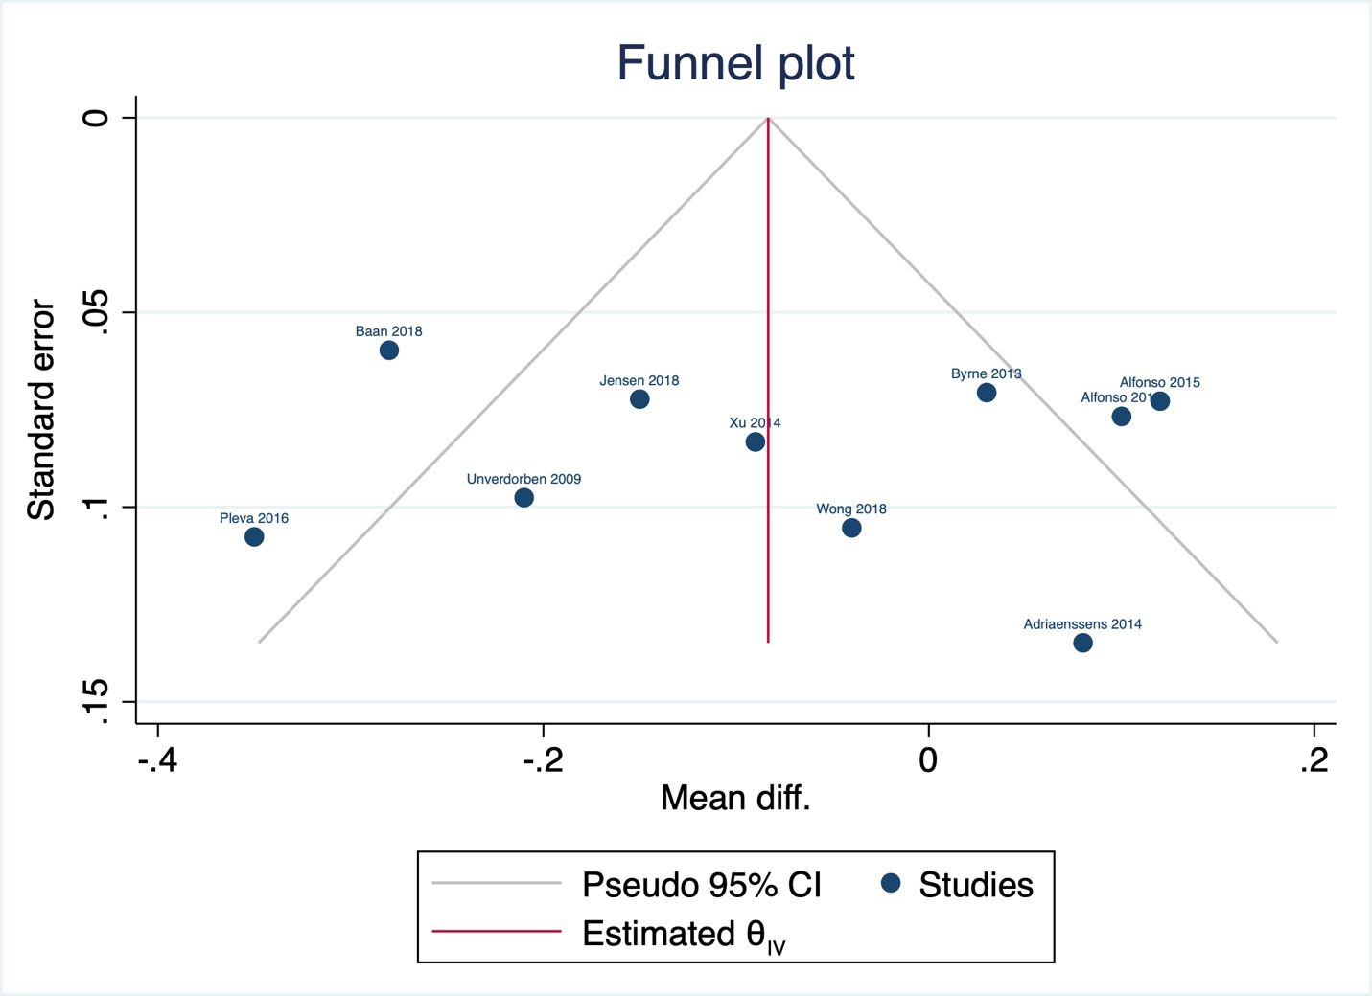
Supplementary Figure 3: Funnel plot of LLL.

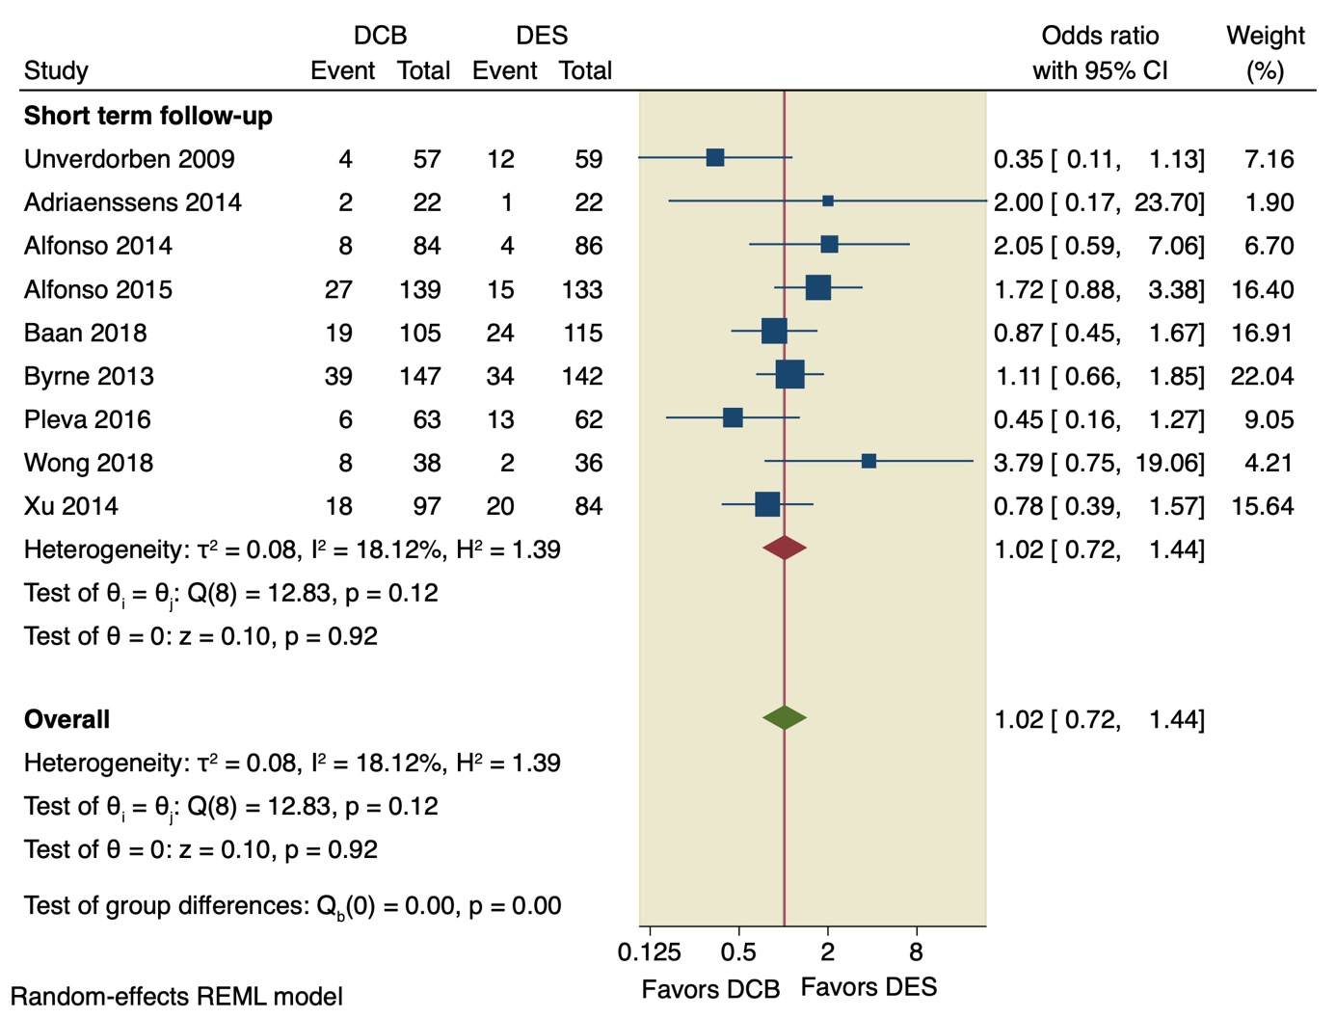
Supplementary Figure 4: Pooled estimates from RCTs evaluating the effect of DCB on the incidence of in-stent binary restenosis with a random-effects model. DCB: Drug-coated balloons; DES: drug-eluting stents; CI: confidence interval.

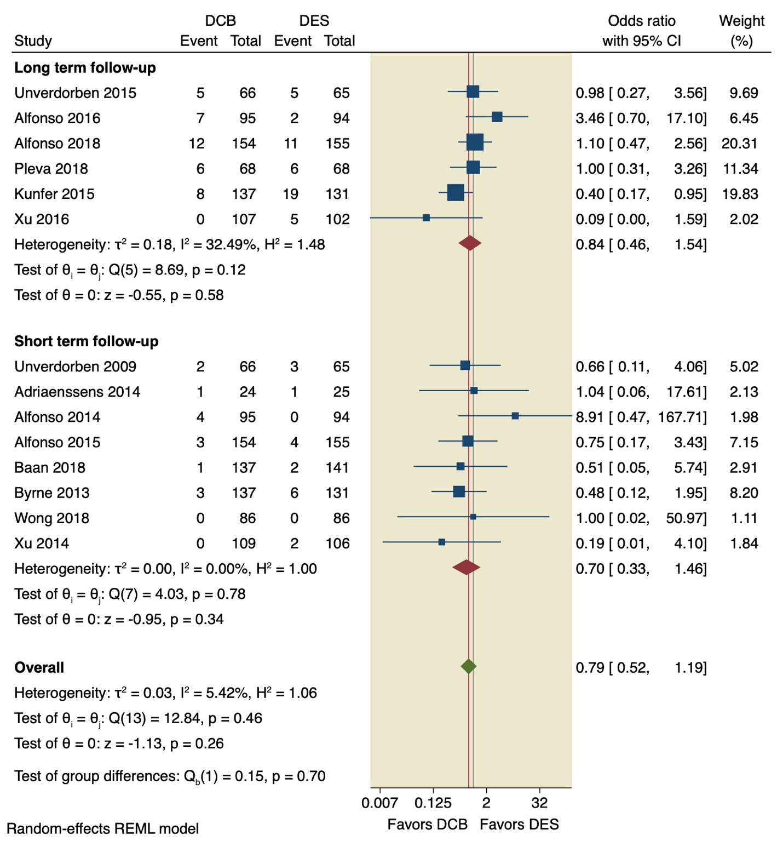
Supplementary Figure 5: Pooled estimates from RCTs evaluating the effect of DCB on the incidence of all-cause death with a random-effects model. DCB: Drug-coated balloons; DES: drug-eluting stents; CI: confidence interval.
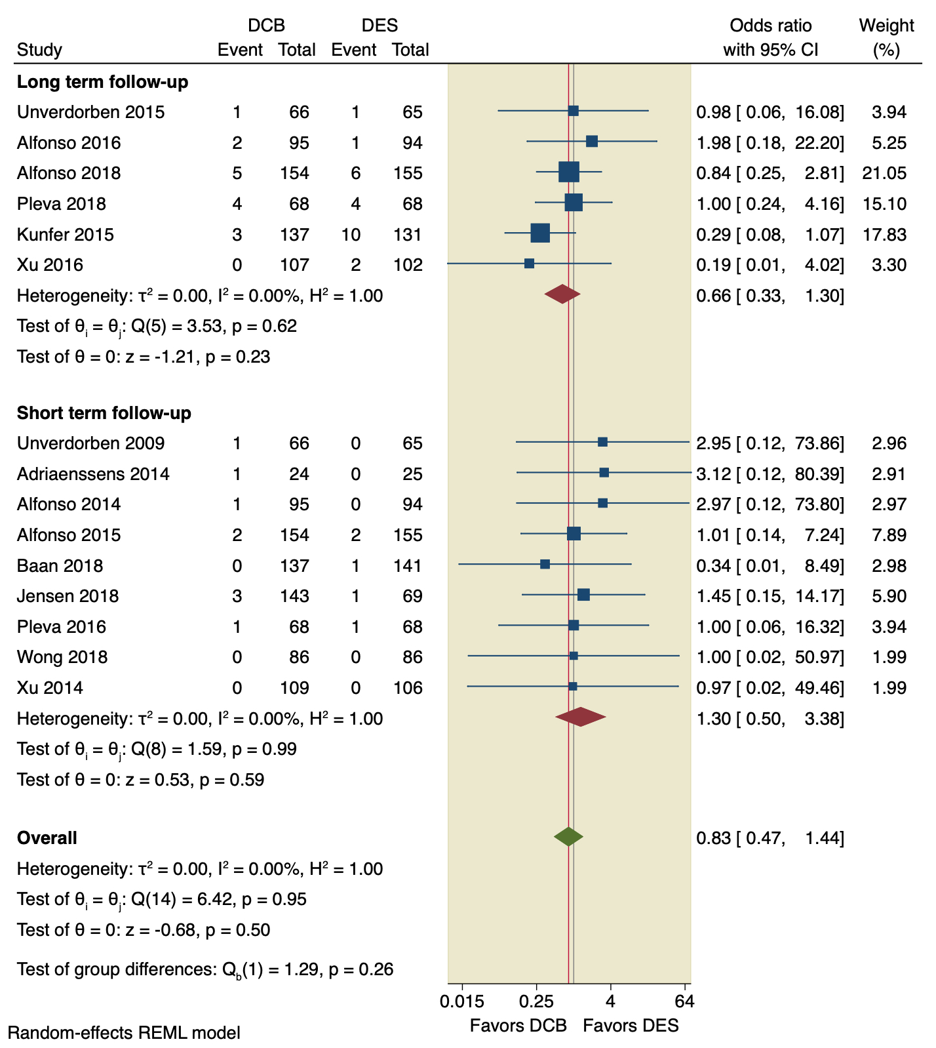
Supplementary Figure 6: Pooled estimates from RCTs evaluating the effect of DCB on the incidence of cardiac death with a random-effects model. DCB: Drug-coated balloons; DES: drug-eluting stents; CI: confidence interval.
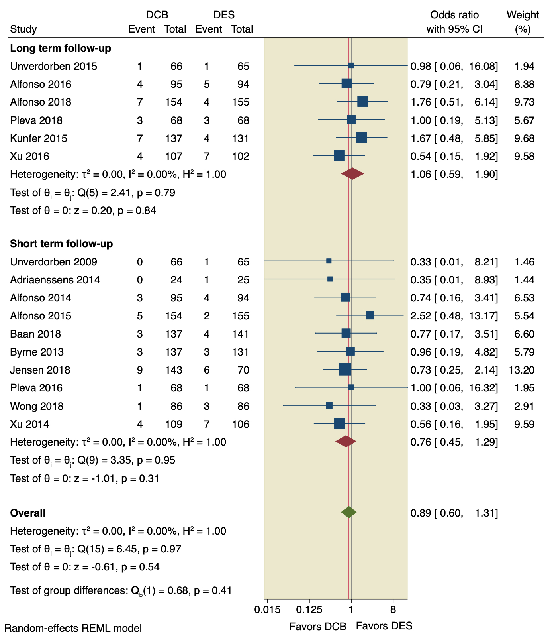
Supplementary Figure 7: Pooled estimates from RCTs evaluating the effect of DCB on the incidence of MI with a random-effects model. DCB: Drug-coated balloons; DES: drug-eluting stents; CI: confidence interval.
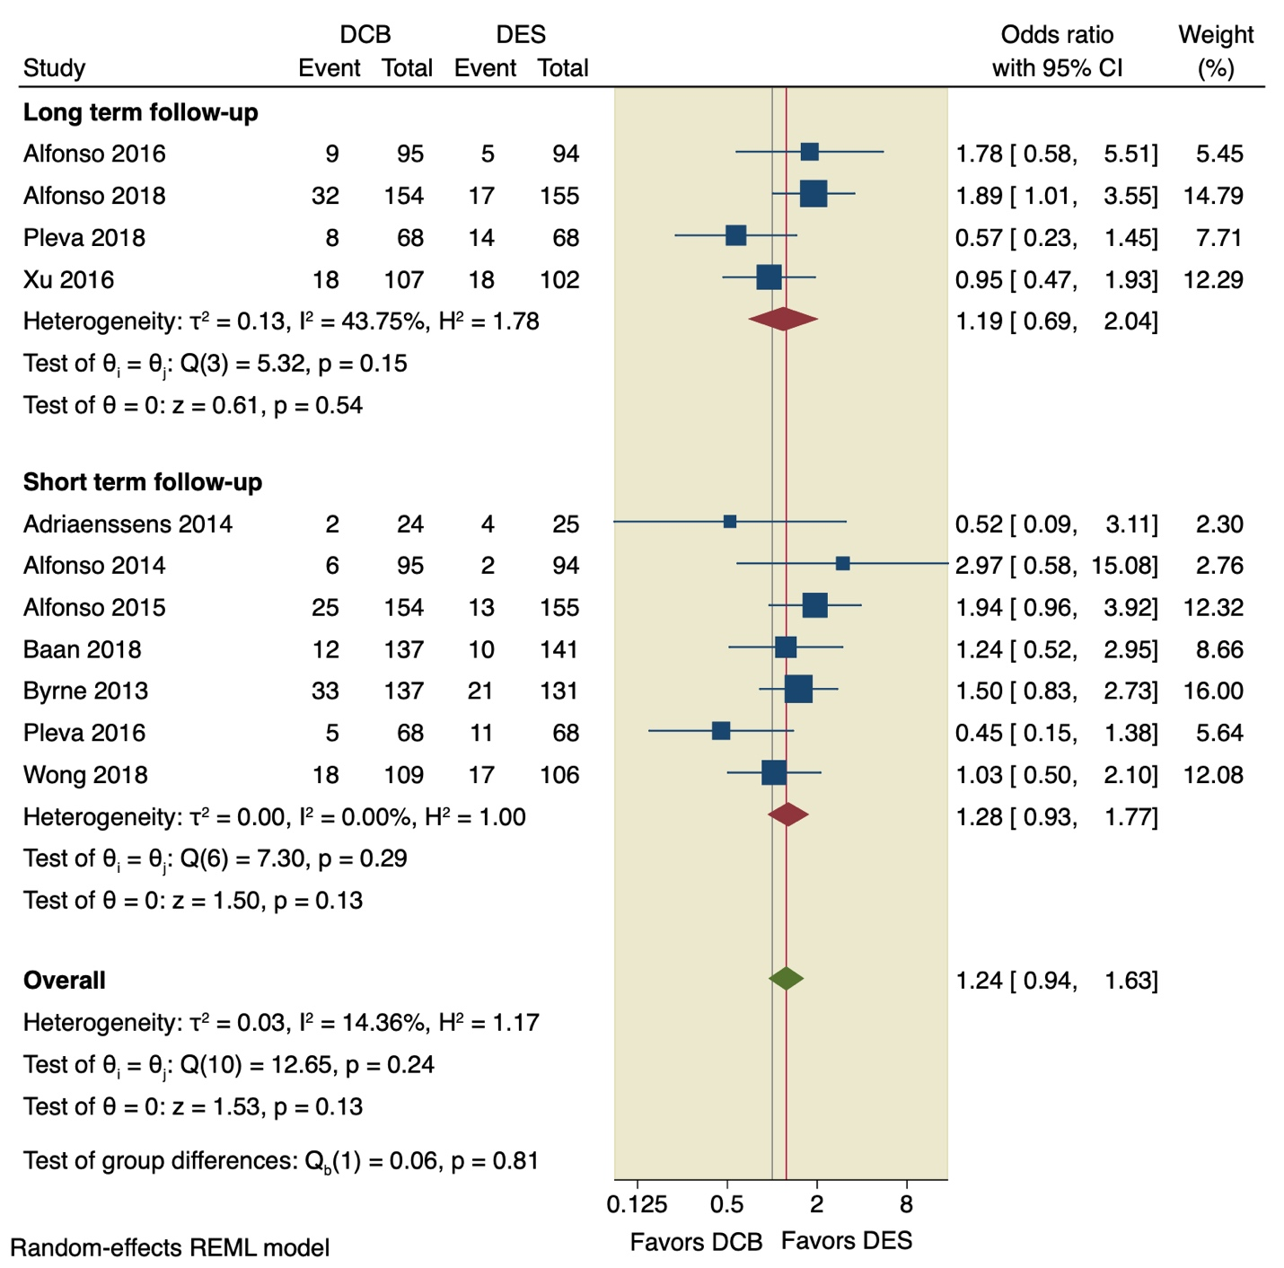
Supplementary Figure 8: Pooled estimates from RCTs evaluating the effect of DCB on the incidence of TVR with a random-effects model. DCB: Drug-coated balloons; DES: drug-eluting stents; CI: confidence interval.

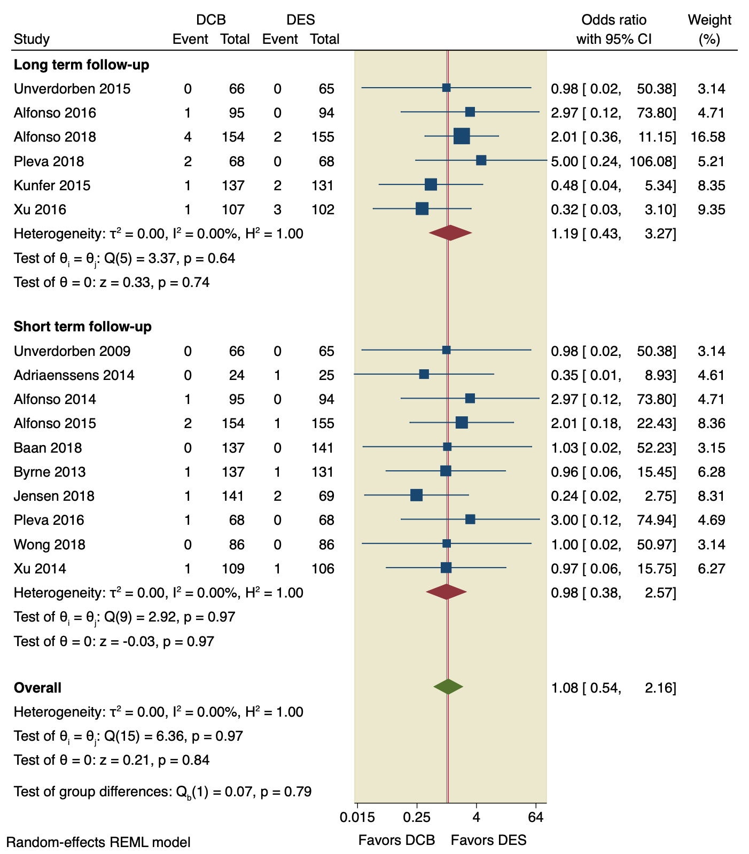
Supplementary Figure 9: Pooled estimates from RCTs evaluating the effect of DCB on the incidence of stent thrombosis with a random-effects model. DCB: Drug-coated balloons; DES: drug-eluting stents; CI: confidence interval.
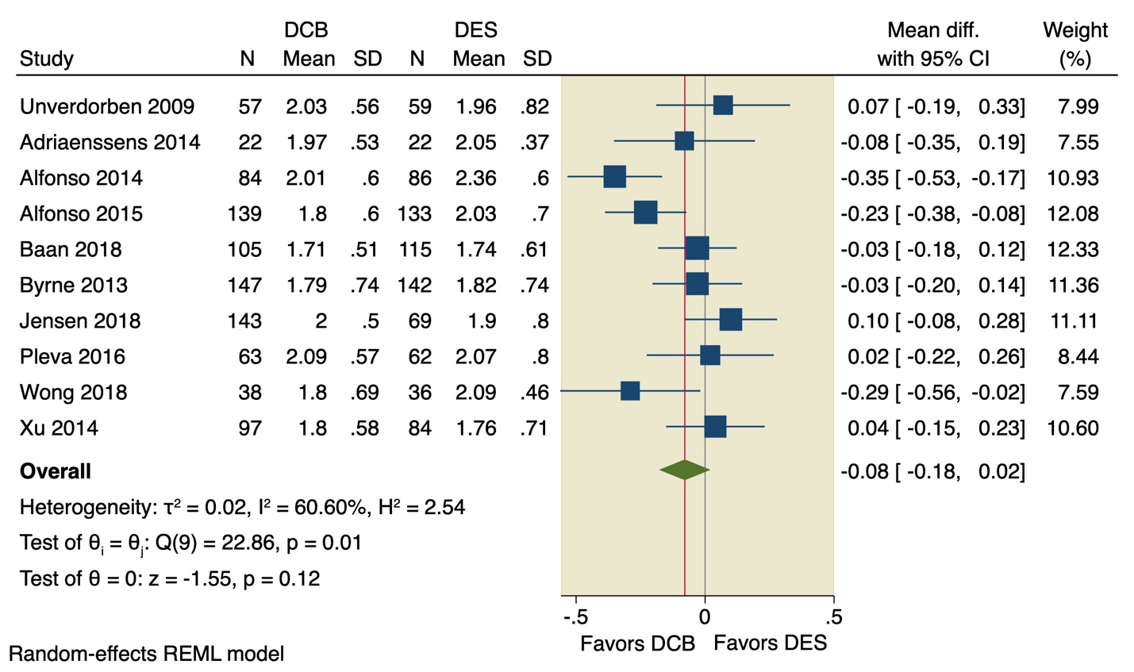
Supplementary Figure 10: Pooled estimates from RCTs evaluating the effect of DCB on the MLD with a random-effects model. DCB: Drug-coated balloons; DES: drug-eluting stents; CI: confidence interval.

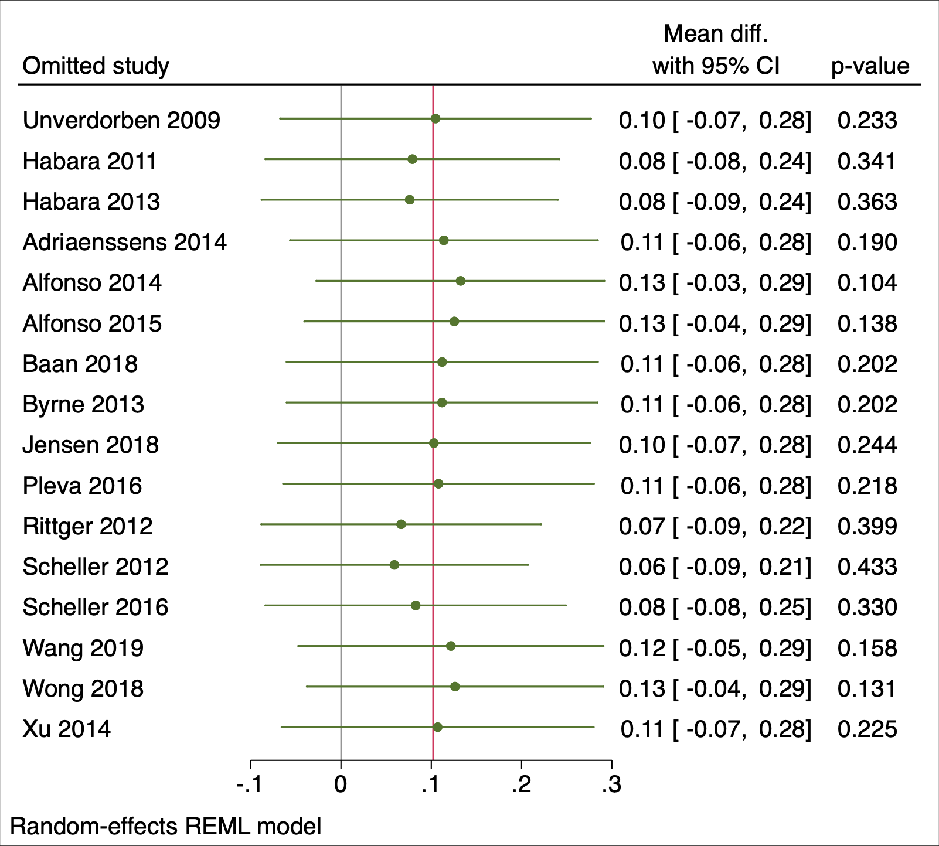
Supplementary Figure 11: Leave-one-out of MLD.

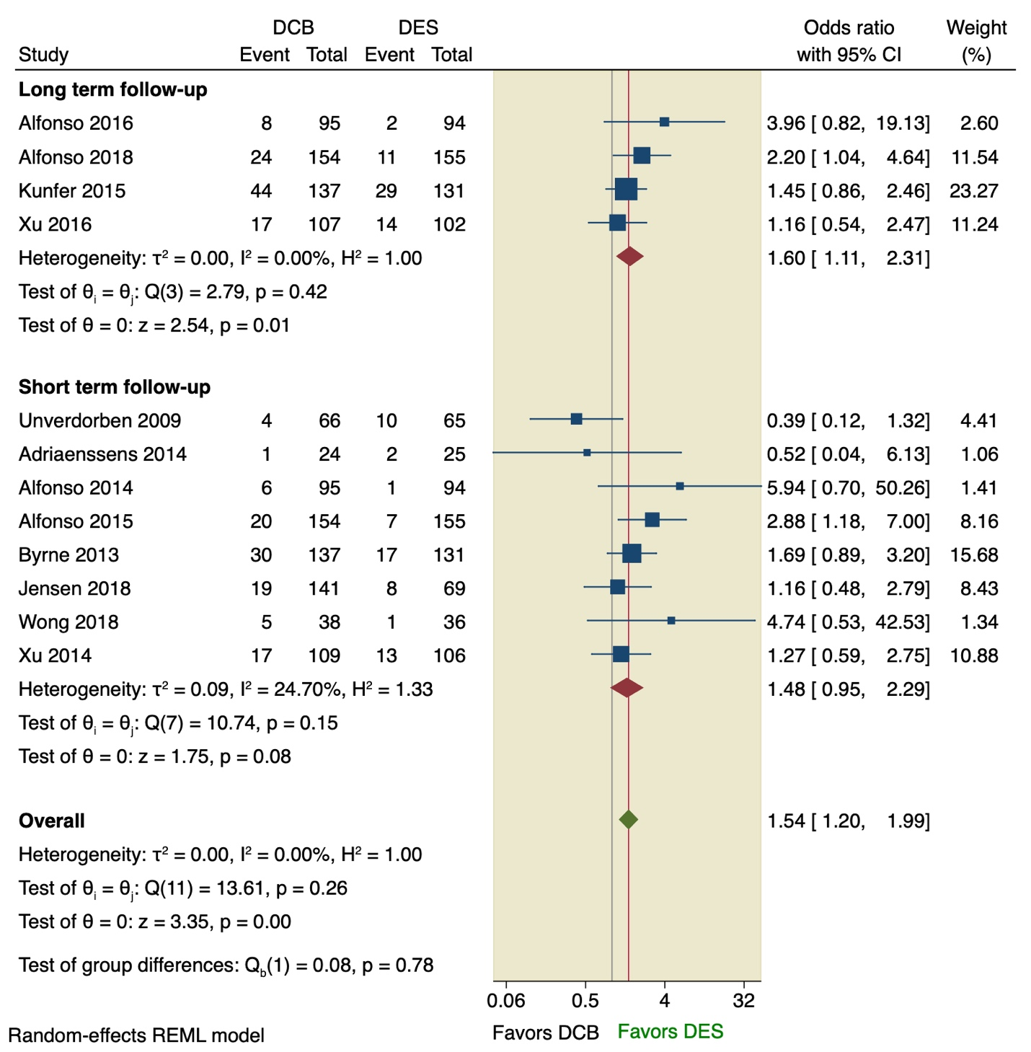
Supplementary Figure 12: Pooled estimates from RCTs evaluating the effect of DCB on the TLR with a random-effects model. DCB: Drug-coated balloons; DES: drug-eluting stents; CI: confidence interval.

