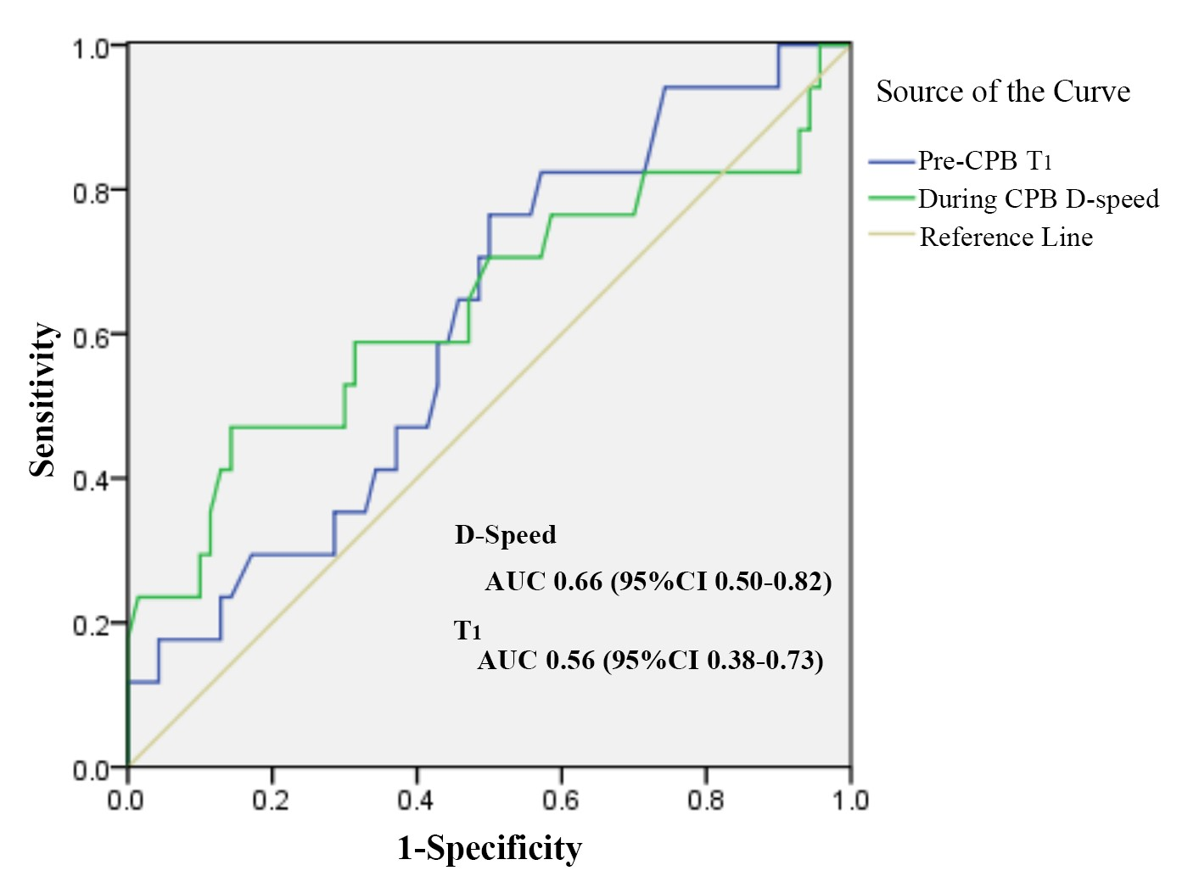
Figure S1. Receiver operating characteristic curve of pre-CPB T₁ and during CPB D-speed to predict intraoperative hyperlactatemia. CBP, cardiopulmonary bypass; T₁, resaturation time; D-speed, desaturation speed

